Laptop 20-50W

Desktop computer 80-150W

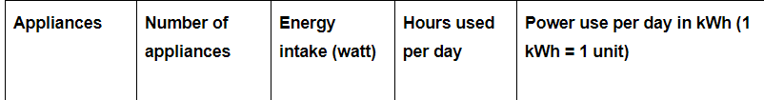



Problem in system sleep mode:

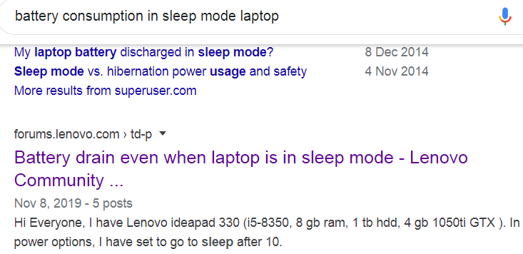

Sleep - faster to shut down and restart, uses significant power but not near full power while sleeping. Use for suspending maybe 5 minutes to a couple of hours to save some power and time.

Hibernate - slower to shut down and restart but takes no power while suspended

Shutdown - computer fully off no power like hibernate, but loses all programs and data that are running and not saved. May be slower to boot up than restoring from hibernate.

For 2–3 days sleep will run down you battery. You should use hibernate if you want to leave applications and their data in memory, shutrodwn if you want to start from scratch.

4.5k views · [View Upvoters](https://www.quora.com/Does-a-laptop-on-hibernate-consume-battery-if-not-used-for-two-to-three-days)

[Upvote· 1314](https://www.quora.com/Does-a-laptop-on-hibernate-consume-battery-if-not-used-for-two-to-three-days)

[Share](https://www.quora.com/Does-a-laptop-on-hibernate-consume-battery-if-not-used-for-two-to-three-days)

|  |  |  |
| --- | --- | --- |
| ****The basis of comparison Between Hibernate vs Sleep mode**** | ****Hibernate**** | ****Sleep**** |
| ****Power Usage**** | Zero power | Low power consumption |
| ****Resumption**** | Slow | Instant |
| ****Applicability**** | Generally when the system is idle for a longer time period and also the rebooting after shutdown will be a time taking the process | Preferred when the system is idle for a shorter period of time |
| ****Synonyms**** | Suspended to disk (in Linux), Safe Seep (in Mac), S4 (in ACPI) | Standby (in Windows older version), Suspended to RAM (in Linux), S3 in ACPI |
| ****Process Function**** | The process is saved to hard-disk | The process is stopped and the work is saved in the RAM memory |
| ****Mode Demonstration**** | While the system is in the Hibernate mode a user will not be able to use the system | A Sleeping computer is still working; it is running the basic functions behind and using the electricity. To avoid system issues one must make the system shut down time to time. |