Core Cucumber

**Testing Team**

**9/3/2019**

**Table of Contents**

**1. Introduction** 2

**2. Prerequisite** 2

**3. Web Automation Manual** 3

**3.1. BDD Framework - Project Structure** 3

**3.2. Local/Remote Desktop Execution Guide** 3

**3.3. Working with TestData Excel Sheet & DataTables** 5

**3.3. Working with TestData Excel Sheet & DataTables** 5

**3.4. Reporting** 7

# **1. Introduction**

We provide step by step instruction for implementing the features in Core Cucumber Maven Framework related to Web page Automation.

# **2. Prerequisite**

The user is expected to have basic knowledge on

1. OOPS Concept with Core Java
2. Eclipse IDE
3. Selenium Web-driver using Java
4. BDD Framework
5. GIT
6. Maven
7. TestNG Framework

# **3. Web Automation Settings**

## **3.1. BDD Framework - Project Structure**

## 

## **3.2. Remote/Local Browser Execution Guide**

* **To Execute in Local Machine**

You just need to right click the **TestNGRunRegression.xml** in \src\test\resources\TestNGRunRegressionTests.xml and run as -> TestNG Suite.

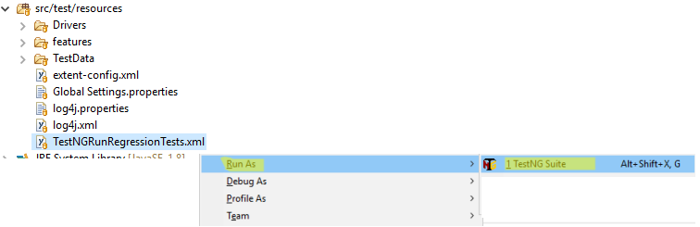

* + **Chrome browser execution Example on Local**:
    - follow the Steps described in the below Project Explorer Picture
    - Right click the RunCucumberTestLocal.java and Run as Test

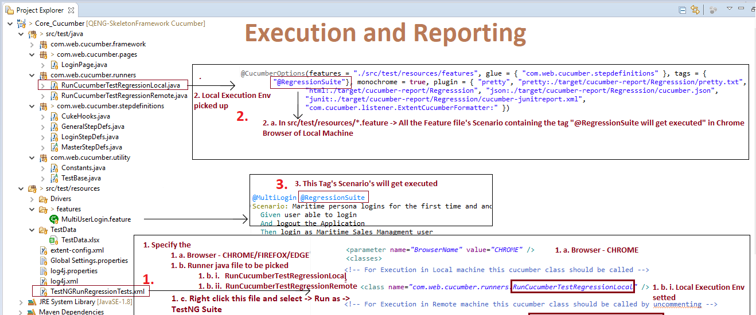

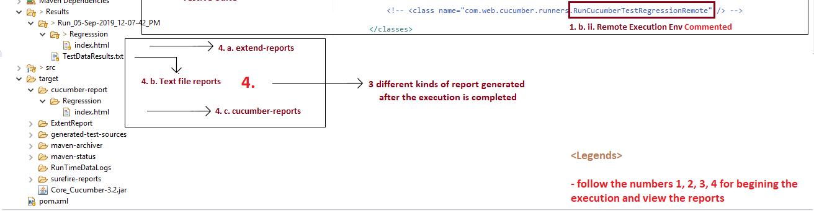

* **To Execute in Other Browser:**
  + Naviagate to..src\test\resources\TestNGRunRegressionTests.xml and update the required browser name,

value=’FIREFOX’ or

value=’’CHROME’ or

value=”INTERNET_EXPLORER” or

value =”EDGE”



* **To Execute in Jenkins Machine:**
  + Naviagate to..src\test\resources\TestNGRunRegressionTests.xml and update as suggested below Image Illustration,

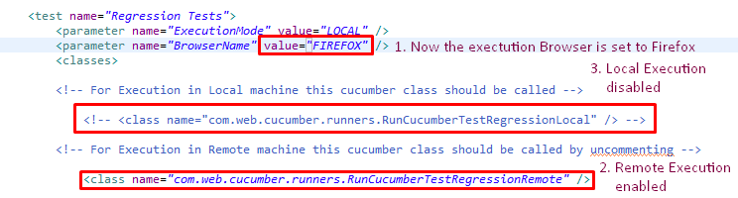

Note: This Project is a freestyle and you need to configure the Project in the

## **3.3.** **Working with TestData Excel Sheet & DataTables**

* “Reading Input from Excel sheet ” is explained below the example:

The TestData.xlsx avaiable in …src\test\resources\TestData\ will be used as a Test data sheet,

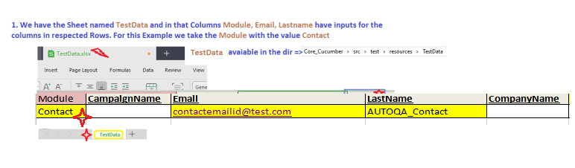

In Above Excel sheet the  is the Module Name which is used in the file which is avaiable at ..src\test\resources\features\*.features

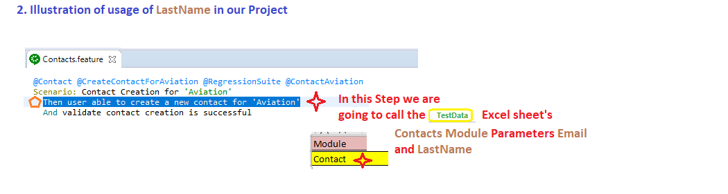

The above highlighted Step which starts with  hyperlinks to the Step class in

…src\test\…\stepdefinitions\*StepDefs.java

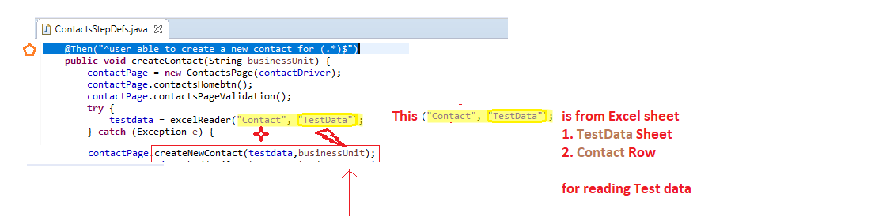

The method in src\test\…\pages\*Page.java calls the **LastName** from the **TestData** Excel sheet. Please follow below image for more understanding!

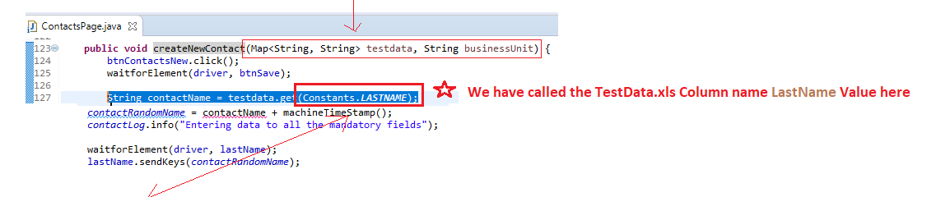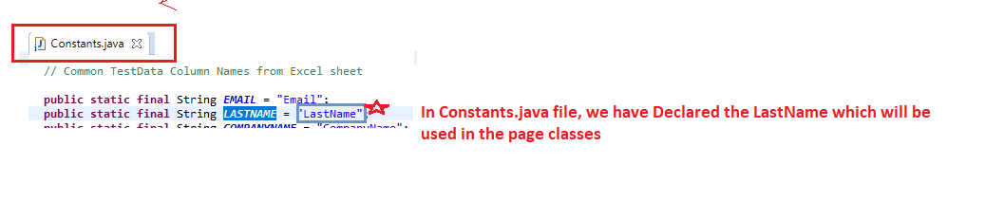

* **Reading Input from Global Properties**

In src\test\resources\Global Settings.properties we have the “Aviation_user” with it’s value which will be used as a input for logging in.



1. Below illustration explains how we are going to use the  in  of …\src\test\resources\features directory

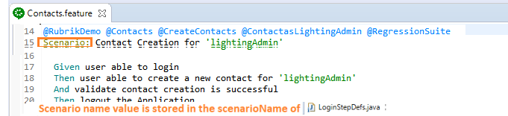

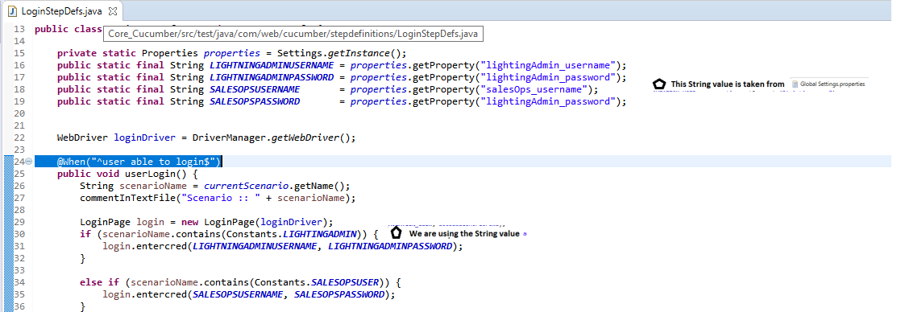

* **Reading Input from DataTables**

This is the standard Cucumber Input reading format and related contents are available @

<http://www.automationtestinghub.com/cucumber-data-table/>

<https://www.tutorialspoint.com/cucumber/cucumber_data_tables.htm>

[http://executeautomation.com/blog/working-with-multiple-data-using- datatable-in-cucumber-for-java/](http://executeautomation.com/blog/working-with-multiple-data-using-datatable-in-cucumber-for-java/)

<https://www.toolsqa.com/cucumber/data-tables-in-cucumber/>

## **3.4. Reporting**

**Step 1:** How to Execute?

You just need to right click the **TestNGRunRegression.xml** in \src\test\resources\TestNGRunRegressionTests.xml and run as -> TestNG Suite.



**Step 2:**

Once the Execution is completed, the reports will be generated in

* 1. Project_Name\Results\Run_DD-MMM-YYYY_HH-MM-SS_PM/AM\TestExecutionReport.html
  2. Project_Name\Results\Run_DD-MMM-YYYY_HH-MM-SS_PM/AM\TestDataResults.txt
  3. Project_Name\target\cucumber-report\Regression\index.html

