**Important Notes:**

* colors & sizes will change based product category for example if shirt or watch there will display size and color etc… if from food items it will change as spicy1 spicy 2 etc… I mentioned comment in **store-item.html**
* **Left side navigation I given register / login / forgot password for your idea once copy paste that** form please comment that 3 links later once taken code.
* Home page text boxes just use now I will add css for style
* You will put search box in header I will add styles later.
* Font will change later
* Images also will change later
* Wherever you will see links like **shop == it is store** (we have food & store)
* Every sub page have back link related category for example user in sub category from there he will go back link to main-categories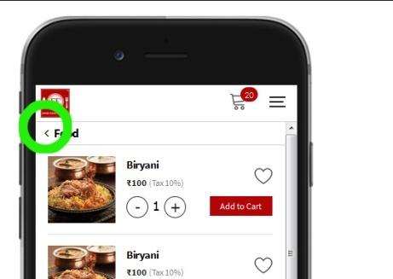

**Below is flow**

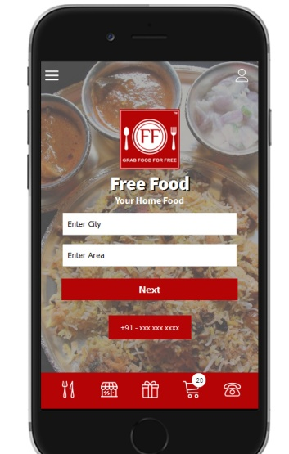

1. Home after selection area it will goes to **food-store.html (User will select food or ecommerce store)**

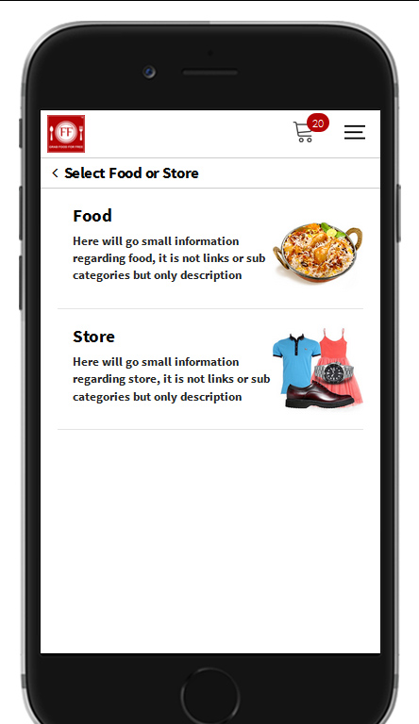

1. Once user select **food** in above screen(food-store.html) he will go to **food-categories.html (example if user select store he will goes to store-categories.html, but both pages only same but titles and sub-categories will display based on categories )**

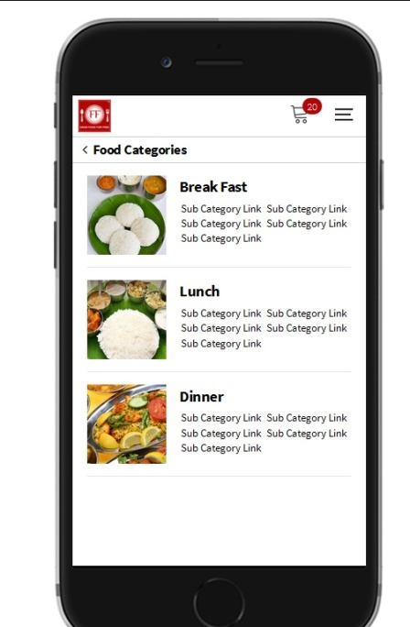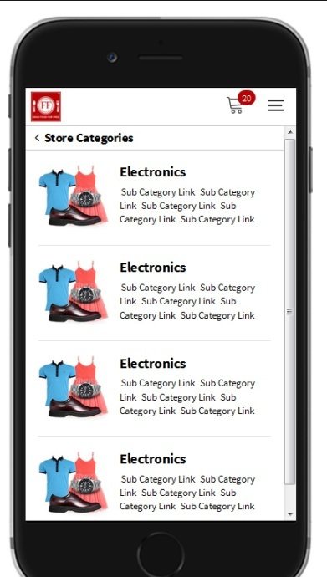

**If select store side above screen will display**

1. **If select break fast in above screen user see all breakfast like below**

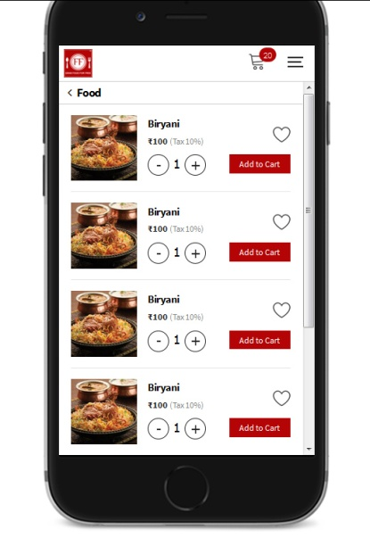

1. If click on any product it will goes to **store-item.html** (content & title will change based on user category if come from ecommerce it will show **store-item.html** or coming from food it will show **food-item.html** but everything same ) page