Internship Completion Certificate
TO WHOM IT MAY CONCERN
This is to formally certify that {{ salutation }} {{ intern_name }} (Reg. No: {{ reg_no }}), {{ college }}, has successfully completed her internship with Analytics Avenue LLP in the role of {{ role }}.
Her internship was carried out for a period of {{ duration }}, from {{ start_date }} to {{ end_date }}, during which she was actively involved in {{ role }} activities under the guidance and supervision of the internal team.
During the internship tenure, she was engaged in responsibilities including {% for r in responsibilities %}{{ r }}{% if not loop.last %}, {% endif %}{% endfor %}. She demonstrated sincere effort, good professional conduct, and a strong willingness to learn throughout the internship period.
This internship provided her with practical exposure to {{ role }} processes, recruitment workflow, and basic HR operations in a professional work environment.
We appreciate her contribution during the internship period and wish her success in her future academic and professional endeavors.
This letter is being issued as an Internship Completion Certificate / Letter of Completion from Analytics Avenue LLP.

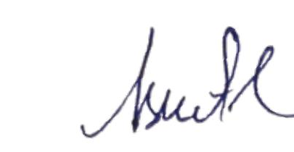
For ANALYTICS AVENUE LLP

Regards,
Aswath R
Human Resource
Analytics Avenue and Advanced Analytics
(Empower your bussiness with data driven insights)

