Offer Letter
Date: {{ letter_date }}
Dear {{ salutation }} {{ candidate_name }},
We are pleased to extend this offer of employment to you for the position of {{ role }} in the {{ department }} department at Analytics Avenue LLP. Your employment will commence from {{ joining_date }}.
Compensation & Benefits
Your total Cost to Company (CTC) is {{ ctc_lpa }} ({{ ctc_annual_str }} per annum), structured as follows:
Salary Component | Monthly Amount
Basic Salary | {{ basic_monthly_str }}
House Rent Allowance (HRA) | {{ hra_monthly_str }}
Provident Fund — Employer Contribution | {{ pf_monthly_str }}
Special Allowance | {{ special_allowance_monthly_str }}
Gross Monthly (Fixed) | {{ gross_monthly_str }}
Variable Pay (Annual, Performance-Based) | {{ variable_annual_str }}
Total CTC (Annual) | {{ ctc_annual_str }}

The variable component of {{ variable_annual_str }} per annum is performance-linked and will be disbursed annually based on individual and organizational performance.
Terms & Conditions
- Probation Period: Your first 3 months will be a probationary period.
- Notice Period: 90 days from either side after confirmation.
- Training Bond: 12 months service bond applies. Early exit attracts recovery of up to ₹1,00,000.
- Background Verification: This offer is subject to successful background verification.

Roles & Responsibilities
During the tenure, the employee is expected to actively participate in:
- End-to-end business development activities
- Client engagement and lead generation
- Follow-ups and achievement of assigned targets
- Preparation of reports and dashboards
- Completion of mandatory technical and professional training programs

We look forward to welcoming you to the Analytics Avenue LLP family. Please sign and return a copy of this letter as confirmation of your acceptance.

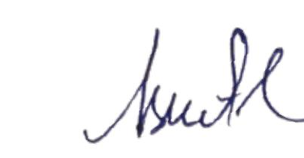
For ANALYTICS AVENUE LLP

Regards,
Aswath R
Human Resource
Analytics Avenue LLP
(Empower your bussiness with data driven insights)

Acceptance of Offer:
I, _____________________accept the offer of employment as {{ role }} at Analytics Avenue LLP
under the terms and conditions outlined in this offer letter.

Signature:
Date:

