**Phase 4 – Application Feedback and Approval Automation**

**Objective**

To automate the approval process for student applications, notify students upon approval, and request feedback after internship completion. This phase ensures only eligible students can apply and prevents duplicate feedback requests.

**0. Quick Setup – Email Deliverability**

**Purpose:** Ensure that test emails can be sent from the Dev org.

**Procedure:**

1. Navigate to **Setup → Email → Deliverability**.
2. Set **Access Level = All Email**.
3. Note: This setting is for testing only. Revert in production if necessary.  
     
     
     
   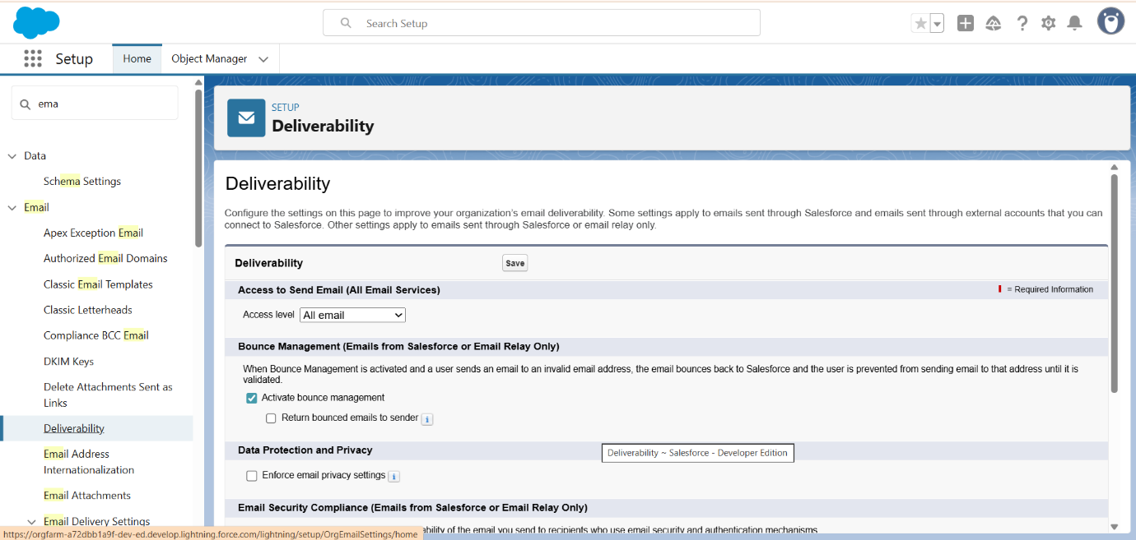

**1. Create Helper Fields on Application (Optional)**

**Purpose:** Track feedback requests and submissions to avoid sending duplicate emails.

**Object:** Application__c → Fields & Relationships → New

| **Field Name** | **Type** | **Label** | **Default Value** |
| --- | --- | --- | --- |
| Feedback_Requested__c | Checkbox | Feedback Requested | Unchecked |
| Feedback_Submitted__c | Checkbox | Feedback Submitted | Unchecked |

**Procedure:**

1. Go to Object Manager → Application__c → Fields & Relationships → New.
2. Create the above two fields with specified types and defaults.
3. Save fields.  
     
   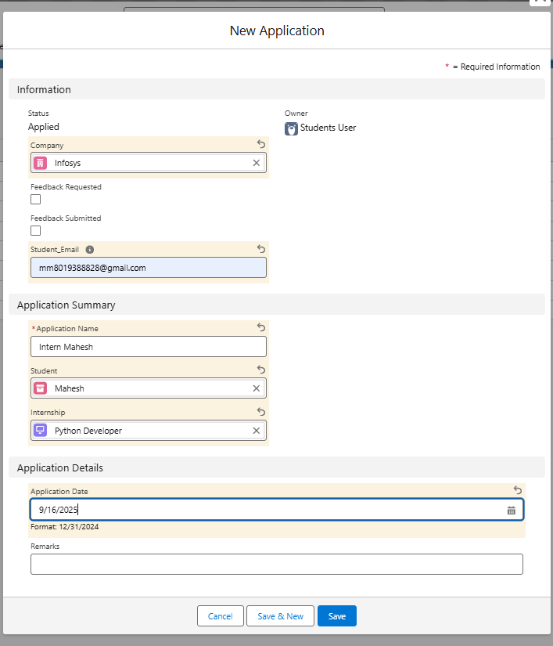

**2. Validation Rule – Block Ineligible Students**

**Purpose:** Prevent students with CGPA below 6.0 from applying.

**Object:** Application__c → Validation Rules → New

**Configuration:**

* **Rule Label:** VR_CGPA_Minimum
* **Formula:**

AND(

NOT(ISBLANK(Student__c)),

NOT(ISBLANK(Student__r.CGPA__c)),

Student__r.CGPA__c < 6

)

* **Error Message:** "Student CGPA must be 6.0 or higher to apply."
* **Error Location:** Field → Student__c

**Procedure:**

1. Create and activate the validation rule.
2. Test by creating an application with a student CGPA < 6 → error should trigger.  
     
     
   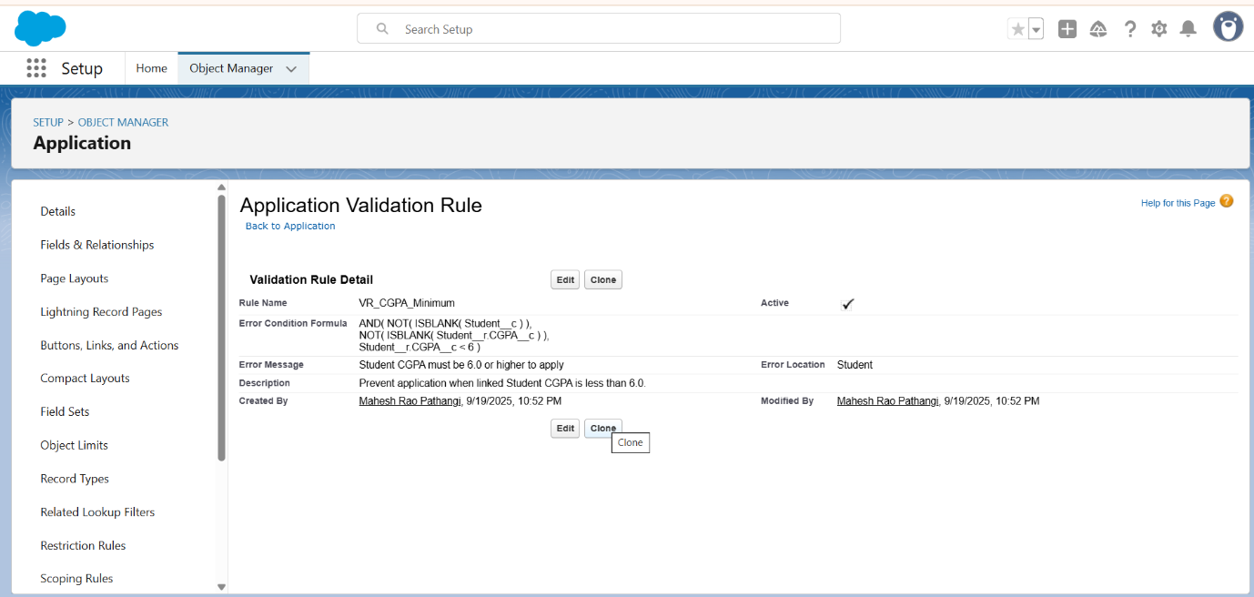  
     
   Also Created A validation rule for student at cgpa filed i.e, cgpa>6  
     
   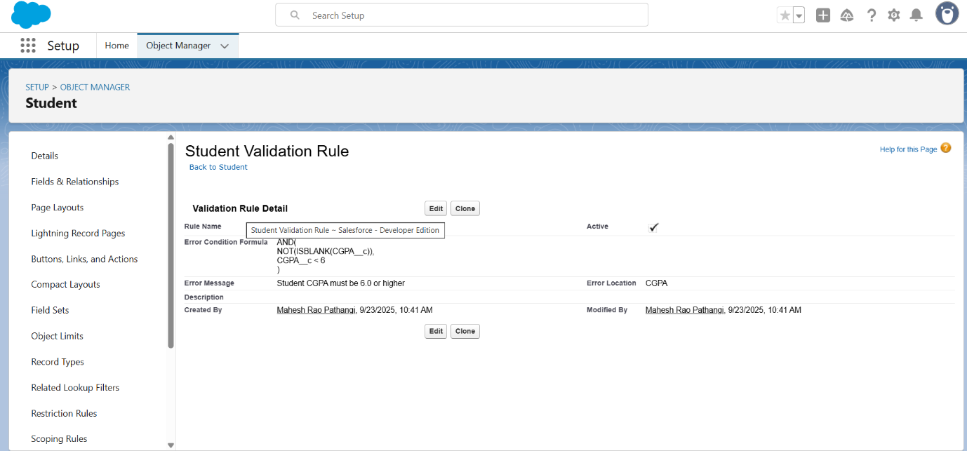  
     
     
     
   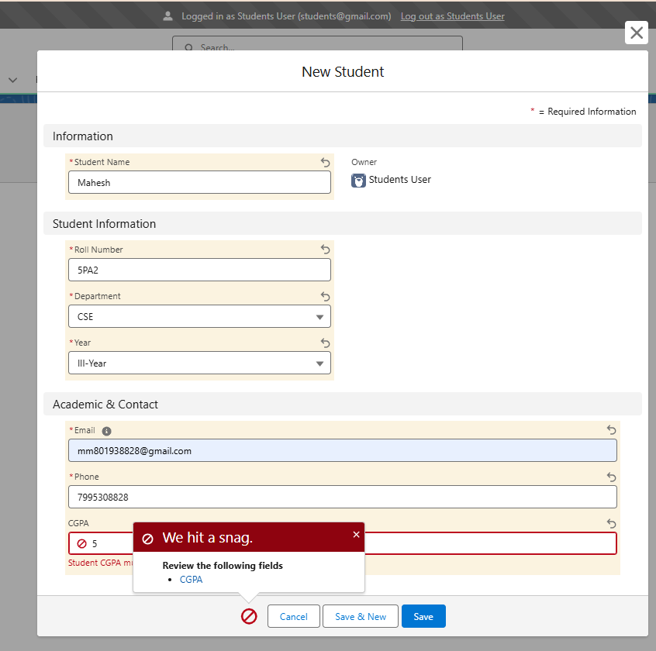

**3. Approval Process – HR Approval**

**Purpose:** Route applications to HR for approval.

**Setup Path:** Setup → Process Automation → Approval Processes → Create New Approval Process → Standard Setup Wizard

**Configuration:**

* **Object:** Application
* **Process Name:** Application_Approval_Process
* **Entry Criteria:** Status__c = Applied
* **Initial Submitters:** Record Submitter (or specific profiles)
* **Approver:** Automatically assign to users in Role → Company HR
* **Approval Steps:** Single step for HR
* **Final Approval Actions:** Field Update → Status__c = Approved
* **Final Rejection Actions:** Field Update → Status__c = Rejected

**Procedure:**

1. Configure the approval process as per above.
2. Activate the approval process.  
     
   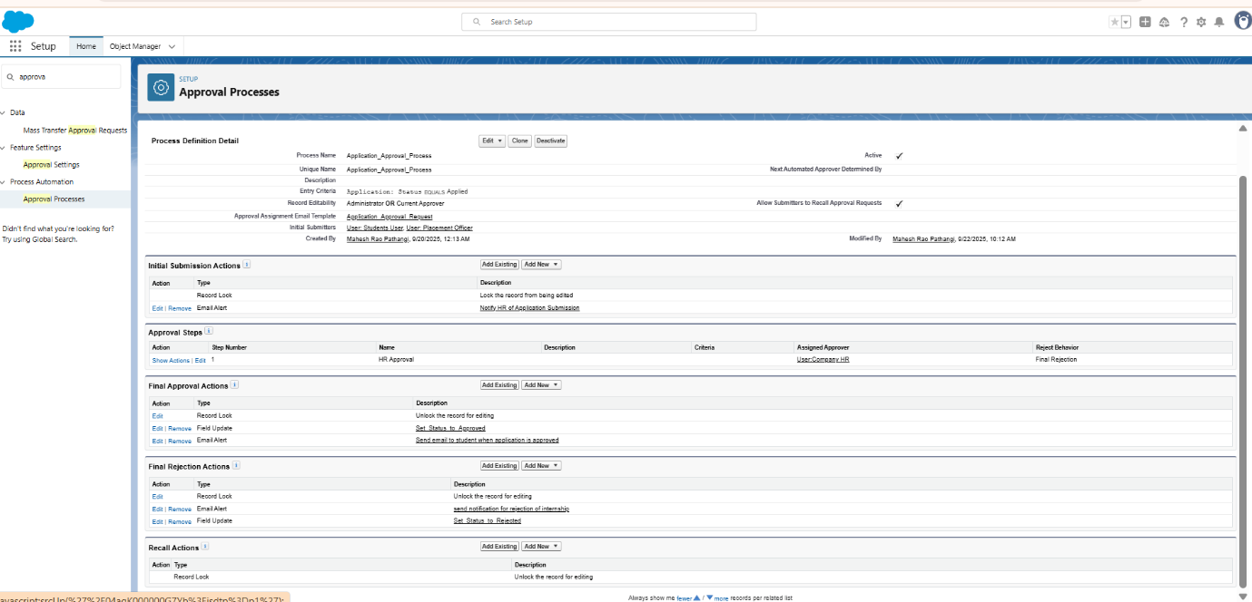

**4. Add “Submit for Approval” Button**

**Purpose:** Enable users to submit applications for approval from the record page.

**Procedure:**

1. Go to Object Manager → Application → Page Layouts → Edit the layout.
2. In **Salesforce Mobile and Lightning Experience Actions**, drag **Submit for Approval** into the actions bar.
3. Save the layout.  
     
   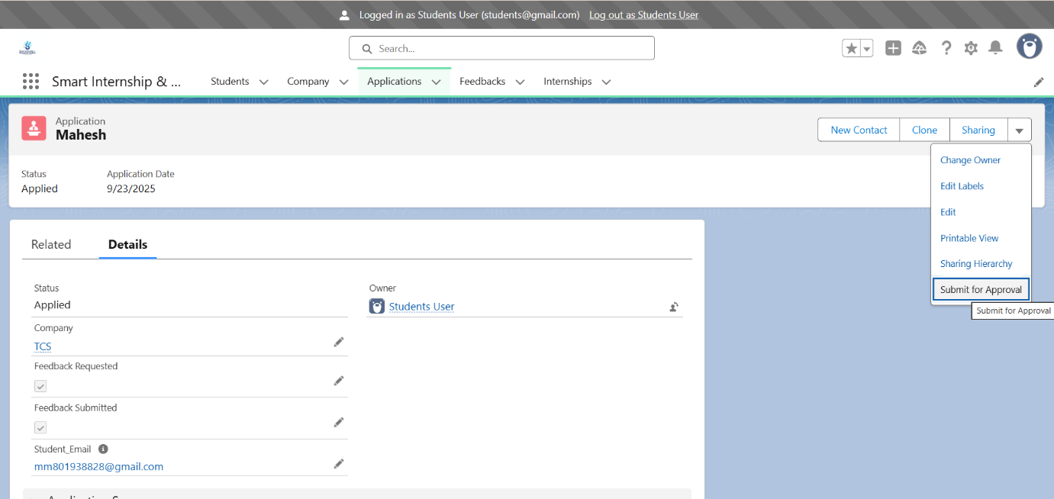  
     
   **After Approval By HR:  
     
   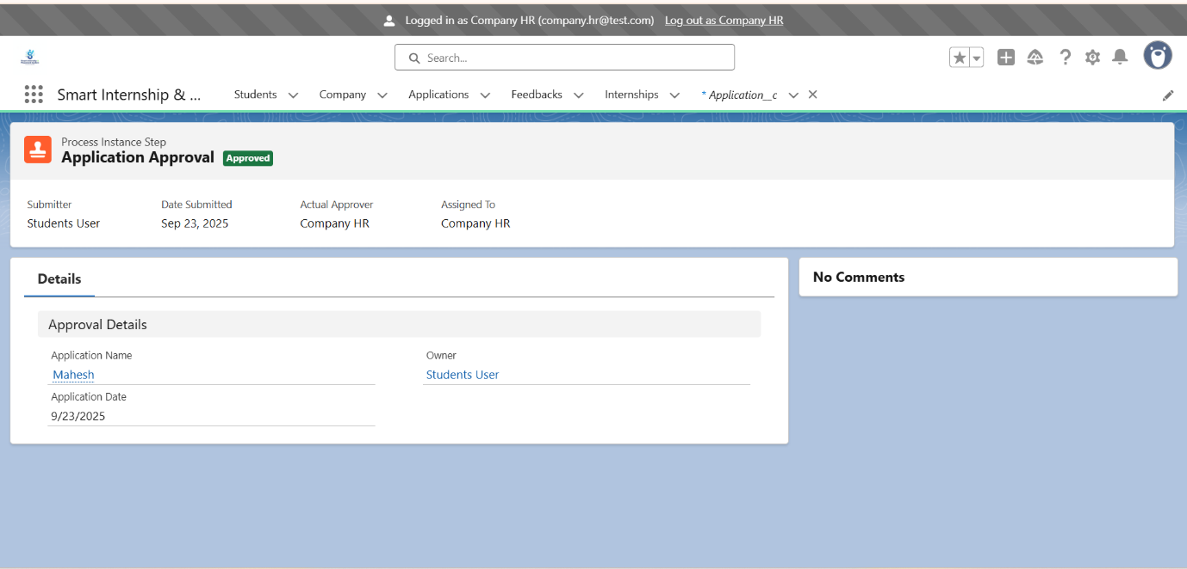  
     
     
     
     
   Rejection Access For HR:**  
   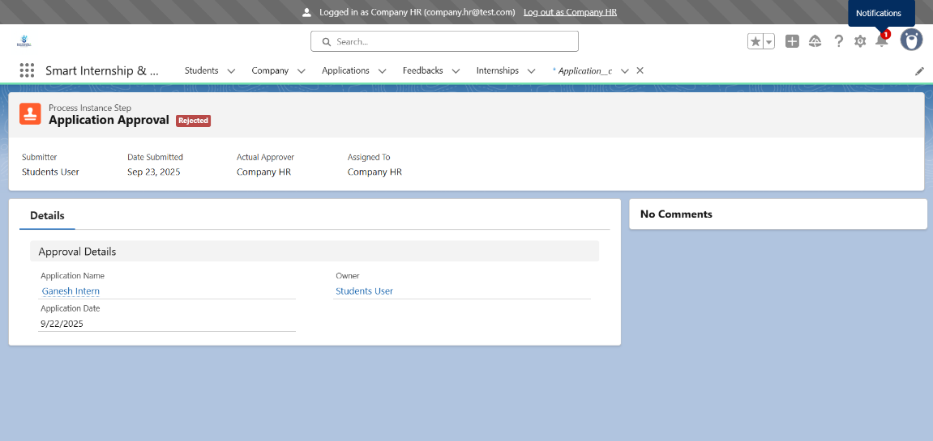  
     
     
   ->after student submits for an approval HR receives notification  
     
   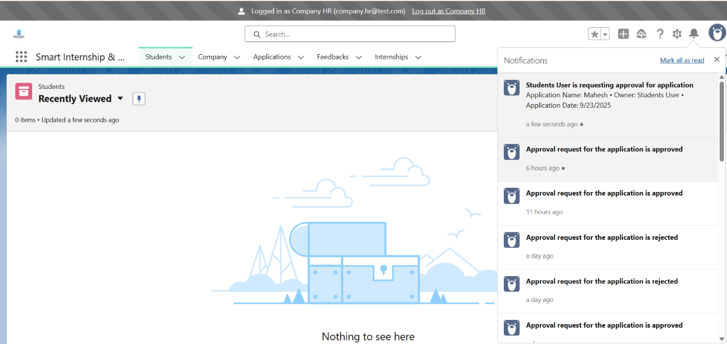

**5. Record-Triggered Flow – Email Notification on Approval**

**Purpose:** Notify students immediately after HR approval.

**Setup Path:** Setup → Process Automation → Flows → New Flow → Record-Triggered Flow

**Configuration:**

* **Object:** Application__c
* **Trigger:** Record is updated
* **Run Flow:** After record is saved
* **Condition:** Status__c = Approved
* **Optimization:** Actions and Related Records

**Flow Steps:**

1. **Get Student Record:** Retrieve the Student__c record linked to the application.
2. **Send Email Action:** Send approval notification to the student.

**Procedure:**

1. Configure the flow as above.
2. Activate the flow.
3. Test: Submit an application → HR approves → verify student receives email.  
     
     
   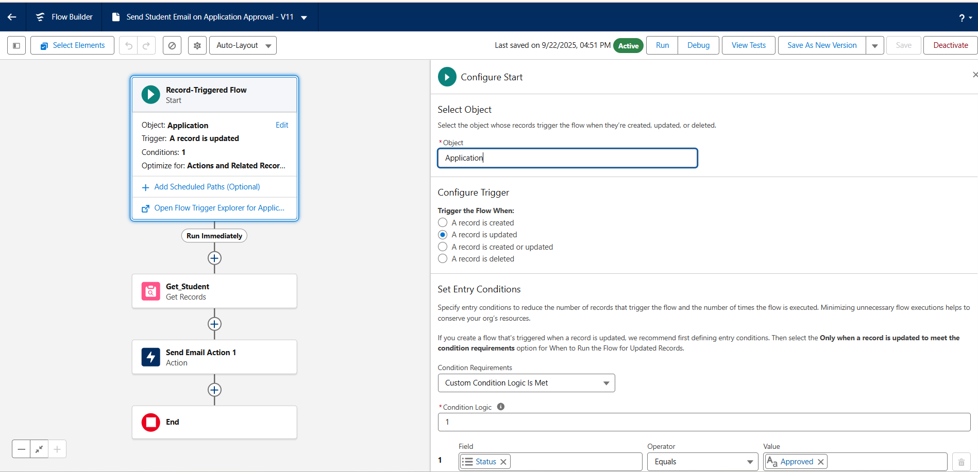  
     
   **Email Alerts used for different process automation:  
   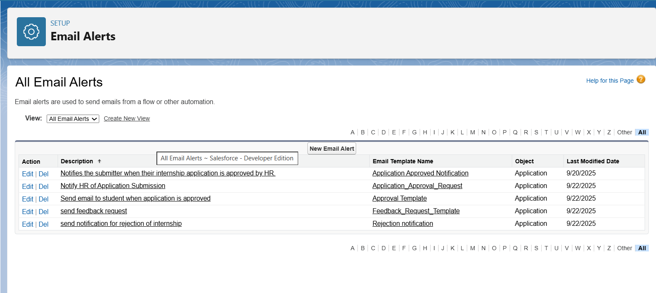**  
     
    **Student Approval Notification Mail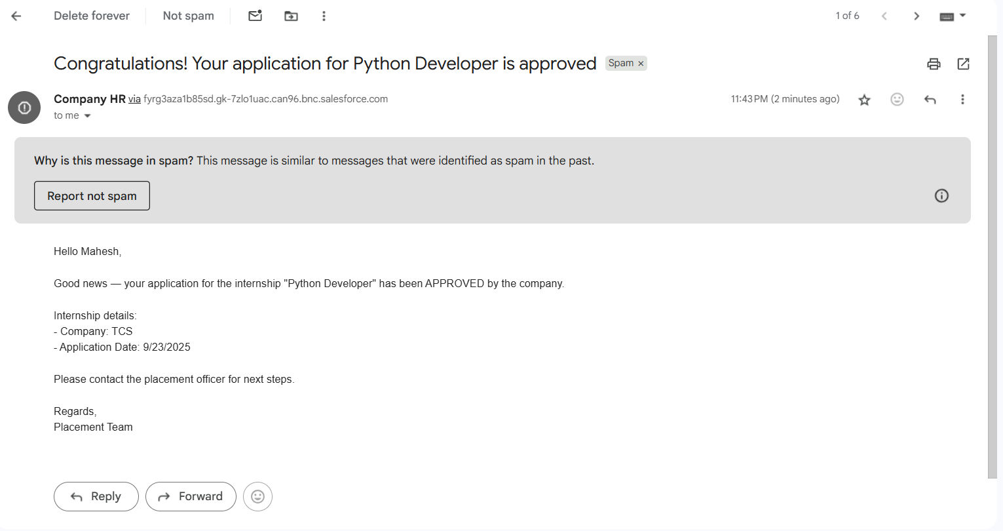 Student Rejection Notification Mail**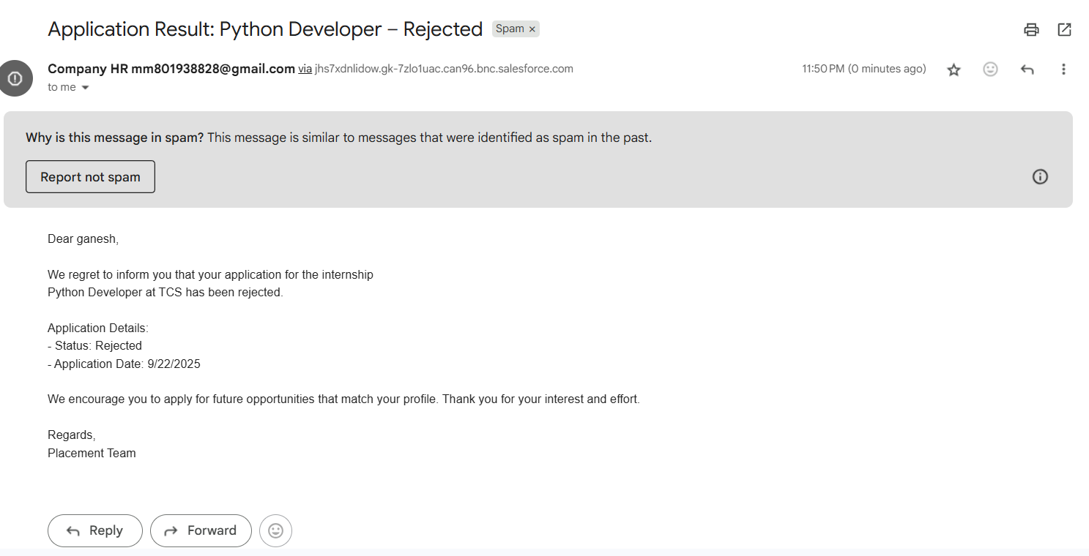

**6. Scheduled Flow – Request Feedback**

**Purpose:** Automatically request feedback from students after internship completion.

**Setup Path:** Setup → Flows → New Flow → Scheduled-Triggered Flow

**Configuration:**

* **Start Date/Time:** Choose a convenient time (e.g., 00:10 AM)
* **Frequency:** Daily

**Flow Steps:**

1. **Get Applications:** Retrieve all Application__c records where:
   * Status__c = Approved
   * Feedback_Requested__c = False
   * Internship__r.End_Date__c ≤ $Flow.CurrentDate
2. **Loop Through Records:** Process each application.
3. **Get Student Record:** Retrieve associated Student__c.
4. **Send Email:** Request feedback from the student.
5. **Update Application Record:** Set Feedback_Requested__c = True for processed records.

**Procedure:**

1. Configure the scheduled flow with the steps above.
2. Activate the flow.
3. Test: Create an application with internship end date = today → verify scheduled email and Feedback_Requested__c update.  
     
   **Feedback Flow for student To submit the Feedback**  
     
   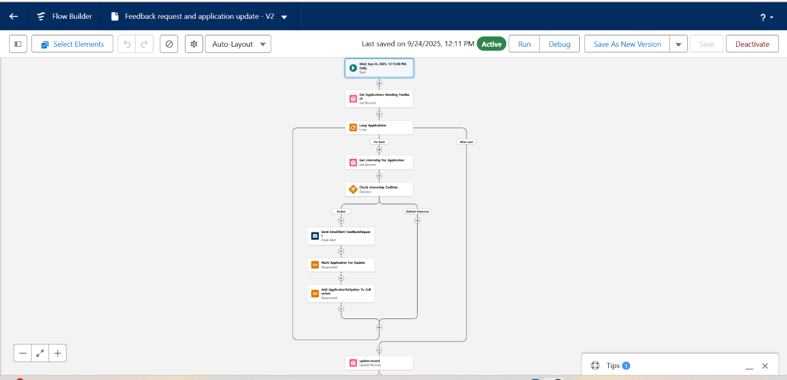

**Feedback Notification Mail to student user mail:**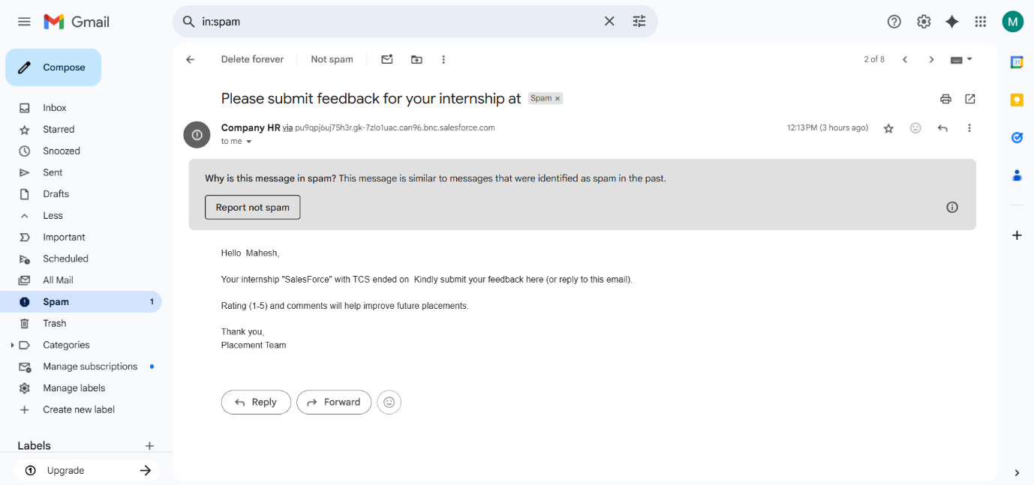  
  
  
  
**Feedback Screen flow for students to submit their Feedback:**  
  
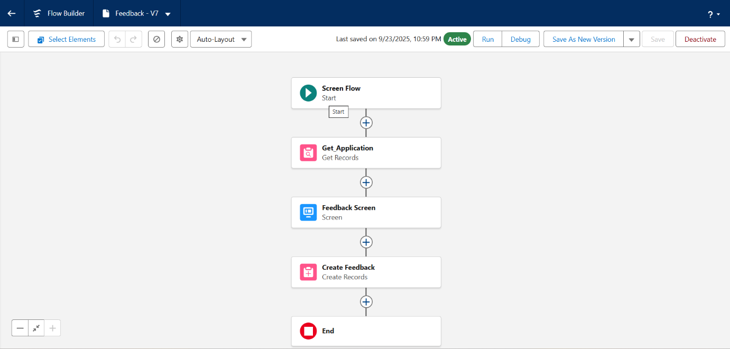  
  
 **Submit feedback button for submitting their feedback by logging into their accounts:**  
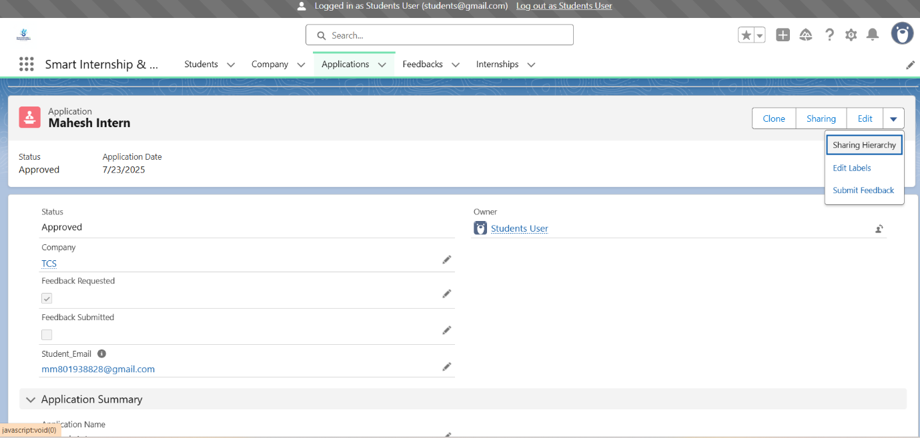  
  
 **Feedback Screen to submit their Feedback:**  
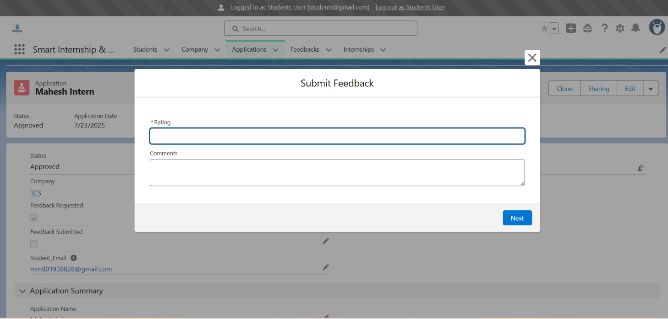 **Feedback records are updated successfully:**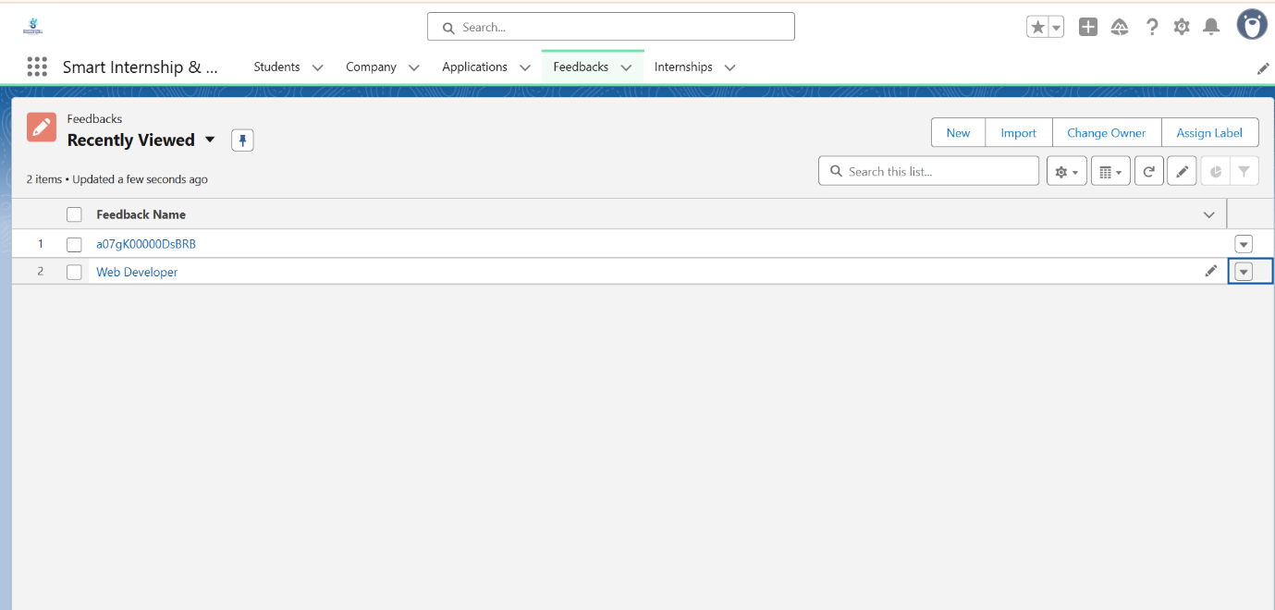

**Outcome**

* Applications below minimum CGPA are blocked.
* HR can approve/reject applications.
* Students receive immediate approval notifications.
* Feedback requests notifications are automated post-internship. And updated into feed back records successfully.