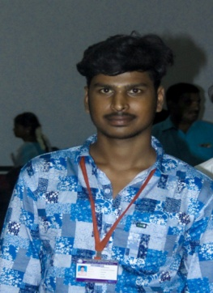**RESUME**

MAHESHKUMAR.S

S/O-SELVARAJ

1/20,Kurunjinagar Street ,

Tiruppathur -630211, Phone No:9361106667

Tiruppathur(Taluk), Email id : [mk2974695@gmail.com](mailto:mk2974695@gmail.com)

Sivagangai(Dist).

**ACADEMIC PERFORMANCE**

* **HIGHER EDUCATION**

Awarded with 74.4% marks in Government higher secondary school kottaiyiruppu.

Sivagangai.

* **HIGHER SECONDARY EDUCATION**

Awarded with 80% marks in Government higher secondary school kottaiyiruppu , Sivagangai.

SKILLS

* I Know basic computer Knowledge.
* MS office.
* C & JAVA,PHP,PYTHON programming language.

**PERSONAL DETAILS**

NAME : MAHESHKUMAR.S

DATE OF BIRTH : 23/06/2004.

GENTER : MALE.

AGE : 18.

RELIGION : HINDU.

NATIONALITY : INDIAN.

LANGUAGES KNOWN : TAMIL,ENGLISH.

MARTIAL STATAUS : UNMARRIED.

**DECLARATION**

I hereby declare that the above given details are trun to the best of my knowledge.

Your’s Sincerely,

S.Maheshkumar.

**BIO DATA**

**Name** : S.Mahesh Kumar

**Mobile** : 9361106667

**Email id** : mk2974695@gmail.com

**Father’s Name** : S.Selvaraj

**Gender**  : Male

**Date of Birth**  : 23/06/2004

**Marital Status** : Single

**Religion** : India

**Languages Known** : Tamil/English

**Qualification**

|  |  |  |  |
| --- | --- | --- | --- |
|  | **Institute Name** | **Year of Passing** | **Marks Percentage** |
| School | GHSS-KOTTAIYIRUPPU | 2021 | 446 |
| Degree | B.SC.IT() | Undergoing | 78% |

**Address :**

s/o : Selvaraj.S,

Kurinchinagar,

Kattamboor(post),

Thiruppattur(T.K), Signature

Sivagangai(Dist).