Map Coloring in Prolog

In mathematics, the famous problem was coloring adjacent planar regions. Two adjacent regions cannot have the same color no matter whatever color we choose. Two regions which share some boundary line are considered adjacent to each other. In the following map, the region is shown by some numerical names.

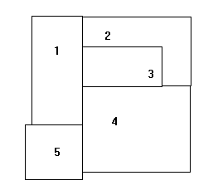

The above numerical name shows which regions are adjacent. Now we are going to consider the following graph:

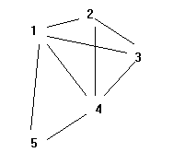

In the above graph, the original boundaries are erased. Now, we have an arc between the two regions name. The arc shows that both regions are adjacent in the original drawing. All the original adjacency information is conveyed by the adjacency graph. Using the following facts or unit clause, the adjacent information can represent in Prolog.

adjacent(1,2).         adjacent(2,1).

adjacent(1,3).         adjacent(3,1).

adjacent(1,4).         adjacent(4,1).

adjacent(1,5).         adjacent(5,1).

adjacent(2,3).         adjacent(3,2).

adjacent(2,4).         adjacent(4,2).

adjacent(3,4).         adjacent(4,3).

adjacent(4,5).         adjacent(5,4).

color(1, orange, x).    color(1, orange, y).

color(2, pink, x).  color(2, pink, y).

color(3, purple, x).    color(3, purple, y).

color(4, red, x).   color(4, pink, y).

color(5, pink, x).  color(5, purple, y).

conflict(R1, R2, Coloring) :-

adjacent(R1, R2),

color(R1, Color, Coloring),

color(R2, Color, Coloring).