HR Analytics Dashboard
Employee Attrition Analysis — Project Documentation
Tool: Power BI | Excel | DAX | Power Query
Author: Mahesh | 2025

1. Project Objective
This project analyzes employee attrition data to identify key factors causing employees to leave. Using Power BI, an interactive dashboard was created to visualize trends, KPIs, and patterns that help HR teams make data-driven decisions.
Main Business Question: Why are employees leaving — and how can the company reduce attrition?

2. Dashboard Preview

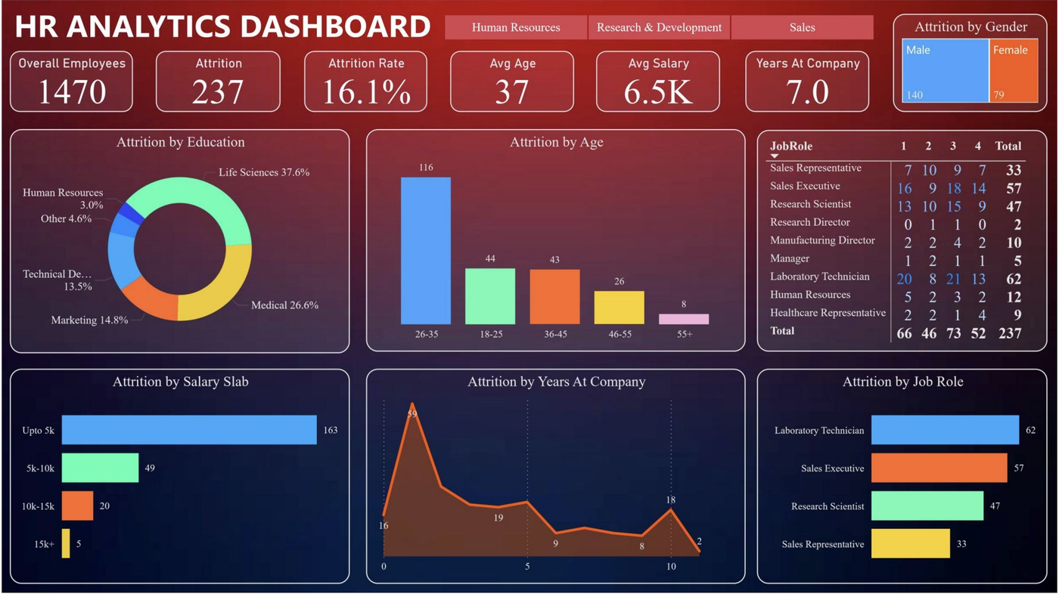
Figure 1: HR Analytics Dashboard — Power BI

3. Key Performance Indicators (KPIs)

KPI Metric | Value | Interpretation
Total Employees | 1,470 | Company workforce size
Attrition Count | 237 | Employees who left
Attrition Rate | 16.1% | ~1 in every 6 employees leaving
Average Age | 37 Years | Mid-career workforce
Average Salary | 6.5K | Moderate salary level
Avg Years at Company | 7.0 Years | Moderate tenure

4. Dataset Overview
- Source: IBM HR Analytics Dataset (Kaggle)
- Total Records: 1,470 employees
- Format: CSV

Key Columns Used
- Age, Gender, Education, Job Role, Department
- MonthlyIncome (mapped to Salary Slab)
- YearsAtCompany, YearsInCurrentRole
- Attrition (Yes / No → converted to 1 / 0 via Power Query)

5. Project Workflow

Step 1 — Excel (Data Understanding)
- Imported raw dataset into Excel
- Explored columns using filters and overview
- Used Pivot Tables to find important columns and trends
- Removed unnecessary columns not needed in dashboard

Step 2 — Power BI (Data Transformation)
- Loaded cleaned data into Power BI Desktop
- Checked and corrected data types in Power Query
- Replaced unclear values with meaningful labels
- Created Attrition Count column: Yes = 1, No = 0
- Removed remaining unnecessary columns

Step 3 — DAX Measure
Attrition Rate = SUM([Attrition Count]) / SUM([Employee Count])
This DAX measure calculates the percentage of employees who left, shown as the main KPI card.

Step 4 — Dashboard Creation
- Single table used — no data modeling required
- Added 6 KPI cards: Employees, Attrition, Rate, Age, Salary, Years
- Built 6 interactive charts (listed in Section 6)
- Added Slicers: Department (HR / R&D / Sales) and Age Group

6. Charts Used & Purpose

Chart Type | Used For | Key Finding
Donut Chart | Attrition by Education | Life Sciences = 37.6% (highest)
Bar Chart | Attrition by Age Group | Age 26–35 = 116 (peak)
Matrix Table | Attrition by Job Role × Satisfaction | Lab Technician Total = 62
Bar Chart | Attrition by Salary Slab | Below 5K = 163 exits
Line / Area Chart | Attrition by Years at Company | Year 1 = 59 (sharp peak)
Bar Chart | Attrition by Job Role | Lab Tech 62 > Sales Exec 57 > Res. Sci 47

7. Key Insights & Analysis

Category | Finding | Business Insight
Education | Life Sciences = 37.6%, Medical = 26.6% | Highly-skilled workers leaving — career growth issue
Age Group | 26–35 = 116 employees left | Young employees dissatisfied early in career
Salary Slab | Below 5K = 163 out of 237 exits | Low salary is the #1 attrition driver
Years at Company | Year 1 = 59 employees (peak) | Onboarding and early experience is poor
Job Role | Lab Tech (62), Sales Exec (57) | High-stress roles = higher attrition
Gender | Male = 140, Female = 79 | Male attrition is significantly higher

8. Business Recommendations
- Improve salary structure for employees earning below 5K
- Strengthen onboarding programs for first 1–2 years of employment
- Reduce workload and pressure for Laboratory Technicians and Sales Executives
- Provide clear career growth opportunities for the 26–35 age group
- Launch retention programs targeting Life Sciences background employees

9. Challenges Faced & Solutions

Challenge | How I Solved It
Identifying key columns from large raw data | Used Pivot Tables in Excel to analyze each column's impact
Converting Attrition Yes/No to numeric | Added calculated column in Power Query: Yes=1, No=0
Writing correct Attrition Rate formula | Used DAX: SUM(Attrition Count) / SUM(Employee Count)
Keeping dashboard clean and professional | Limited to 6 focused visuals with interactive slicers

10. Tools & Technologies
- Microsoft Excel — Data exploration & Pivot Table analysis
- Power BI Desktop — Dashboard creation and visualization
- Power Query — Data cleaning and column transformations
- DAX (Data Analysis Expressions) — KPI and Attrition Rate measure

11. Conclusion
This HR Analytics Dashboard clearly shows that low salary, early-career dissatisfaction, and high-pressure roles are the primary drivers behind the company's 16.1% attrition rate — meaning 1 in every 6 employees is leaving.
By implementing the recommendations in this report, the company can significantly reduce attrition, improve employee satisfaction, and save on hiring and training costs — turning data into real business impact.

