BUSINESS REQUIREMENT DOCUMENT
Stakeholder Insights and Performance Dashboard

Prepared By | Date | Version | Document Type
Mahesh | 8 September 2026 | 1.0 | BRD

1. Project Background
This BRD was created as part of a self-directed Tableau practice project, structured the same way a Business Analyst would document requirements for a real BFSI/insurance client. The goal is to simulate the full BI project lifecycle — requirement gathering, data analysis, dashboard development, testing, and documentation — rather than just building an isolated chart.
Client context (simulated): a fictional insurance company needs a consolidated view of premium performance, profitability, and stakeholder/shareholding structure to support leadership decision-making.

2. Purpose
The dashboard will provide a comprehensive view of key business metrics and data insights related to stakeholders, insurers, and policy performance. It will enable stakeholders to analyse premium trends, profitability, and asset distribution to make data-driven decisions.
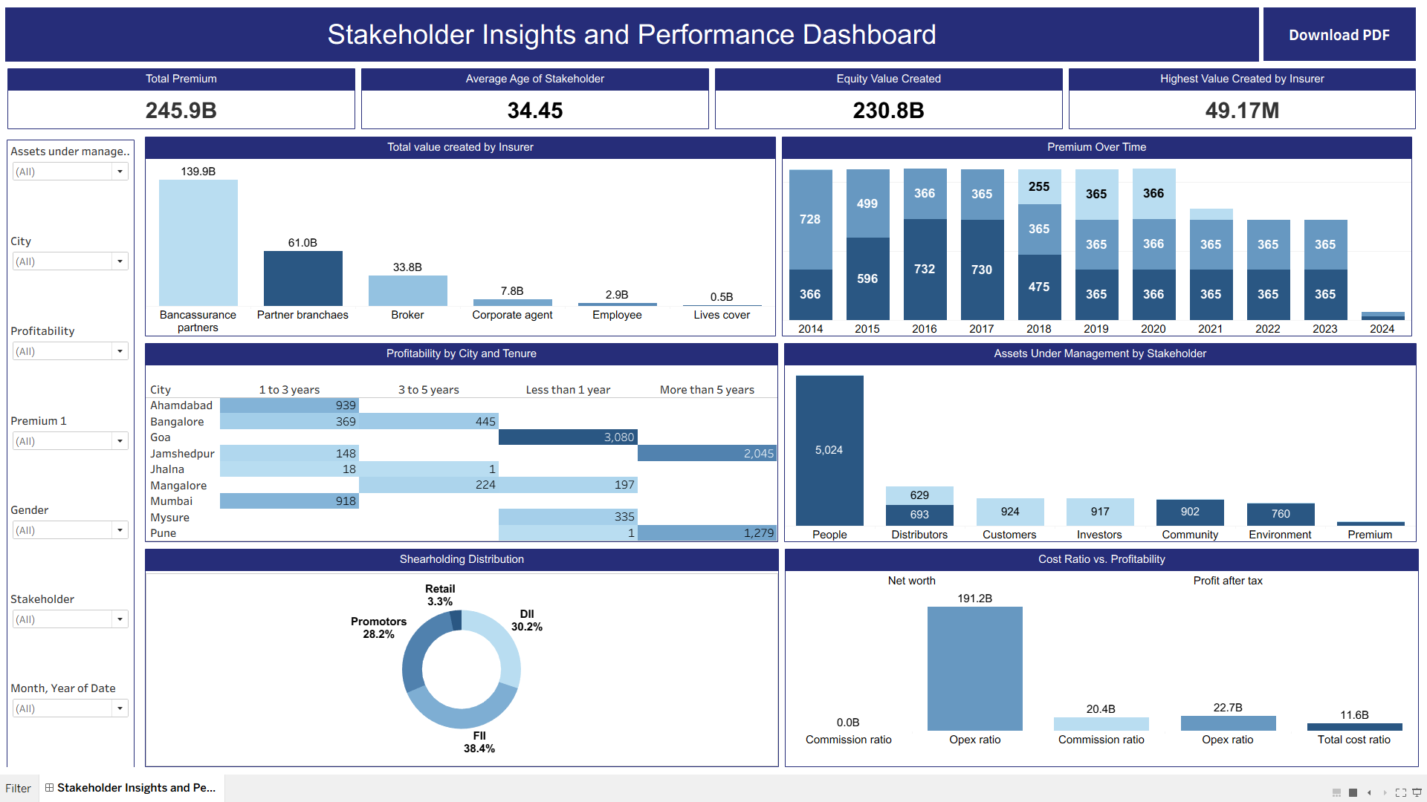

3. Requirements

3.1 Charts and Visualisations
- Compare the total value created by different insurers.
- Display trends in premiums collected over time.
- Showcase the distribution of shareholding patterns among stakeholders.
- Analyse the relationship between cost ratio and profitability.
- Visualise profitability for different cities and policy tenure durations.
- Represent the distribution of assets under management across stakeholders.

3.2 Key Performance Indicators (KPIs)
- Display the total premium collected.
- Show the average age of stakeholders.
- Highlight the total value created for insurers/stakeholders where Assets Under Management is 'Equity'.
- Identify the highest value created by a single insurer.

3.3 Filters
- Filter data by city to focus on specific regions.
- Filter data by stakeholders to analyse their contributions.
- Provide a filter to segment policies based on tenure.
- Allow filtering of data within a specific date range.
- Enable filtering by gender for demographic insights.
- (Added during development) Filter by profitability type and by premium category, for finer-grained analysis.

3.4 Interactivity
- Filters and KPIs update dynamically based on selections, across the entire data source (not a single sheet).
- Tooltips display detailed information on hover for every mark.

3.5 Export Options
- Provide a dedicated PDF export button for stakeholders to download the dashboard.
- Ensure the export captures all visible charts, KPIs, and filter panel labels.

3.6 User Access
- Documented for completeness: in a production deployment, role-based access would control which stakeholder group sees which data. Not implemented in this single-user portfolio build — see Assumptions below.

4. Assumptions and Constraints
- Dataset is a single, pre-cleaned Excel file (Finance_record.xlsx); no multi-table joins or live database connection were required.
- This is an independent practice project — there is no real client, and the requirements above were self-authored to mirror a realistic BRD.
- Role-based access, authentication, and a live watermarked-export pipeline are documented as requirements but not implemented, since the dashboard is hosted as a public, single-user Tableau Public workbook.
- All figures (e.g., 245.9B total premium) are illustrative, generated from sample data, and do not represent any real company.

5. Deliverables
Deliverable | Status
1 interactive Tableau dashboard (6 views + 4 KPIs + filters + PDF export) | Complete
Business Requirement Document (this document) | Complete
User Guide | Complete
Unit Test log (KPI values cross-checked against source data) | Complete
Published Tableau Public link / GitHub repository | In progress

6. Sign-off
Role | Name | Date
Prepared By (Data Analyst / BI Developer) | Mahesh | 8 September 2026
Reviewed By | Self-reviewed (practice project) | 8 September 2026

