USER GUIDE
Stakeholder Insights and Performance Dashboard

Author | Created Date | Version | Last Updated
Mahesh | August 2026 | 1.0 | 8 September 2026

1. Purpose
This dashboard provides a consolidated view of key business metrics and data insights related to stakeholders, insurers, and policy performance. It enables a viewer to analyse premium trends, profitability, shareholding structure, and asset distribution to support data-driven decisions — built in Tableau as a hands-on BI portfolio project.
Project note: this is a self-directed practice project built on an illustrative BFSI/insurance dataset, using the same requirement → build → test → document workflow followed on real client engagements.
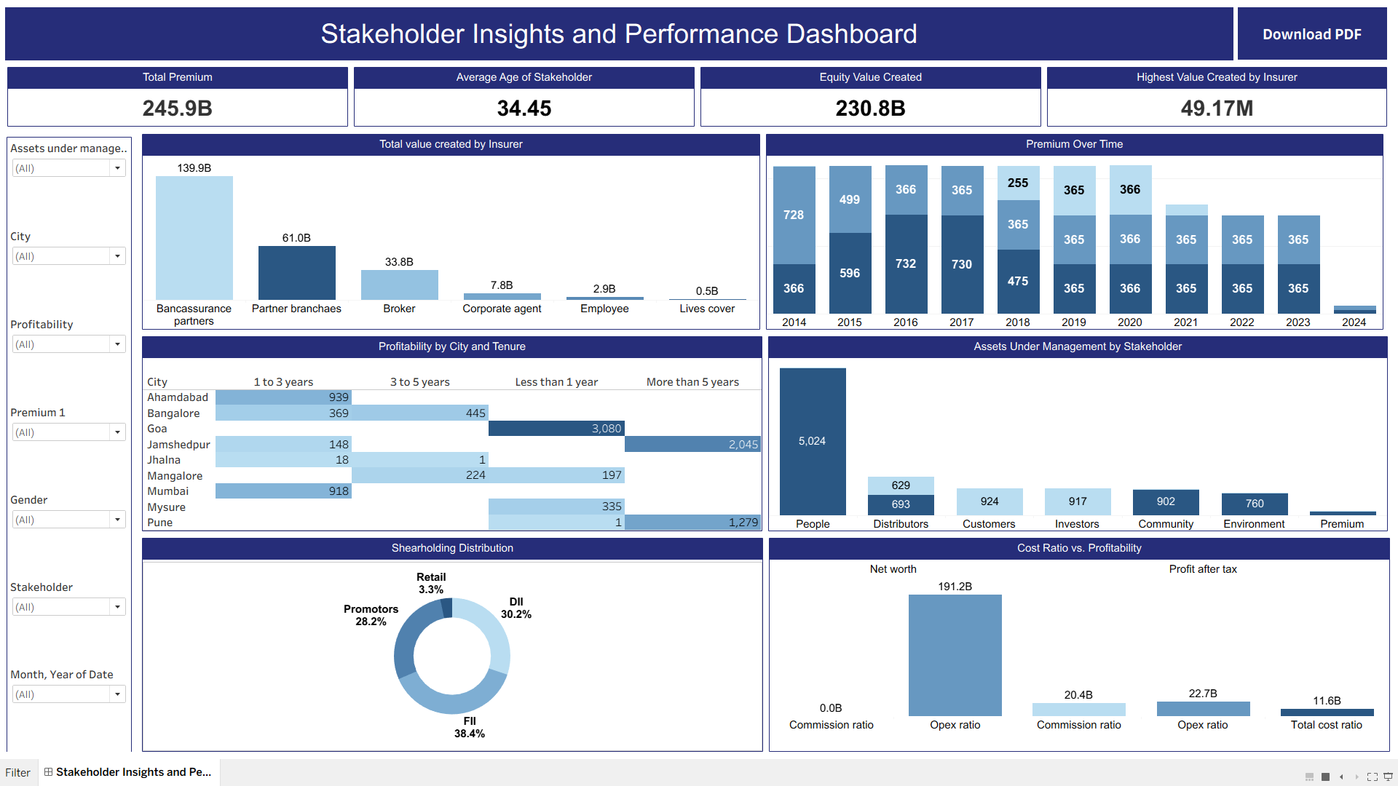

2. Charts and Visualisations
- Total Value Created by Insurer: Compares total value created across the six insurer categories (Bancassurance Partners, Partner Branches, Broker, Corporate Agent, Employee, Lives Cover).
- Premium Over Time: Shows premium collected trends from 2014–2024, split by premium type (New / Renewal / Individual Rated / Single Premium).
- Shareholding Distribution: A donut chart showing shareholding split — Retail, DII, FII, and Promoters.
- Cost Ratio vs. Profitability: Side-by-side bars comparing Net Worth vs. Profit After Tax against Commission Ratio, Opex Ratio, and Total Cost Ratio.
- Profitability by City and Tenure: A colour-shaded crosstab of profitability count by City and Policy Tenure band.
- Assets Under Management by Stakeholder: Shows how Assets Under Management (Equity/Debt) break down across each stakeholder group (People, Distributors, Customers, Investors, Community, Environment, Premium).

3. Key Performance Indicators (KPIs)
KPI Card | Value Shown | Underlying Logic
Total Premium | 245.9B | SUM([Premium]), formatted in billions
Average Age of Stakeholder | 34.45 | AVG([Age])
Equity Value Created | 230.8B | Calculated field ‘value_quity’ — IF [Assets under management] = 'Equity' THEN [Value Created] ELSE 0 END
Highest Value Created by Insurer | 49.17M | MAX([Value Created])

4. Filters
All filters are applied at the data-source level (Apply to Worksheets → All Using This Data Source), so a single selection updates every chart and KPI on the dashboard simultaneously.
- City: Narrows all visuals to a selected city.
- Stakeholder: Isolates a specific stakeholder group's contribution.
- Assets Under Management: Splits the dashboard by Equity vs. Debt.
- Profitability: Filters by Net Worth or Profit After Tax.
- Premium: Filters by premium category (New / Renewal / Individual / Single).
- Gender: Separates Male / Female stakeholder data.
- Month, Year of Date: Restricts the view to a specific month/year.

5. Interactivity
- Dynamic filtering: Selections on any filter refresh all six views and all four KPI cards at once.
- Tooltips: Hovering over any mark (bar, donut segment, cell) shows the underlying value in a tooltip.
- Clean formatting: Chart headers, gridlines, and colour palettes are intentionally hidden/simplified for a clean, presentation-ready look.

6. Export Options
- Download PDF button: Located in the top-right of the dashboard header; captures the current view — including active filter selections — into a PDF.
Note: filter widgets themselves are not selectable inside the exported PDF (this is standard Tableau PDF-export behaviour) — the exported file is a static snapshot of the visuals and KPI values at the time of export.

7. User Access
This project is published as a single-user Tableau Public workbook for portfolio purposes, so role-based access / authentication is not implemented. In a production/enterprise deployment (e.g., Tableau Server or Tableau Cloud), this would be handled through Server permissions so that different stakeholder groups see different row-level or view-level data.

8. Usage Instructions

Navigating the Dashboard
- Use the filter panel on the left to refine data by city, stakeholder, AUM type, profitability, premium, gender, or date.
- Click any mark on a chart (e.g., a city row, a donut segment) to see the tooltip with exact figures.
- All four KPI cards and six visuals update together — no need to refresh manually.

Exporting the Dashboard
- Click the Download PDF button in the top-right of the dashboard header.
- The exported PDF captures whatever filter combination is currently active.

9. Technical Notes (for developers/reviewers)
Item | Detail
Tool | Tableau Desktop / Public, version 2026.2
Data source | Finance_record.xlsx — sheet: Finance Sheet (single flat table, no joins)
Calculated fields | ‘Zero’ (= 0, used for the dual-axis donut chart) and ‘value_quity’ (equity-only value created)
Worksheets | 10 sheets — 6 chart views, 4 KPI cards, plus 1 shared Filter sheet
Layout technique | Horizontal/vertical containers with “Distribute Contents Evenly” for equal sizing; padding and borders manually tuned to match the theme colour

10. Support and Feedback
This is an independent practice/portfolio project. For questions, suggestions, or bug reports, please open an issue on the project's GitHub repository rather than a support inbox.

