DATA ANALYTICS PORTFOLIO PROJECT

UPI Transaction Fraud
& Risk Analytics

An End-to-End FinTech Analytics Project

Python • PostgreSQL • Excel • Power BI

Prepared by: Mahesh Thakare
Aspiring Data Analyst | Data Science & AI (IIT Roorkee Certification)

50,000  TRANSACTIONS ANALYZED | 3.25%  FRAUD RATE DETECTED | ₹67.5L  TOTAL FRAUD LOSS | 17  SQL QUERIES WRITTEN

1. PROBLEM STATEMENT

Business Context
Digital payment platforms in India process millions of UPI transactions every day. As transaction volume grows, fraud attempts grow alongside it — unauthorized transfers, account takeovers, and merchant-side fraud cause direct financial loss and erode customer trust. Most fraud detection in smaller FinTech operations is reactive, relying on customer complaints rather than proactive monitoring.
The Problem
There is no centralized, data-driven view of where fraud is concentrated — by city, merchant, payment channel, time of day, or user profile. Without this visibility, risk teams cannot prioritize investigations, apply targeted controls, or measure whether interventions are working.
Project Objective
This project simulates the role of a Data Analyst inside a FinTech fraud and risk team. The objective is to build a complete analytics pipeline — from raw transaction data to an executive-ready dashboard — that answers a simple business question:
“Where is fraud happening, who is most at risk, and what should the business do about it?”
Scope
- Clean and engineer features from 50,000 synthetic UPI transactions
- Answer 12 business questions through exploratory data analysis in Python
- Design a normalized relational schema and write 17 SQL business queries
- Build an Excel dashboard for day-to-day operational analysis
- Build a 3-page Power BI dashboard for executive-level decision-making

2. DATASET OVERVIEW

The dataset was synthetically generated using Python (Faker + NumPy) to simulate a realistic UPI transaction environment with embedded fraud patterns, while keeping full control over data quality and structure.

Table | Rows | Key Columns
transactions | 50,000 | txn_id, user_id, merchant_id, amount, timestamp, status, channel
users | 5,000 | user_id, name, user_city, kyc_status, account_age_days
merchants | 500 | merchant_id, merchant_name, category, merchant_city, is_verified
fraud_labels | 50,000 | txn_id, is_fraud, fraud_type
payment_failures | ~3,500 | txn_id, failure_reason, retry_count, resolved

Engineered Features
Beyond the raw columns, the following features were created during the cleaning phase to support fraud analysis:
- txn_hour, txn_day, txn_month — time-based fields extracted from the transaction timestamp
- late_night_flag — flags transactions between 11 PM and 4 AM
- amount_zscore, high_amount_flag — statistical outlier detection on transaction amount
- amount_bucket — categorical amount range (Small / Medium / Large / Very Large)
- account_cohort — New (<90 days) / Growing (90–365 days) / Established (1yr+)
- merchant_fraud_rate — historical fraud rate per merchant

3. TECH STACK & WORKFLOW

Stage | Tool | Purpose
Data Generation | Python (Faker, NumPy) | Build a realistic synthetic dataset
Cleaning & EDA | Python (Pandas, Matplotlib, Seaborn) | Clean data, engineer features, answer 12 business questions
Database | PostgreSQL | Normalized schema, 17 business SQL queries
Operational Dashboard | Excel (Power Query, PivotTables) | Row-level investigation tool for the operations team
Executive Dashboard | Power BI | 3-page interactive dashboard for management decisions

Project Workflow
Raw Data Generation (Python)
|
v
Data Cleaning + Feature Engineering (Python)
|
v
Exploratory Data Analysis -- 12 business questions (Python)
|
v
PostgreSQL --> 5 normalized tables --> 17 SQL queries
|
+------------------+------------------+
v v
Excel Dashboard Power BI Dashboard
(operational / row-level) (3-page executive view)

4. EXPLORATORY DATA ANALYSIS — PYTHON

All 50,000 transactions were merged into a single working DataFrame, cleaned, and enriched with the features listed in Section 2. Twelve business questions were then answered using Pandas, Matplotlib, and Seaborn, each tied to a specific fraud or risk decision.

Step 1 — Merging Source Tables
The five raw tables were joined into a single master DataFrame to support cross-cutting analysis (user attributes, merchant attributes, and fraud labels together in one place).
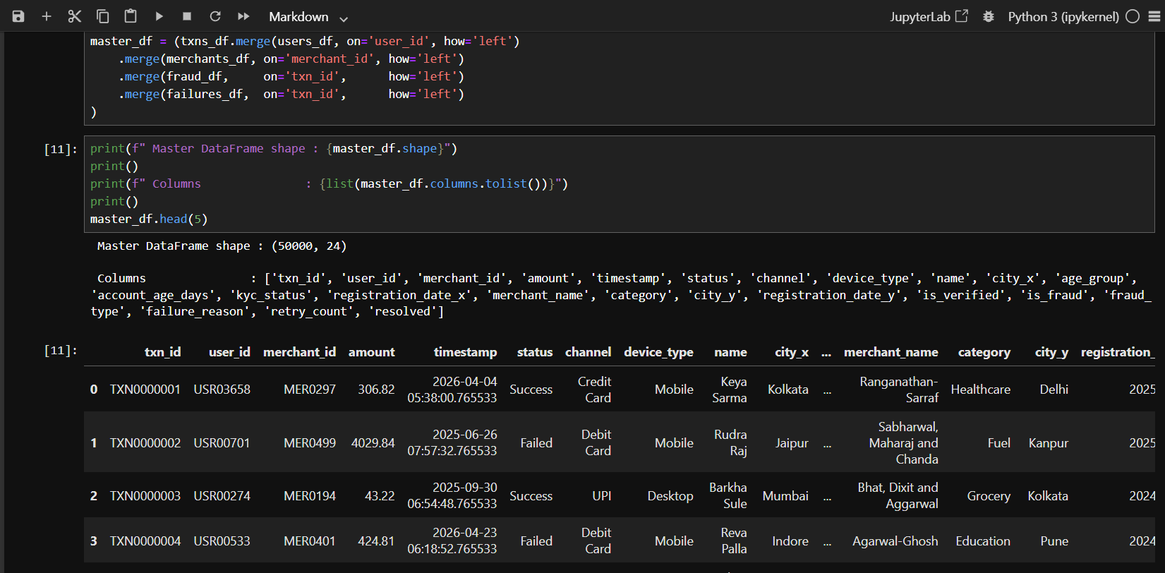
Figure 1: Merging users, merchants, transactions, fraud labels, and payment failures into one master DataFrame (50,000 rows × 24 columns).
Step 2 — Data Cleaning
Nulls were reviewed in context — a null fraud_type, for example, simply means the transaction was not fraudulent, and was filled accordingly rather than dropped.
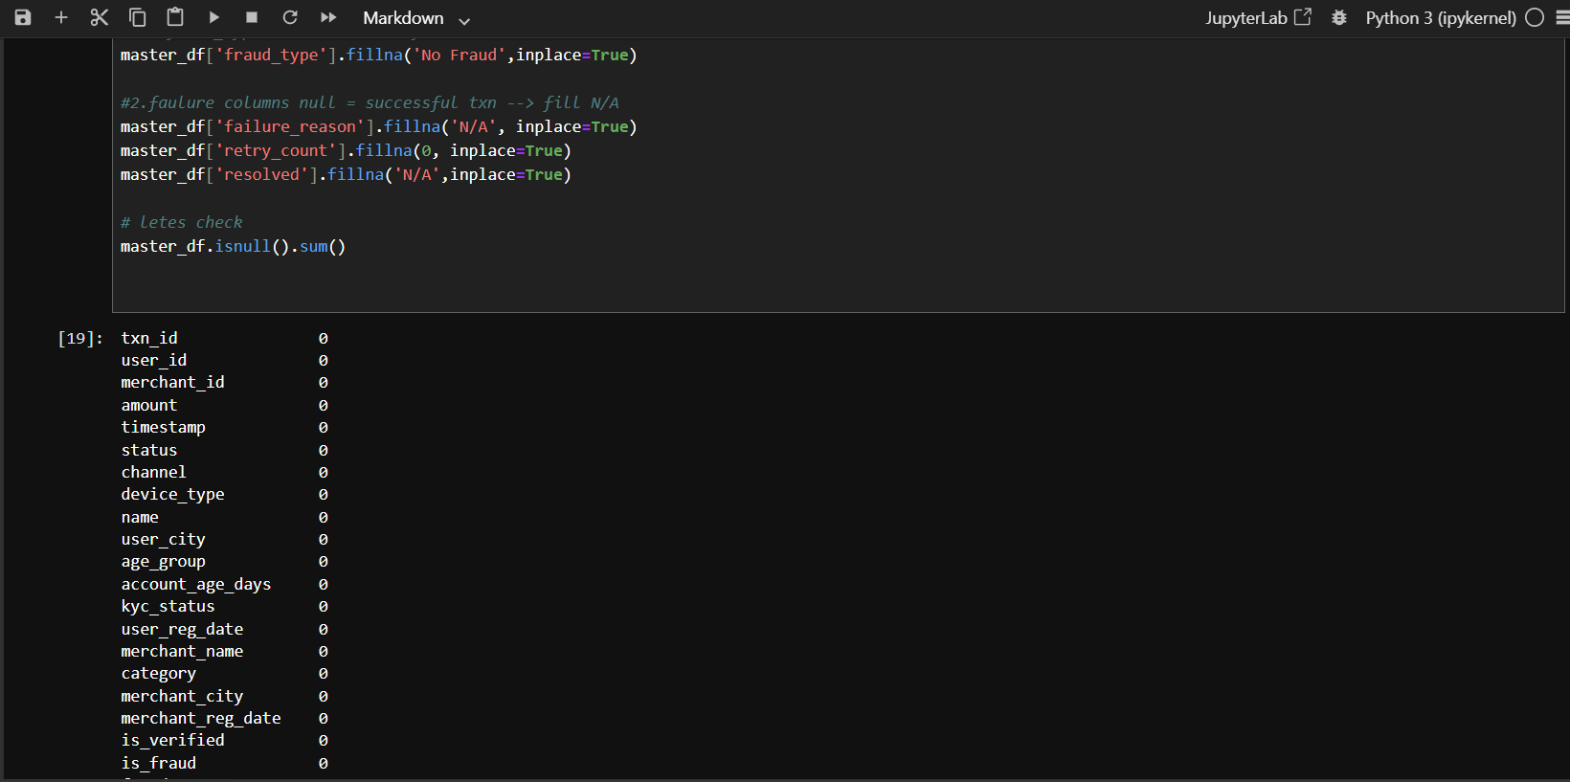
Figure 2: Verifying that all null values have been resolved after applying business-aware fill logic.
Step 3 — Feature Engineering
New time-based and risk-based columns were derived to make fraud patterns visible to later analysis — most importantly txn_hour, which underpins the late-night fraud window analysis.
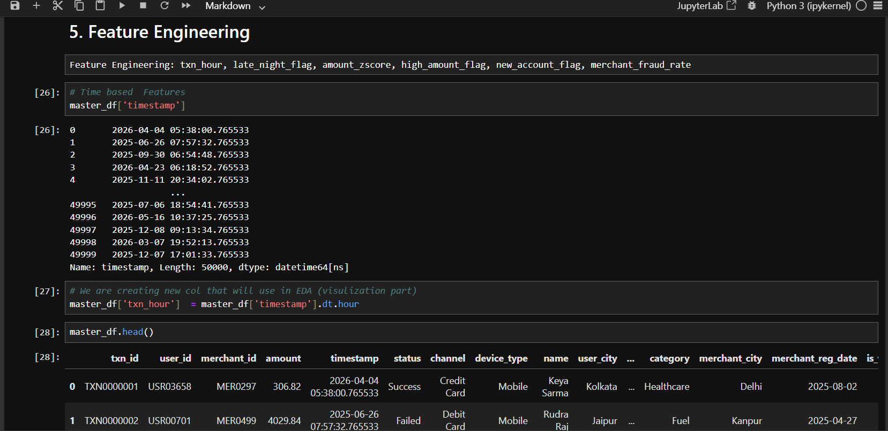
Figure 3: Extracting the transaction hour from the timestamp column to enable time-of-day fraud analysis.

Key EDA Findings
A sample of the business questions explored, with charts generated in Python:

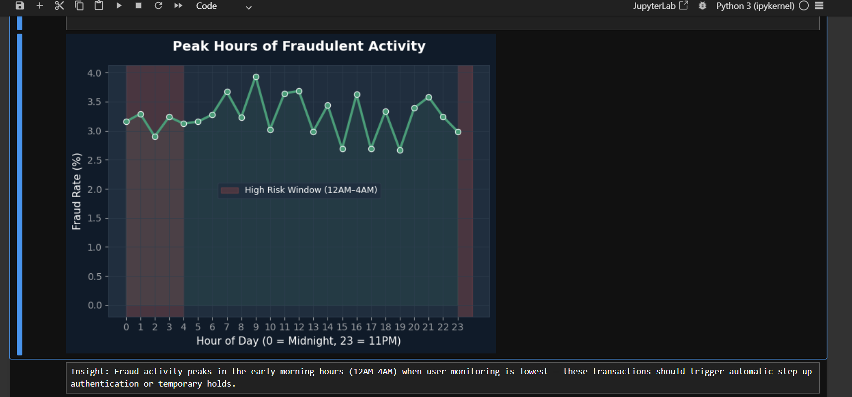
Insight: Fraud activity peaks in the early morning hours (12AM–4AM) when user monitoring is lowest — these transactions should trigger automatic step-up authentication or temporary holds.

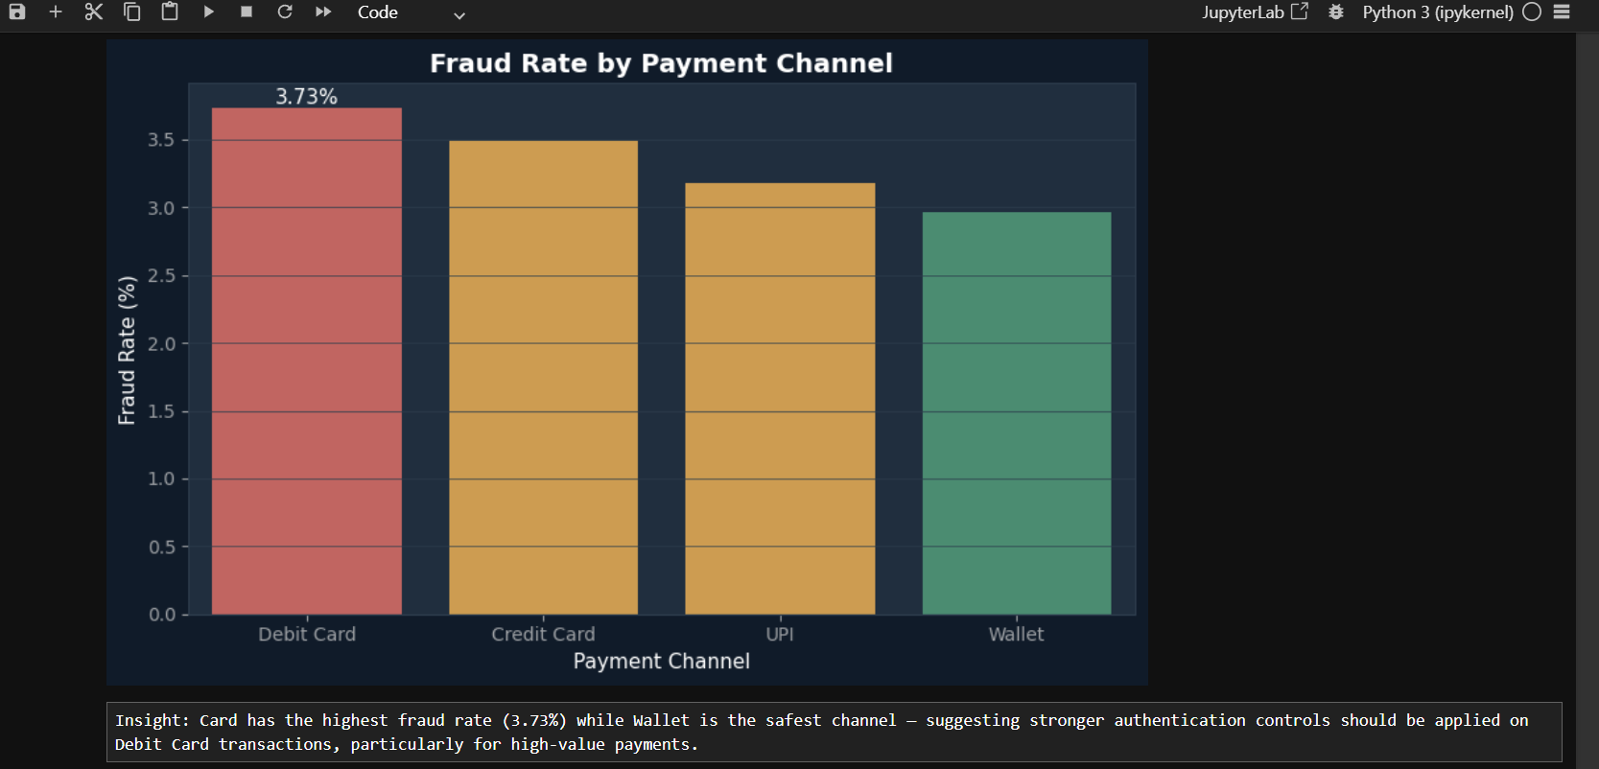
Insight: Debit Card transactions show the highest fraud rate (3.73%) while Wallet is the safest channel — stronger authentication should be prioritized for Debit Card payments, particularly high-value ones.

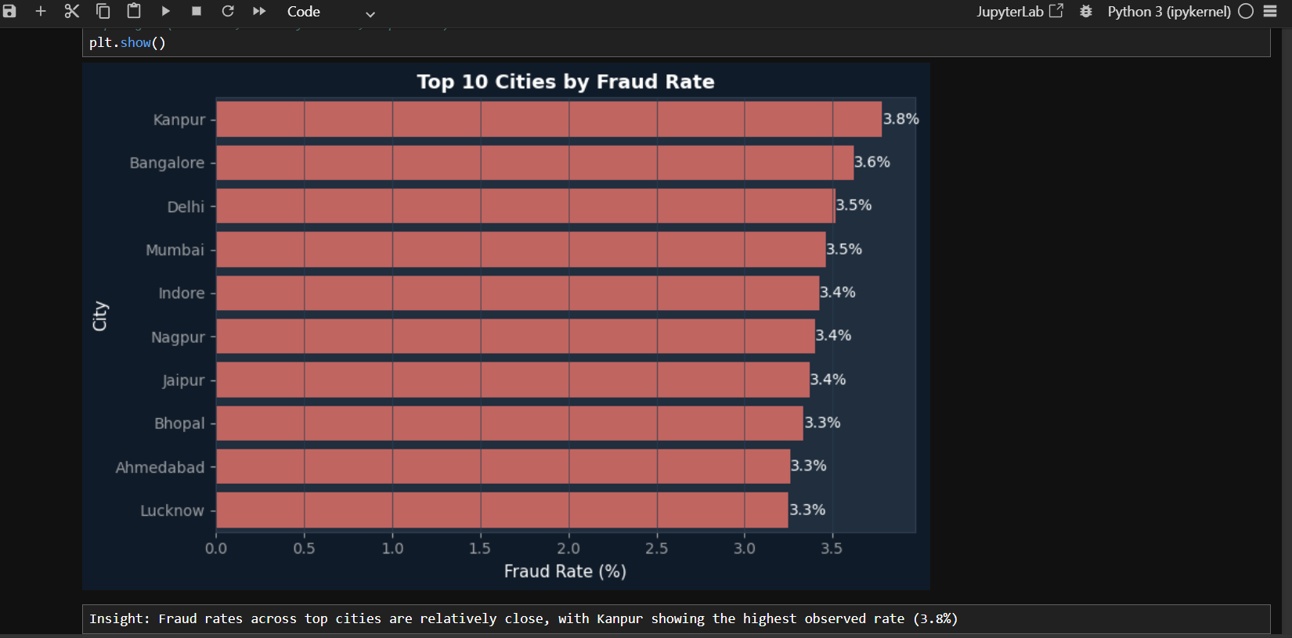
Insight: Fraud rates across the top 10 cities are relatively close, with Kanpur showing the highest observed rate (3.8%) — suggesting fraud in this dataset is broadly distributed rather than concentrated in one region.

The full set of 12 questions covered city-level fraud rate, time-of-day risk, merchant category risk, fraud vs. legitimate amount patterns, KYC status impact, monthly trend, payment channel risk, top risky merchants, transaction status distribution, high-value transaction risk, device-type risk, and new-vs-established account risk.

5. DATA ANALYSIS — SQL (POSTGRESQL)

The cleaned data was loaded into a normalized PostgreSQL schema of five related tables. Seventeen business queries were then written to answer questions that the Python EDA could not — deeper joins, window functions, and row-level risk scoring that a relational database handles more naturally than a flat DataFrame.

Schema Design
- users, merchants, transactions, fraud_labels, payment_failures — 5 normalized tables
- Primary keys on txn_id, user_id, merchant_id; foreign keys linking transactions to all four other tables
- Indexes added on user_id, merchant_id, status, and timestamp for query performance

Query Highlights
# | Business Question | SQL Concept Used
Q1 | What is the overall fraud KPI summary? | Aggregation, CASE
Q4 | Who are the top 10 riskiest merchants? | JOIN, HAVING, LIMIT
Q5 | Does retry count improve resolution rate? | JOIN, GROUP BY
Q7 | Is fraud increasing or decreasing month over month? | CTE, LAG() window function
Q8 | Which users show 5+ transactions within 1 hour? | CTE, COUNT() OVER, LAG()
Q9 | Which users should be flagged CRITICAL / HIGH / MEDIUM / LOW? | CTE, CASE risk labeling
Q15 | Do unverified merchants carry higher fraud exposure? | JOIN, COUNT(DISTINCT)
Q17 | Which merchant cities show the highest fraud concentration? | JOIN, RANK() window function

Q4 — Top 10 Riskiest Merchants
Identifies merchants whose fraud rate is roughly 2–3x the platform average, with a minimum transaction volume filter (HAVING COUNT(*) >= 10) to avoid flagging low-volume merchants on noisy data.
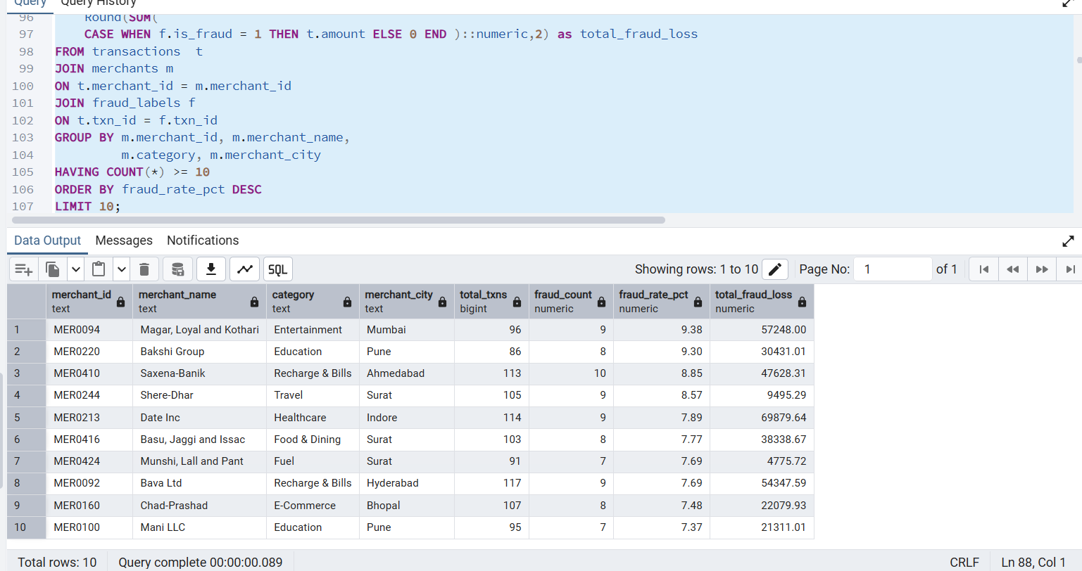
Figure 4: Top 10 merchants ranked by fraud rate, with total fraud loss per merchant.

Q9 — High Risk User Labeling
Converts a raw personal fraud rate into an actionable business label using a CASE expression — turning a number into a decision the risk team can act on directly.
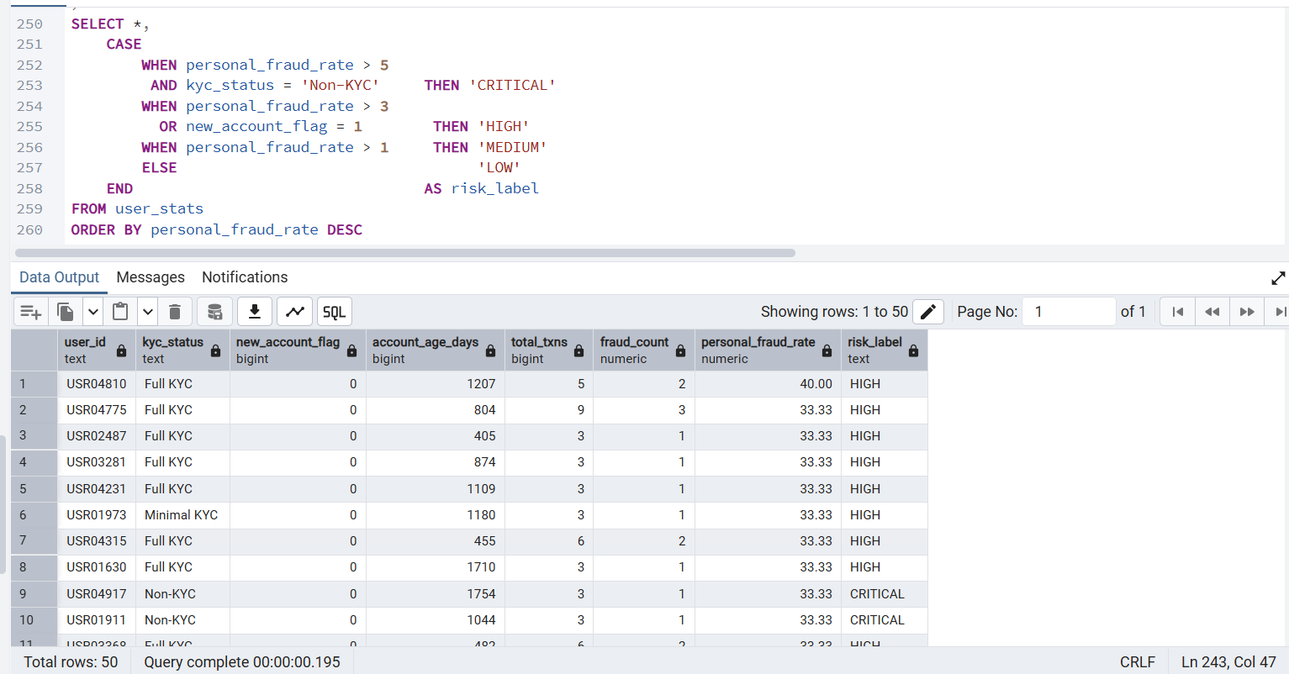
Figure 5: Users classified into CRITICAL, HIGH, MEDIUM, and LOW risk tiers based on personal fraud rate, KYC status, and account age.

Q15 — Verified vs. Unverified Merchant Risk
Compares fraud exposure between verified and unverified merchants to test whether merchant verification meaningfully reduces fraud.
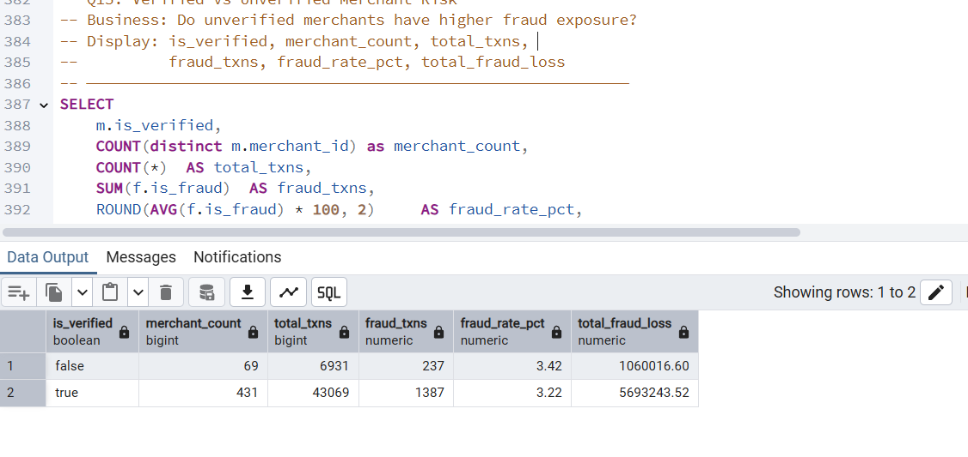
Figure 6: Unverified merchants show a fraud rate of 3.42% versus 3.22% for verified merchants — a measurable but modest difference.

6. OPERATIONAL DASHBOARD — EXCEL

The Excel dashboard was built for the operations team — a row-level tool for day-to-day investigation rather than executive reporting. It connects directly to the cleaned transaction-level data via Power Query and supports ad-hoc filtering by month, city, channel, and KYC status.

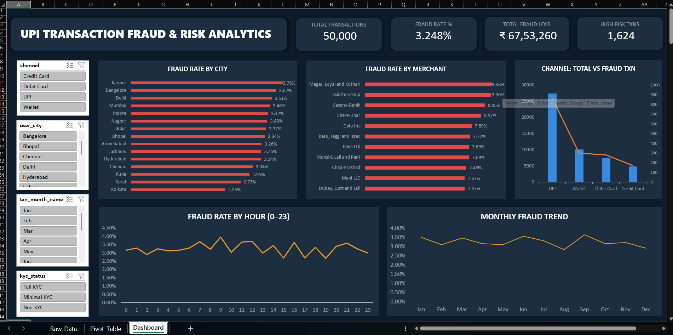
Figure 7: Excel operational dashboard — KPI cards, fraud-rate breakdowns by city, merchant, channel, and time, with live slicers.

Dashboard Components
- 4 KPI cards: Total Transactions, Fraud Rate %, Total Fraud Loss, High Risk Transactions
- Fraud Rate by City and by Merchant — horizontal bar charts, sorted descending
- Channel: Total vs. Fraud Transactions — dual-axis comparison
- Fraud Rate by Hour and Monthly Fraud Trend — line charts
- Slicers: Channel, City, Month, KYC Status — connected across all PivotTables

7. EXECUTIVE DASHBOARD — POWER BI

A 3-page Power BI dashboard was built on top of the same PostgreSQL schema, designed for senior management to monitor fraud trends, merchant risk, and user risk without needing to read raw data. Each page targets a different audience and decision.

Page 1 — Executive Overview
Top-level KPIs and trends for leadership: overall fraud rate, transaction failure rate, total fraud loss, and where fraud concentrates by city and payment channel.
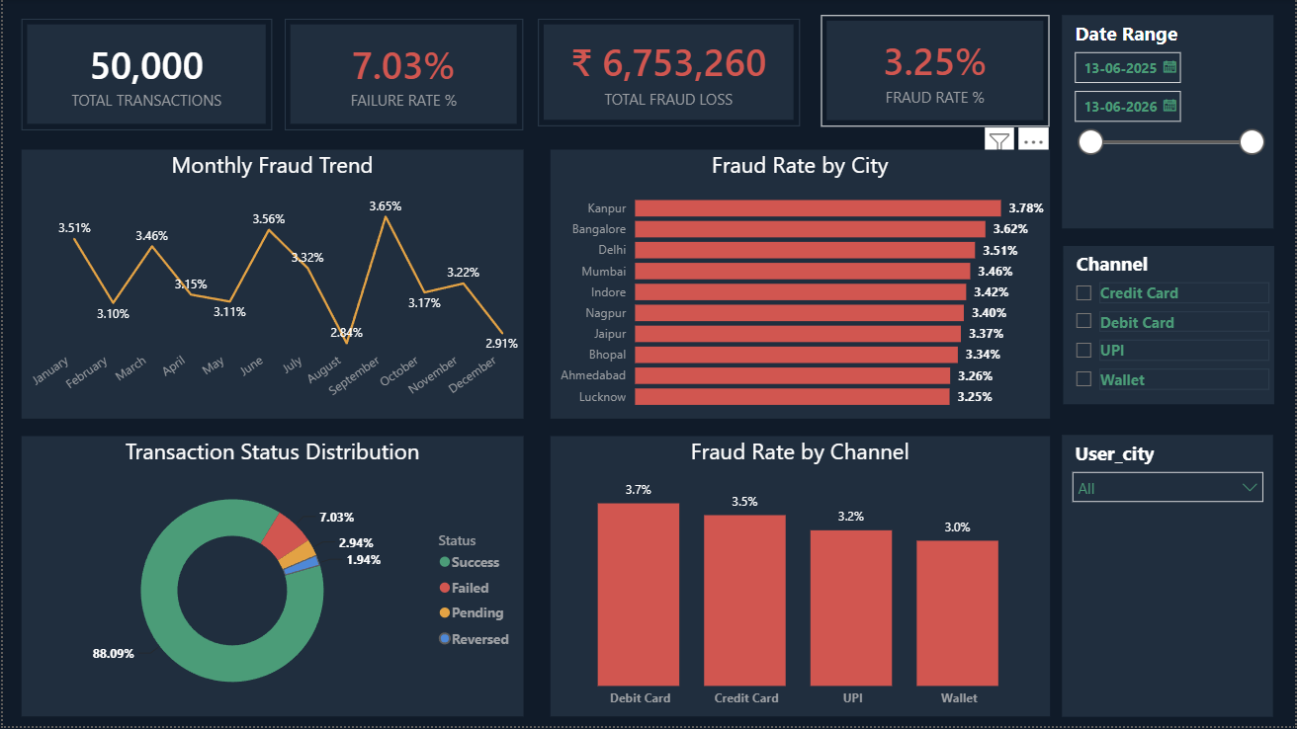
Figure 8: Power BI Page 1 — Executive Overview.

Page 2 — Merchant Risk Analysis
Built for the fraud and merchant-relations team: identifies the highest-risk merchants, risk by category, and a city-level fraud heatmap to guide manual review and onboarding decisions.
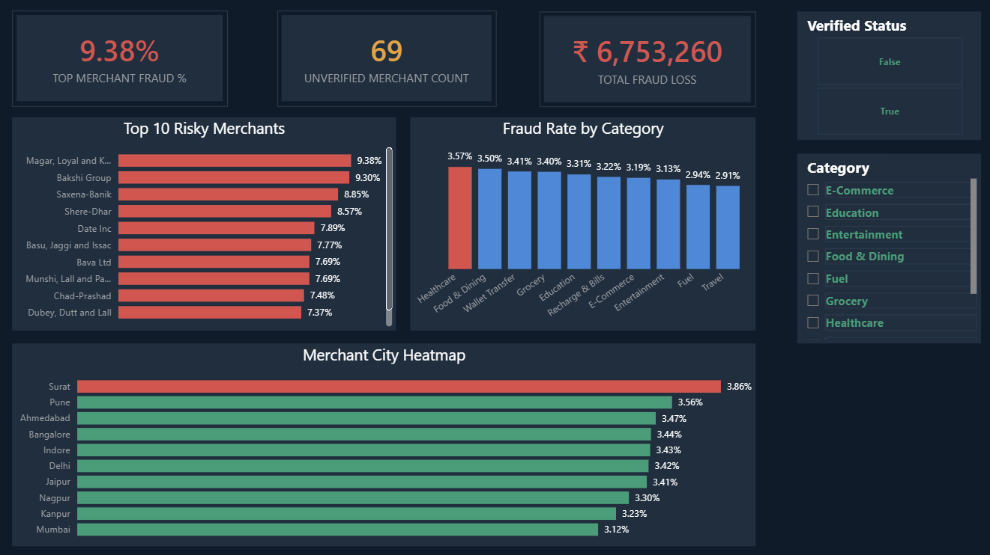
Figure 9: Power BI Page 2 — Merchant Risk Analysis.

Page 3 — User Risk Profiles
Built for the risk and compliance team: surfaces fraud rate by KYC status and account cohort, age-group risk distribution, and a ranked table of the highest-risk individual users.
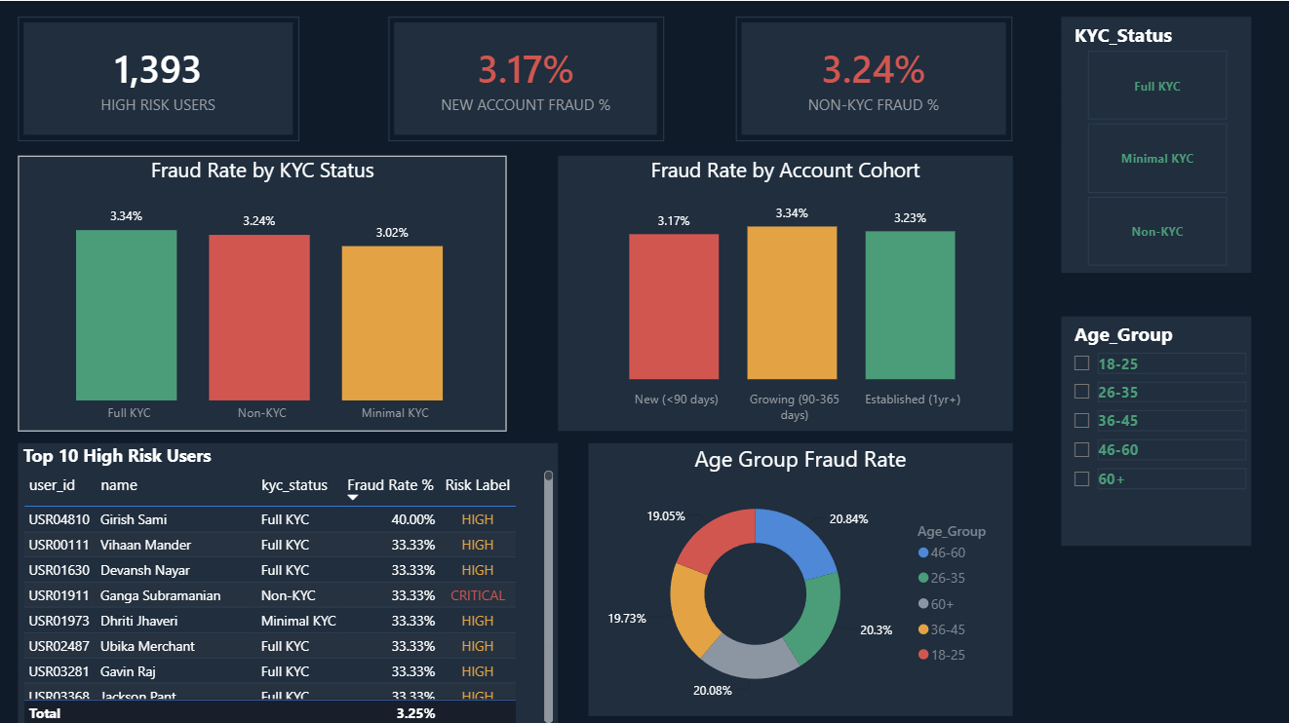
Figure 10: Power BI Page 3 — User Risk Profiles.

Design Consistency
A single Dark Navy / Teal / Gold / Red color theme was applied consistently across Python charts, the Excel dashboard, and all three Power BI pages — red always signals fraud or risk, teal signals safety, and gold flags warnings or trends.

8. KEY INSIGHTS

# | Finding
1 | Fraud peaks between 12 AM and 4 AM, when monitoring is lowest — a clear window for step-up authentication.
2 | Debit Card carries the highest fraud rate (3.73%) among all payment channels; Wallet is the safest.
3 | The top 10 riskiest merchants show fraud rates of 7.4%–9.4% — roughly 2–3x the platform average.
4 | Unverified merchants show a modestly higher fraud rate (3.42%) than verified merchants (3.22%).
5 | KYC status alone is not a strong fraud predictor in this dataset — behavioral signals matter more.
6 | New and established accounts show similar fraud rates, suggesting fraud is not limited to new sign-ups.

9. BUSINESS RECOMMENDATIONS

Finding | Recommended Action
Late-night fraud concentration (12 AM–4 AM) | Apply step-up authentication (OTP) on large transactions during this window
Debit Card has the highest channel fraud rate | Add additional verification for high-value Debit Card transactions
Top 10 merchants drive disproportionate fraud loss | Flag for manual review; consider reduced settlement limits
Unverified merchants carry higher exposure | Tighten onboarding verification before activating new merchants
Payment failures cause measurable revenue leakage | Investigate top failure reasons (e.g. server timeouts) as an engineering priority

10. TOOLS & SETUP

Requirements
Python 3.x
pandas, numpy, matplotlib, seaborn, faker, sqlalchemy, psycopg2-binary
PostgreSQL 18+
Microsoft Excel (Power Query, PivotTables)
Power BI Desktop

How to Run
- Run notebooks/01_data_generation.ipynb to generate the 5 raw CSVs
- Run notebooks/02_eda_cleaning.ipynb for cleaning, feature engineering, and EDA
- Execute sql/schema.sql in PostgreSQL, then load the cleaned CSVs into the 5 tables
- Run sql/business_queries.sql to reproduce the 17 business queries
- Open excel/excel_dashboard.xlsx and refresh the Power Query connection
- Open powerbi/upi_fraud_risk_analytics.pbix and refresh the PostgreSQL connection

UPI Transaction Fraud & Risk Analytics — End-to-End Data Analytics Project
Prepared by Mahesh Thakare | Python · PostgreSQL · Excel · Power BI

