1. Install nuxt on local

Run below command on command prompt

npm create nuxt@latest <project-name>

cd <project-name>

or follow below link for installation

<https://nuxt.com/docs/4.x/getting-started/installation>

1. Extract source code in project directory
2. Install postgreSql on local and import database into postgresql as per guide given in below link

<https://chatgpt.com/share/687aad47-f53c-8000-8757-68365c43facd>

use below syntax to copy data into database

\copy products(data) FROM '/full/path/to/all_products.jsonl;

1. Write database details in nuxt.config.ts file as shown in screenshot

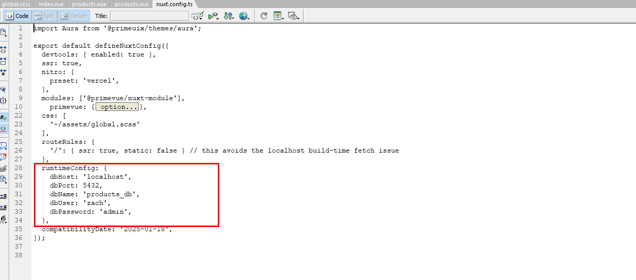

Please keep the database details unchanged for convenience.

1. To start project on local use below command

npm run dev

1. install **PrimeVue** and **Fuse.js in project directory**

npm install [primevue@^4.0.0](mailto:primevue@%5e4.0.0)

npm install fuse.js