Linux Fundamentals – Hands-on Practical Documentation
Cloud & DevOps Learning Journey

About This Document
This document contains selected screenshots from my Linux learning and practical exercises. It records the commands and administration tasks I practised while building my Linux foundation for Cloud and DevOps.

Topics Practised
- User management
- Group management
- Password management
- File and directory management
- Linux filesystem navigation
- vi editor practice
- File permissions
- Basic process management
- Common Linux commands
Note: This is a learning record with selected practical evidence, not a complete collection of every command or exercise studied.

Practical Evidence

User account information and Linux account-management practice
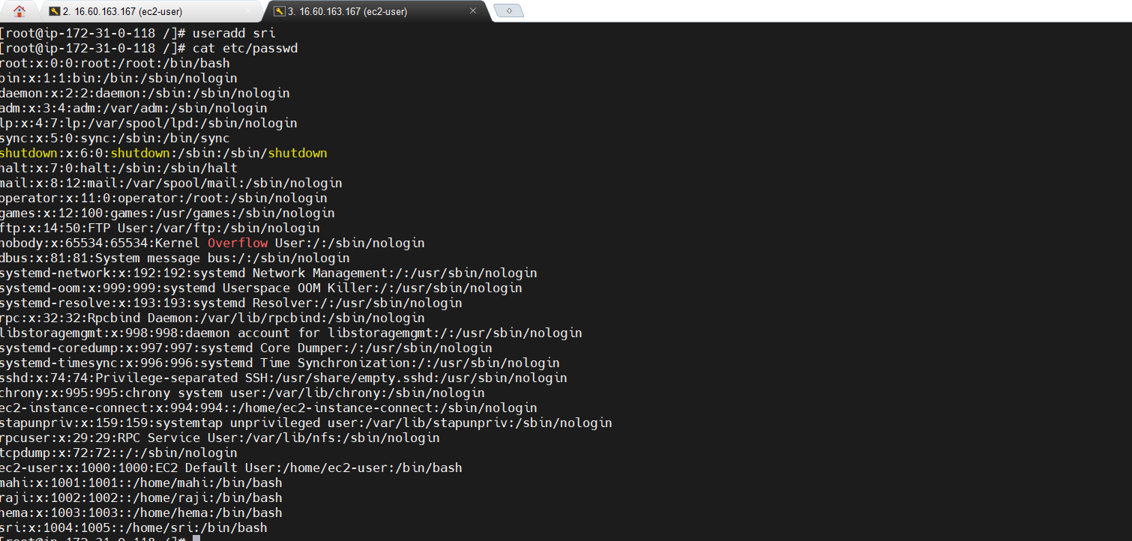
Figure 1: User account information and Linux account-management practice

Changing a user password with passwd
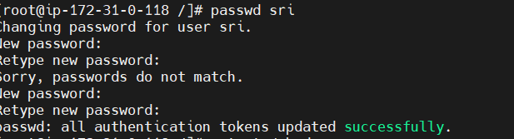
Figure 2: Changing a user password with passwd

Listing home-directory contents
Figure 3: Listing home-directory contents

Creating a Linux group
Figure 4: Creating a Linux group

Viewing group information
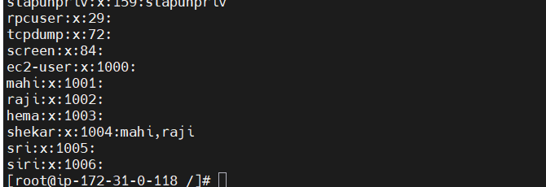
Figure 5: Viewing group information

Adding a user to a group with usermod
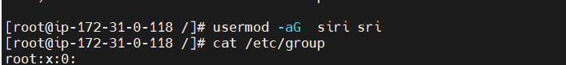
Figure 6: Adding a user to a group with usermod

Viewing Linux user account information
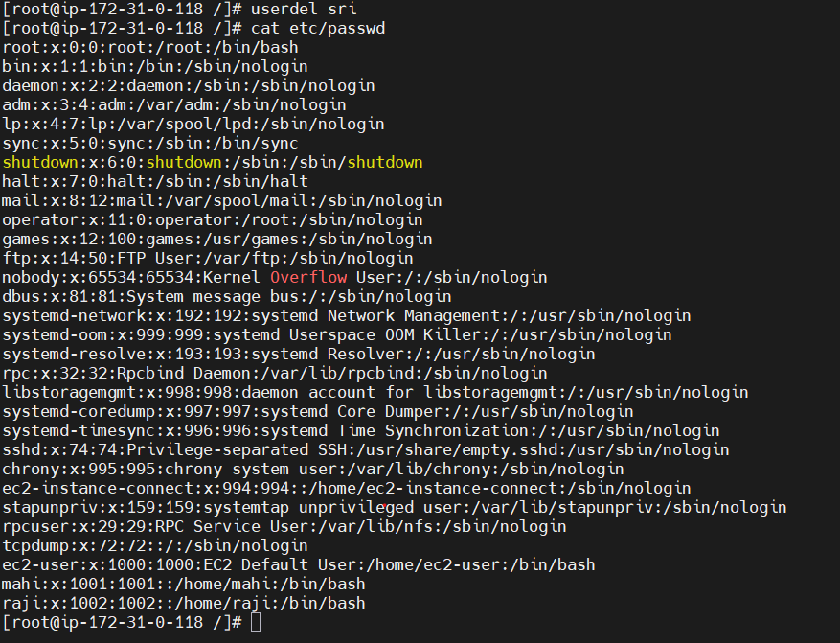
Figure 7: Viewing Linux user account information

Locking and unlocking a user account
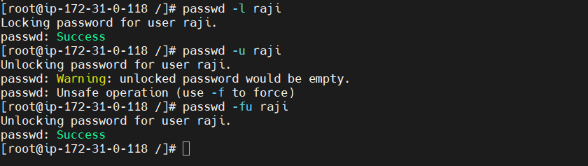
Figure 8: Locking and unlocking a user account

Deleting a Linux group and checking group information
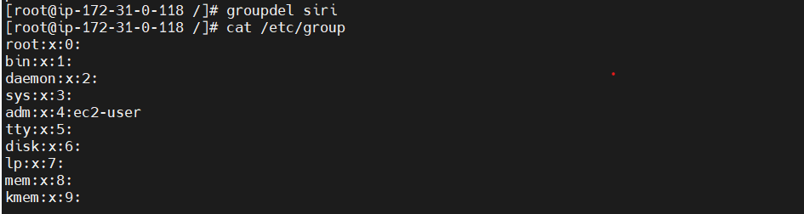
Figure 9: Deleting a Linux group and checking group information

Practising ls and related file-listing commands
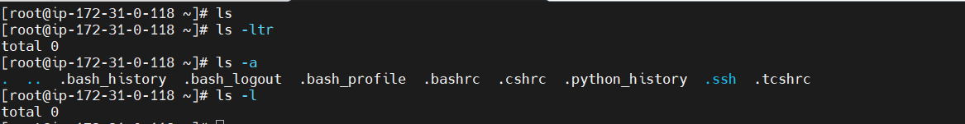
Figure 10: Practising ls and related file-listing commands

Navigating the Linux filesystem and working with directories
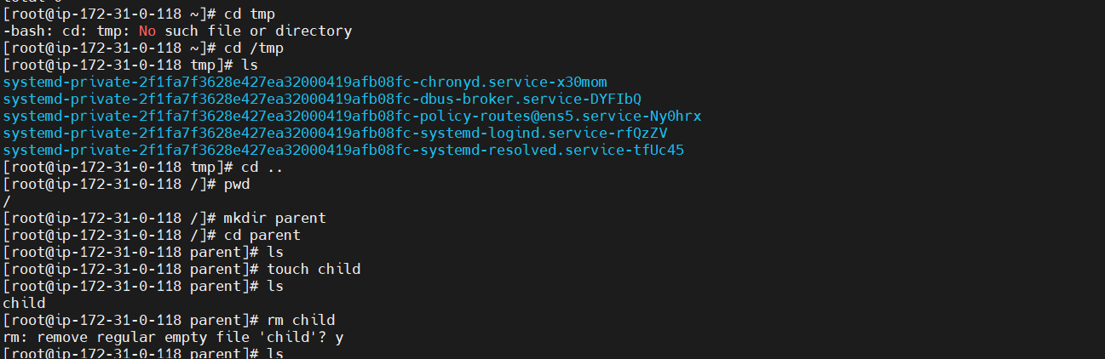
Figure 11: Navigating the Linux filesystem and working with directories

Listing filesystem contents with ls -ltr
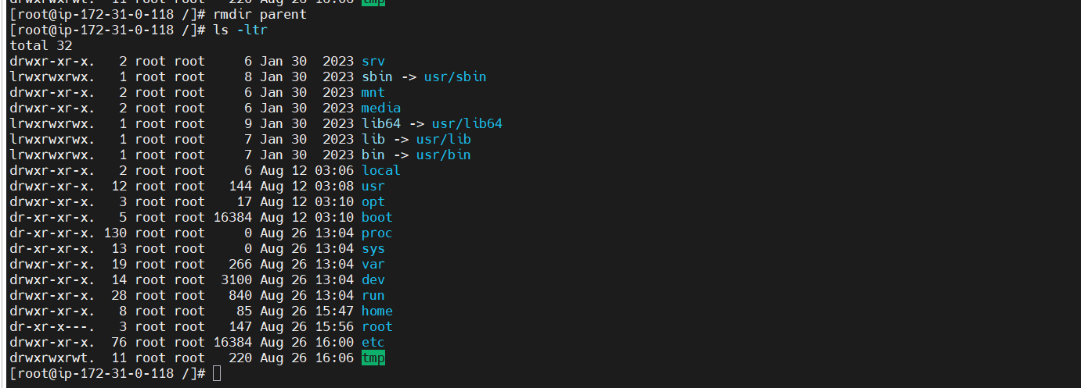
Figure 12: Listing filesystem contents with ls -ltr

Practising file creation, editing and copying
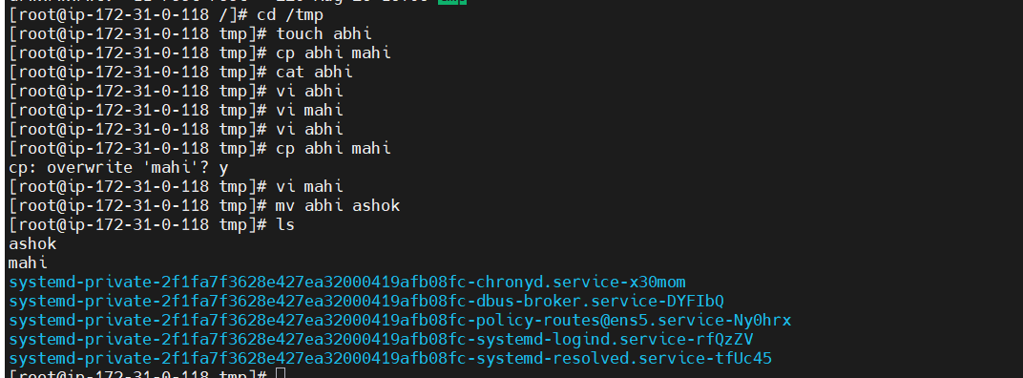
Figure 13: Practising file creation, editing and copying

Command-line and file-management practice
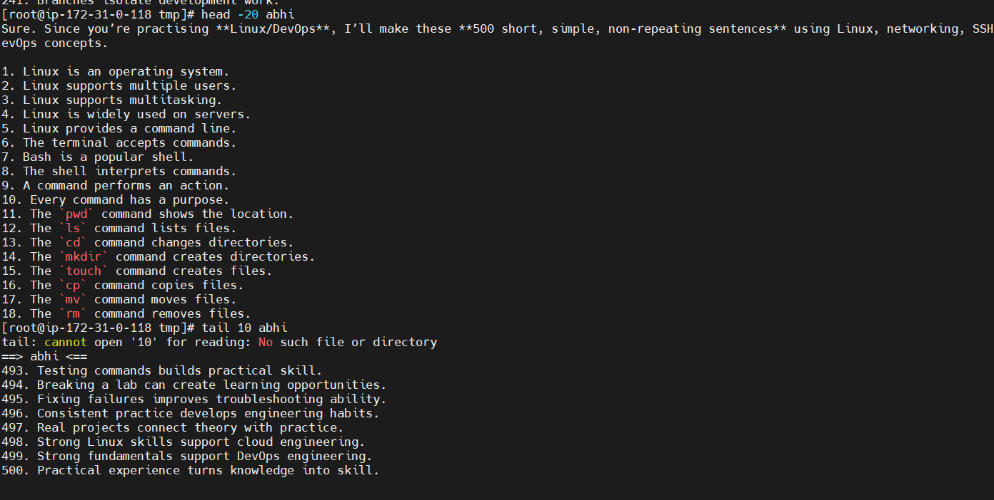
Figure 14: Command-line and file-management practice

Practising shell commands and text output
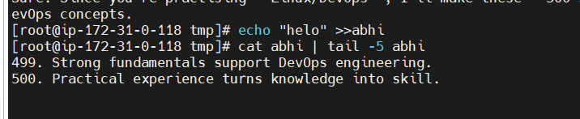
Figure 15: Practising shell commands and text output

File listing and shell practice
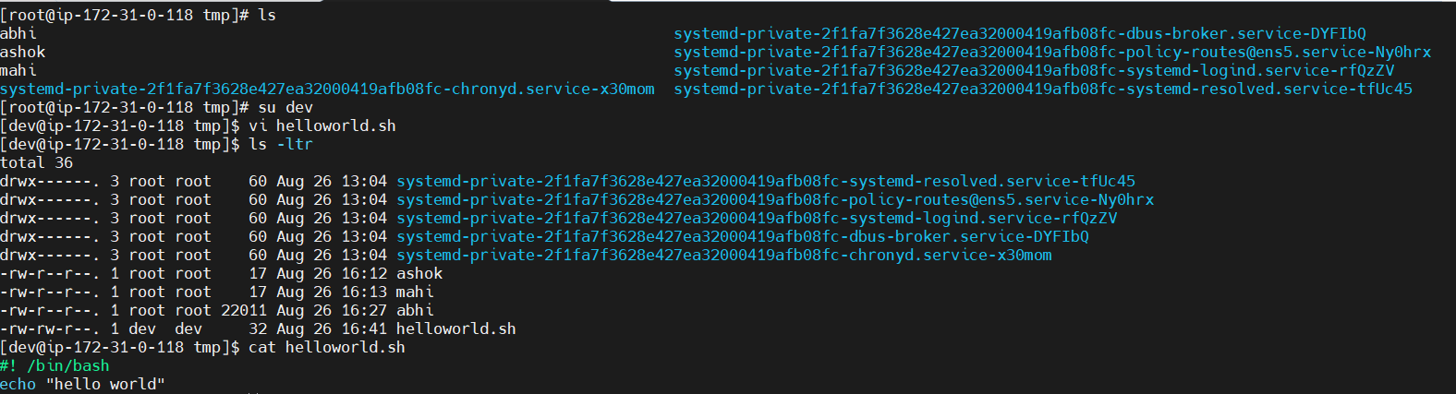
Figure 16: File listing and shell practice

File permissions and directory-management practice
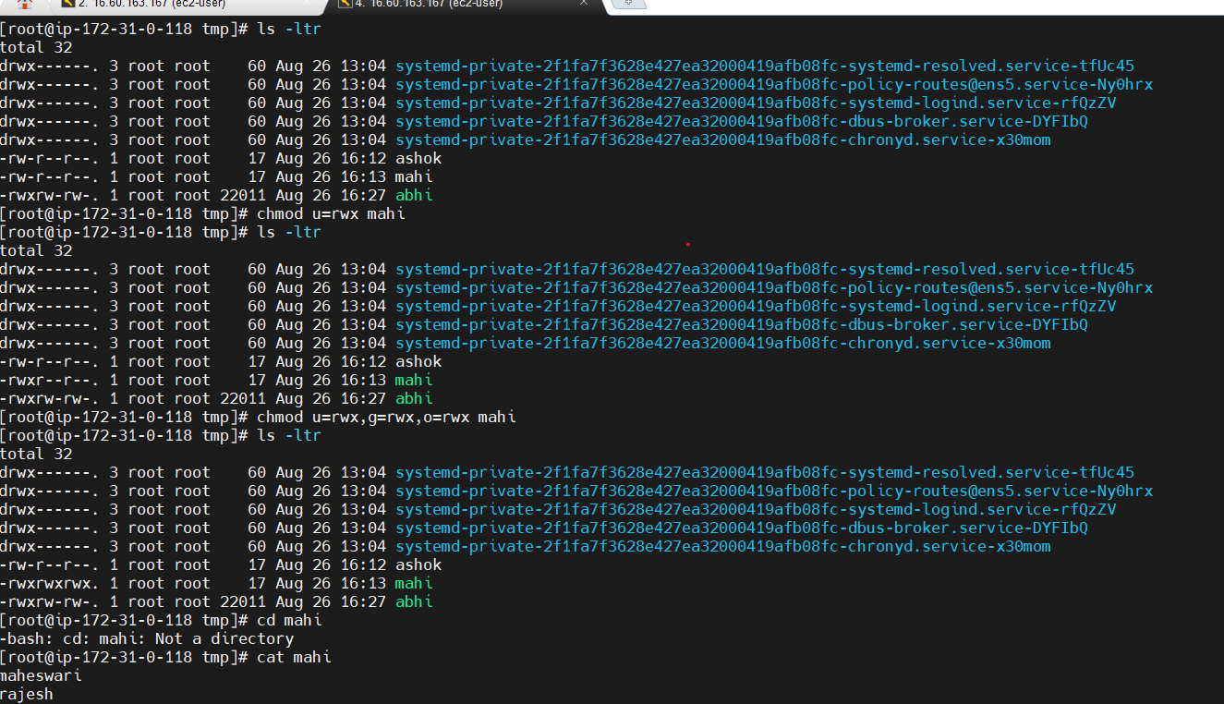
Figure 17: File permissions and directory-management practice

Changing file permissions and verifying results
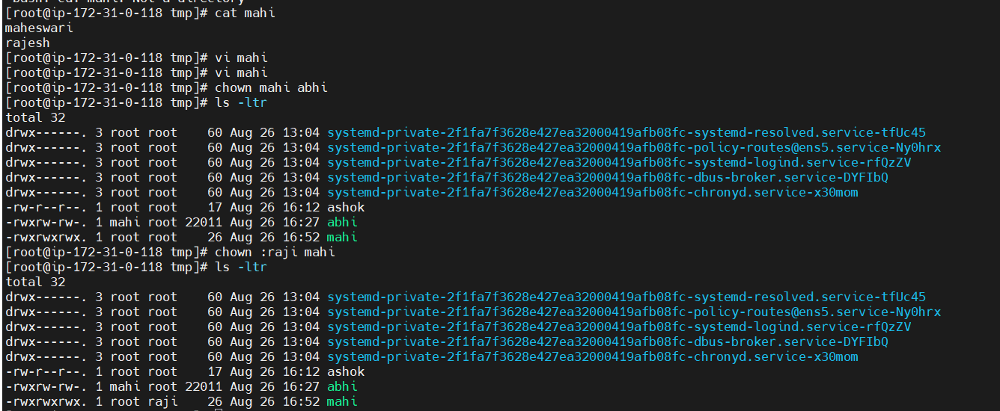
Figure 18: Changing file permissions and verifying results

Process-management practice using ps
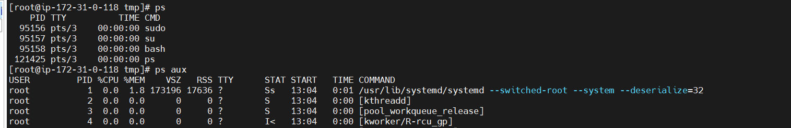
Figure 19: Process-management practice using ps

Privacy / Security Note
The original document contained a screenshot showing /etc/shadow. That screenshot has been removed from this GitHub-ready copy because it contains password-hash information. Only non-sensitive practical screenshots are included here.

Next Steps
Continue strengthening Linux and networking fundamentals, then progress to shell scripting, Git/GitHub, AWS and the wider Cloud/DevOps toolset.

