**Project1 Name**: **Software installation**

**Name:** Mahesh Kambala: **Batch:06-** **01-2022** : **Tutor:** Raham Shaik

**Java Installation on Ubuntu:**

1. Created an EC2 Instance with Ubuntu ami
2. Updated the instance by using the command (apt-get update -y)
3. Installed JRE Package by using the (apt-get install default-jre -y)
4. Installed JDK Package by using the (apt-get install default-jdk -y)
5. Checked Java Version
6. Wrote the script on the /etc/profile.d/jdk11.sh
7. A screenshot of a computer

   Description automatically generated with medium confidence
8. I have run the script to print the Java_Home and Path

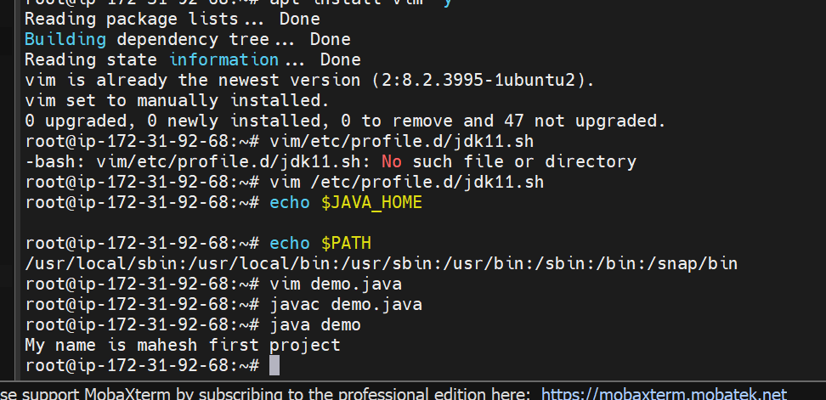

Run a Basic Java program:  
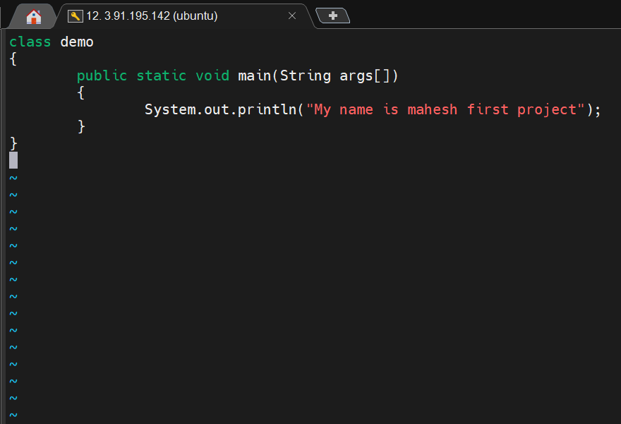

**PYTHON INSTALLATION ON UBUNTU:**

1. Installed Python by running the command (apt-get install python3 -y)
2. Installed Python version 3.8 by running the command (apt-get install python3.8 -y)
3. Executed code

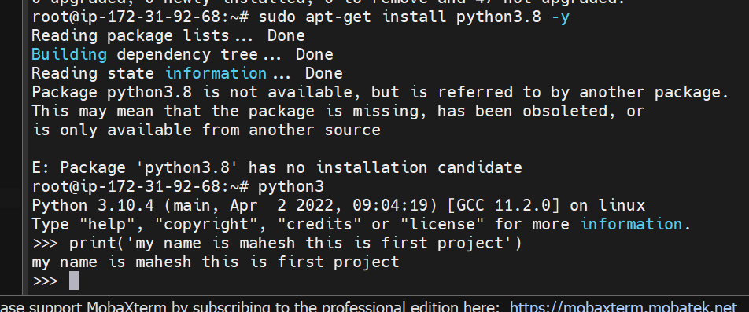**NODEJS INSTALLATION ON UBUNTU:**

1. Installed nodejs by running the command ( apt install nodejs -y )
2. Checked version after the installation.
3. run the program by using the (nodejs) command.
4. Exited from nodejs by using the (.exit ) command.

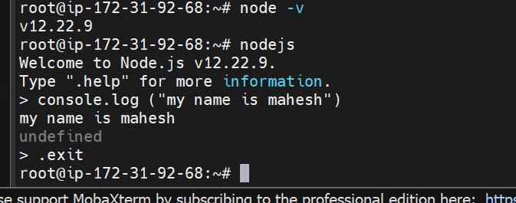

**ARANGO INSTALLATION ON UBUNTU:**

1. add the repository key to apt : wget -q https://download.arangodb.com/arangodb39/DEBIAN/Release.key
2. sudo apt-key add - < Release.key
3. Use apt-get to install arangodb:
4. By running the “echo 'deb https://download.arangodb.com/arangodb39/DEBIAN/ /' | sudo tee/etc/apt/sources.list.d/arangodb.list”command
5. I have restarted the arangodb by running the (systemctl start arangodb3) command.
6. Checked the status of the arangodb. It is actively running.
7. Ran arangosh, below is the pop-up to enter to arango shell
8. Created the New Database by running ( db._createDatabase(“maheshdb”);

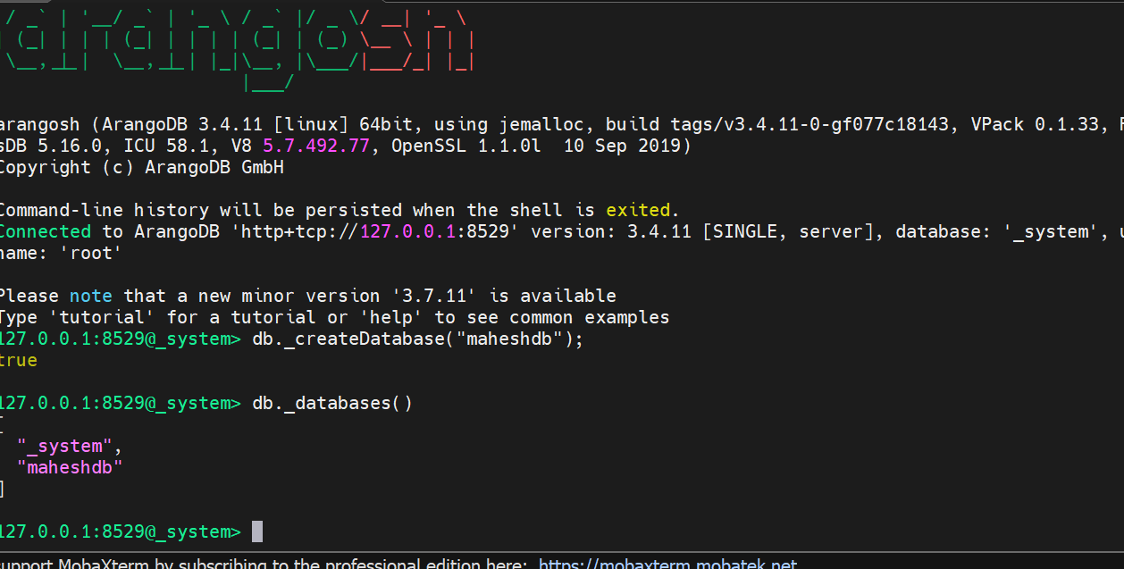

1. Ran ( vim /etc/arangodb3/arangod.conf ) command, on arangodb configuration file added

Checked the arangodb3 status by running the ( systemctl status arangodb3) command.

1. Take the public IP address and used port 8529 to launch the arango db and used the root as a username and password which was provided earlier while installing the arango db.

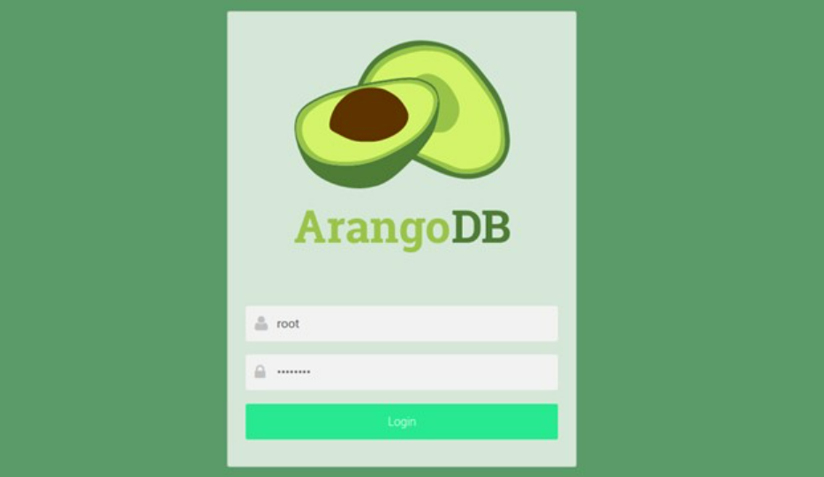

**PERCONA MYSQL INSTALLATION ON UBUNTU:**

1. Install GnuPG, the GNU Privacy Guard ( apt install gnupg2) command.
2. Fetch the repository packages from Percona web (wget https://repo.percona.com/apt/percona-release_latest.$(lsb_release -sc)_all.deb ) command.
3. Install the downloaded package with dpkg. To do that, I have run the following commands as root ( dpkg -i percona-release_latest.$(lsb_release -sc)_all.deb )

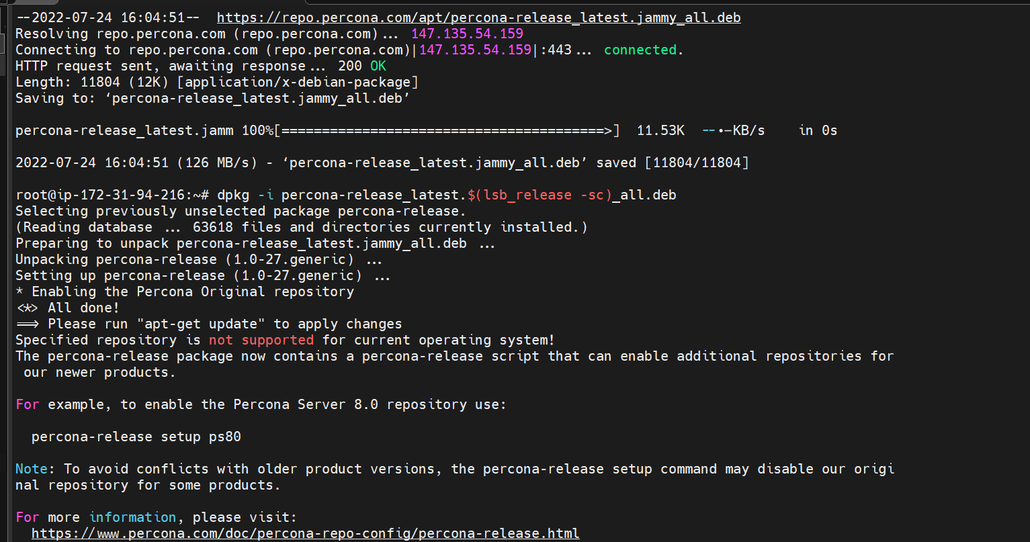

Ran percona-release setup ps80 for enabling the percona server 8.0 Repositories

1. Configuring Percona Server
2. Setup default authentication plugin as use strong password encryption

1. Ran mysql -u root –p command to enter into the database shell, it will ask the password which was configured while installing the percona server, we have to enter the password to go percona server.
2. Created Database and checked how many databases are there. Delete the database and exited.

**MONGO DB INSTALLATION ON UBUNTU:**

1. Mongodb is part of the ubuntu repositories we no longer need to get the resources from the internet.
2. Installed mongodb by running (apt install -y mongodb) command.
3. By running the ( apt update -y ) it will update the mongodb repositories.
4. We start mongodb services by running the (service mongodb start ) command.
5. Checked mongodb status by running the (service mongodb status ) command.

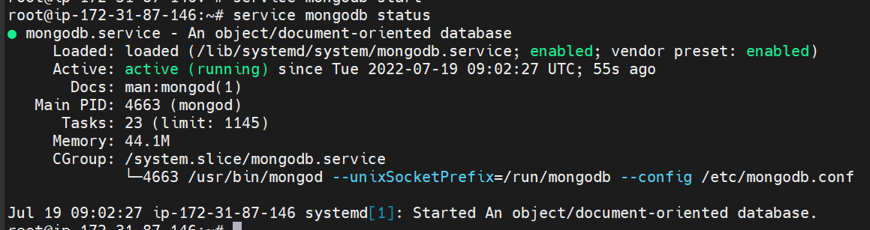

1. Upon running the mongo command it will open the mongo shell

