https://developer.cisco.com/learning/tracks/get_started_with_nso/nso-service-dev/service-dev-101/introduction/
Learn how NSO services simplify network operations, how they work, and how to develop a template-based service.
Objectives

After completing this Lab, you will:

Be able to describe the benefits of services in NSO.
Understand the difference between a service model and a service instance.
See how to design and operate a template-based service.
Understand the benefits and implications of the FASTMAP algorithm.

Prerequisites

Labs: Complete the following Labs:
YANG for NSO Module.
XML for NSO Module.

Slide 2:
Why Services?
Service orchestration simplifies network operations and management of network services. Instead of focusing on a particular device and system configuration that builds a network service, only the important inputs are collected, and the rest of the steps and processes for delivery are automated. The actual details, such as vendor-specific configurations on network devices and the correct ordering of steps, are abstracted from the user of the service. This results in consistent configurations, prevention of errors, outages, and overall cost reduction of managing a network.
Setting up the Environment
For this Learning Lab you can use either an NSO instance running in the workspace on the right, or an instance running locally in your environment. Before we can experiment with services, few things need to be set up; read more details about individual steps in Learn NSO with netsim.

1. Prepare netsim devices and NED packages:
1.Load NSO environment:source $NCS_DIR/ncsrc
2.Moving into working directory: cd ~/src
3. Create simulated network: ncs-netsim --dir nso-instance/netsim create-network $NCS_DIR/packages/neds/cisco-ios-cli-3.0 1 dist-rtr
4. Add more devices to network ncs-netsim --dir nso-instance/netsim add-to-network $NCS_DIR/packages/neds/cisco-ios-cli-3.0 1 internet-rtr
Core Router (IOS-XR) : ncs-netsim --dir nso-instance/netsim add-to-network $NCS_DIR/packages/neds/cisco-iosxr-cli-3.5 1 core-rtr

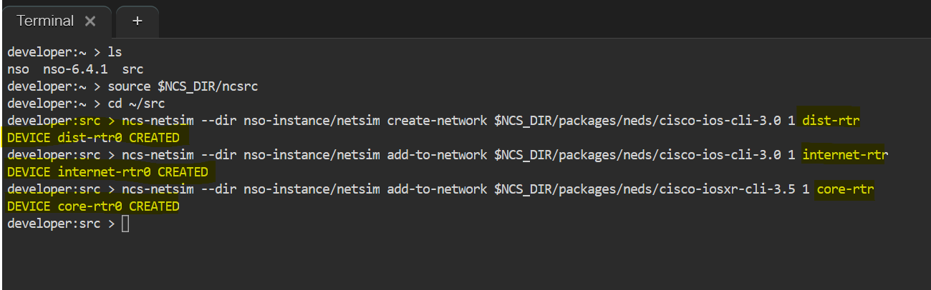
Create an NSO instance:
To initialize a complete NSO runtime environment:
This command creates and configures an NSO runtime environment and connects it with your simulated routers (netsim devices previously connected).
ncs-setup --dest nso-instance --netsim-dir nso-instance/netsim
Start netsim and NSO (this may take a couple of seconds):
Step 6: Go to NSO directory: cd nso-instance/
Step 7: Start simulated devices: ncs-netsim start
Step 8: Start NSO: ncs
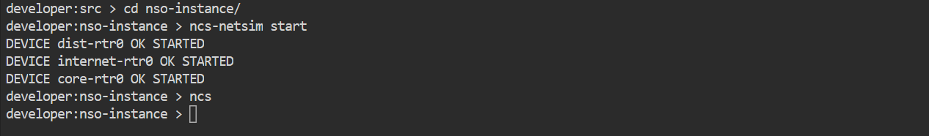
Manual configuration being pushed into netsim devices using ncs_load via IPC ports in Cisco NSO.
ie., injecting interface configuration directly into simulated devices, which is an important preparation step before syncing.
configured GigabitEthernet interfaces on netsim devices using ncs_load via device-specific IPC ports, preparing them for NSO service deployment.
(Note: IPC:(Inter-Process Communication port):each netsim device uses a unique IPC port to allow direct communication between NSO tools (like ncs_load) and the simulated device.)
ncs_load command
↓
uses NCS_IPC_PORT
↓
connects to netsim device
↓
pushes CLI config
↓
device updated ✅
Modify devices' configuration - the services assume GigabitEthernet interfaces and the netsim configuration does not contain that initially:
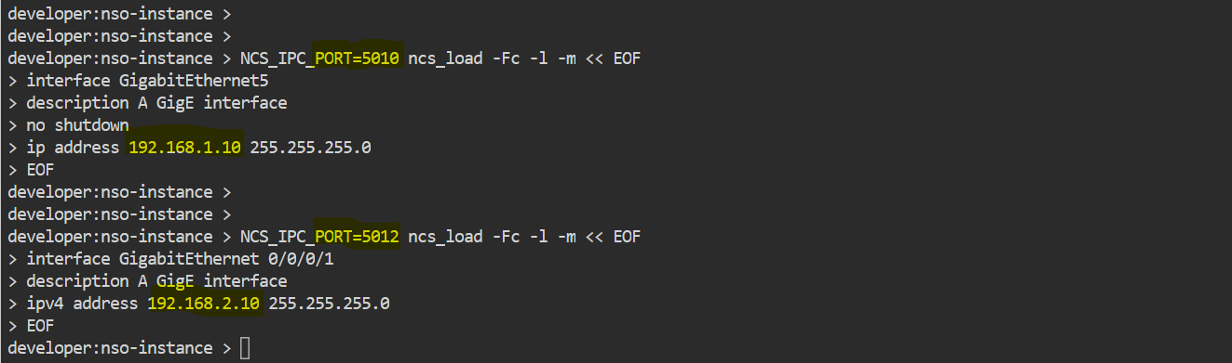
It is necessary to retrieve existing configuration on the devices so that it is synchronized with what is in NSO's device manager:
Logging into the Cisco NSO CLI as admin and are ready to manage devices and services.

Devices sync-from pulls configuration from devices and store it in NSO’s CDB, ensuring NSO and devices are fully synchronized and ready for service deployment.
NSO CLI command
↓
NSO connects to each device (netsim)
↓
Fetches running configuration
↓
Stores config in NSO CDB
↓
Marks device as "in sync"

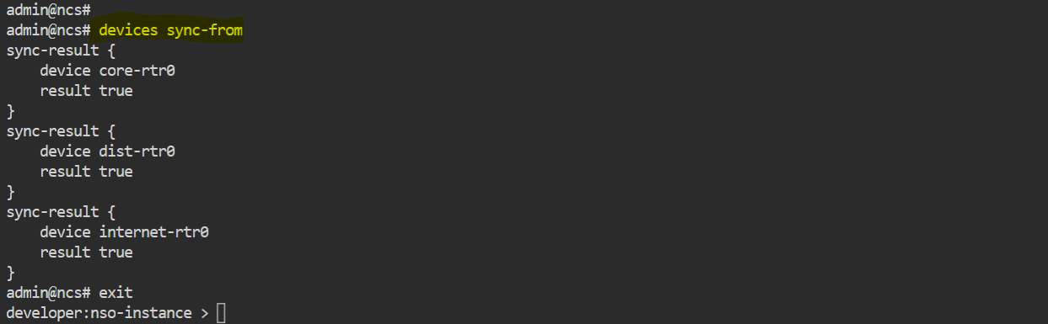
Add an Existing Service to NSO

Downloads Cisco DevNet lab files from GitHub Stores them in ../lab-files/
Copy L3VPN Package into NSO packages directory
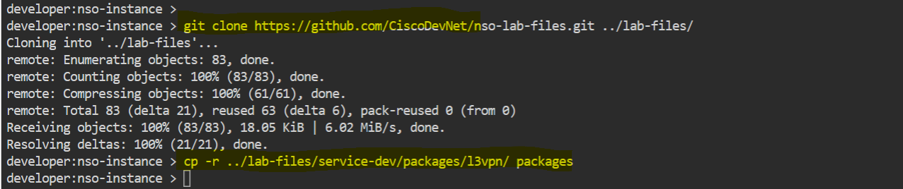

This step compiles the L3VPN NSO service package by converting its YANG model into an internal format (.fxs) so that NSO can understand and use the service.
YANG Model (l3vpn.yang)
↓ (compile using ncsc(ncsc: NSO YANG compiler))
FXS File (l3vpn.fxs):( .fxs is a compiled binary representation of a YANG model that NSO uses at runtime.)
↓
Loaded into NSO
↓
Service becomes usable ✅
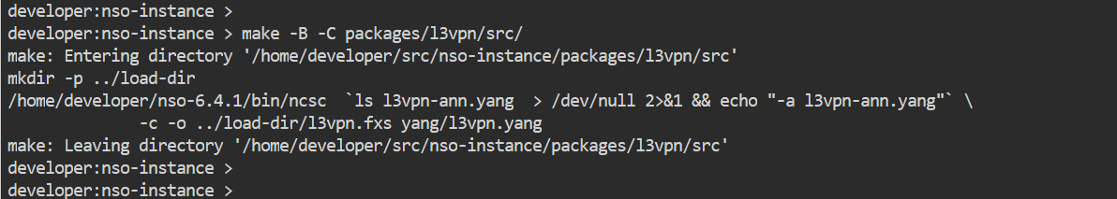
Login into Cisco NSO CLI
packages reload is an NSO operation used to load or refresh all service and device packages, making newly added or updated packages (like L3VPN) active and available for use in the NSO system.
packages reload command-
↓
NSO enters upgrade mode (System upgrade is starting)
↓
Loads all packages from packages directory (packages/, NEDs + services)
↓
Reads compiled (.fxs) files
↓
Registers services, YANG models, templates, Services (l3vpn)
↓
Packages become active ✅

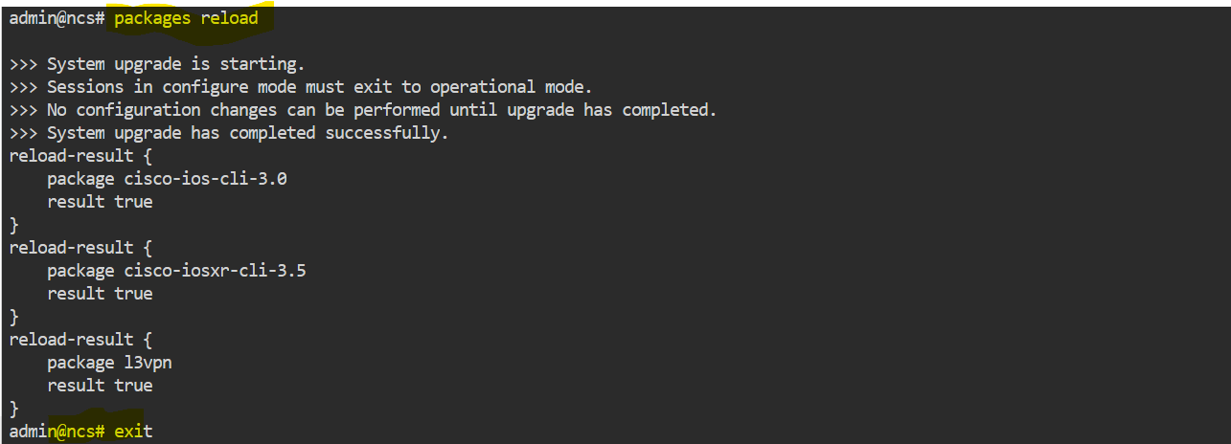

Output shows the L3VPN service data model hierarchy, defining how VPNs, links, devices, interfaces, and routing configurations are structured in NSO.

l3vpn (vpn-name)
↓
link (link-id)
↓
device + interface + routing
↓
static routes (prefix + mask)

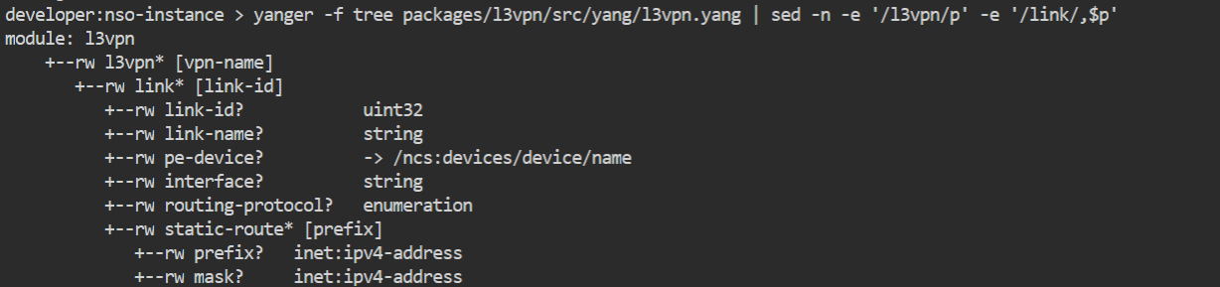

creation of an L3VPN service instance using NSO CLI, where user inputs based on the YANG model are captured and stored in the NSO configuration database (CDB), preparing the service for deployment.
Enter NSO CLI
↓
Enter configuration mode
↓
Create L3VPN service instance
(using YANG-defined structure)
↓
User inputs service data
(vpn, link, device, interface, routing)
↓
NSO validates input (based on YANG)
↓
Service configuration stored in CDB
↓
Service instance created ✅
↓
Ready for commit (deployment) 🚀

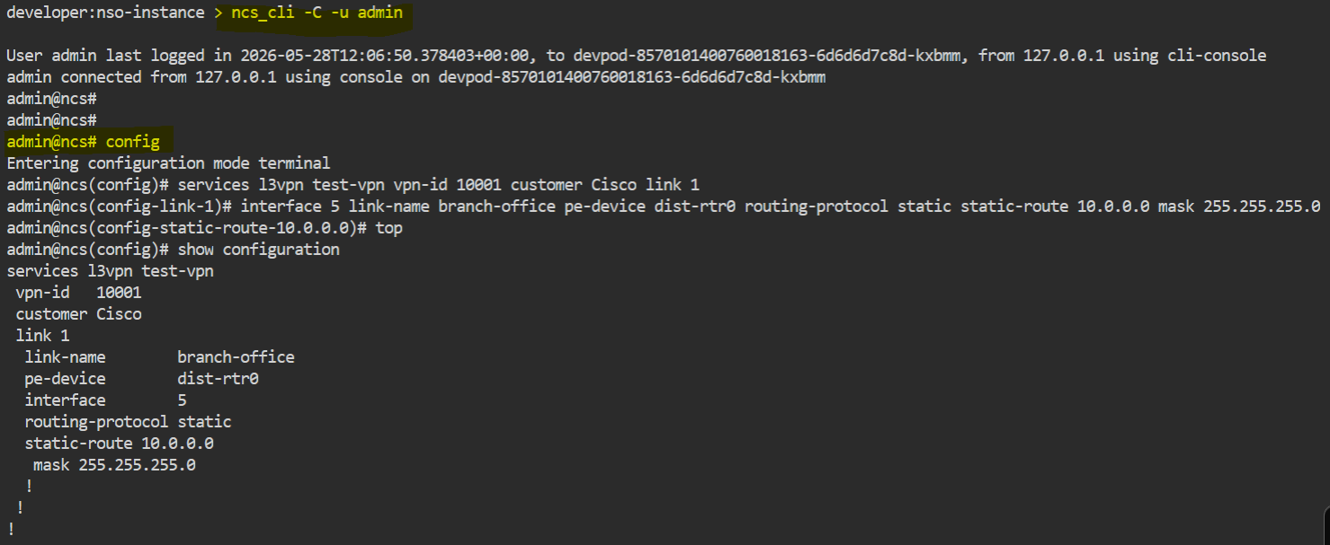

👉 commit dry-run is an NSO operation used to simulate service deployment by showing the exact configuration changes that will be pushed to devices, without actually applying them.
👉 commit and-quit applies the configuration, triggering NSO service logic (FASTMAP) to generate and push device configuration.
Service created in NSO (CDB)
↓
commit dry-run
↓
NSO triggers FASTMAP (simulation mode)
↓
Service data → Translated into device configuration
↓
Shows:
• VRF configuration
• Interface configuration
• Static routes
↓
No changes applied to device ❌ (preview only)
↓
User verifies generated config ✅
↓
commit and-quit
↓
NSO triggers FASTMAP (real execution)
↓
Service → Device configuration generated
↓
Configuration pushed to device (dist-rtr0)
↓
Device updated ✅
↓
Service deployed successfully 🚀

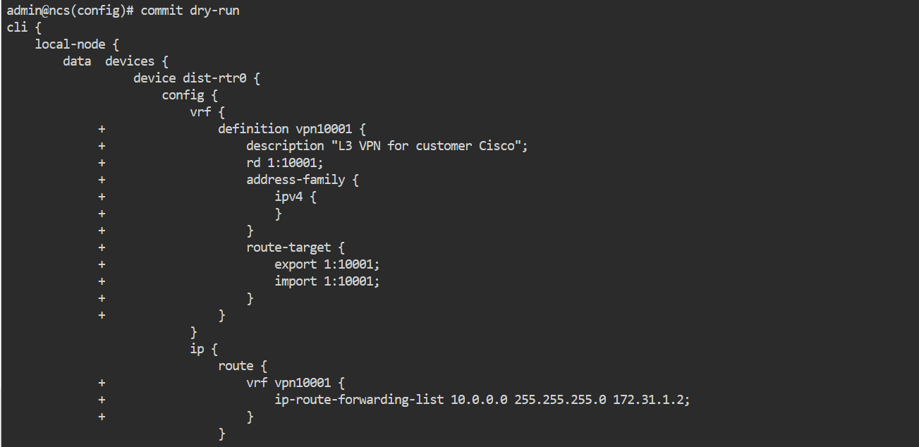
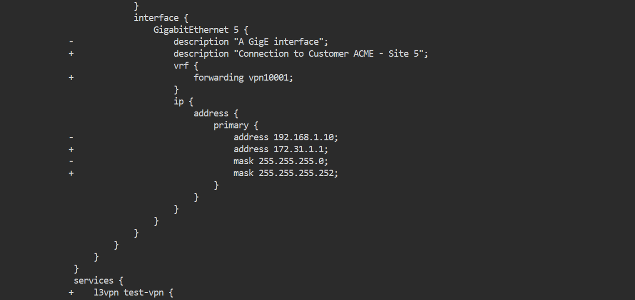
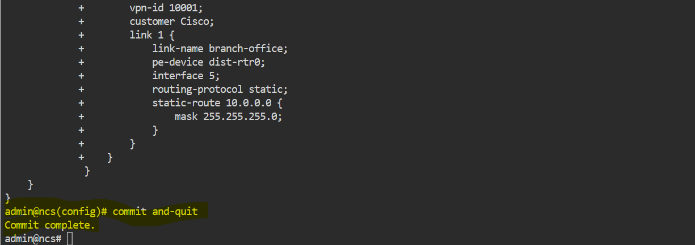

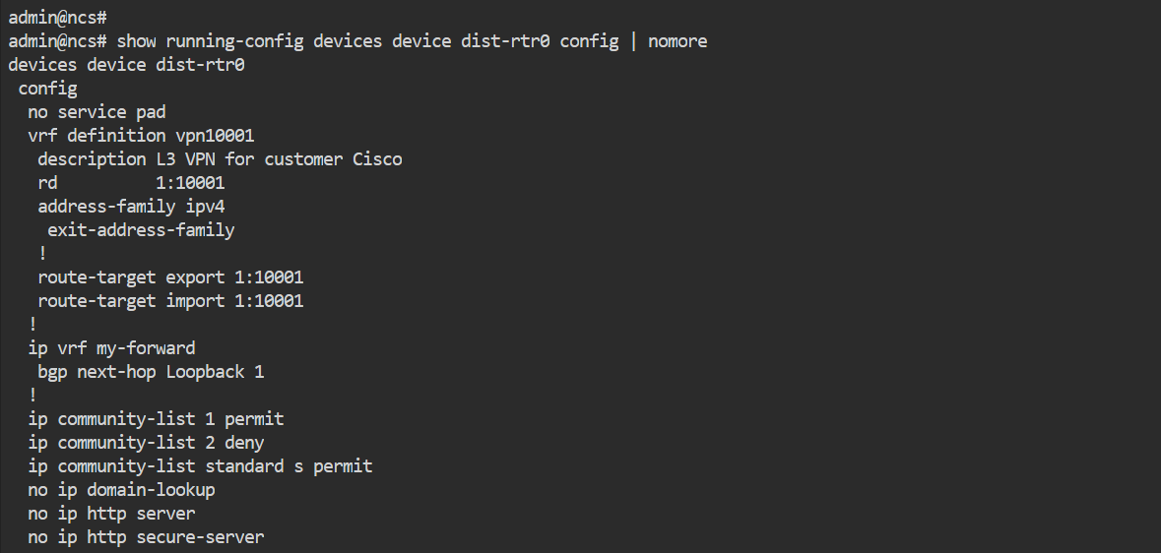
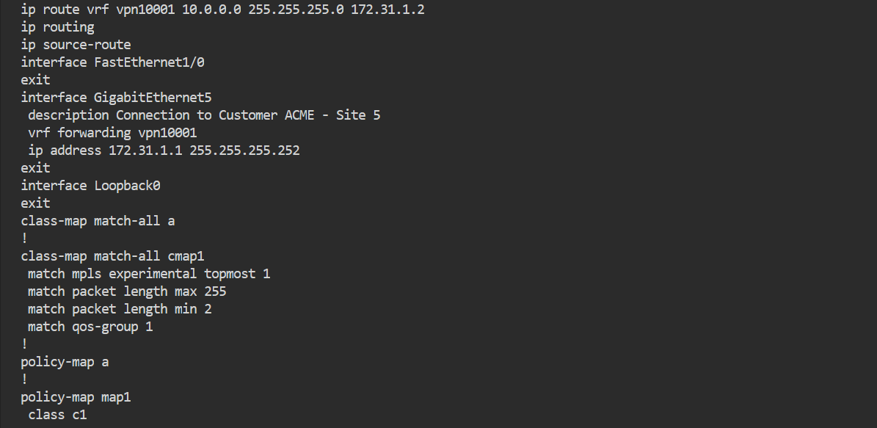
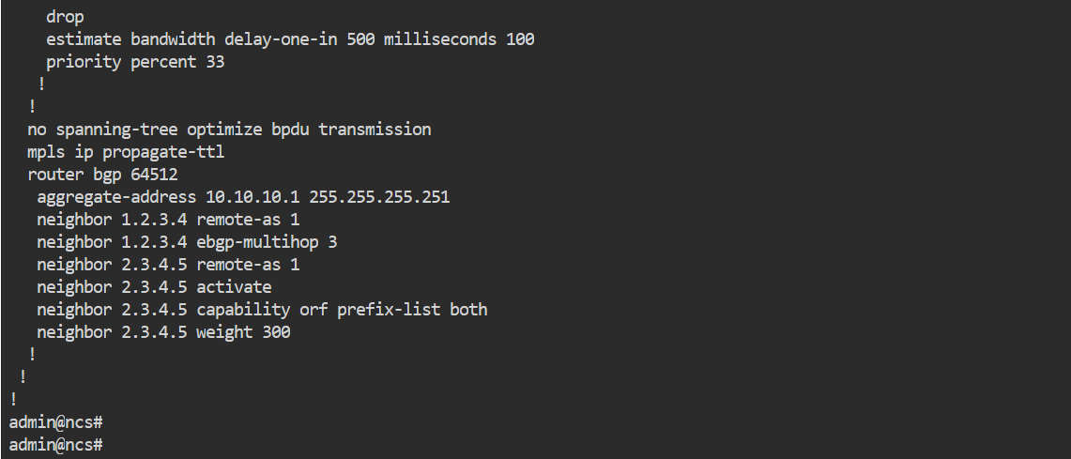

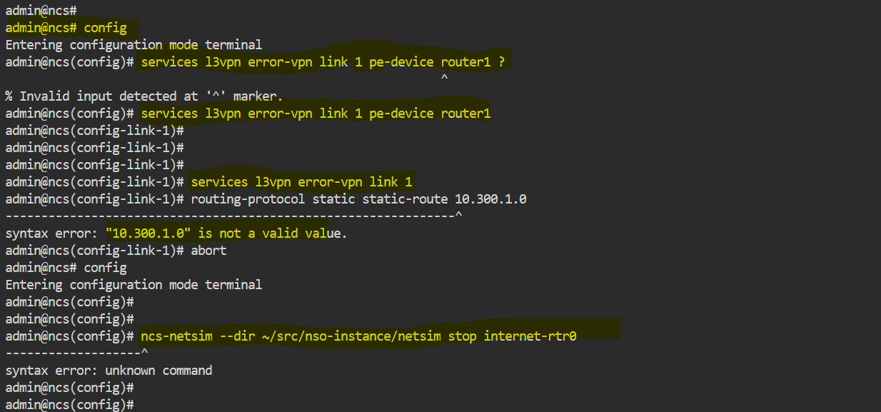

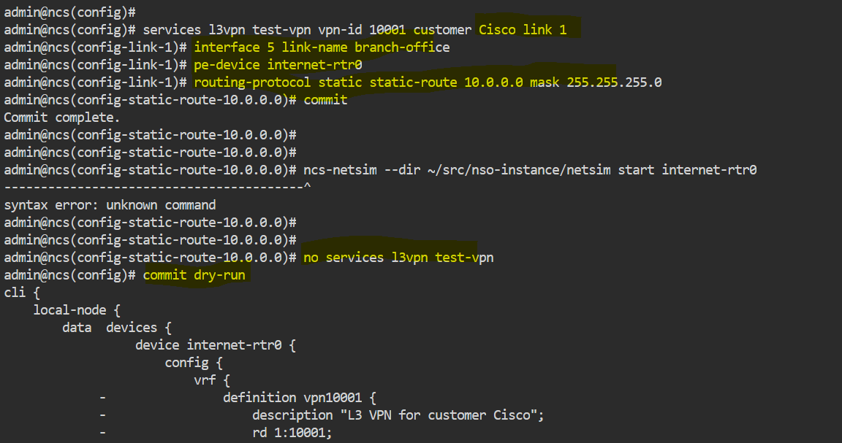
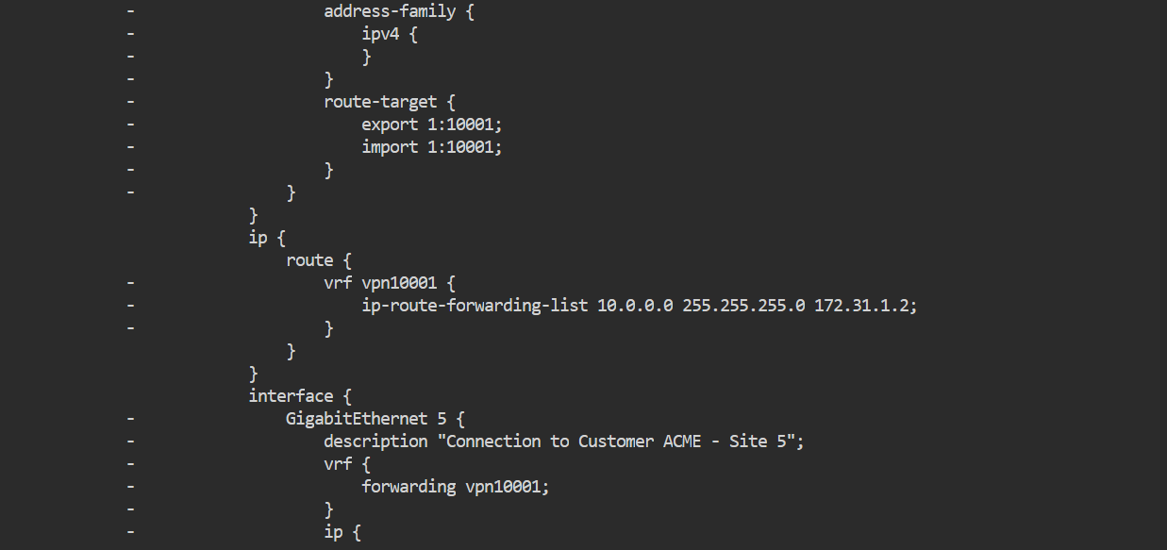
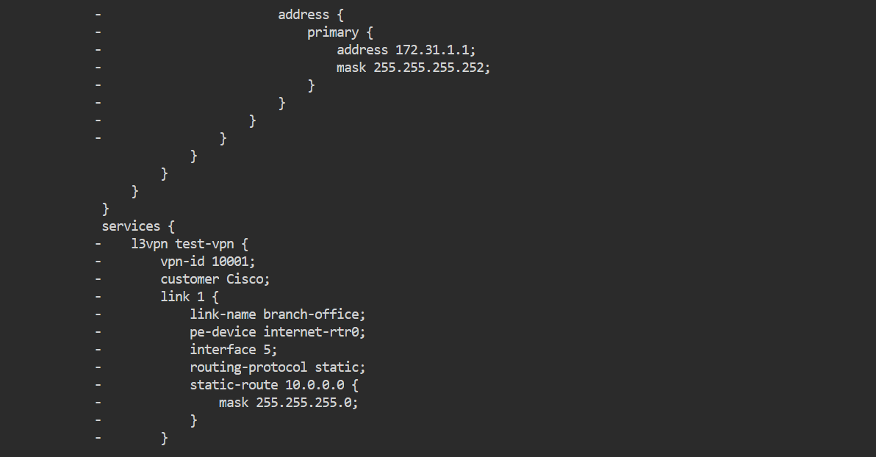
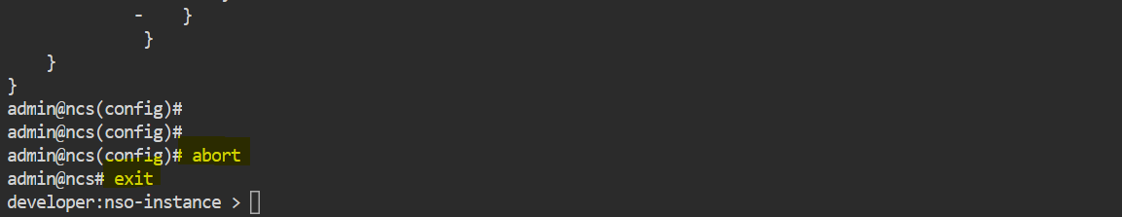
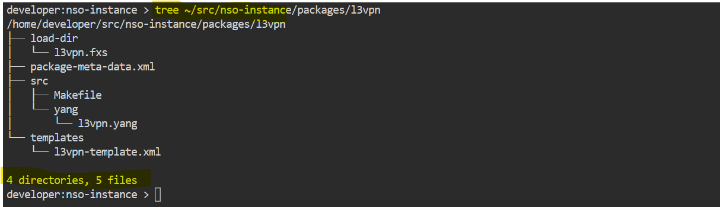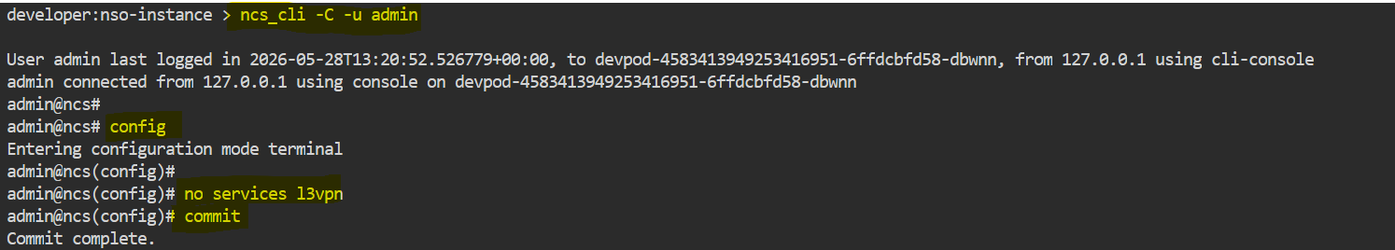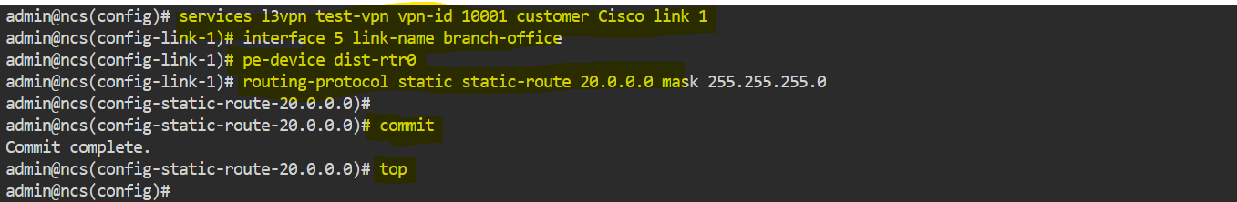

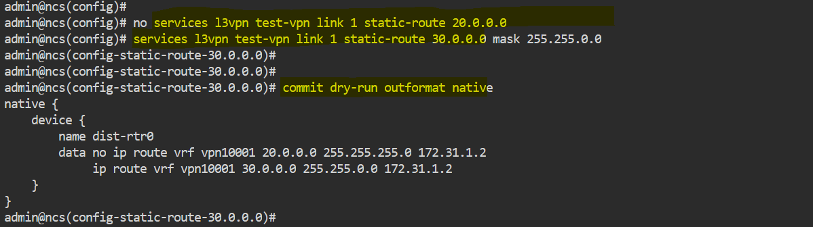

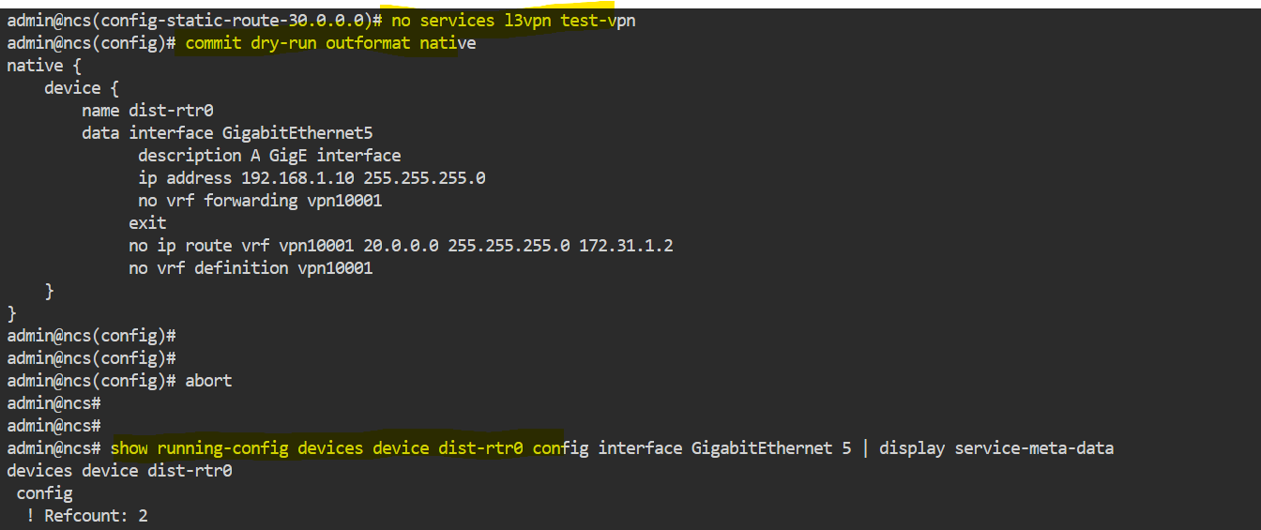

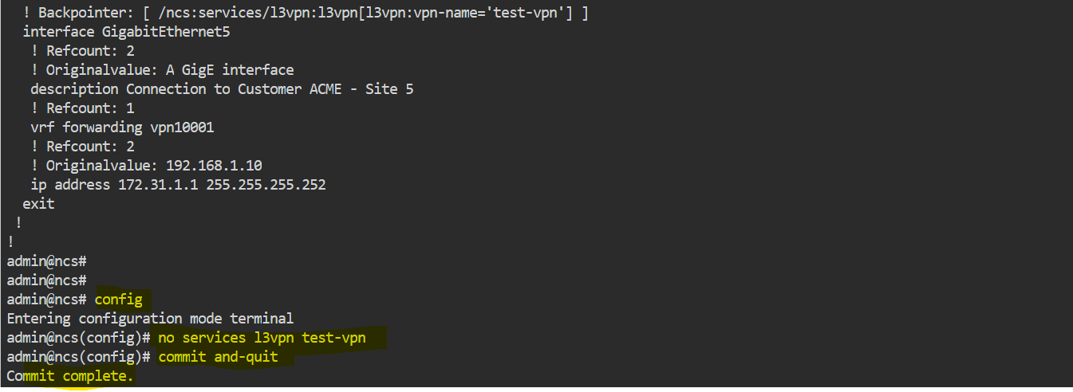

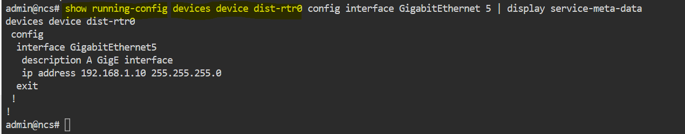

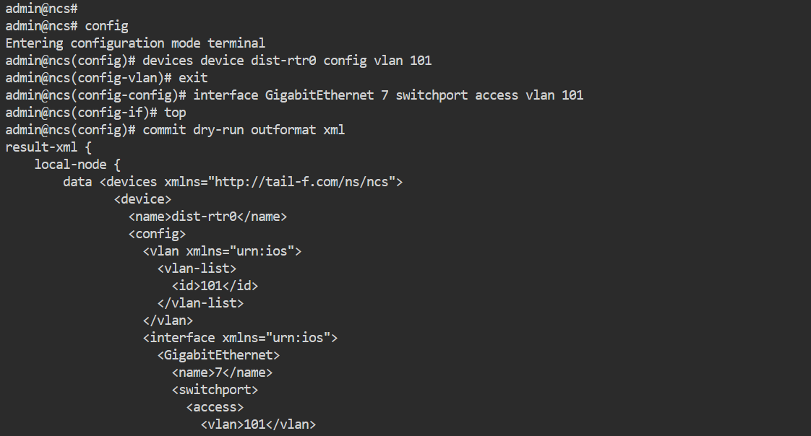

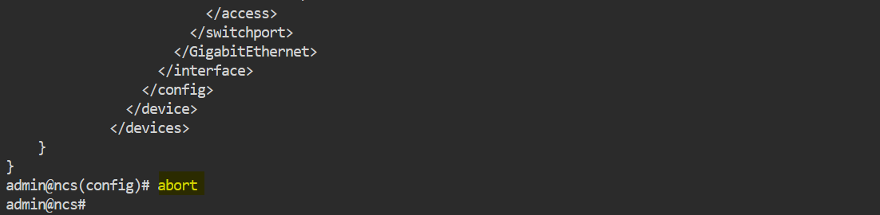

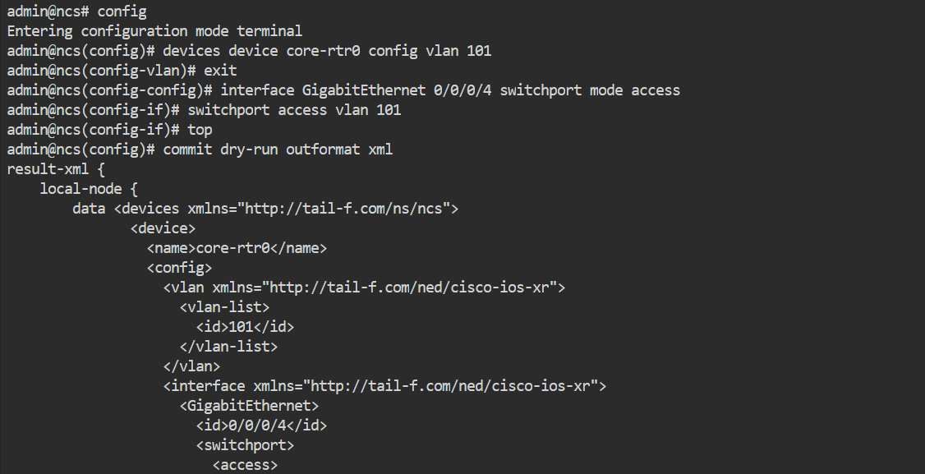
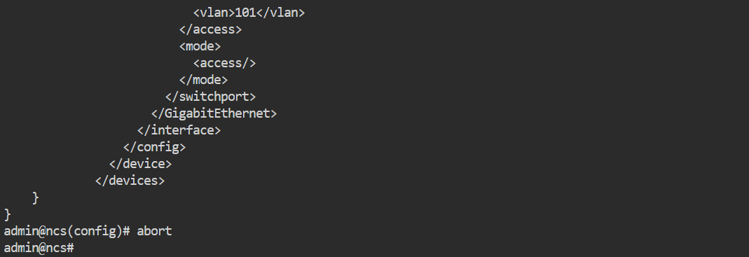

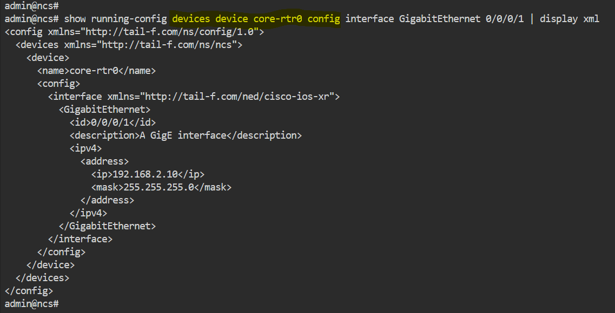

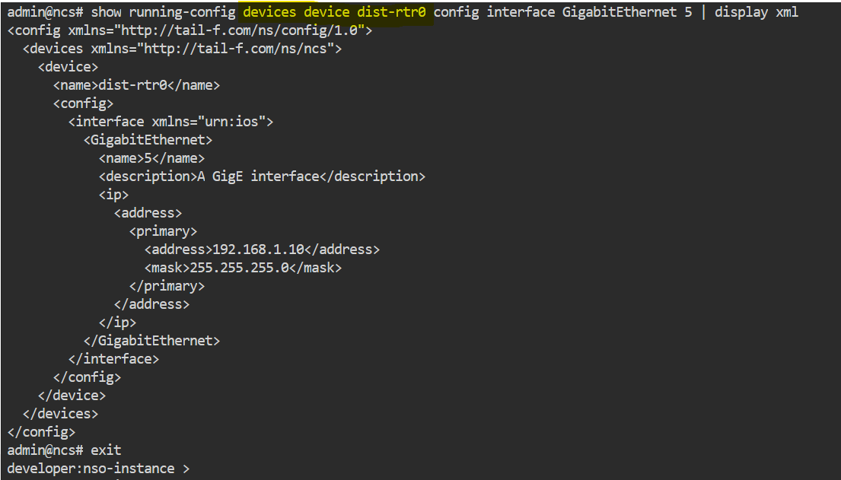
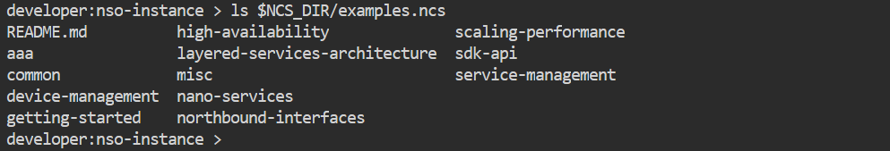
Create a Template-Based Servic
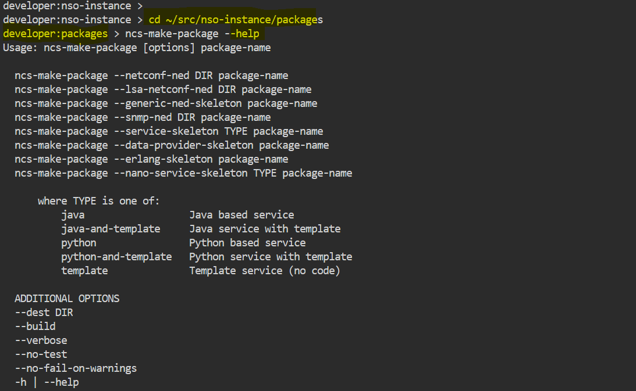
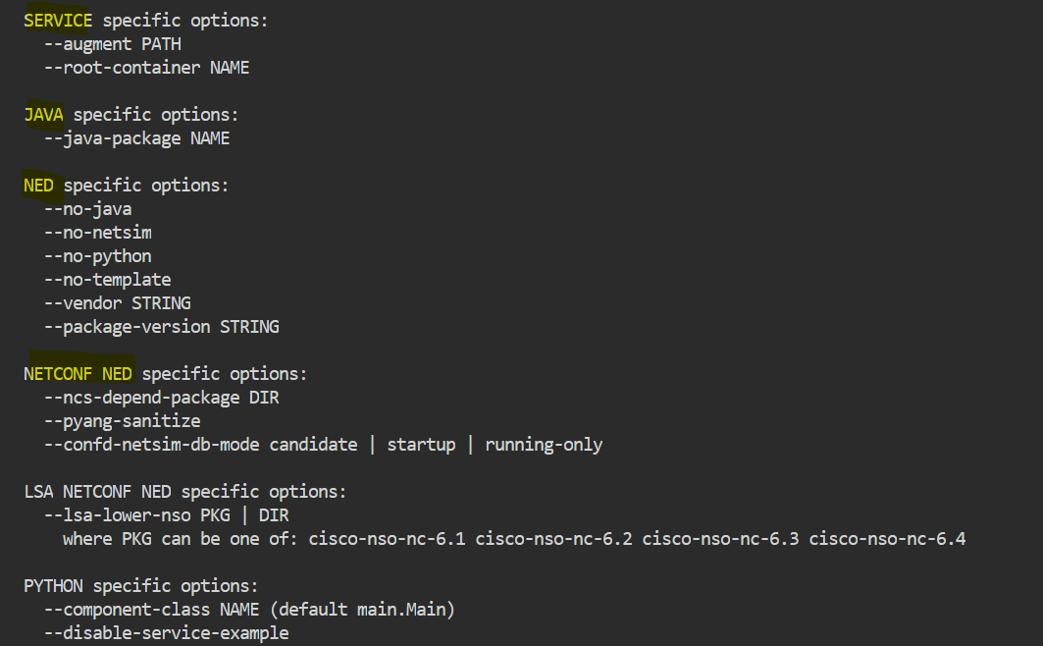
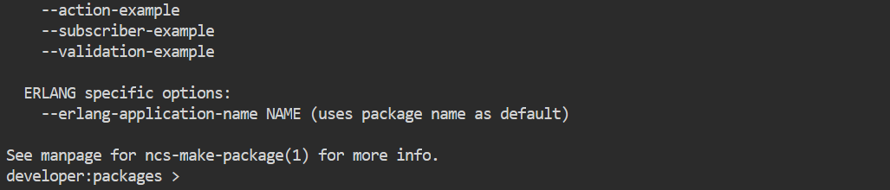

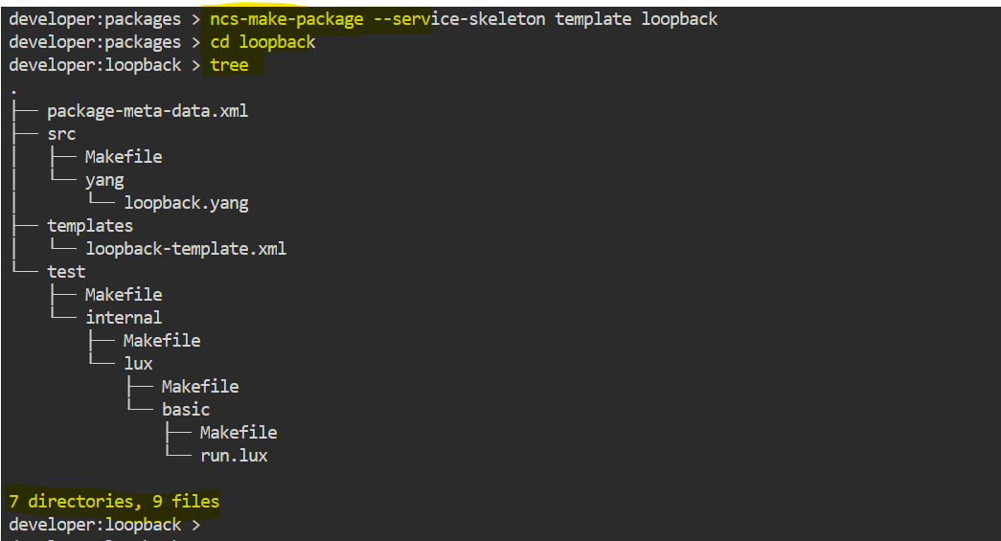

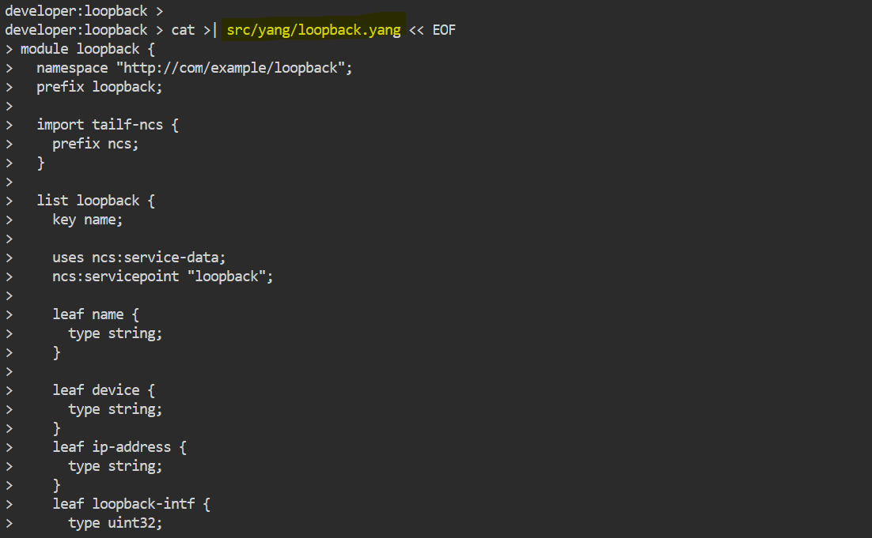
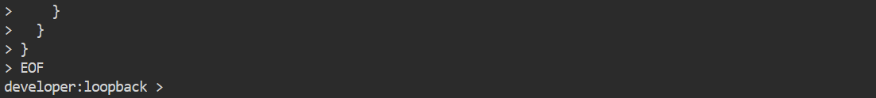

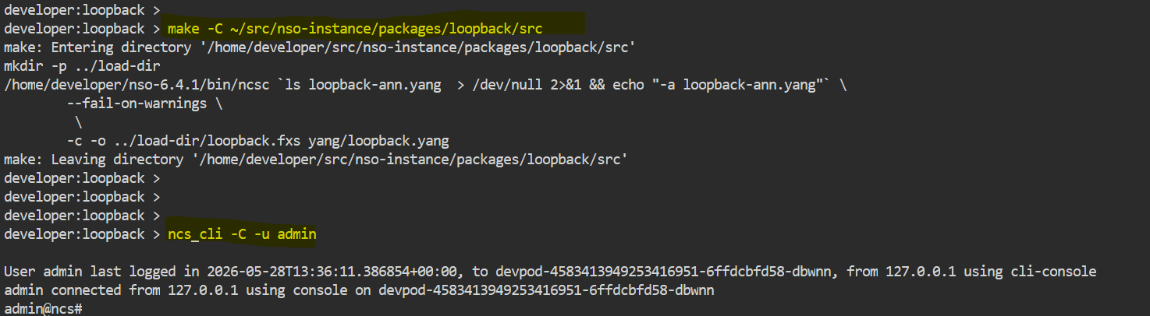

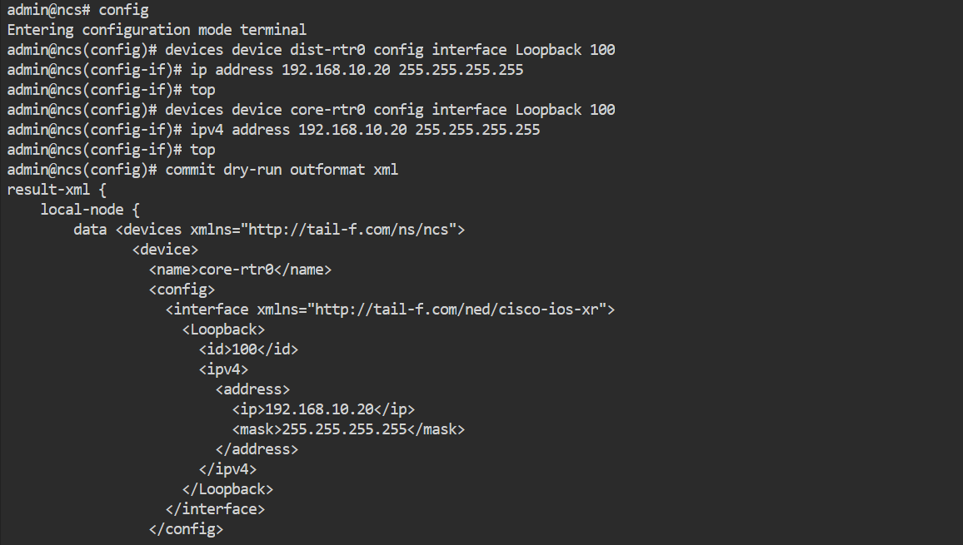
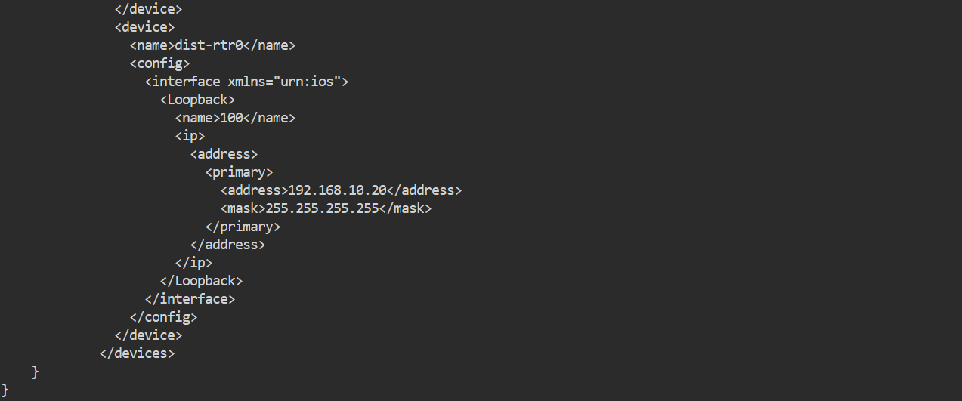

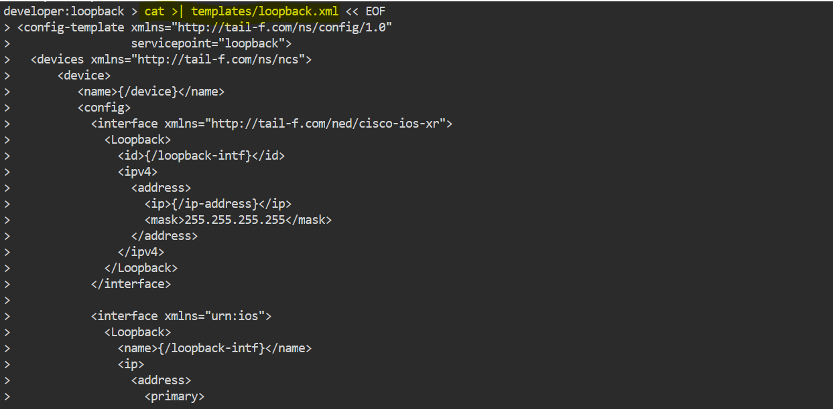
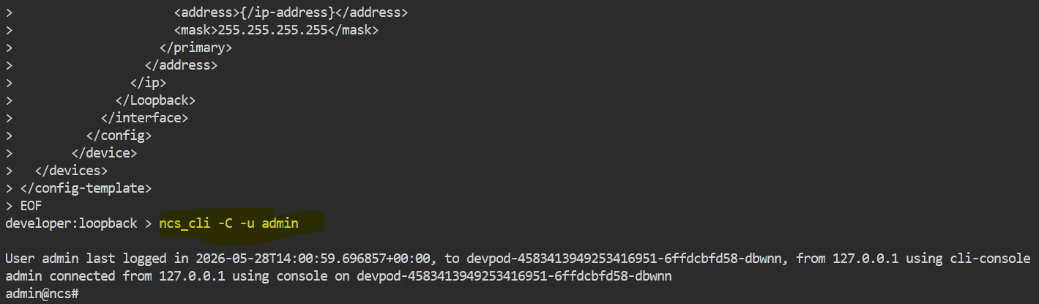

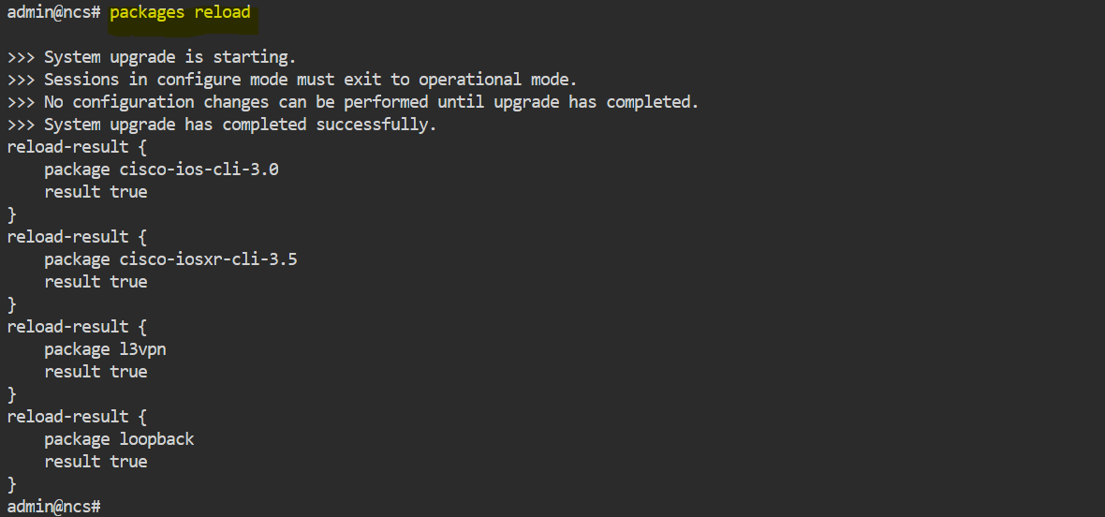

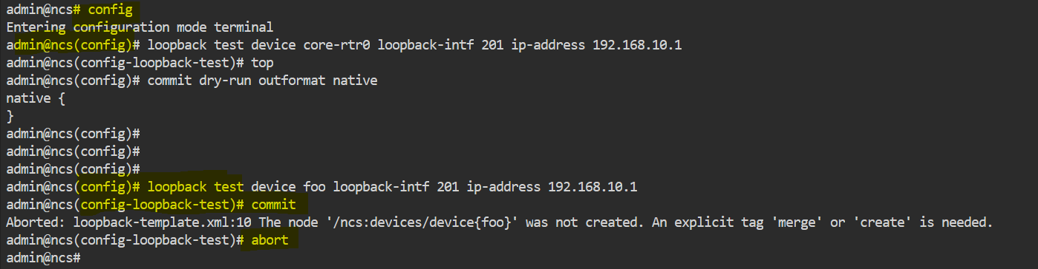

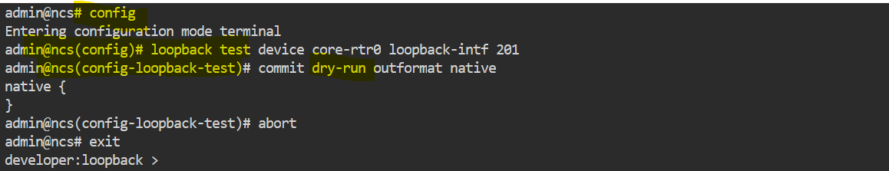

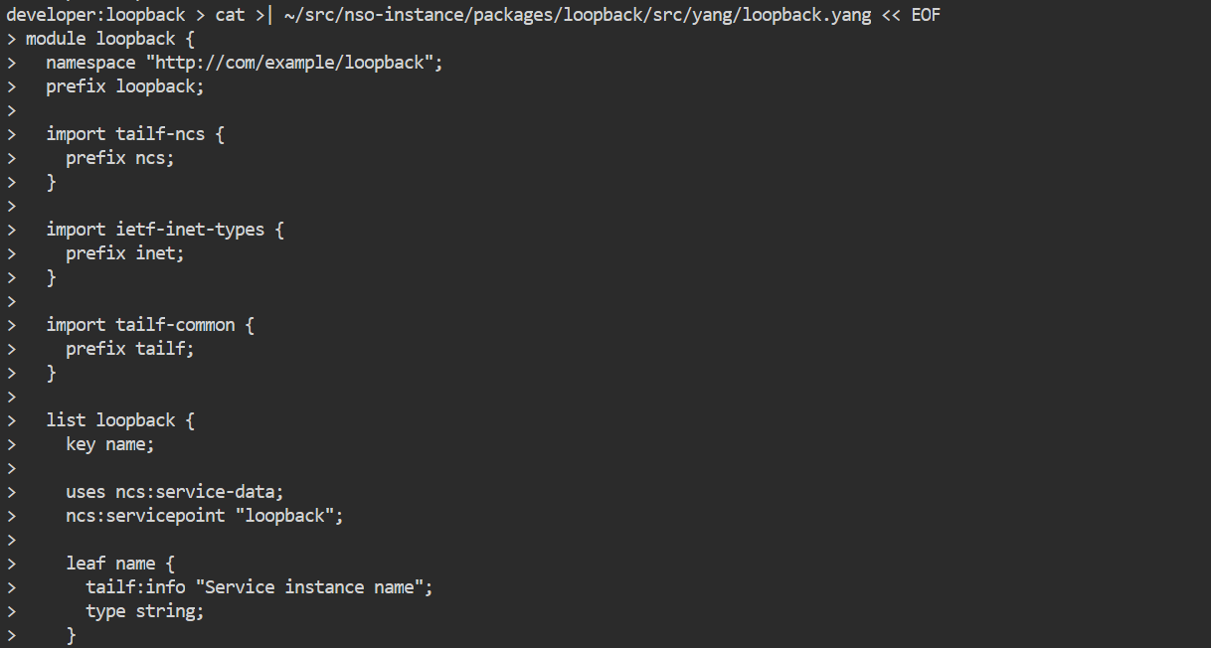
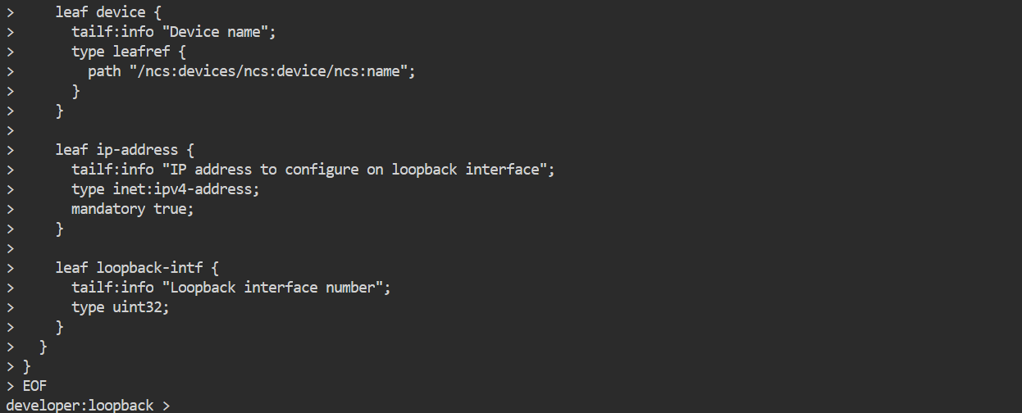

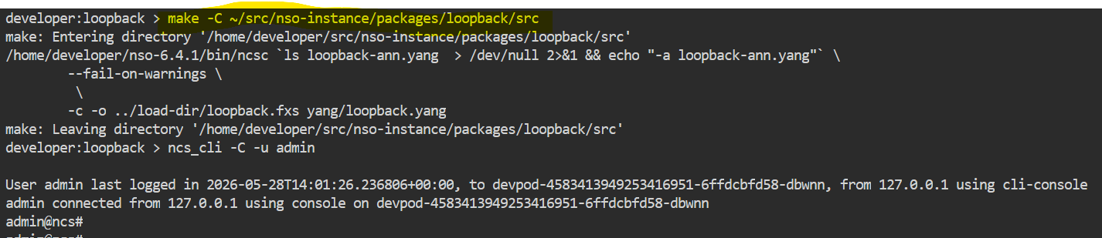

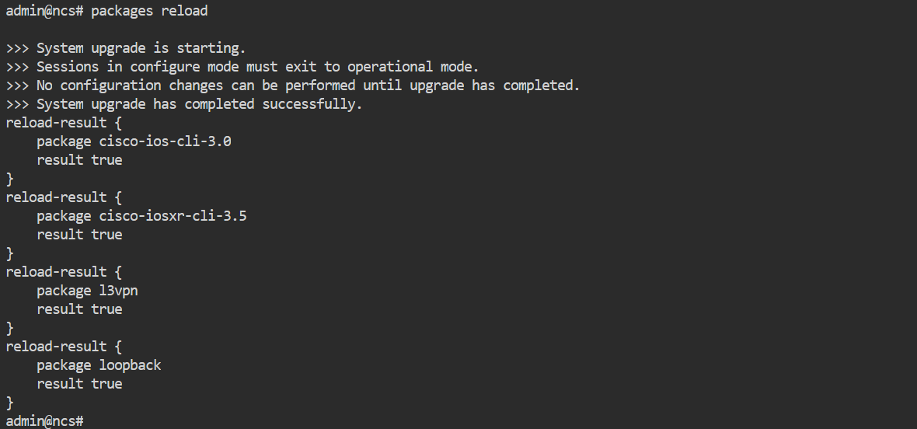

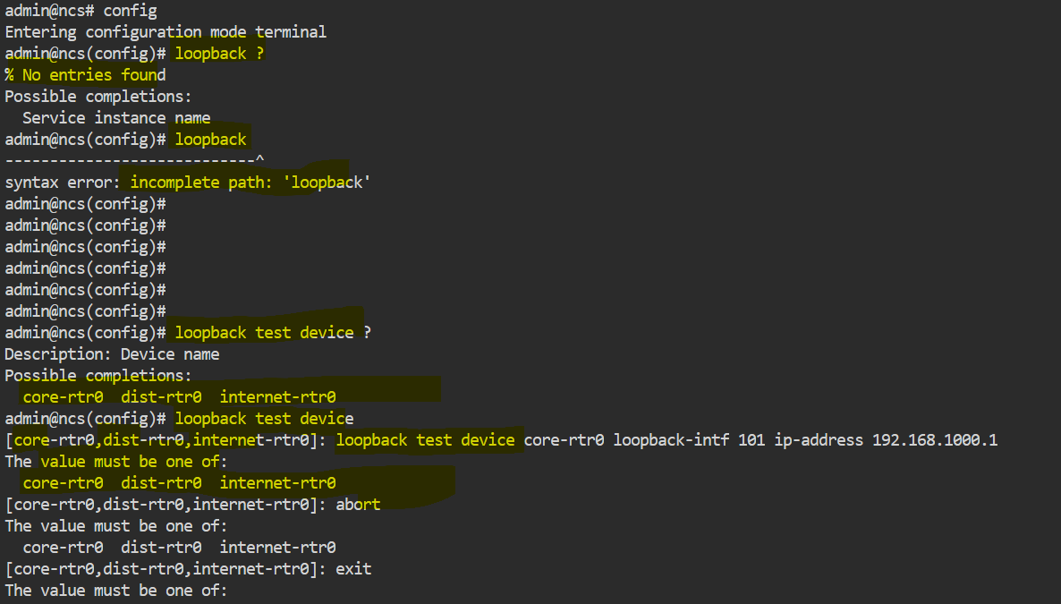
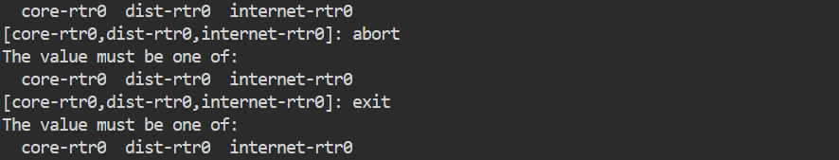

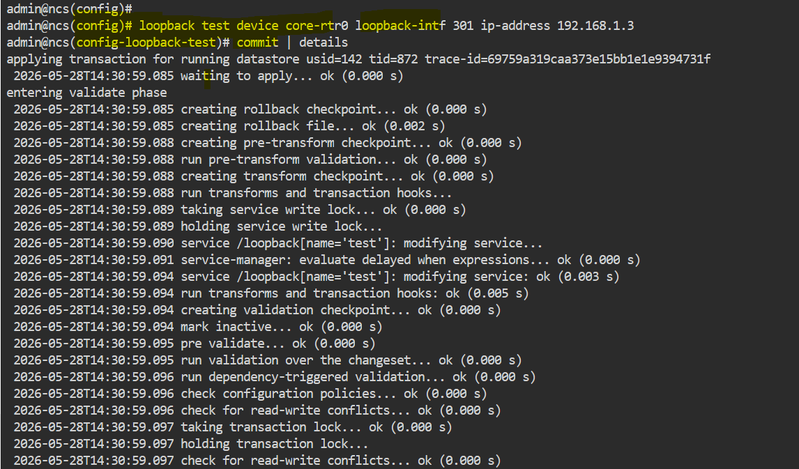
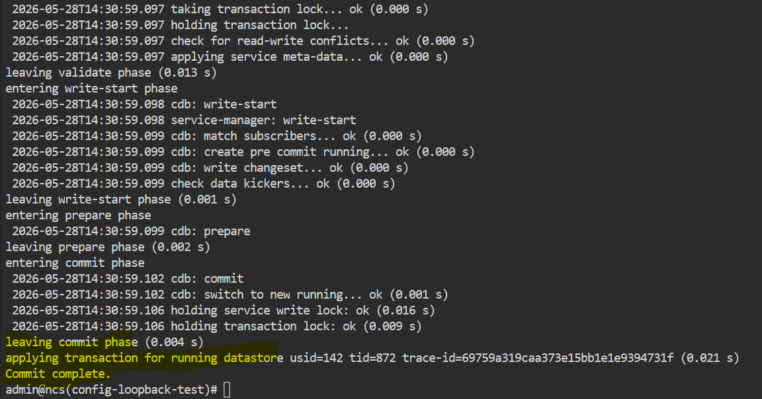
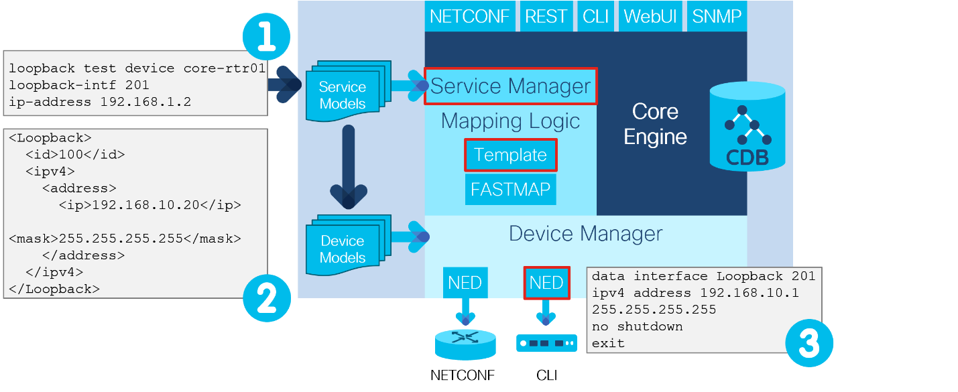
------
Types of Services
There are different types of services that are supported in NSO. They differ in how mapping logic between the YANG model and the device configuration is implemented.
- Template-based service:
  - Mapping is implemented by using XML templates.
  - Easiest and fastest to develop. Templates are the best option to start exploring NSO service development.
  - Limited options for service parameter manipulation and integrations.
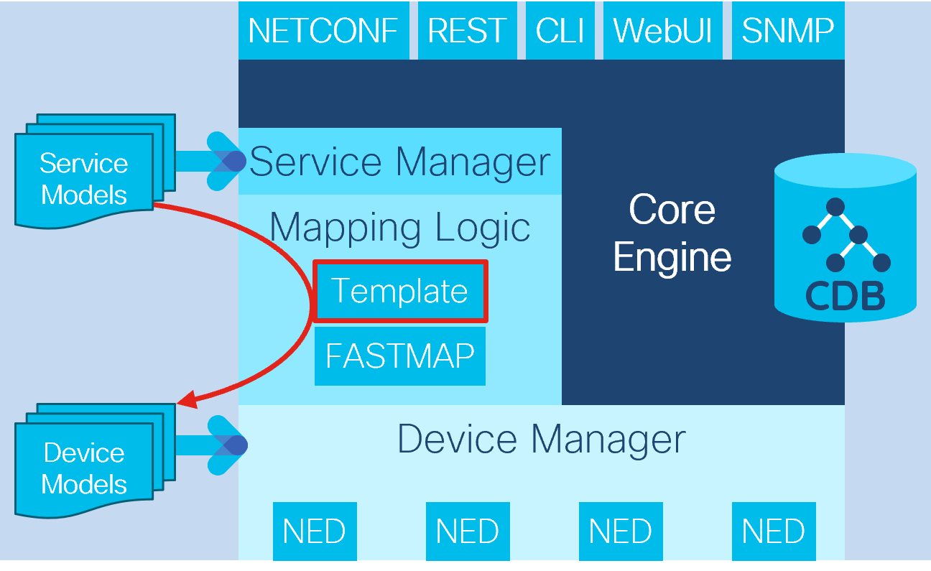
- Python- or Java-based service:
  - More options for implementation—IP address calculations, additional parameter checking
  - Integrations with external systems possible (IP Address Management [IPAM])
  - More challenging to implement mappings to the device in code
Note: Python is the preferred language of choice for NSO development, with best documentation and community support. Java is mostly used for NED development, but is fully supported for service development too.
Putting Everything Together
Talk to us
When you configure and commit a new service instance, NSO performs a series of steps to send a configuration to a device. Understanding these steps will help you when you must troubleshoot a service.
NSO creates a northbound interface directly from the service model. After you write your service YANG model and load it into NSO, it becomes available through CLI. You can also perform the same configuration of a new service instance by using RESTCONF, NETCONF, or web-based UI.
The following figure shows how a service model influences the behavior of a northbound interface.
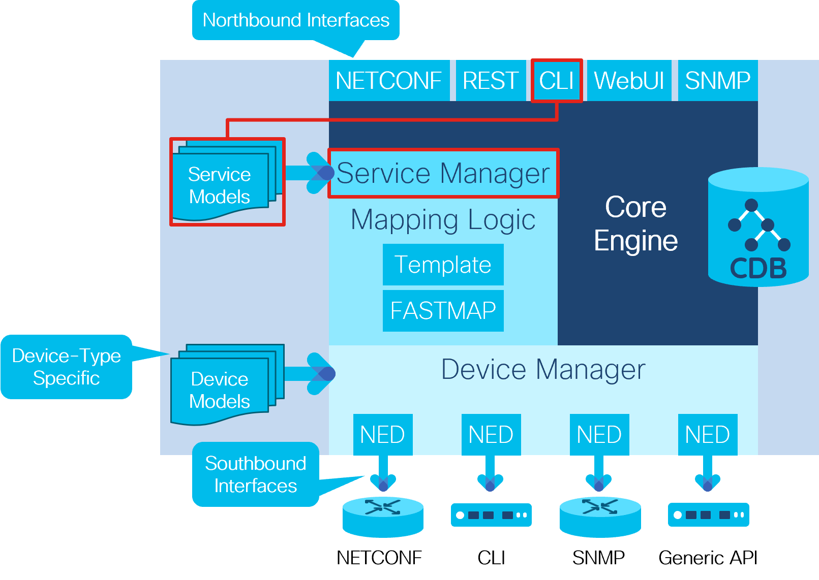
Let's see what happens during a new service instance creation.
Connect to the NSO CLI, enter the configuration mode and start configuring a new loopback service instance.
In the output, you can observe the complete flow of committing a service instance. Refer to the following figure to better understand the flow step by step:
- Service instance is configured through one of the northbound interfaces, and parameters are checked against restrictions in the YANG model.
- Device configuration is generated by mapping service parameters to device model through a template.
- NED translates this into CLI commands that are sent to the device.

Note: One common problem that can happen here is that while the resulting device configuration is syntactically correct, it can still be rejected by the device. The rejection may be due to operational limitations, such as nonexistent physical resources (interface for example) or a conflicting configuration already on the device. The commit | details command can help you troubleshoot this.
Conclusion
You have learned how to develop a simple template based service in NSO using YANG and XML. With the help of FASTMAP, you can quickly develop new NSO service, focusing only on what service must configure, leaving update and removal to NSO. This enables quick and efficient development and service management.
Congratulations! You've completed Introduction to NSO Service Development

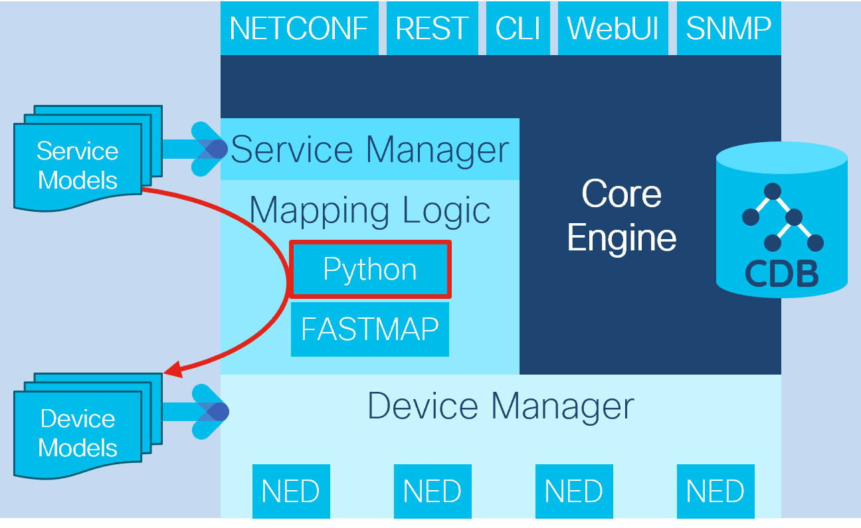
- Python, Java, and template-based service
  - Best of both approaches
  - Templates for mapping to device configurations
  - Python code for calculations and integrations
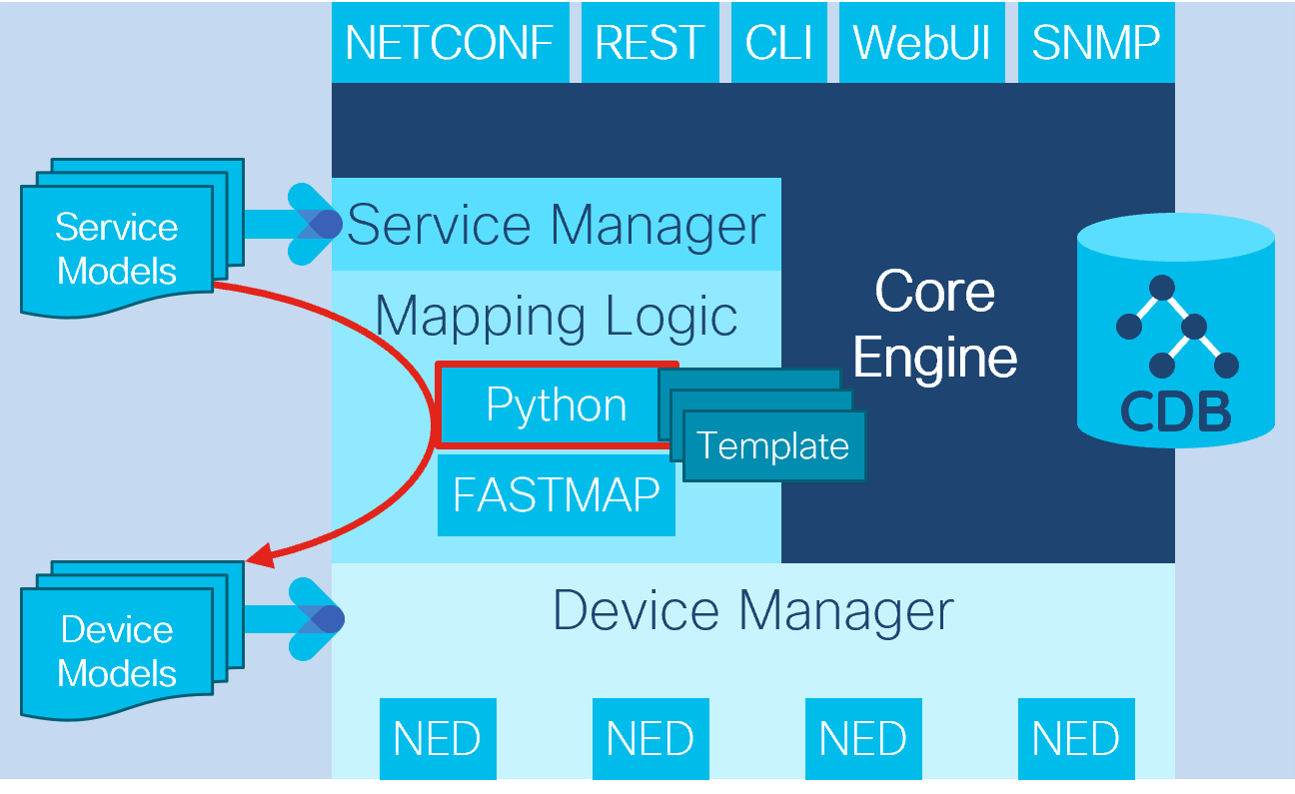
The l3vpn service that is used in the example is a template-based service. Looking into the package contents you find the YANG model and the XML template. Look into them and try to understand the connection between the YANG model and the XML template

