DEVELOPMENT NSO
Acceptance Test Procedure Document
Environment: CFS 172.28.2.17 RFS 172.28.2.18, 172.28.2.19, 172.28.2.20
LSA Deployment (CFS/RFS)
Cisco Network Services Orchestrator (NSO)
Revision History
Revision No. | Date of Submission | Description of Revision | Prepared By | Date of submission for Review | Review completed Date
1.0 | 07th Jul26 | Initial version |  | 07-07-2026

Prepared by | Reviewed By | Approved by

Table of Contents
1. Introduction 4
Deployment Details 4
2 Test Cases Summary 5
3. Access and System Health Verification 6
Test Case 1: Authenticating into the NSO Environment (Login) 6
Test Case 2: Verifying System Health and Runtime Status 7
4. Device Connectivity and Configuration Synchronization 7
Test Case 3: Validating Device Reachability and Sync from the CFS Layer 7
Test Case 4: Validating Device Reachability and Sync from the RFS Layer 9
5. Package Management 11
Test Case 5: Verifying Installed Package Status (Service Package Check) 11
Test Case 6: Package Upgrade Workflow 12

1 Introduction
This acceptance test plan documents the tests performed on the Cisco NSO (Network Services Orchestrator) platform to validate the installation, connectivity, and operational readiness of the LSA (Layered Service Architecture) deployment across the CFS (Customer Facing Service) and RFS (Resource Facing Service) layers for the T-Fiber network.
Acceptance testing included verification of user authentication and system access, platform health and runtime status, device connectivity and configuration synchronization across both the CFS and RFS layers, and the operational status of installed service packages. Additional testing was performed to validate the successful migration and recompilation of service packages from Cisco NSO 5.7.3 to Cisco NSO 6.4.11, ensuring continuity of provisioning automation across the version upgrade.
Each test case documented in this plan includes the procedure followed, the expected result, and the actual outcome, supported by relevant logs and screenshots as evidence of successful validation.

Deployment Details

Environment | 172.28.2.17 (CFS - Customer Facing Service)
RFS Node | 172.28.2.18 (RFS - Resource Facing Service)
Cluster Nodes | RFS-18, RFS-19, RFS-20
Deployment Type | LSA (Layered Service Architecture) - RFS/CFS

2 Test Cases Summary
The table below summarizes each verification step performed. Detailed procedure, expected result, and supporting evidence (screenshots) are documented against each test case.
# | Checkpoint | What It Confirms | Type | Result
1 | Authenticating into the NSO Environment (Login) | Authorized staff can securely authenticate and access the NSO/CFS server via SSH. | CLI | PASS
2 | Verifying System Health and Runtime Status | The NSO orchestration platform is running, with all required modules active and correct version/runtime details displayed. | CLI | PASS
3 | Validating Device Reachability and Sync from the CFS Layer | Registered devices (RFS-18, RFS-19, RFS-20) are reachable, connectable, and their configurations sync correctly into NSO from the CFS layer. | CLI | PASS
4 | Validating Device Reachability and Sync from the RFS Layer | Registered field devices are reachable, connectable, and their configurations sync correctly into NSO from the RFS layer. | CLI | PASS
5 | Verifying Installed Package Status (Service Package Check) | The installed NSO packages are correctly displayed along with an active operational status. | CLI | PASS
6 | Package Upgrade Workflow | Service packages are successfully updated, recompiled, reloaded, and operational on Cisco NSO 6.4.11. | CLI | PASS

3. Access and System Health Verification

These test cases are performed directly on the NSO command-line interface (CLI) and validate the platform, its connectivity, and its provisioning logic before any web-facing verification is attempted.
Test Case 1: Authenticating into the NSO Environment (Login)
Description: | Validates that an authorized user can securely authenticate and gain shell access to the NSO/CFS server via SSH, confirming that platform access controls are functioning correctly.
Procedure: | 1.Launch a terminal or SSH client.  2.Connect to the Linux server using the command:  ssh <username>@<server-ip>  3.Enter the configured password when prompted.  4.Confirm that login is successful and the shell prompt is displayed.
Expected Result: | The user should be successfully authenticated and granted access to the server without any login errors. The system should display shell prompt (admin1@cfsleader:~$) indicating successful SSH access.
Result: | ☐ OK ☐ Not OK
Logs/Snaps: (if Any) | 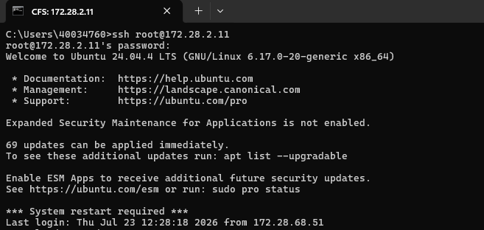  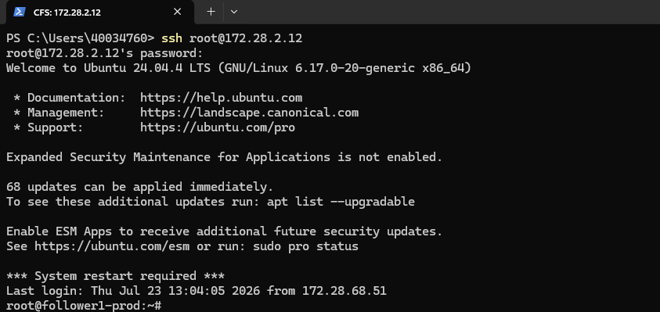  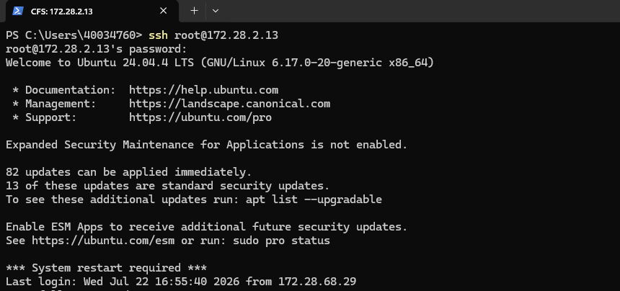  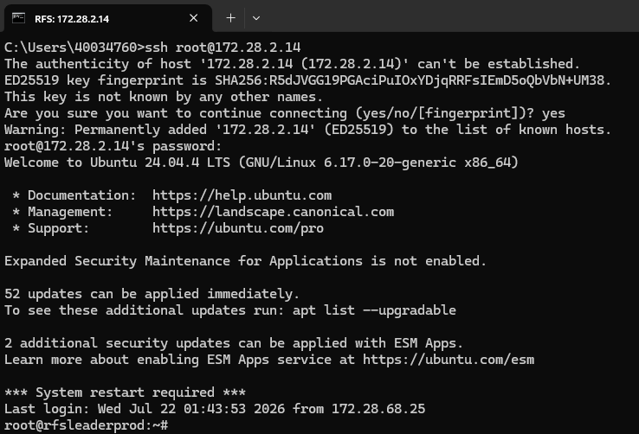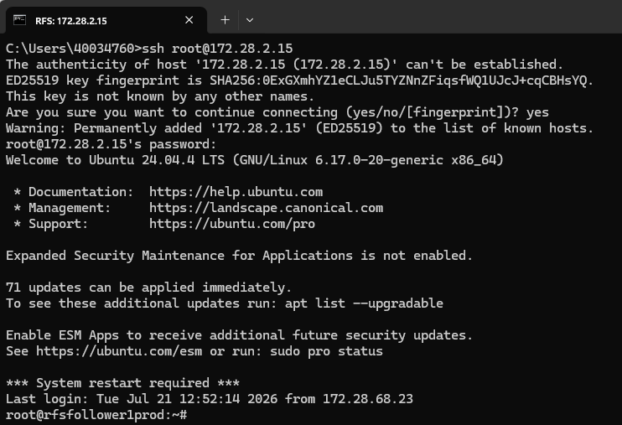  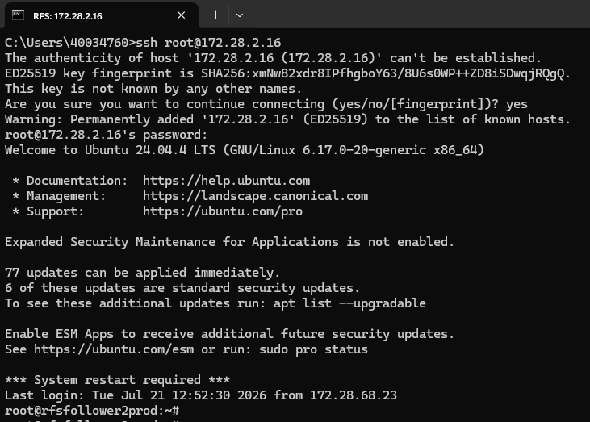  Administrator logging into the NSO CLI.

Test Case 2: Verifying System Health and Runtime Status
Description: | Validates that the Cisco NSO orchestration engine is running correctly by confirming key runtime parameters including NSO version, daemon PID, active modules, configuration file location, installation directory, and runtime directory are all reported without error.
Procedure: | 1. Access the Linux shell/CLI.  2. Execute the command: ncs --status.  3. Review the output for NSO version, daemon state, running modules, process ID, configuration file, installation directory, and runtime directory.  4. Confirm that the NSO status is displayed as started and all required modules are running.
Expected Result: | The command should successfully display the NSO runtime details. The NSO status should be started, the daemon process should be running with a valid PID, the configured modules (backplane, netconf, cdb, cli, snmp, webui) should be active, and the NSO version information should be displayed without errors.
Result: | ☐ OK ☐ Not OK
Logs/Snaps: (if Any) | 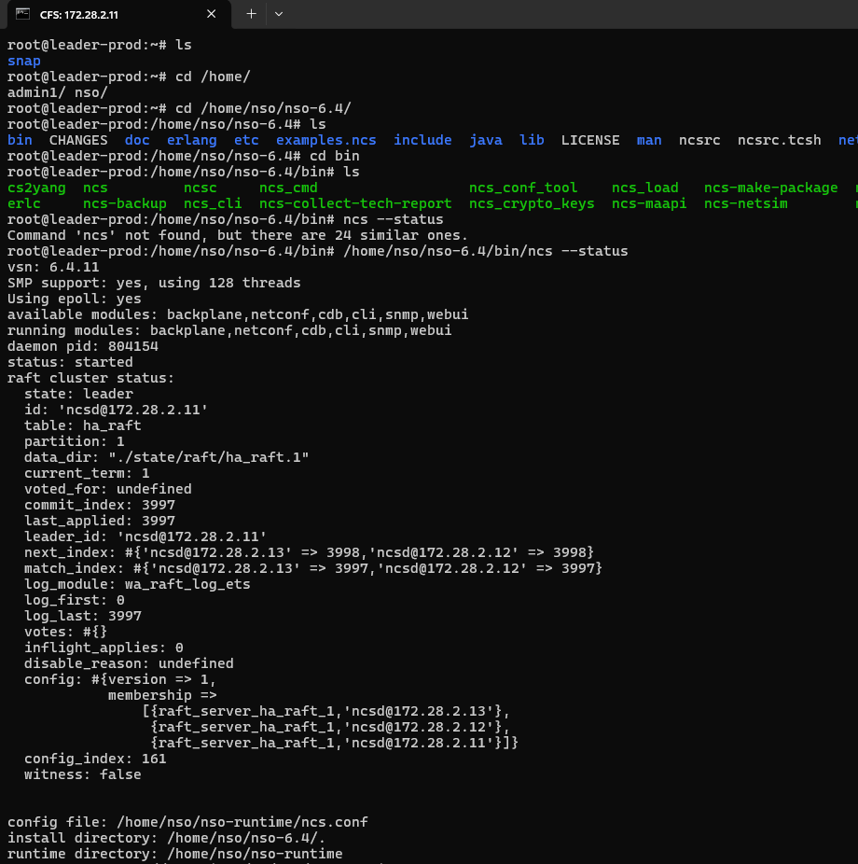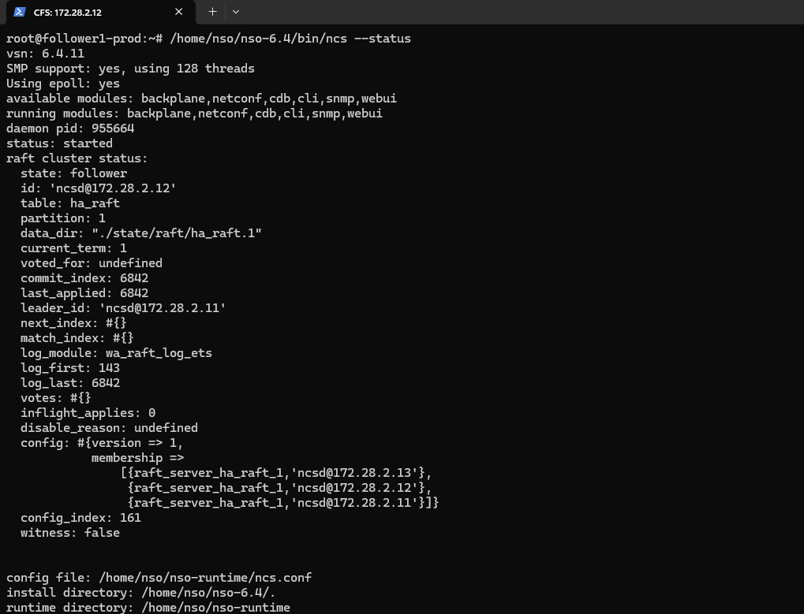  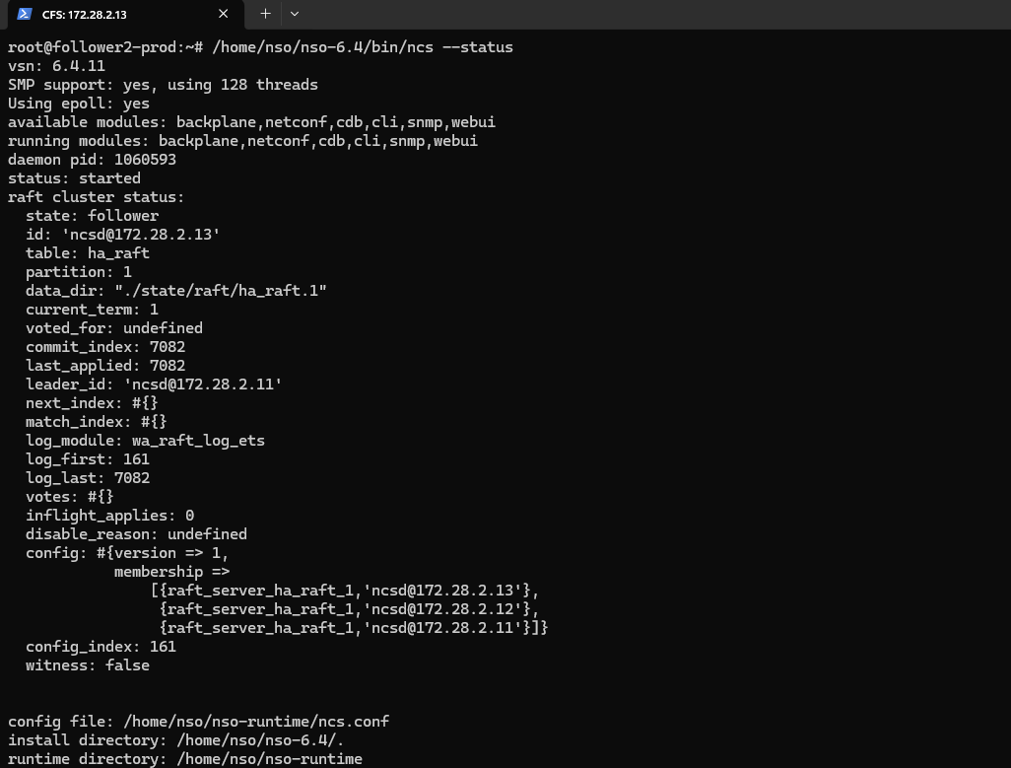  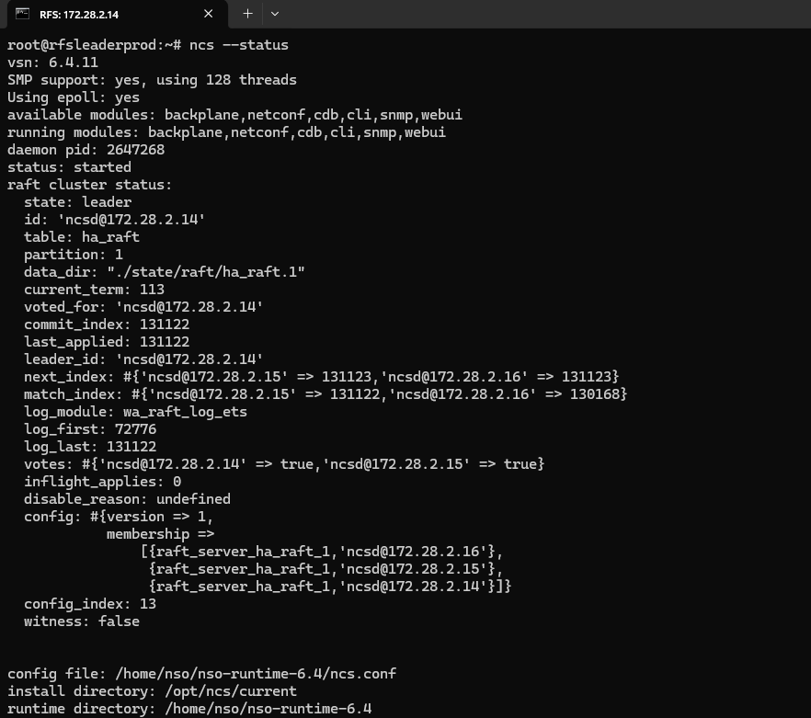  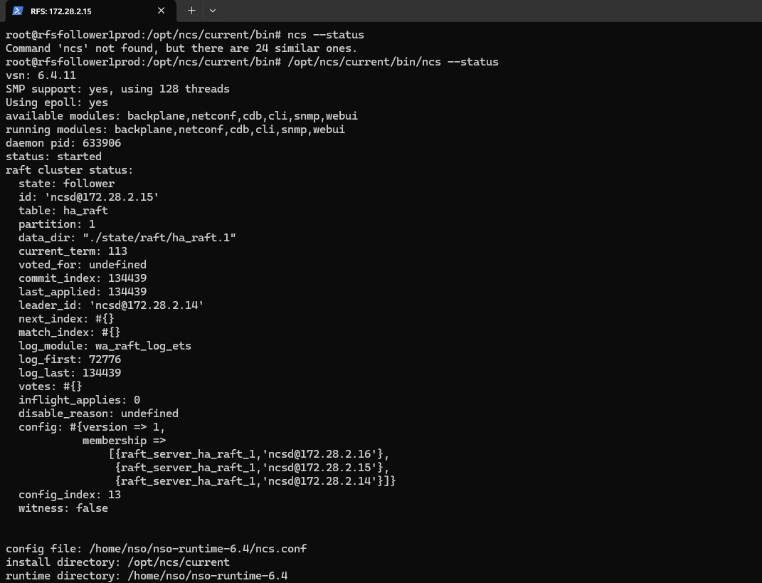  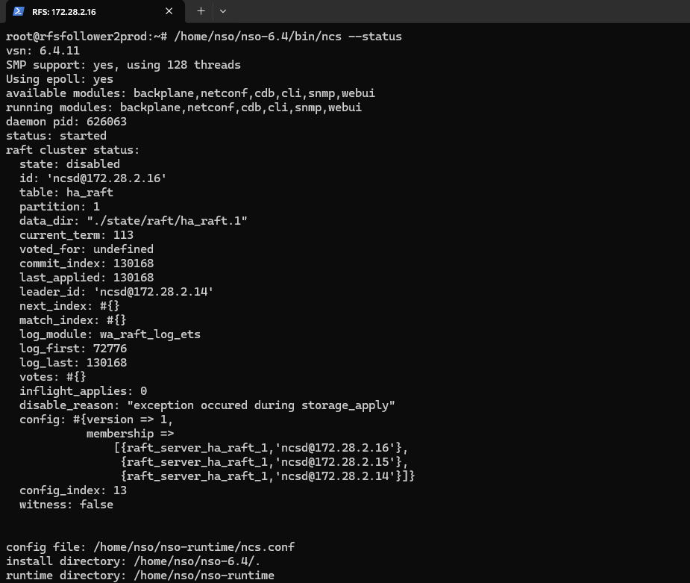  NSO status check confirming the platform is running.

4. Device Connectivity and Configuration Synchronization
Test Case 3: Validating Device Reachability and Sync from the CFS
Description: | Verifying end-to-end device handling in Cisco NSO from the CFS system listing registered devices, verifying connectivity, and synchronizing configurations.
Procedure: | 1.Run show devices list to confirm devices (RFS-18, RFS-19, RFS-20) are registered and unlocked.  2.Execute devices device <name> connect for each device to validate reachability and establish a session.  3.Perform devices sync-from to pull the live configuration from all connected devices into NSO.
Expected Result: | Devices appear in the list with correct addresses and NED IDs.  Each connection attempt returns result true with confirmation of successful connectivity.  Synchronization completes with results true for all devices, ensuring NSO’s internal state matches the actual device configurations.
Result: | ☐ OK ☐ Not OK
Logs/Snaps: (if Any) | Show devices list from CFS  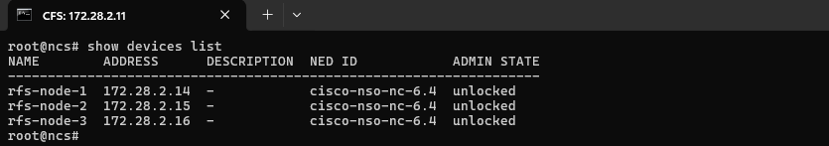  devices device RFS-18,19,20 connect from CFS  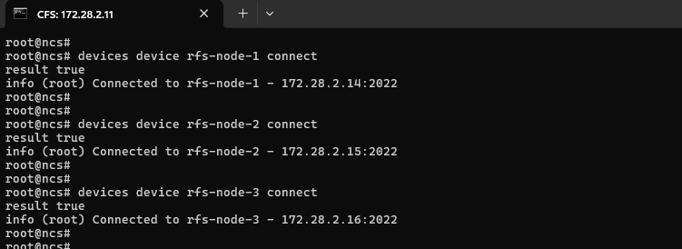devices sync-from from CFS  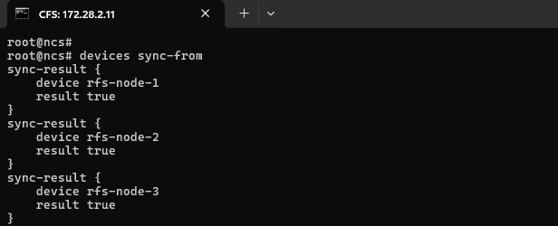  Show devices list from CFS  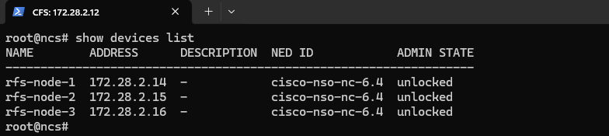  devices device RFS-18,19,20 connect from CFS  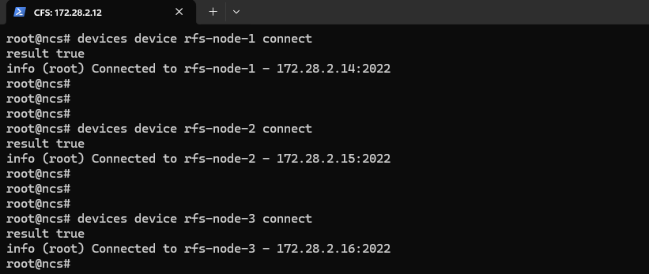  devices sync-from from CFS  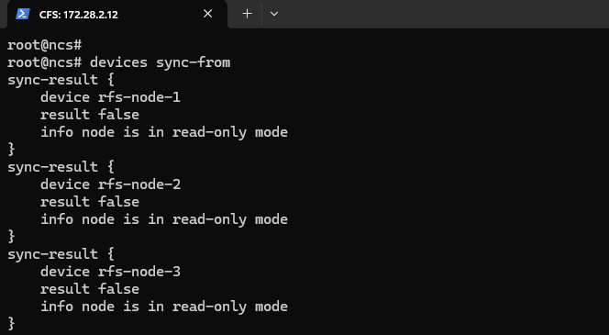  Show devices list from CFS  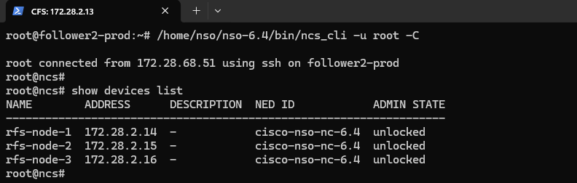  devices device RFS-18,19,20 connect from CFS  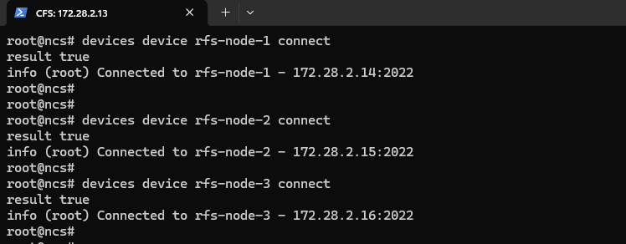  devices sync-from from CFS  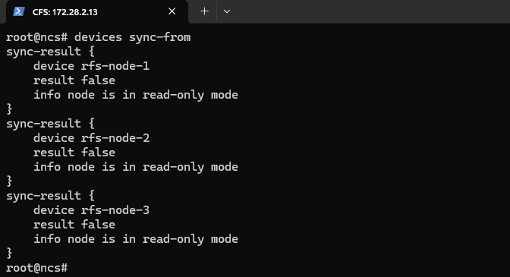

Test Case 4: Validating Device Reachability and Sync from the RFS
Description: | Validating device connectivity and configuration synchronization in Cisco NSO from the RFS system. This ensures that registered devices can be reached, connected, and their live configurations synchronized into NSO’s internal database.
Procedure: | 1.Run show devices list to confirm devices (NOCTESTGAC001, NOCTESTGAC002, NOCTESTMAR001, SECURASOGPRO001, nokia-ams-pkga, tejas-ems-pkga) are registered and unlocked.  2.Execute devices device <name> connect for each device to validate reachability and establish a session.  Example: devices device NOCTESTGAC001 connect  3.Perform devices device <name> sync-from to pull the live configuration from each connected device into NSO.  Example: devices device NOCTESTGAC001 sync-from  4.Repeat steps 2–3 for all listed devices.
Expected Result: | 1.Devices appear in the list with correct addresses, NED IDs, and admin states set to unlocked.  2.Each connection attempt returns result true with confirmation of successful connectivity (e.g., “Connected to NOCTESTGAC001 - 172.17.128.1:22”).  3.Synchronization completes with result true for all devices, ensuring NSO’s internal state matches the actual device configurations.
Result: | ☐ OK ☐ Not OK
Logs/Snaps: (if Any) | Show devices list from CFS  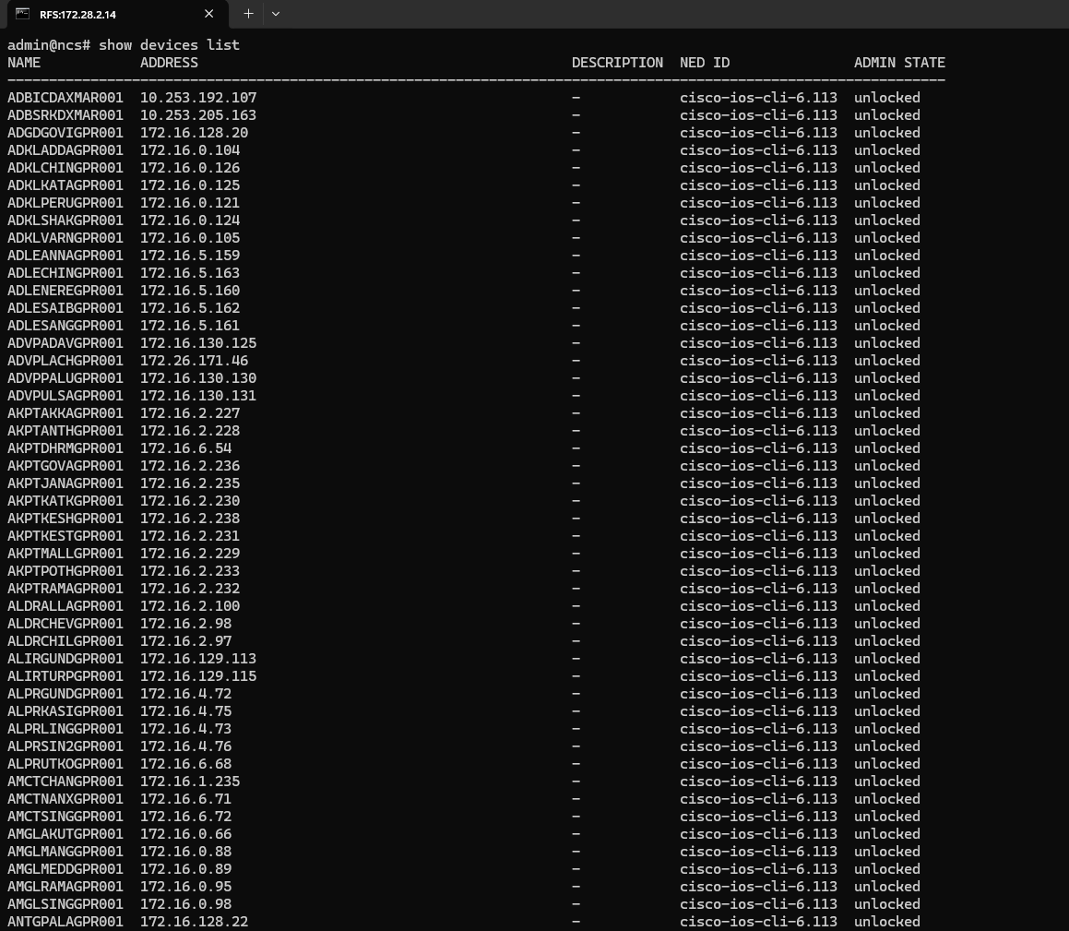devices device RFS-18,19,20 connect from CFS  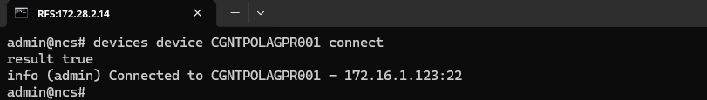  devices sync-from from CFS  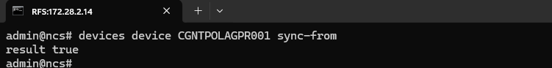  Show devices list from CFS  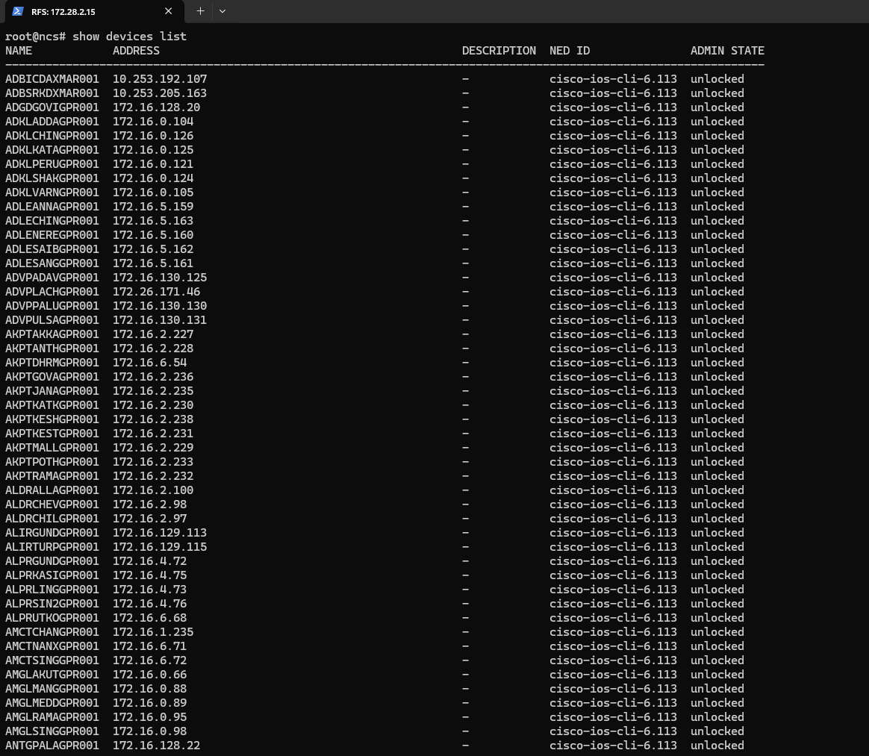  devices sync-from from CFS  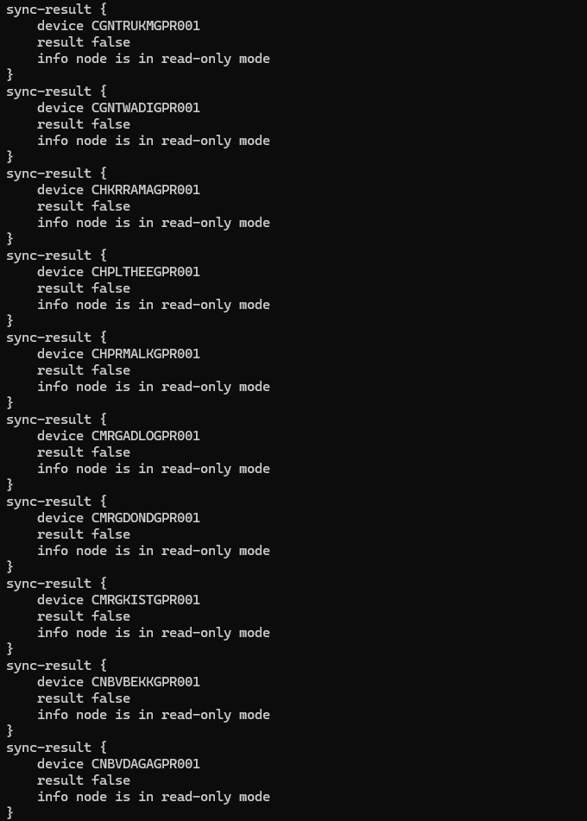  Show devices list from CFS  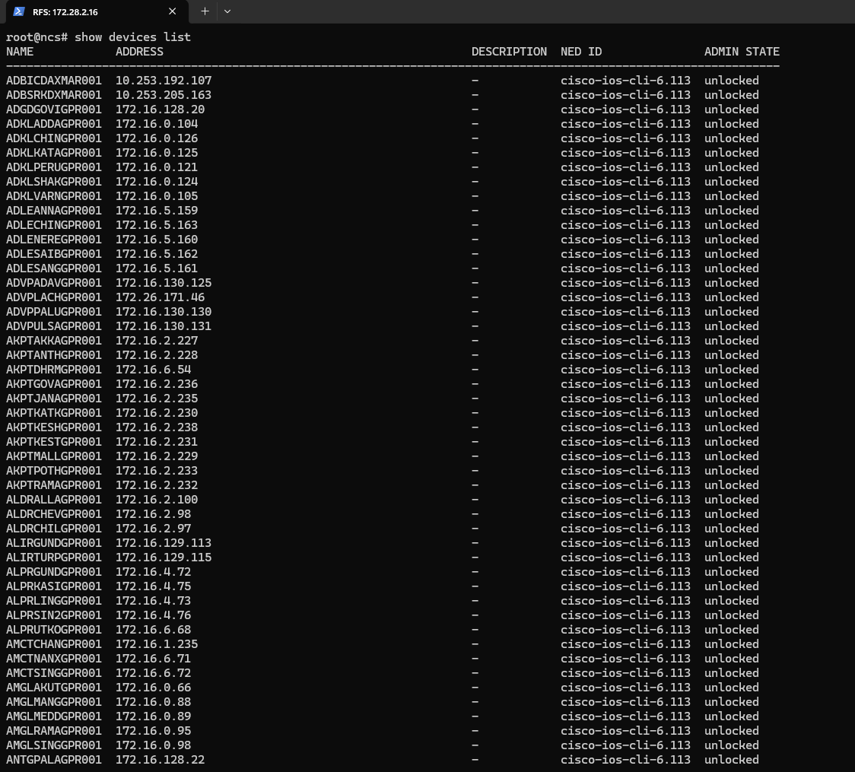  devices sync-from from CFS  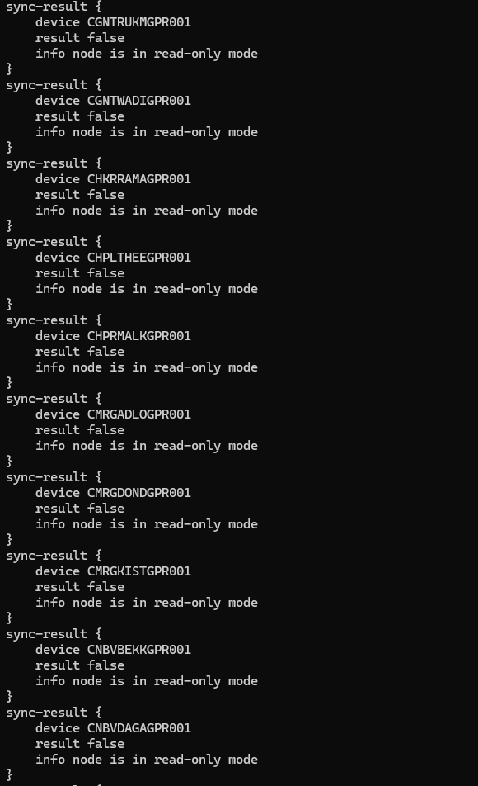  Device connectivity list confirming reachable network devices.

5. Package Management
Test Case 5: Verifying Installed Package Status (Service Package Check)
Description: | Verify that the installed NSO packages are displayed along with their operational status
Procedure: | Execute the command: show packages package oper-status  - Review the list of installed packages displayed in the output.  - Verify the package names and their operational status.  - Confirm that the package operational status information is displayed for all listed packages.
Expected Result: | The command should display the list of installed packages along with their operational status information.
Result: | ☐ OK ☐ Not OK
Logs/Snaps: (if Any) | 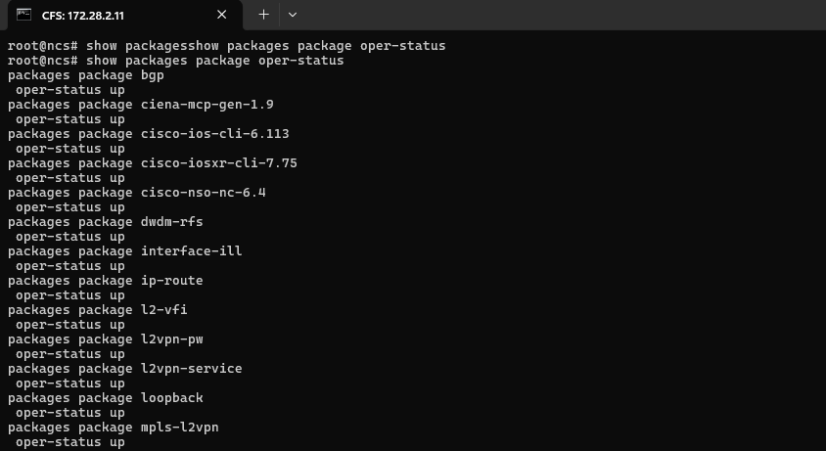  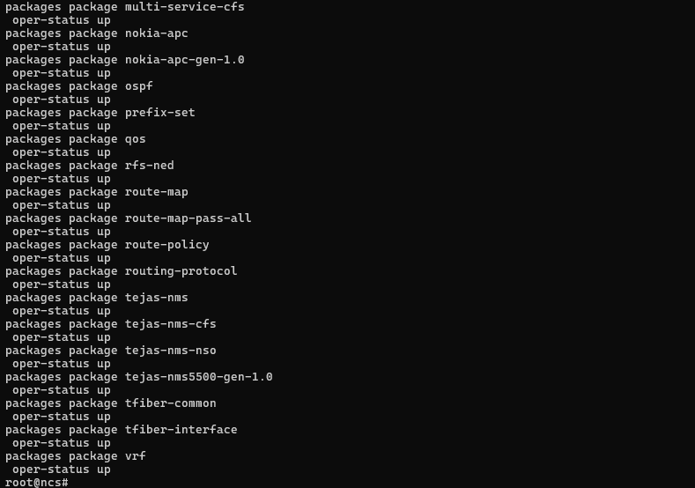  2  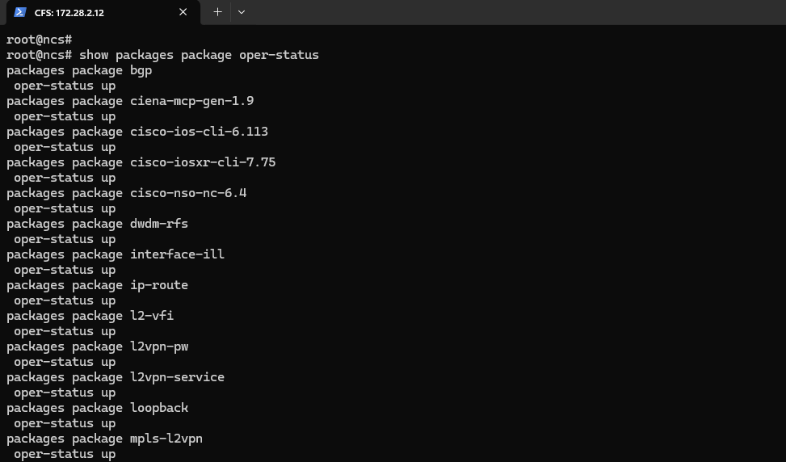  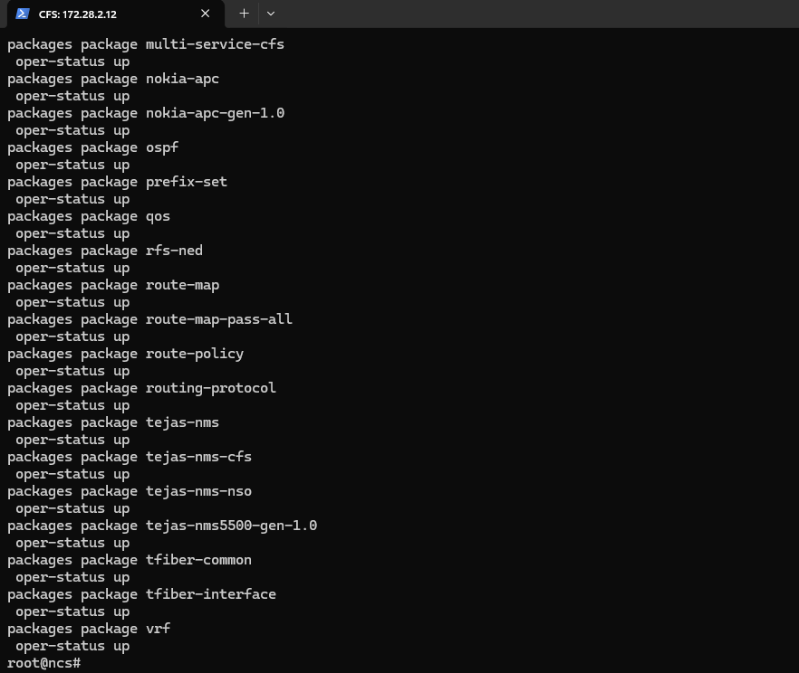  3  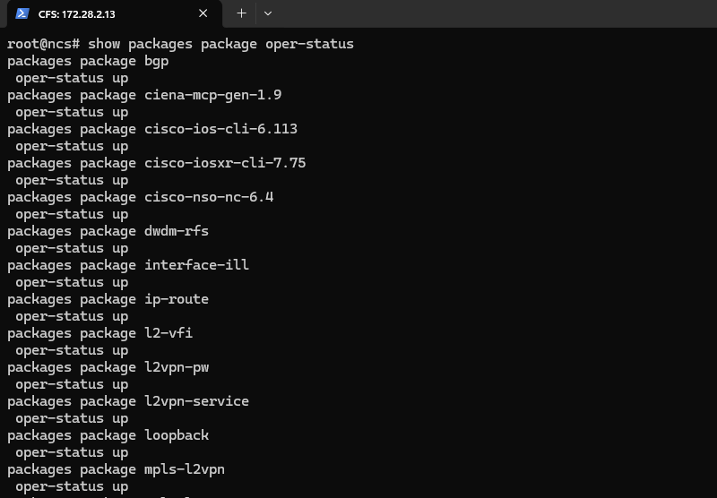  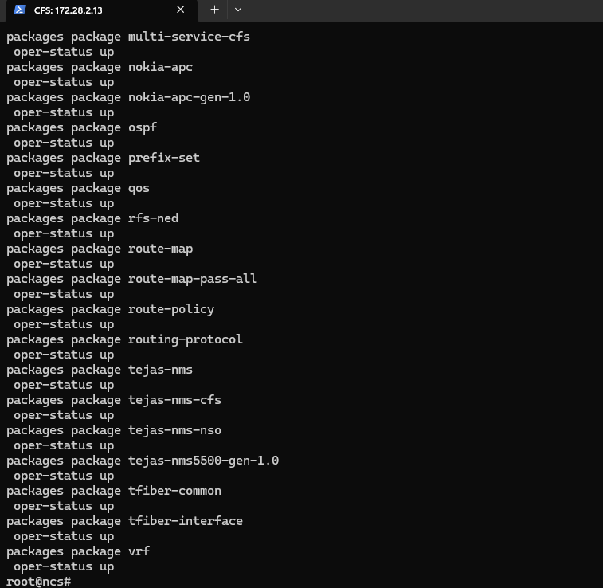  4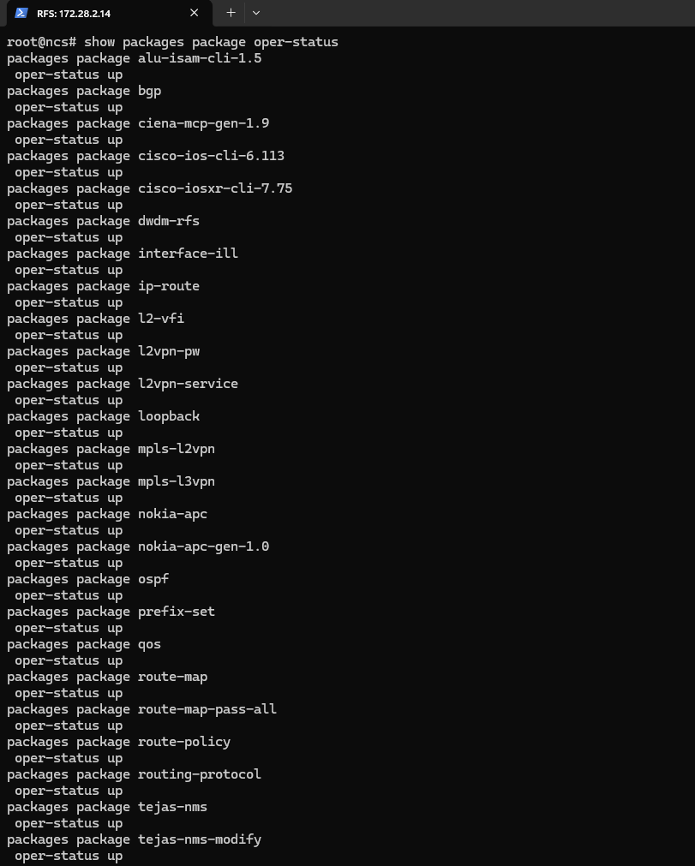  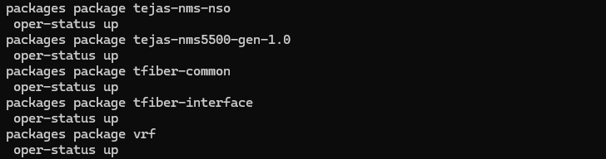  5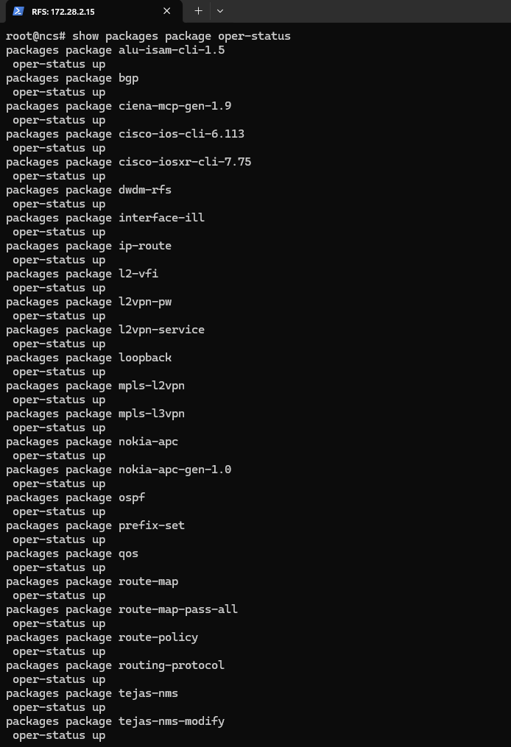  6  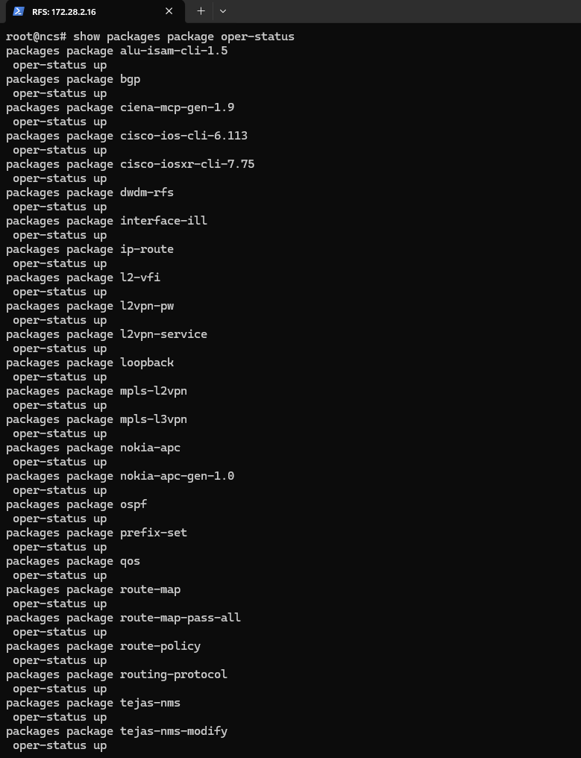  Service package operational status — confirmed active.

Test Case 6: Package Upgrade Workflow
Description: | Verify that service packages are successfully updated, recompiled, reloaded, and operational on Cisco NSO 6.4.11.
Procedure: | Procedure:  - Navigate to the NSO packages directory:  - cd /home/nso/nso-runtime-6.4/packages  - Verify that all required package directories are present:  - ls -ltr  - Navigate to the BGP package source directory:  - cd bgp/src  - Rebuild the package:  - make clean all  - Login to the NSO CLI:  - ncs_cli -u admin -C  - Reload all packages:  - packages reload  - Verify package operational status:  - show packages package oper-status  - Verify that the migrated packages display an operational status of up.
Expected Result: | - Package source code compiles successfully.  - Package reload completes successfully.  - Migrated packages are loaded into NSO.  - Package operational status is displayed as up.  - No compilation or loading errors are observed for the validated packages.
Result: | ☐ OK ☐ Not OK
Logs/Snaps: (if Any) | Package directory listing (ls -ltr)  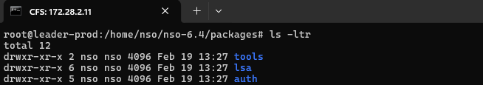  2  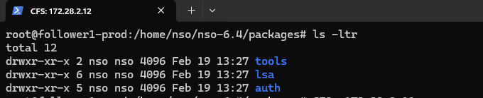  3  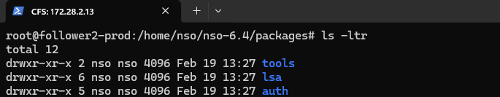  4  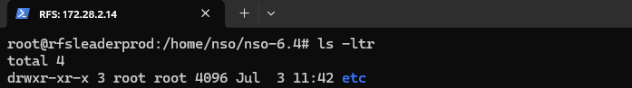  5  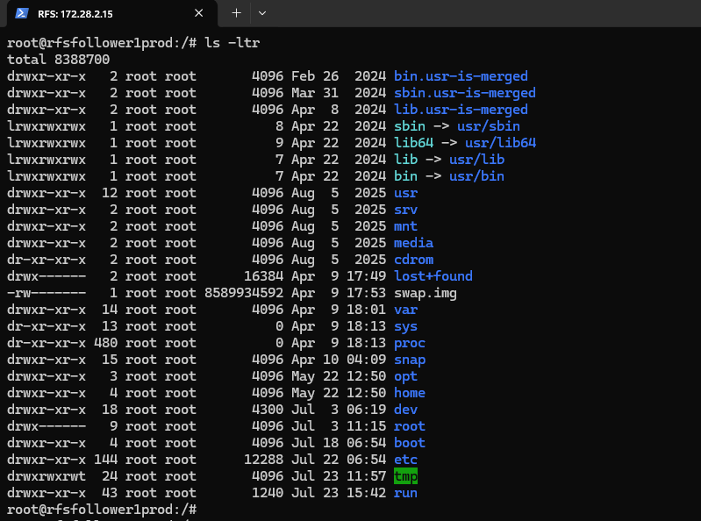  6  