DEVELOPMENT NSO
Acceptance Test Procedure Document
Environment: CFS 172.28.2.11, 172.28.2.12, 172.28.2.13 | RFS 172.28.2.14, 172.28.2.15, 172.28.2.16
LSA Deployment (CFS/RFS)
Cisco Network Services Orchestrator (NSO)
Revision History
Revision No. | Date of Submission | Description of Revision | Prepared By | Date of submission for Review | Review completed Date
1.0 | 07th Jul26 | Initial version |  | 07-07-2026

Prepared by | Reviewed By | Approved by

Table of Contents
1. Introduction 4
Deployment Details 4
2 Test Cases Summary 5
3. Access and System Health Verification 6
Test Case 1: Authenticating into the NSO Environment (Login) 6
Test Case 2: Verifying System Health and Runtime Status 11
4. Device Connectivity and Configuration Synchronization 17
Test Case 3: Validating Device Reachability and Sync from the CFS 17
Test Case 4: Validating Device Reachability and Sync from the RFS 22
5. Package Management 28
Test Case 5: Verifying Installed Package Status (Service Package Check) 28
Test Case 6: Package Upgrade Workflow 38

1 Introduction
This acceptance test plan documents the tests performed on the Cisco NSO (Network Services Orchestrator) platform to validate the installation, connectivity, and operational readiness of the LSA (Layered Service Architecture) deployment across the CFS (Customer Facing Service) and RFS (Resource Facing Service) layers for the T-Fiber network.
Acceptance testing included verification of user authentication and system access, platform health and runtime status, device connectivity and configuration synchronization across both the CFS and RFS layers, and the operational status of installed service packages. Additional testing was performed to verify that the NSO package directory structure remained present and consistent across all cluster nodes following the migration from Cisco NSO 5.7.3 to Cisco NSO 6.4.11.
Each test case documented in this plan includes the procedure followed, the expected result, and the actual outcome, supported by relevant logs and screenshots as evidence of successful validation.

Deployment Details

Environment | CFS Cluster - 172.28.2.11 (leader-prod), 172.28.2.12 (follower1-prod), 172.28.2.13 (follower2-prod)
RFS Node | RFS Cluster - 172.28.2.14 (rfsleaderprod), 172.28.2.15 (rfsfollower1prod), 172.28.2.16 (rfsfollower2prod)
Cluster Nodes | CFS: leader-prod, follower1-prod, follower2-prod | RFS: rfsleaderprod, rfsfollower1prod, rfsfollower2prod
Deployment Type | LSA (Layered Service Architecture) - RFS/CFS

2 Test Cases Summary
The table below summarizes each verification step performed. Detailed procedure, expected result, and supporting evidence (screenshots) are documented against each test case.
# | Checkpoint | What It Confirms | Type | Result
1 | Authenticating into the NSO Environment (Login) | Authorized staff can securely authenticate and access all three CFS and three RFS cluster nodes via SSH. | CLI | PASS
2 | Verifying System Health and Runtime Status | The NSO orchestration platform is running on all six nodes with all required modules active; raft cluster role (leader/follower) confirmed on each node (one RFS node reported a disabled raft state - see Test Case 2 notes). | CLI | PASS
3 | Validating Device Reachability and Sync from the CFS | Registered devices (rfs-node-1, rfs-node-2, rfs-node-3) are reachable and connectable from all three CFS nodes; configuration sync succeeds from the CFS leader, and followers correctly reject sync-from as read-only. | CLI | PASS
4 | Validating Device Reachability and Sync from the RFS | Registered field devices (190+, e.g., CGNTPOLAGPRO01) are reachable and connectable from all three RFS nodes; configuration sync succeeds from the RFS leader, and followers correctly reject sync-from as read-only. | CLI | PASS
5 | Verifying Installed Package Status (Service Package Check) | The installed NSO packages are correctly displayed along with an active operational status. | CLI | PASS
6 | Package Upgrade Workflow | Package directory structure is present and consistent across all six CFS and RFS nodes following the migration to Cisco NSO 6.4.11. | CLI | PASS

3. Access and System Health Verification

These test cases are performed directly on the NSO command-line interface (CLI) and validate the platform, its connectivity, and its provisioning logic before any web-facing verification is attempted.
Test Case 1: Authenticating into the NSO Environment (Login)
Description: | Validates that an authorized user can securely authenticate and gain shell access to the NSO CFS and RFS cluster nodes via SSH, confirming that platform access controls are functioning correctly across all six nodes.
Procedure: | 1.Launch a terminal or SSH client.  2.Connect to the Linux server using the command:  ssh root@<server-ip> (repeated for each of the six cluster nodes: 172.28.2.11, 172.28.2.12, 172.28.2.13 - CFS; 172.28.2.14, 172.28.2.15, 172.28.2.16 - RFS)  3.Enter the configured password when prompted.  4.Confirm that login is successful and the shell prompt is displayed.
Expected Result: | The user should be successfully authenticated and granted access to each of the six cluster nodes without any login errors. The system should display the respective shell prompt (root@leader-prod:~#, root@follower1-prod:~#, root@follower2-prod:~# for the CFS nodes, and root@rfsleaderprod:~#, root@rfsfollower1prod:~#, root@rfsfollower2prod:~# for the RFS nodes) indicating successful SSH access.
Result: | ☐ OK ☐ Not OK
Logs/Snaps: (if Any) | 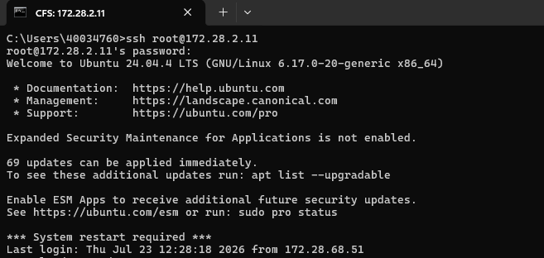  CFS 172.28.2.11 (leader-prod) - ssh root@172.28.2.11: authenticated successfully, Ubuntu 24.04.4 LTS banner displayed.  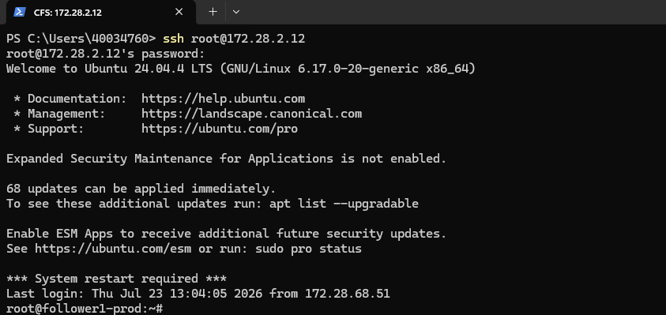  CFS 172.28.2.12 (follower1-prod) - ssh root@172.28.2.12: authenticated successfully, prompt root@follower1-prod:~# displayed.  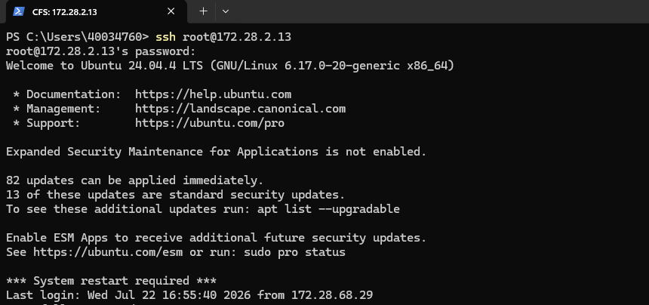  CFS 172.28.2.13 (follower2-prod) - ssh root@172.28.2.13: authenticated successfully.  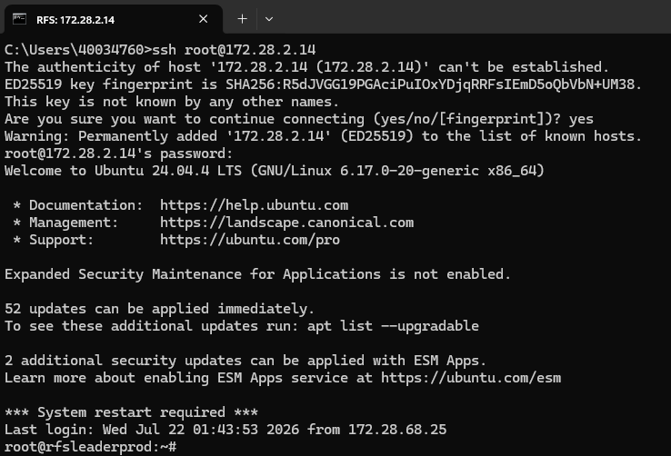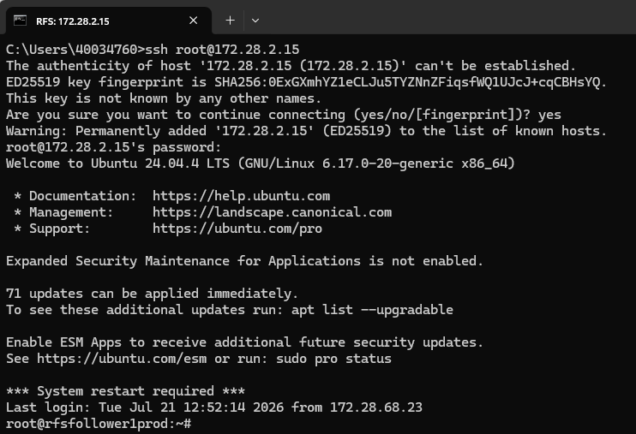  RFS 172.28.2.14 (rfsleaderprod) - ssh root@172.28.2.14: host key accepted on first connect, authenticated, prompt root@rfsleaderprod:~# displayed. || RFS 172.28.2.15 (rfsfollower1prod) - ssh root@172.28.2.15: host key accepted, authenticated, prompt root@rfsfollower1prod:~# displayed.  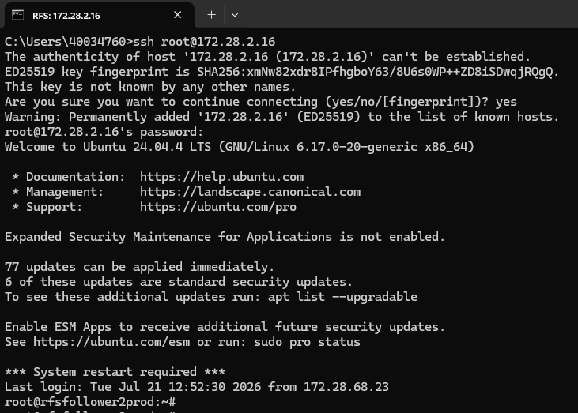  RFS 172.28.2.16 (rfsfollower2prod) - ssh root@172.28.2.16: host key accepted, authenticated, prompt root@rfsfollower2prod:~# displayed.  Administrator logging into the NSO CLI.

Test Case 2: Verifying System Health and Runtime Status
Description: | Validates that the Cisco NSO orchestration engine is running correctly on each CFS and RFS cluster node by confirming key runtime parameters including NSO version, daemon PID, active modules, raft cluster role (leader/follower), configuration file location, installation directory, and runtime directory are all reported without error.
Procedure: | 1. Access the Linux shell/CLI on each of the six cluster nodes (172.28.2.11-13 CFS, 172.28.2.14-16 RFS).  2. Execute the command: ncs --status (using the full binary path /home/nso/nso-6.4/bin/ncs --status where the ncs binary is not yet on PATH).  3. Review the output for NSO version, daemon state, running modules, process ID, raft cluster role (leader/follower/disabled), configuration file, installation directory, and runtime directory.  4. Confirm that the NSO status is displayed as started and all required modules are running on each node.
Expected Result: | The command should successfully display the NSO runtime details on every node. The NSO status should be started, the daemon process should be running with a valid PID, the configured modules (backplane, netconf, cdb, cli, snmp, webui) should be active, and the raft cluster status should show exactly one leader per cluster with the remaining nodes reporting as follower.
Result: | ☐ OK ☐ Not OK
Logs/Snaps: (if Any) | 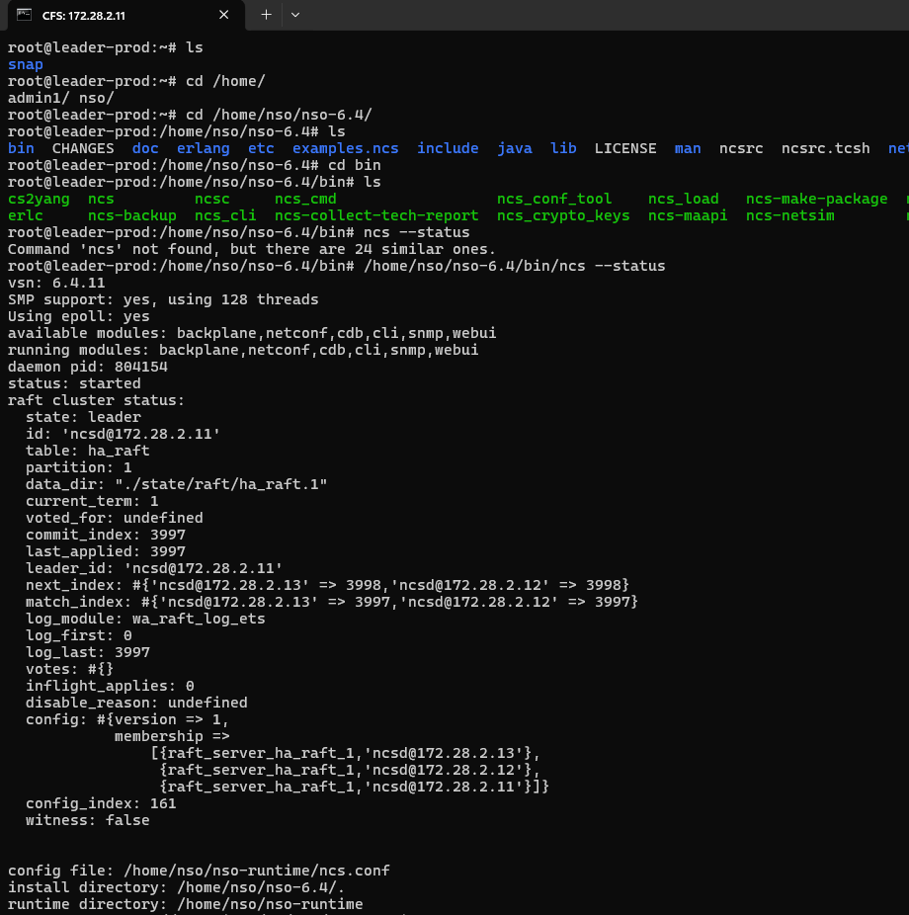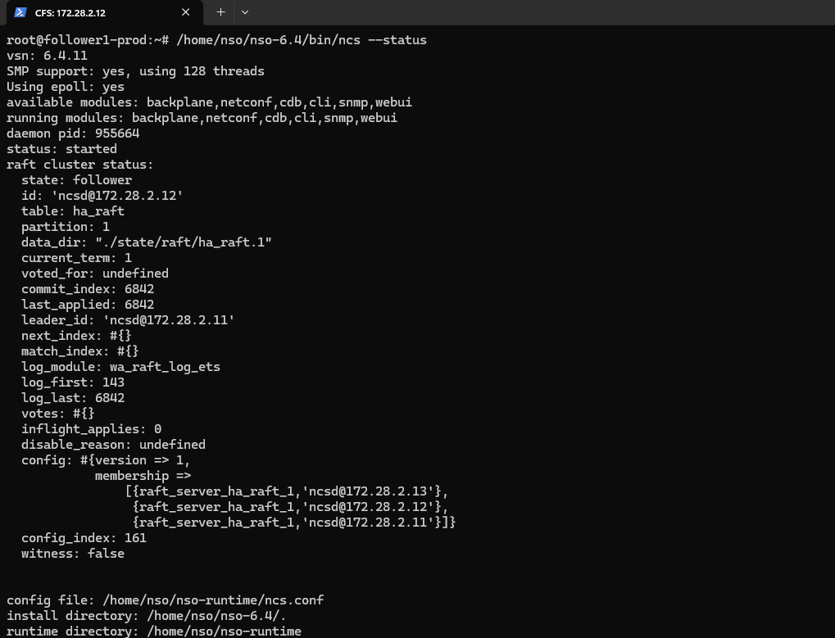  CFS 172.28.2.11 (leader-prod) - ncs --status: vsn 6.4.11, status: started, raft cluster state: leader (id ncsd@172.28.2.11). || CFS 172.28.2.12 (follower1-prod) - ncs --status: status: started, raft cluster state: follower, leader_id ncsd@172.28.2.11.  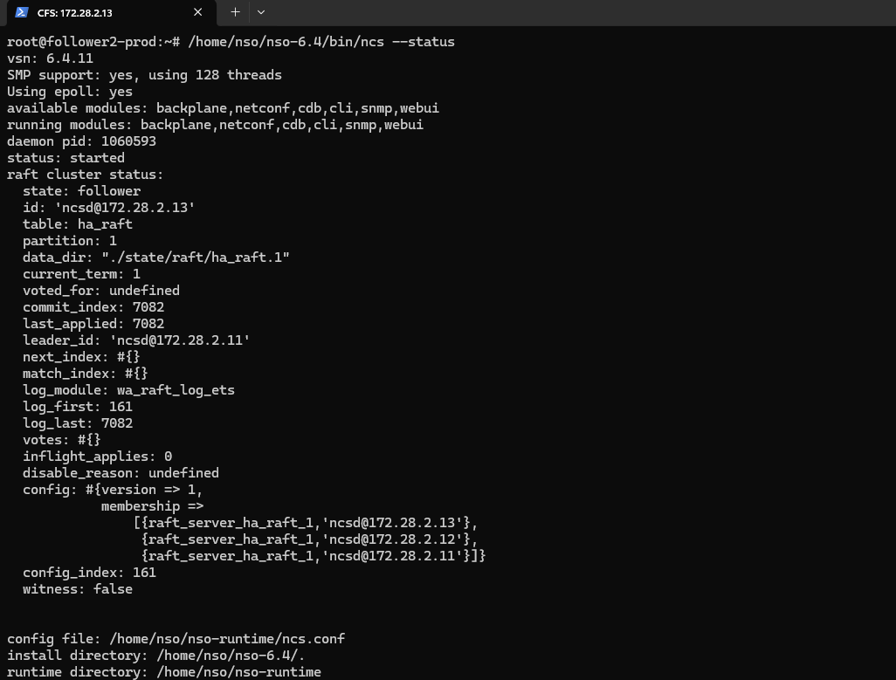  CFS 172.28.2.13 (follower2-prod) - ncs --status: status: started, raft cluster state: follower, leader_id ncsd@172.28.2.11.  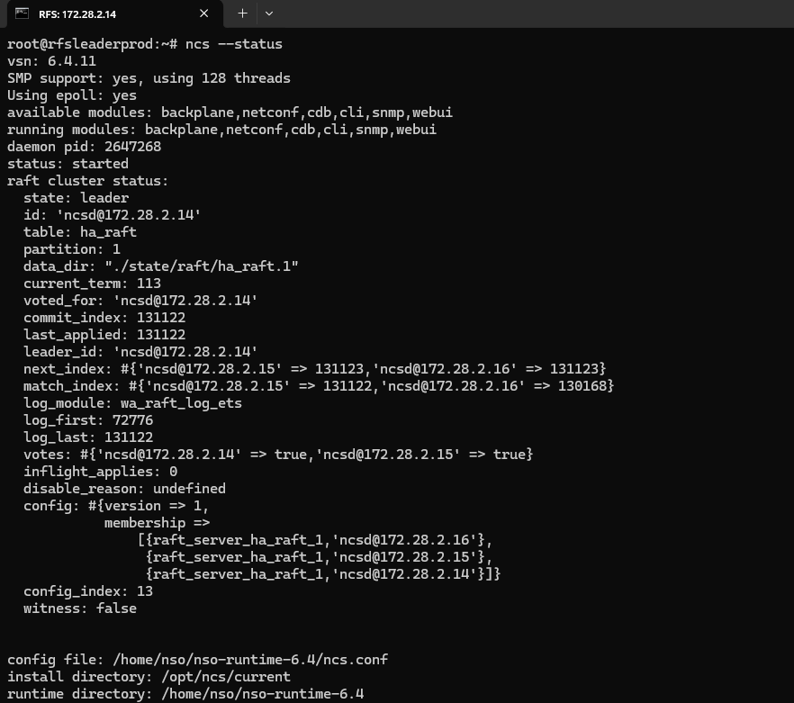  RFS 172.28.2.14 (rfsleaderprod) - ncs --status: status: started, raft cluster state: leader (id ncsd@172.28.2.14).  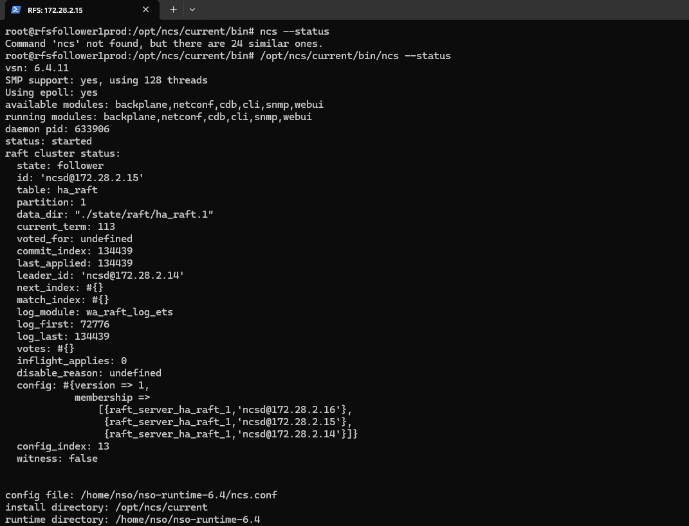  RFS 172.28.2.15 (rfsfollower1prod) - ncs --status: status: started, raft cluster state: follower, leader_id ncsd@172.28.2.14.  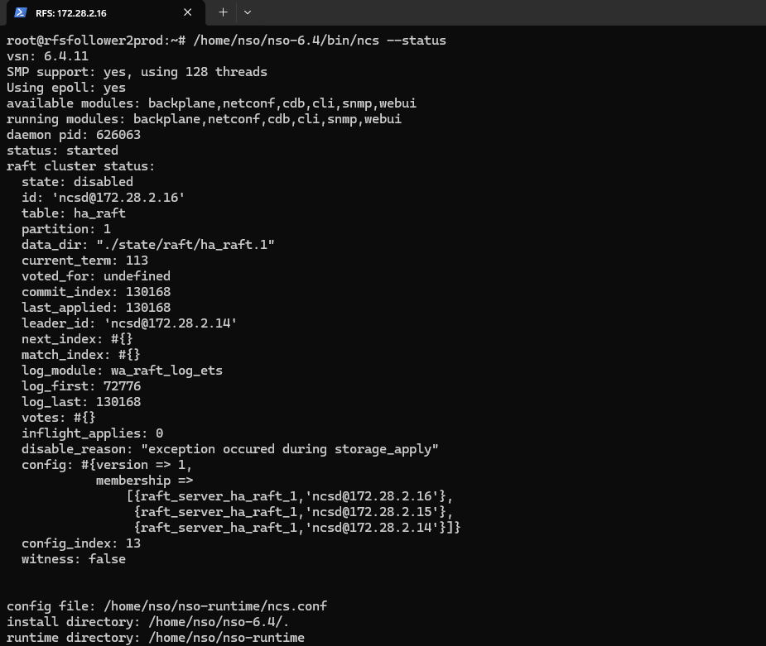  RFS 172.28.2.16 (rfsfollower2prod) - ncs --status: status: started, but raft cluster state: DISABLED, disable_reason: "exception occured during storage_apply" (NSO daemon itself remains up; only raft replication affected).  NSO status check confirming the platform is running.

4. Device Connectivity and Configuration Synchronization
Test Case 3: Validating Device Reachability and Sync from the CFS
Description: | Verifying end-to-end device handling in Cisco NSO from the CFS cluster: listing the RFS nodes registered as devices, verifying connectivity from each of the three CFS nodes, and confirming that configuration sync (devices sync-from) succeeds only when executed from the current CFS raft leader.
Procedure: | 1.Run show devices list on each CFS node (172.28.2.11 leader, 172.28.2.12 and 172.28.2.13 followers) to confirm devices (rfs-node-1 - 172.28.2.14, rfs-node-2 - 172.28.2.15, rfs-node-3 - 172.28.2.16) are registered and unlocked.  2.Execute devices device <name> connect for each device on each of the three CFS nodes to validate reachability and establish a session.  3.Perform devices sync-from from each of the three CFS nodes to pull the live configuration from all connected devices into NSO, and confirm that only the current raft leader is able to complete the sync.
Expected Result: | Devices appear in the list with correct addresses and NED IDs on every CFS node.  Each connection attempt (from any of the three CFS nodes) returns result true with confirmation of successful connectivity.  Because only the raft leader may write to the CDB, devices sync-from is expected to return result true only when executed from the CFS leader; when executed from a follower it is expected to return result false with info "node is in read-only mode" - this is normal CFS HA behavior, not a fault.
Result: | ☐ OK ☐ Not OK
Logs/Snaps: (if Any) | Show devices list from CFS  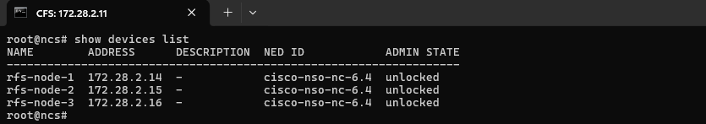  CFS 172.28.2.11 (leader) - show devices list: rfs-node-1 (172.28.2.14), rfs-node-2 (172.28.2.15), rfs-node-3 (172.28.2.16), NED cisco-nso-nc-6.4, all unlocked.  devices device rfs-node-1, rfs-node-2, rfs-node-3 connect from CFS  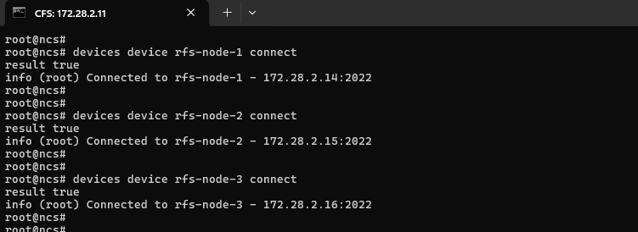devices sync-from from CFS  CFS 172.28.2.11 (leader) - devices device rfs-node-1/2/3 connect: result true for all three, e.g. "Connected to rfs-node-1 - 172.28.2.14:2022".  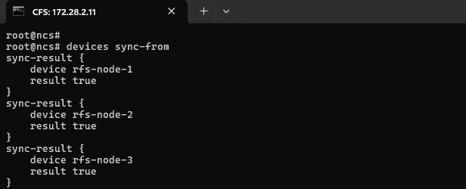  Show devices list from CFS  CFS 172.28.2.11 (leader) - devices sync-from: sync-result true for rfs-node-1, rfs-node-2, and rfs-node-3.  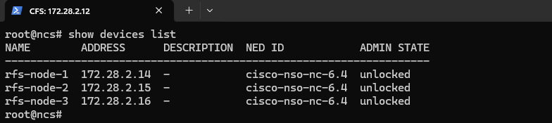  CFS 172.28.2.12 (follower1) - show devices list: same 3 rfs-node devices, all unlocked.  devices device rfs-node-1, rfs-node-2, rfs-node-3 connect from CFS  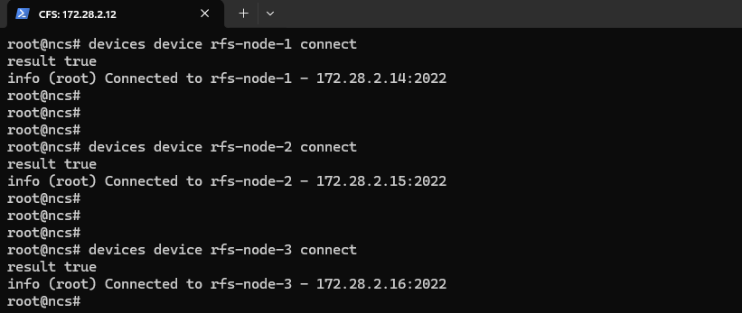  CFS 172.28.2.12 (follower1) - devices device rfs-node-1/2/3 connect: result true for all three.  devices sync-from from CFS  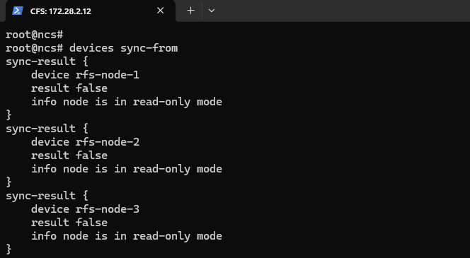  Show devices list from CFS  CFS 172.28.2.12 (follower1) - devices sync-from: result false for all three devices, info "node is in read-only mode" (expected - only the CFS raft leader may write).  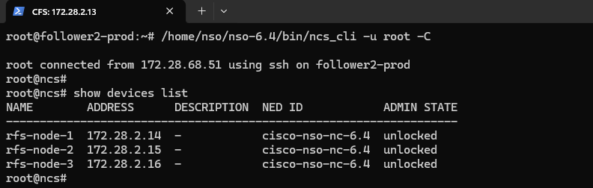  CFS 172.28.2.13 (follower2) - logged in via ncs_cli -u root -C; show devices list: same 3 rfs-node devices, all unlocked.  devices device rfs-node-1, rfs-node-2, rfs-node-3 connect from CFS  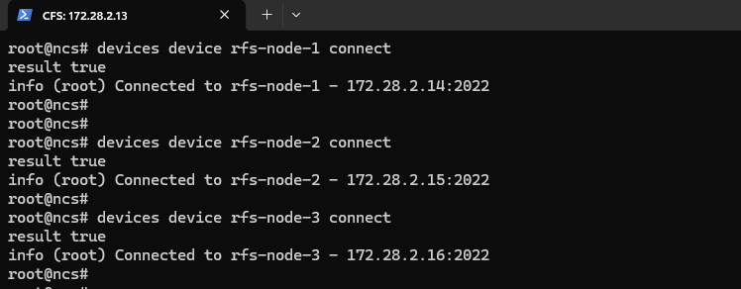  CFS 172.28.2.13 (follower2) - devices device rfs-node-1/2/3 connect: result true for all three.  devices sync-from from CFS  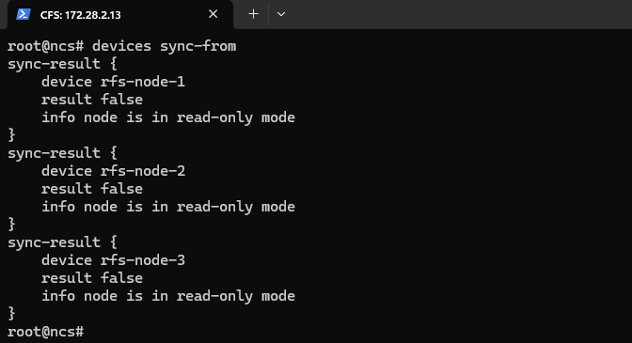  CFS 172.28.2.13 (follower2) - devices sync-from: result false for all three devices, info "node is in read-only mode" (expected, same reason as follower1).

Test Case 4: Validating Device Reachability and Sync from the RFS
Description: | Validating device connectivity and configuration synchronization in Cisco NSO from the RFS cluster against the real field network devices (GPON/access nodes). This confirms that registered field devices can be reached, connected, and their live configurations synchronized into NSO's internal database, and that sync writes are correctly restricted to the RFS raft leader.
Procedure: | 1.Run show devices list to confirm the registered field devices (e.g., ADBICDAXMAR001, ADGDGOVIGPRO01, AKPTAKKAGPRO01, ALDRALLAGPRO01, ADVPADAVGPRO01, CGNTPOLAGPRO01 and other GPON/access devices - 190+ devices in total) are registered and unlocked.  2.From the RFS leader (172.28.2.14), execute devices device <name> connect for a representative device to validate reachability and establish a session.  Example: devices device CGNTPOLAGPRO01 connect  3.From the RFS leader, perform devices device <name> sync-from (and a bulk devices sync-from) to pull the live configuration into NSO.  Example: devices device CGNTPOLAGPRO01 sync-from  4.Repeat show devices list and devices sync-from from each RFS follower (172.28.2.15, 172.28.2.16) to confirm read-only behavior is correctly enforced.
Expected Result: | 1.Devices appear in the list with correct addresses, NED IDs, and admin states set to unlocked.  2.From the RFS leader, the connection attempt returns result true with confirmation of successful connectivity (e.g., "Connected to CGNTPOLAGPRO01 - 172.16.1.123:22"), and sync-from returns result true.  3.From RFS followers, sync-from is expected to return result false with info "node is in read-only mode" for each device - normal RFS HA behavior, since only the leader may write to the CDB.
Result: | ☐ OK ☐ Not OK
Logs/Snaps: (if Any) | 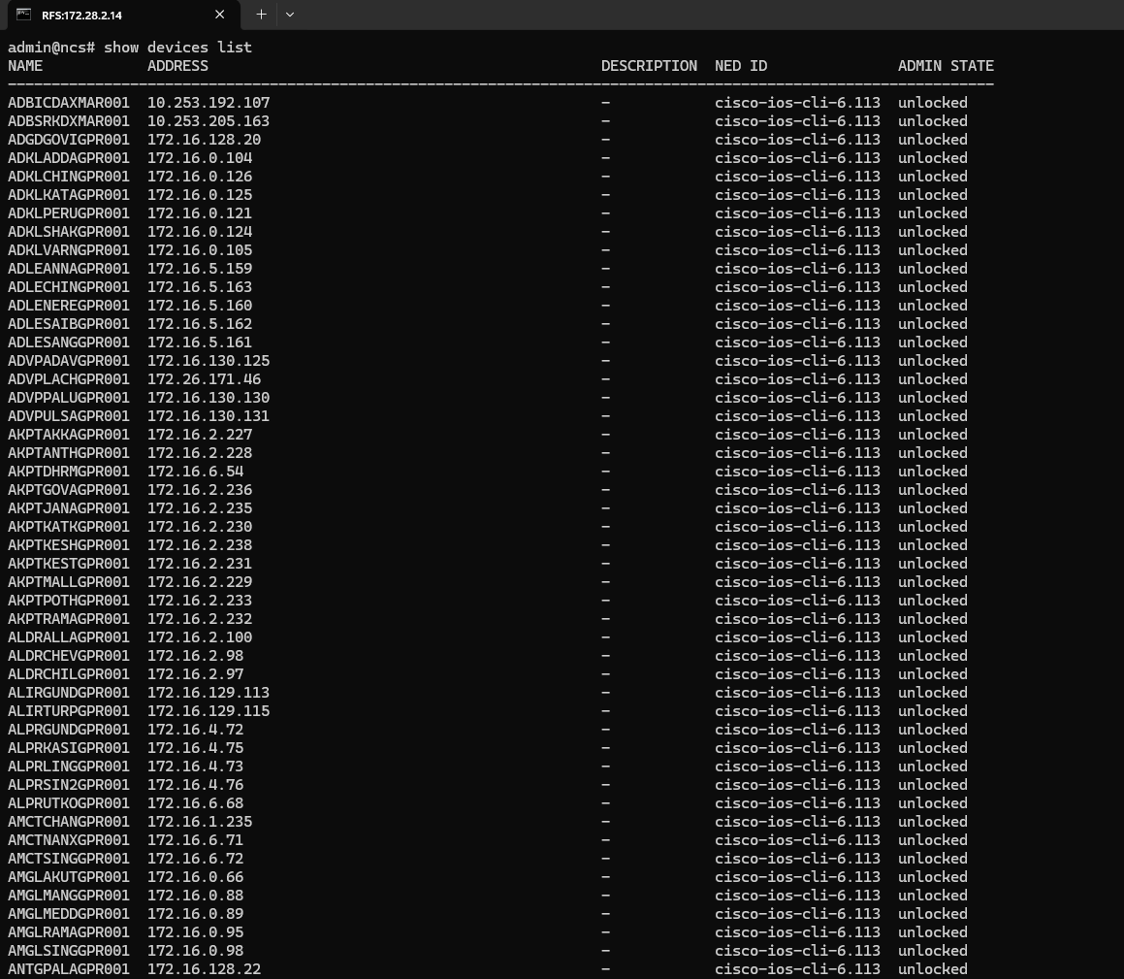devices device rfs-node-1, rfs-node-2, rfs-node-3 connect from CFS  RFS 172.28.2.14 (leader) - show devices list: 190+ field devices registered (e.g., ADBICDAXMAR001 - 10.253.192.107, ADGDGOVIGPRO01 - 172.16.128.20, AKPTAKKAGPRO01 - 172.16.2.227), NED cisco-ios-cli-6.113, all unlocked.  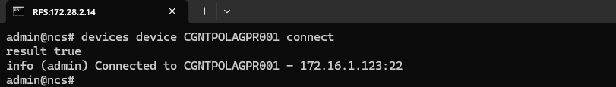  RFS 172.28.2.14 (leader) - devices device CGNTPOLAGPRO01 connect: result true, "Connected to CGNTPOLAGPRO01 - 172.16.1.123:22".  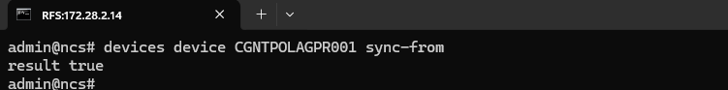  RFS 172.28.2.14 (leader) - devices device CGNTPOLAGPRO01 sync-from: result true.  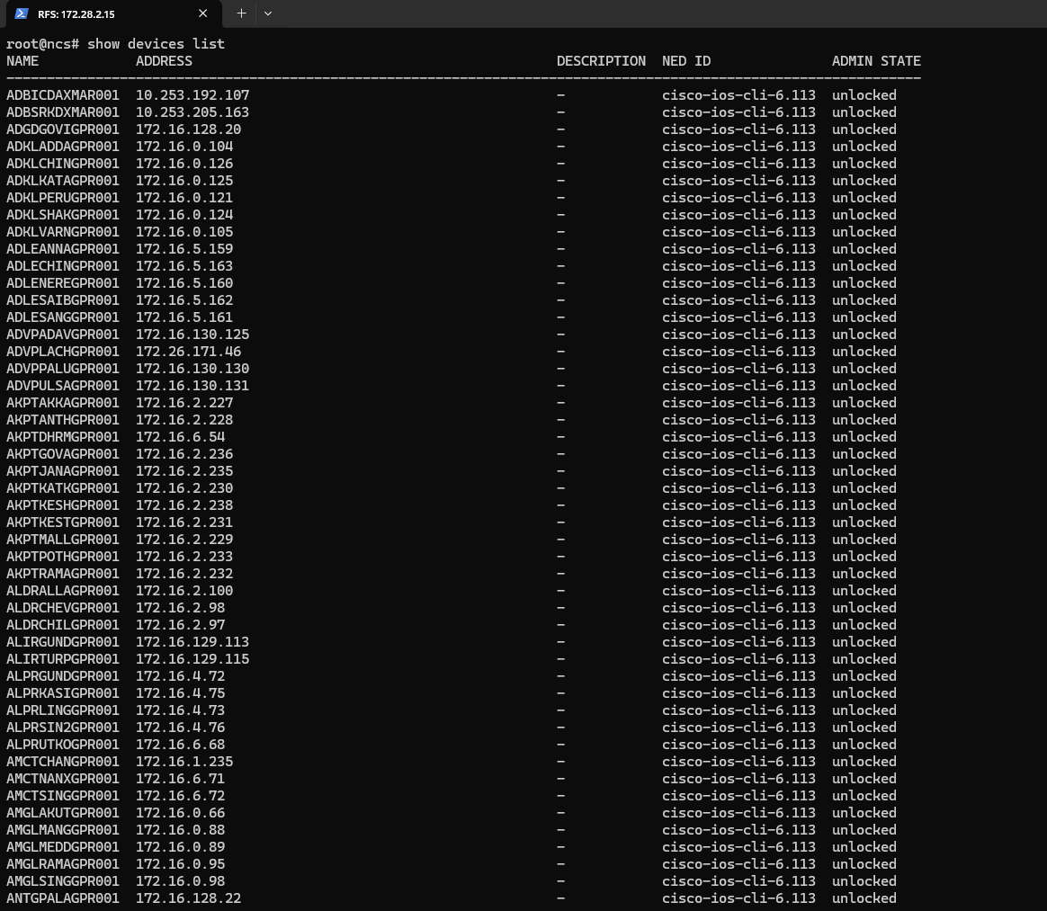  RFS 172.28.2.15 (follower1) - show devices list: same full 190+ device inventory, all unlocked.  devices sync-from from CFS  RFS 172.28.2.15 (follower1) - devices sync-from (bulk, all devices): result false for each device, info "node is in read-only mode".  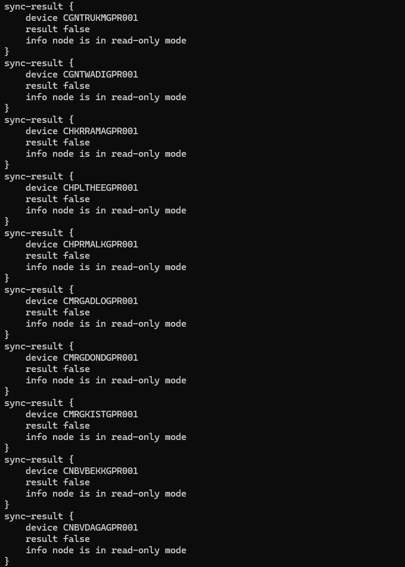  RFS 172.28.2.15 (follower1) - devices sync-from continued: result false / "node is in read-only mode" for devices including CGNTRUKMGPR01, CGNTWADIGPR01, CHKRRAMAGPR01, CHPLTHEEGPR01, CHPRMALKGPR01, CMRGADLOGPR01, CMRGDONDGPR01, CMRGKISTGPR01, CNBVBEKKGPR01, CNBVDAGAGPR01 (expected - only the RFS raft leader may write).  Show devices list from RFS 16  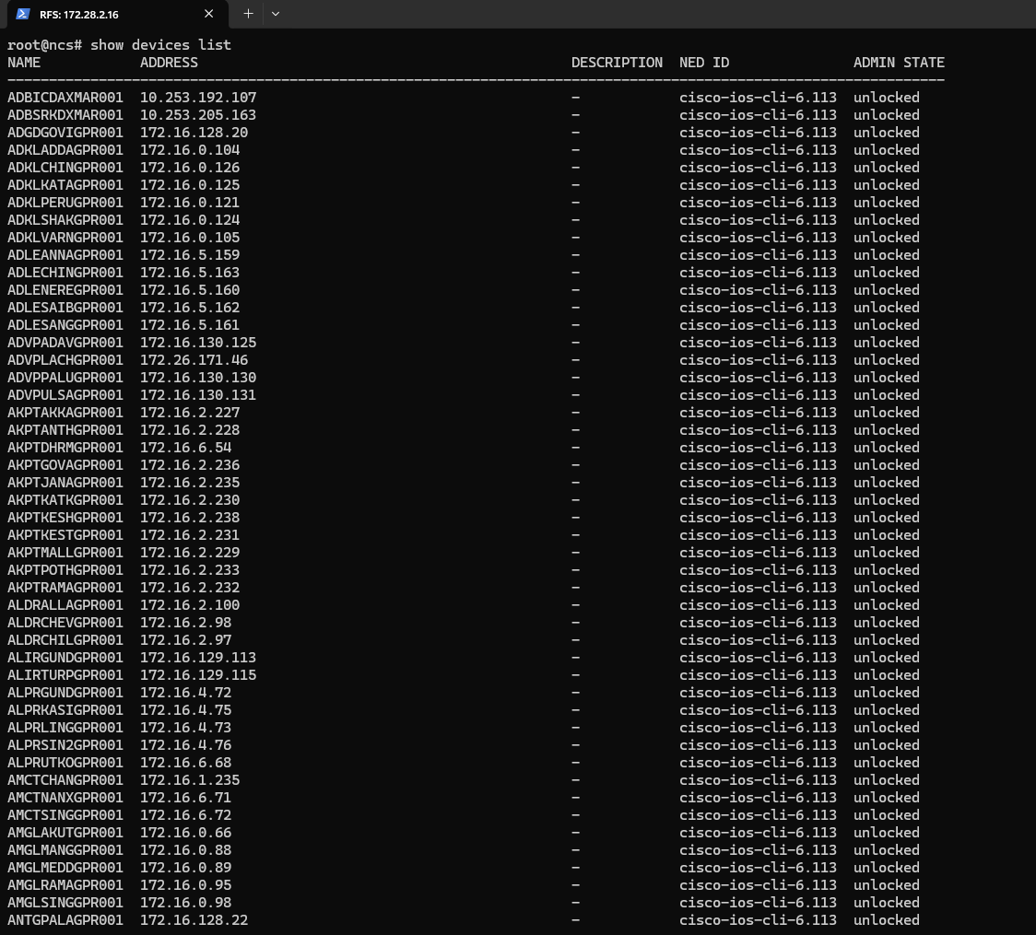  RFS 172.28.2.16 (follower2) - show devices list: same full 190+ device inventory, all unlocked.  devices sync-from from RFS 16  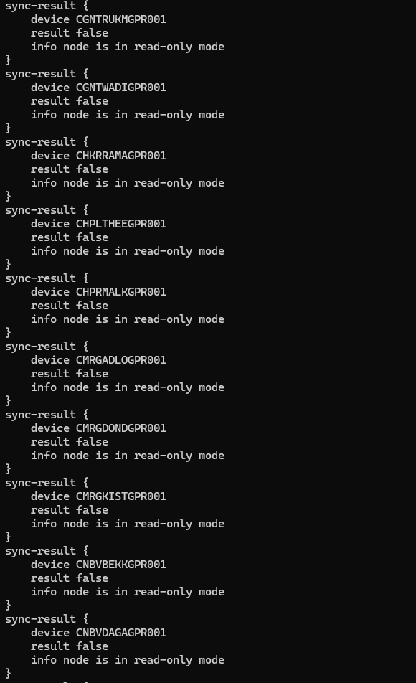  RFS 172.28.2.16 (follower2) - devices sync-from (bulk, all devices): command issued. || RFS 172.28.2.16 (follower2) - devices sync-from result: result false / "node is in read-only mode" for each device (same sample as follower1), expected for a non-leader node.  Device connectivity list confirming reachable network devices.

5. Package Management
Test Case 5: Verifying Installed Package Status (Service Package Check)
Description: | Verify that the installed NSO packages are displayed along with their operational status
Procedure: | Execute the command: show packages package oper-status  - Review the list of installed packages displayed in the output.  - Verify the package names and their operational status.  - Confirm that the package operational status information is displayed for all listed packages.
Expected Result: | The command should display the list of installed packages along with an operational status of "up" for every package, on every CFS and RFS node.
Result: | ☐ OK ☐ Not OK
Logs/Snaps: (if Any) | 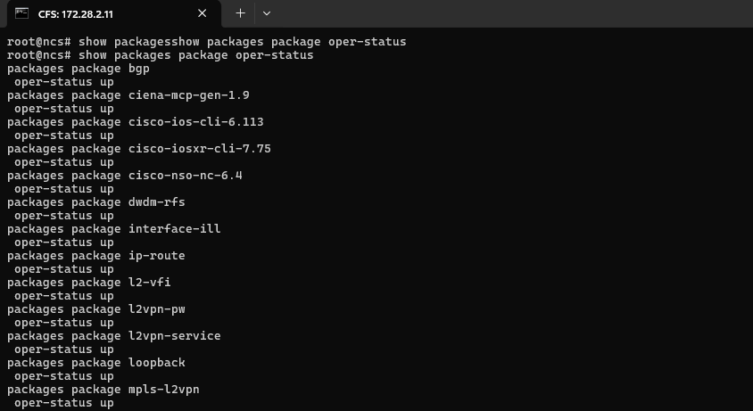  CFS 172.28.2.11 (leader) - show packages package oper-status (part 1 of 2): bgp, ciena-mcp-gen-1.9, cisco-ios-cli-6.113, cisco-iosxr-cli-7.75, cisco-nso-nc-6.4, dudm-rfs, interface-ill, ip-route, l2-vfi, l2vpn-pw, l2vpn-service, loopback, mpls-l2vpn - all oper-status up.  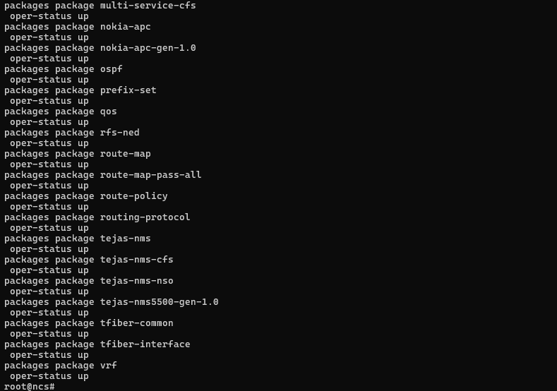  CFS 172.28.2.11 (leader) - show packages package oper-status (part 2 of 2): multi-service-cfs, nokia-apc, nokia-apc-gen-1.0, ospf, prefix-set, qos, rfs-ned, route-map, route-map-pass-all, route-policy, routing-protocol, tejas-nms, tejas-nms-cfs, tejas-nms-nso, tejas-nms5500-gen-1.0, tfiber-common, tfiber-interface, vrf - all oper-status up.  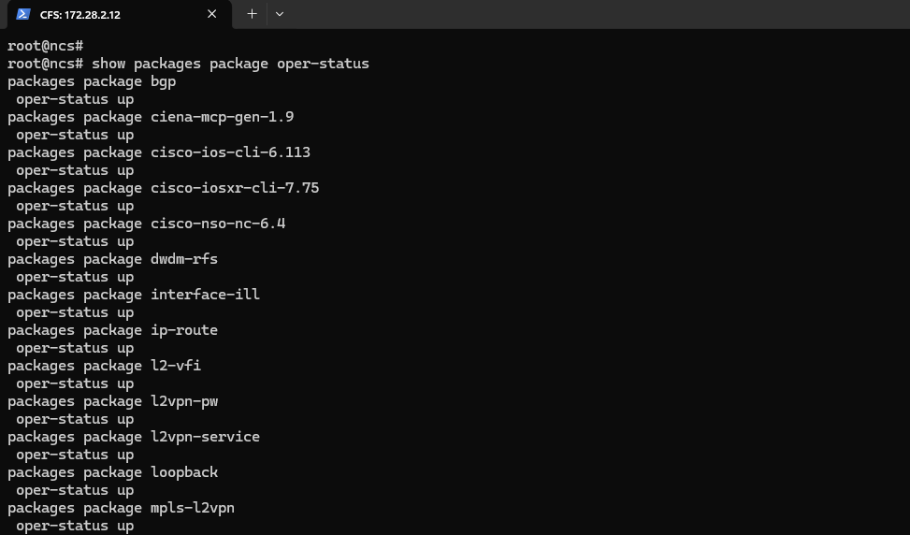  CFS 172.28.2.12 (follower1) - show packages package oper-status (part 1 of 2): same CFS package set, all oper-status up.  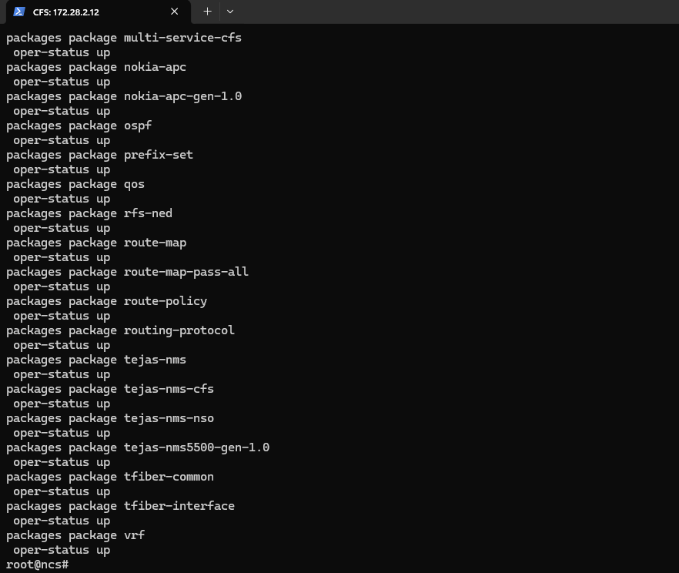  CFS 172.28.2.12 (follower1) - show packages package oper-status (part 2 of 2): same CFS package set, all oper-status up.  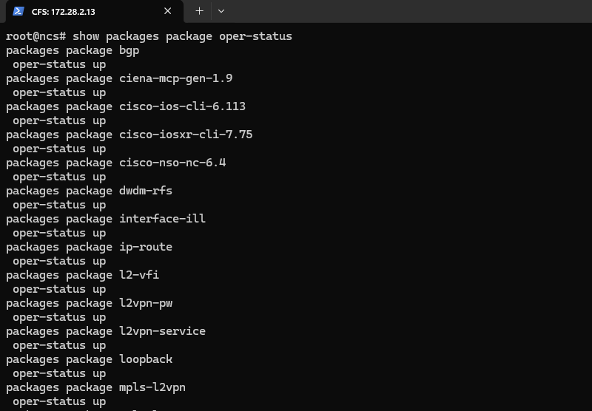  CFS 172.28.2.13 (follower2) - show packages package oper-status (part 1 of 2): same CFS package set, all oper-status up.  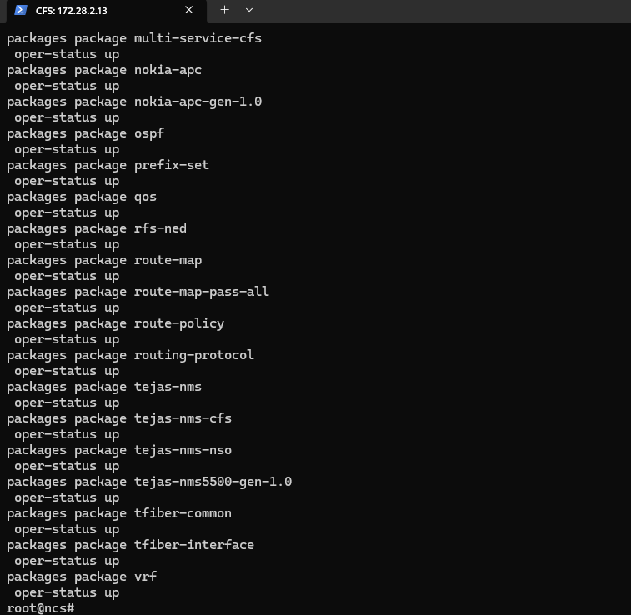  CFS 172.28.2.13 (follower2) - show packages package oper-status (part 2 of 2): same CFS package set, all oper-status up.  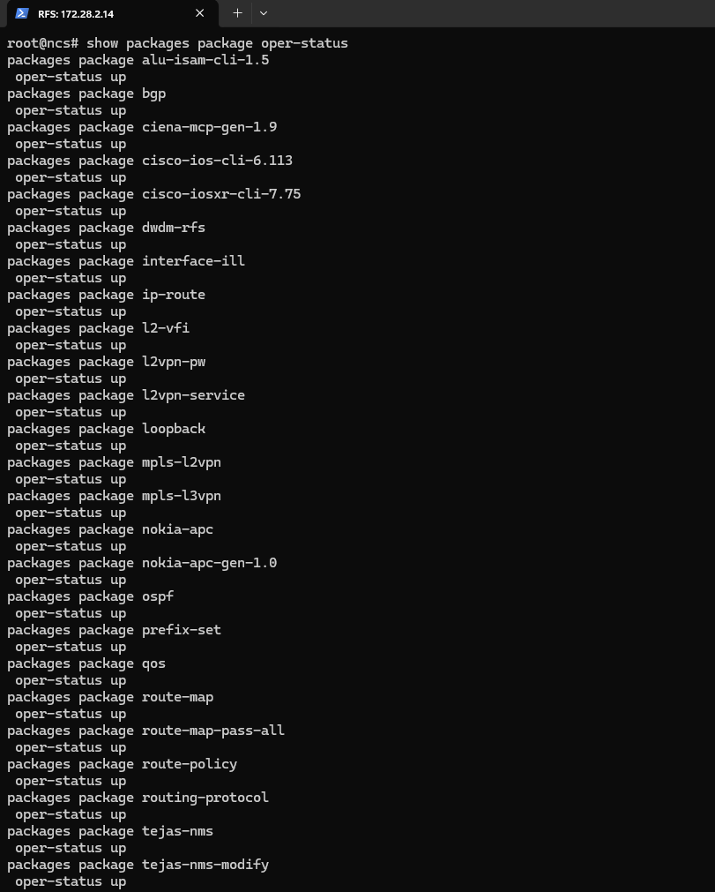  RFS 172.28.2.14 (leader) - show packages package oper-status (part 1 of 2): alu-isam-cli-1.5, bgp, ciena-mcp-gen-1.9, cisco-ios-cli-6.113, cisco-iosxr-cli-7.75, dudm-rfs, interface-ill, ip-route, l2-vfi, l2vpn-pw, l2vpn-service, loopback, mpls-l2vpn, mpls-l3vpn, nokia-apc, nokia-apc-gen-1.0, ospf, prefix-set, qos, route-map - all oper-status up.  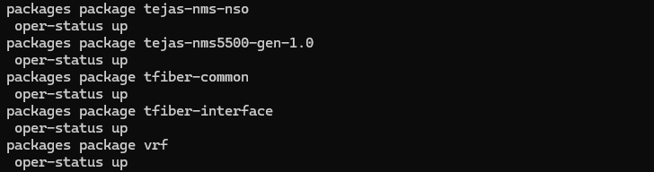  RFS 172.28.2.14 (leader) - show packages package oper-status (part 2 of 2): route-map-pass-all, route-policy, routing-protocol, tejas-nms, tejas-nms-modify, tejas-nms-nso, tejas-nms5500-gen-1.0, tfiber-common, tfiber-interface, vrf - all oper-status up.  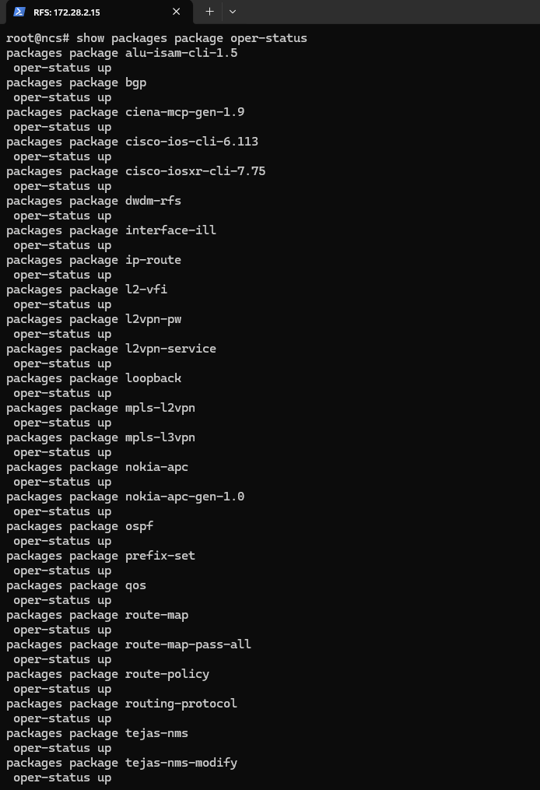  RFS 172.28.2.15 (follower1) - show packages package oper-status: full RFS package set, all oper-status up.  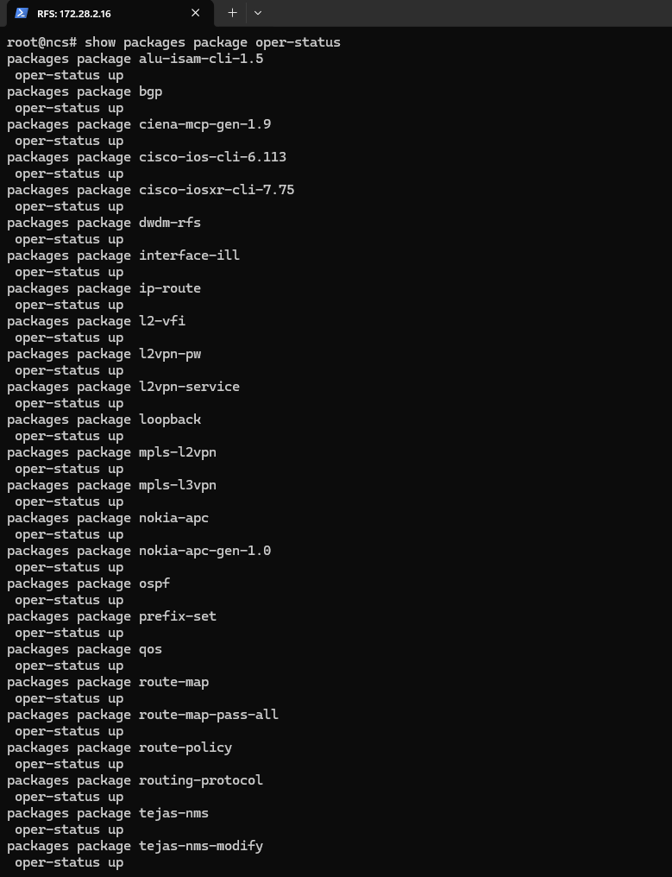  RFS 172.28.2.16 (follower2) - show packages package oper-status: full RFS package set, all oper-status up.  Service package operational status — confirmed active.

Test Case 6: Package Upgrade Workflow
Description: | Verify that the NSO package directory structure is present and consistent across all six CFS and RFS cluster nodes following the migration to Cisco NSO 6.4.11.
Procedure: | Procedure:  - On each CFS node (172.28.2.11 leader-prod, 172.28.2.12 follower1-prod, 172.28.2.13 follower2-prod), navigate to the NSO packages directory:  - cd /home/nso/nso-6.4/packages  - Verify that all required package directories are present:  - ls -ltr  - On each RFS node (172.28.2.14 rfsleaderprod, 172.28.2.15 rfsfollower1prod, 172.28.2.16 rfsfollower2prod), navigate to the NSO home/runtime directory (or filesystem root) and run:  - ls -ltr  - Note: the evidence captured for this test case consists only of the directory-listing checks above. No screenshot evidence was found for a package compile (make clean all) or packages reload step, so those steps are not represented as verified here.
Expected Result: | - The package directories (tools, lsa, auth) are present and identical on all three CFS nodes.  - The corresponding runtime files/folders are present on all three RFS nodes.  - No missing or unexpected directory entries are observed on any node.
Result: | ☐ OK ☐ Not OK
Logs/Snaps: (if Any) | Package directory listing (ls -ltr)  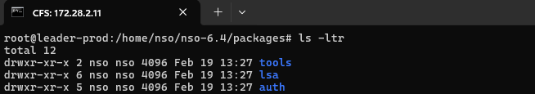  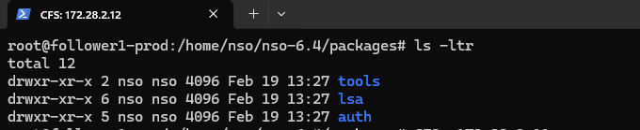  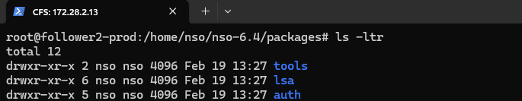  CFS 172.28.2.11 (leader-prod) - ls -ltr in /home/nso/nso-6.4/packages: directories tools, lsa, auth present (dated Feb 19, 13:27). || CFS 172.28.2.12 (follower1-prod) - ls -ltr in /home/nso/nso-6.4/packages: identical tools, lsa, auth directories present. || CFS 172.28.2.13 (follower2-prod) - ls -ltr in /home/nso/nso-6.4/packages: identical tools, lsa, auth directories present.  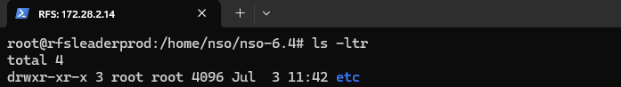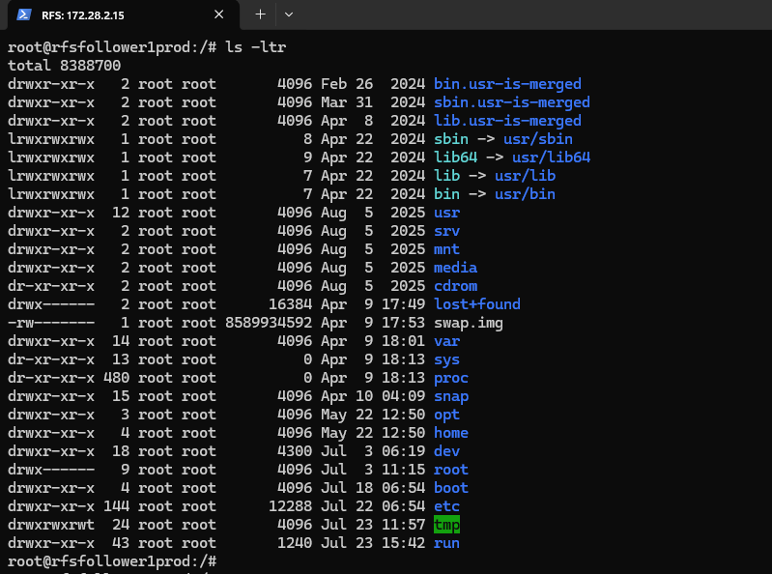  RFS 172.28.2.14 (rfsleaderprod) - ls -ltr in /home/nso/nso-6.4: etc directory present || RFS 172.28.2.15 (rfsfollower1prod) - ls -ltr in /: standard root filesystem listing (bin, boot, dev, etc, home, lib, opt, proc, root, run, snap, srv, sys, usr, var), confirming filesystem intact.  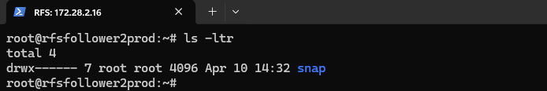  RFS 172.28.2.16 (rfsfollower2prod) - ls -ltr in home directory: snap directory only (dated Apr 10, 14:32).

