**Admin: Assign Students :**

* When User trying to assign and save, page is loading and displaying as below.
* the URL should not contain their Gmail.
* Similarly for Advisor

**CSS: changes**

.country_interested 🡪width ->145px,text-aligh:center

**Both Todo and Assign students modal**: .modal-dialog🡪width🡪1111px

**Advisor:Todo Items :**

Popup Change:

Add new column to input comments which is text area

Hide/show conditional check:

* By Default the popup **should not display “Assign” header** ,It should be displayed only when the save button is clicked
* on Save:
  + Yes/Interested:
    - Change: Yes, to Interested
    - when user selected Interested and clicked save, the **dropdown in student interested** should be **hidden** and display Assign header and check box.
    - Output should be: include comments as above screenshot too
    - Graphical user interface

      Description automatically generated
    - Bug: 
      * on check the assign column, save tick (Assign) button is not working
      * if there are multiple checkboxes, if user is checking few and reloads and try to check the other assign check boxes and save it is not working
  + No/Not interested:
    - Change: No to Not Interested
    - when user selected No/Not Interested, the whole column should be disappeared.
  + Future Follow-up:
    - When user selected Future Follow-up, that data must be displayed in Admin.in “Reverted students” modal.
    - Bug: The Follow up student is also going back to Assign Student
  + No-Response
    - when user selected No-response the whole column should be disappeared.

output should be:

**Advisor::**

**Admin: Reverted Students:**

Popup Change:

**Add new column** to view **comments** added in Todo items

Expected output:

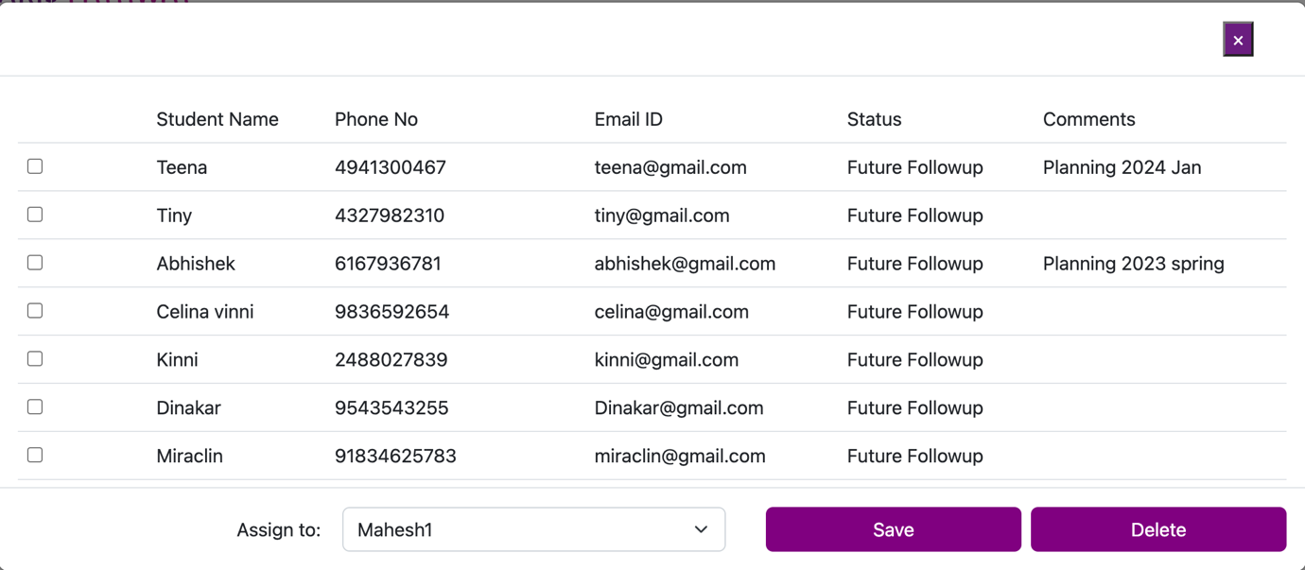

* on check Save: User should be able to check and can reassign to advisor, so on save multiple data can be assigned.
* on Check Delete: User should be able to delete multiple record.

Bug Admin items which are not working:

* View tasks Search is not working,
* Create Advisor/Consultant
* Create Offer letter top navigation bar is not visible.
* Create offer letter signature image is not visible.

Bugs in Advisor:

profile->view offer letter not working.

Change:

Notification: reply msg icon as shown below, on click a popup should display name of the user, text area and a button as shown in the below popup screen, please arrange and beautify, that popup should also hold the old msgs.

