Person table car table

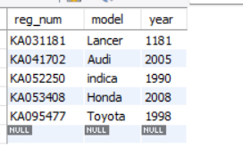

Accindent table owns table

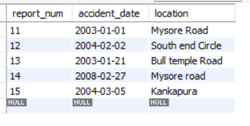 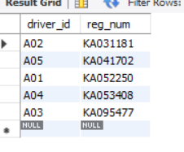

Participated table

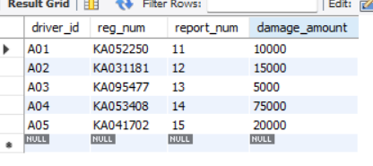

SDL>>select accident_date , location from accident;



SQL>>update participated set damage_amount=25000

where reg_num='KA053408' and report_num=14;

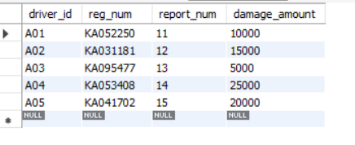

SQL>>select driver_id from participated where damage_amount >= 25000;



SQL>>SELECT * FROM participated ORDER BY damage_amount DESC

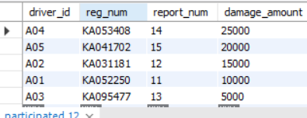

SQL>>SELECT AVG(damage_amount) FROM participated;

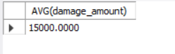

SQL>>SELECT MAX(damage_amount) FROM participated;

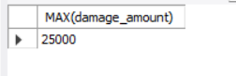

SQL>>insert into accident values(16,"2008-03-08","Domlur");

