Sonetel DevOps Problem Statement

Nginx is a free, open-source, high-performance HTTP server. Your first task is to set up a simple Nginx web server to serve a static “Hello World” HTML. To do that:

I have Created my aws account and login

First we need to create network setup for creating Ec2 Instances

**Aws-Vpc-Subnets-SecurityGroups-Routetable**

Create Vpc:

Goto Vpc services Select Your Vpcs

Select Create Vpc & Give ipv4 range

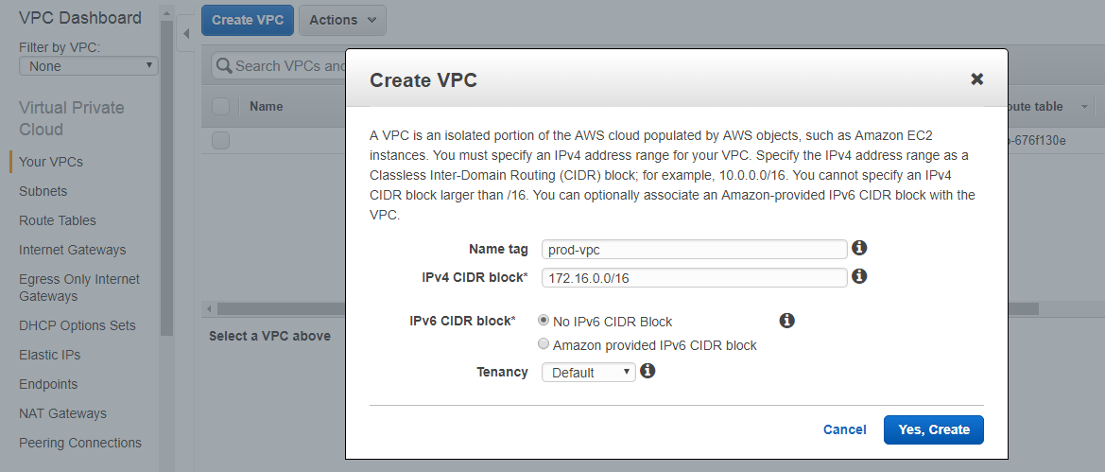

2.Create subnets

Select Subnets & Create New subnet & Give Name and ipv4 range

I have created two subnets for two zones

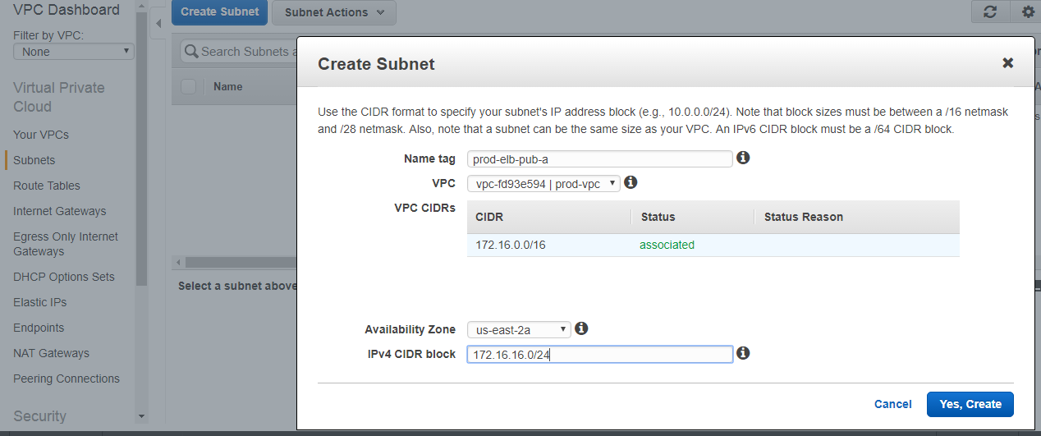

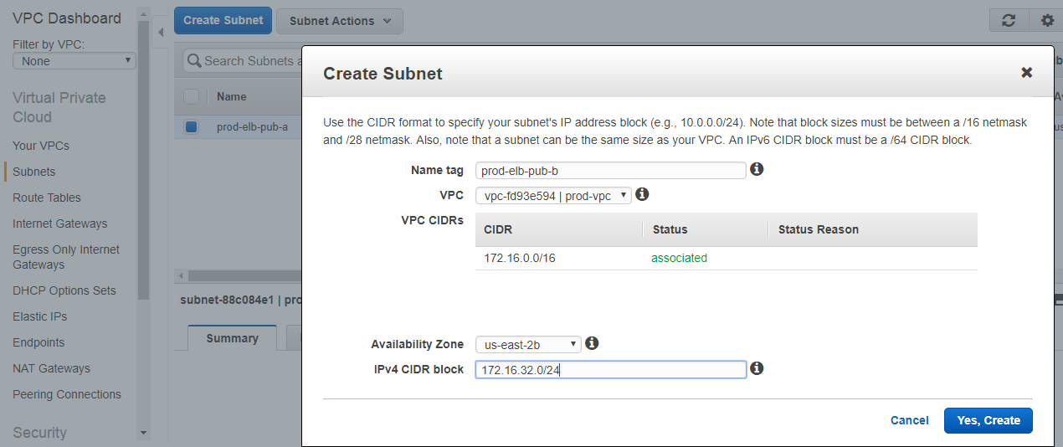

3.Create Security Groups

Goto Security Groups & select Create security Group

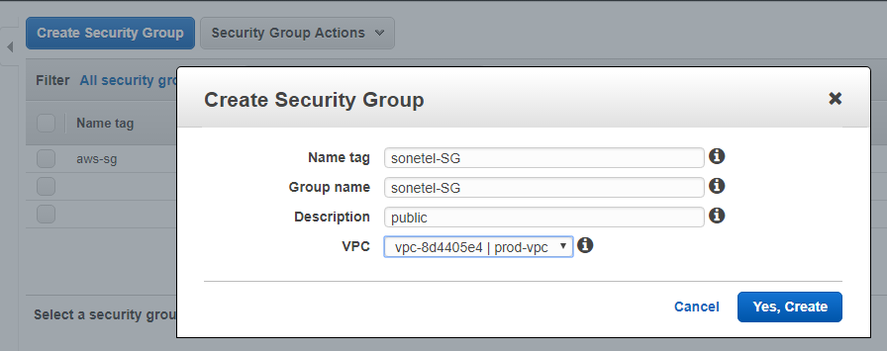

Add inbound rules

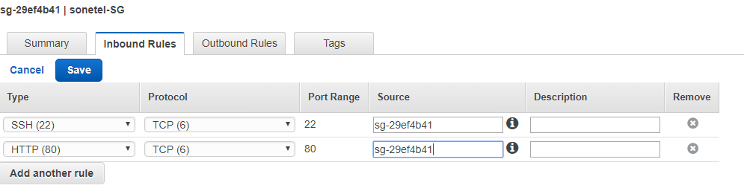

Now create Route Table with your selected vpc and associated your subnets with route table

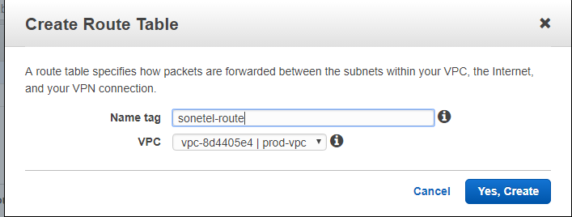

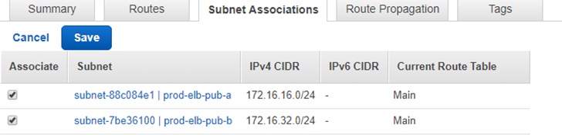

Creating Ec2 Instance:

Goto Ec2 services->Launch instance

Step 1: Choose an Amazon Machine Image (AMI)



Step 2: Choose an Instance Type

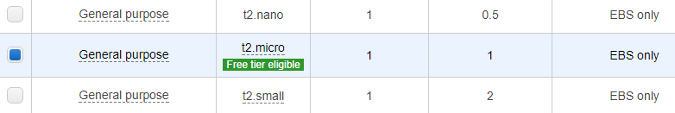

Step 3: Configure Instance Details

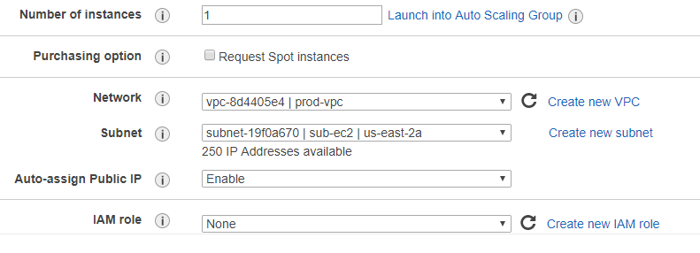

Step 4: Add Storage



Step 5: Configure Security Group

I am selecting my existing security group

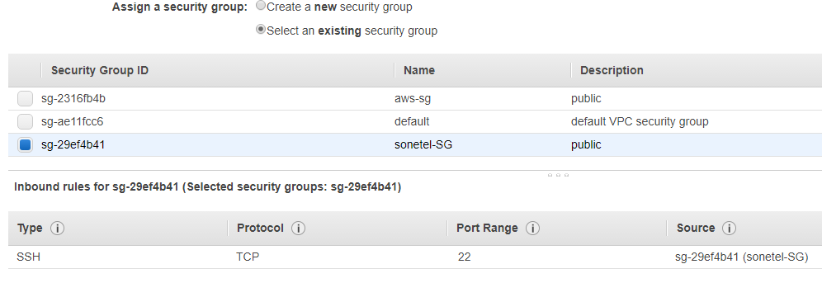

Create key pair and launch instance and view



Now select the running ec2 instance and connect from your local Linux machine with keypair and ip address

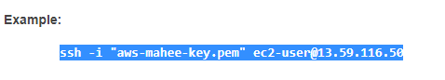

After connecting to Ec2 instance

Install nginx server





Now goto Ngnix config file and configure the nginx server



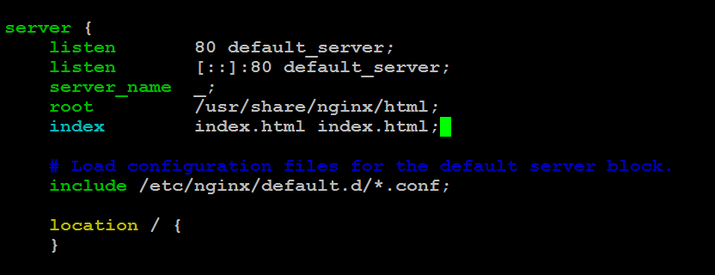

Now goto nginx root directory /usr/share/nginx/html

Create index.html file

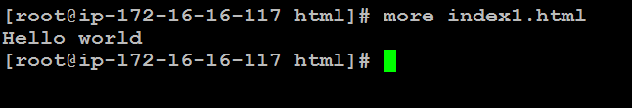

Start the nginx service



Now goto your browser and enter ec2 ip address

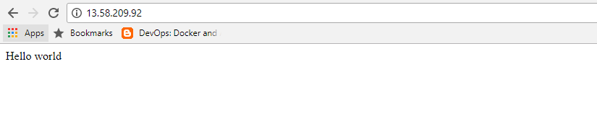

Installing puppet master in ec2 instance

## Enable the Puppet Package Repository

rpm -ivh https://yum.puppetlabs.com/puppetlabs-release-el-6.noarch.rpm

## 

## Install Puppet on the Puppet Master Server

## vim /etc/yum.repos.d/puppetlabs.repo

## 

yum install puppetserver

## 

### Upgrading

**#** puppet resource package puppet-server ensure=latest

Create web-server role in Master Server

## Goto # cd /etc/puppet/modules

## Create a directory “apache” and in apache create sub-directories

## mkdir apache->cd apache-> mkdir {files,manifests,templates,tests}

## 