PROGRAM 3: VACUUM CLEANER PROBLEM
Aim
The aim of this experiment is to implement the Vacuum Cleaner Problem using a Simple Reflex Agent.
Objective
To clean all dirty rooms using a simple vacuum cleaner agent.
Algorithm
Algorithm: VacuumCleaner()
Step 1: Start.
Step 2: Initialize the environment with two rooms (A and B).
Step 3: Place the vacuum cleaner in the initial room.
Step 4: Check whether the current room is Dirty or Clean.
Step 5: If the room is Dirty,
Clean the room.
Step 6: Otherwise,
Move to the next room.
Step 7: Repeat Steps 4 to 6 until all rooms become Clean.
Step 8: Display the final status of all rooms.
Step 9: Stop.
FLOW CHART
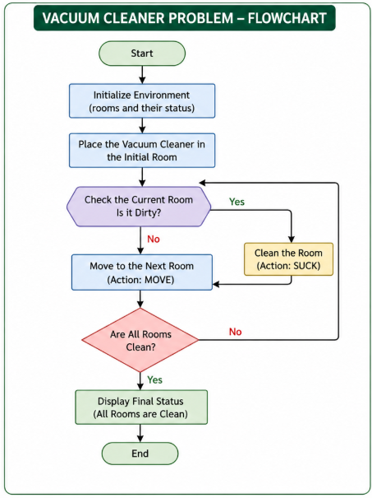

SOURCE CODE:
def vacuum_cleaner(env, location):
steps = []
while 'Dirty' in env.values():
if env[location] == 'Dirty':
steps.append(f"Cleaning {location}")
env[location] = 'Clean'
else:
steps.append(f"{location} is already clean")
location = 'B' if location == 'A' else 'A'
return steps

# Initial environment: both rooms dirty
environment = {'A': 'Dirty', 'B': 'Dirty'}
start_location = 'A'

actions = vacuum_cleaner(environment, start_location)
for action in actions:
print(action)
print("192311189-B mahesh babu")
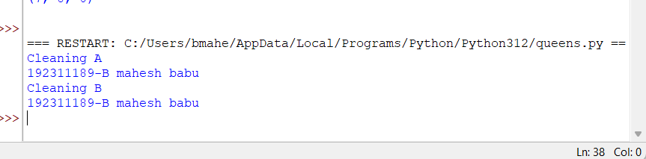

Result
Thus, the Python program for the Vacuum Cleaner Problem was executed successfully.

