EXPERIMENT 1: 8-Queen Problem

Aim: To solve the 8-Queen problem using the Backtracking algorithm.

Objectives:
- To understand the 8-Queen problem.
- To implement the Backtracking algorithm.
- To place eight queens on a chessboard so that no two queens attack each other.
- To find a valid solution efficiently.

Algorithm:
- Start with the first row.
- Place a queen in a safe column.
- Move to the next row.
- If a safe position is found, place the queen.
- If no safe position exists, backtrack to the previous row.
- Repeat until all eight queens are placed.
- Display the solution.

Flow Chart

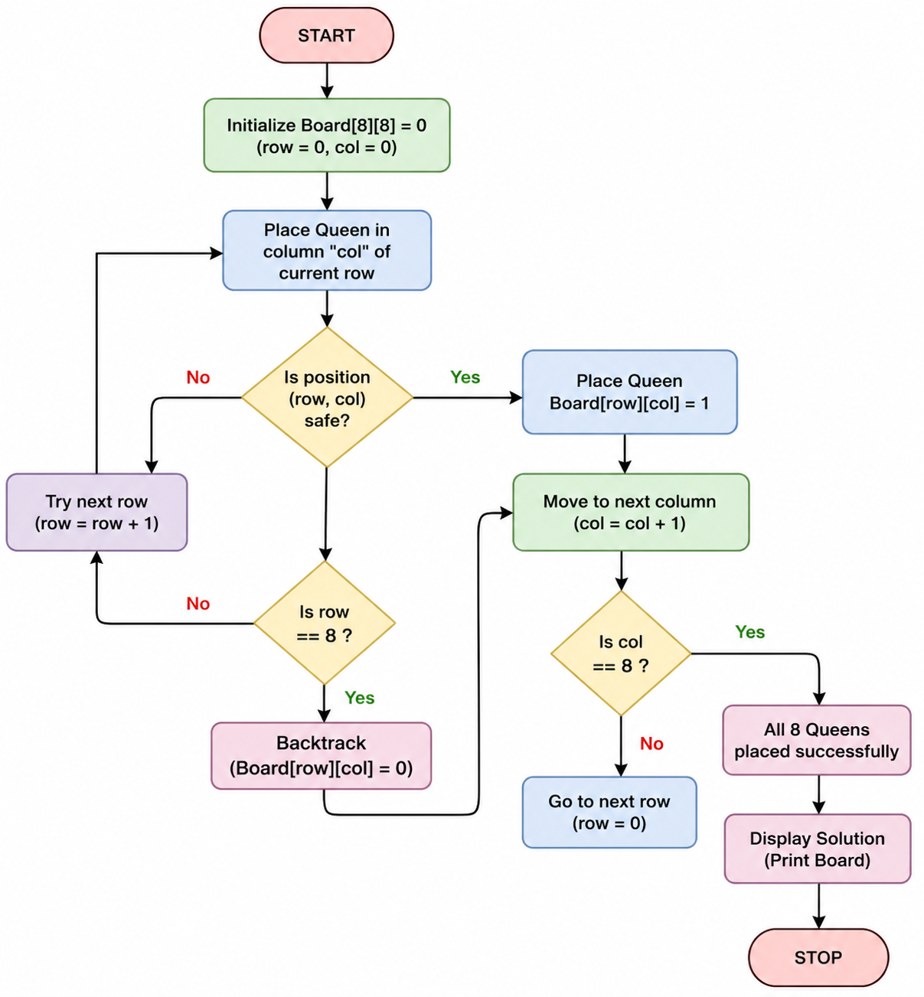

Source Code:
print("192311189 - Mahesh Babu")
print("Enter the number of queens:")
N = int(input())
board = [[0] * N for _ in range(N)]
def attack(i, j):
# Check row and column
for k in range(N):
if board[i][k] == 1 or board[k][j] == 1:
return True
# Check diagonals
for k in range(N):
for l in range(N):
if (k + l == i + j) or (k - l == i - j):
if board[k][l] == 1:
return True
return False
def N_queens(n):
if n == 0:
return True
for i in range(N):
for j in range(N):
if (not attack(i, j)) and (board[i][j] != 1):
board[i][j] = 1
if N_queens(n - 1):
return True
board[i][j] = 0
return False
# Solve the problem
if N_queens(N):
print("\nSolution:")
for row in board:
print(row)
else:
print("No solution exists.") 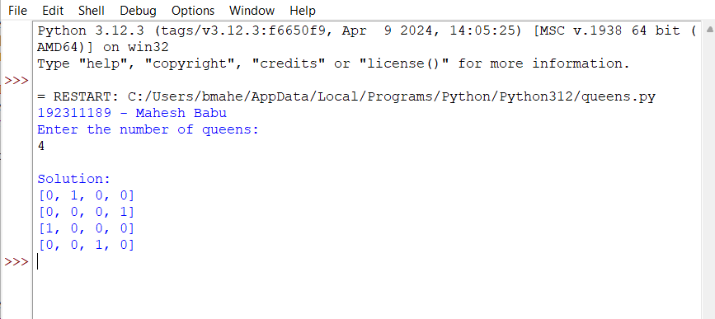

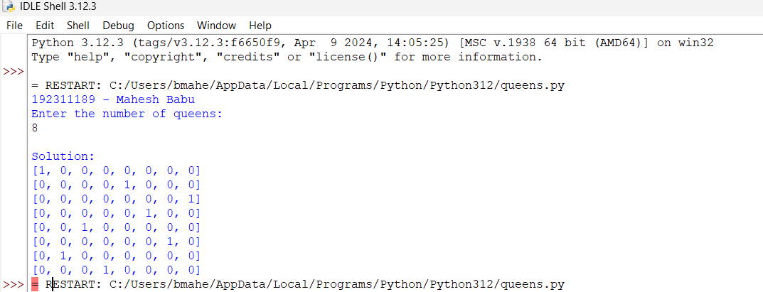

Result:
The 8-Queen problem was successfully solved using the Backtracking algorithm, and all eight queens were placed on the chessboard such that no two queens attack each other.

