Question  
Please create the CSS necessary to turn the two attached HTML files into the pictures below:

File 1:  
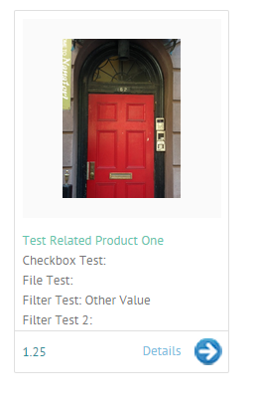

Note: The width of the box with the borders should be 217px

File 2:

Using the CSS you created in part one, add in the necessary styles to make a row of the boxes responsive to screen size (depending on screen size, there should be 1 or more of the product boxes on a line, so that the width of the screen is filled up, with as many rows as necessary to display all of the boxes):

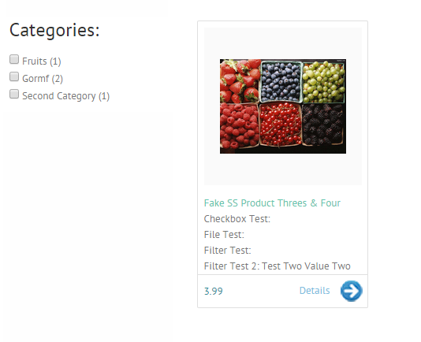

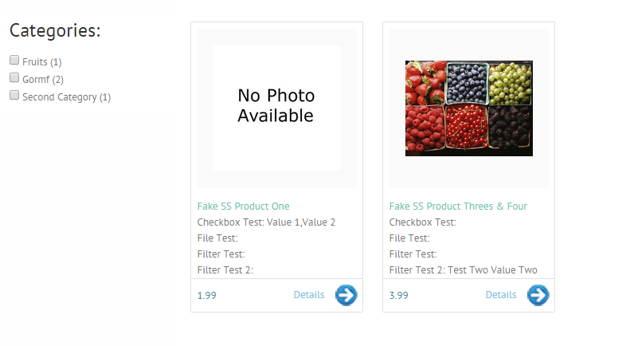

The smallest screen should have one box per line, slightly larger screens would have two boxes per line, screens larger than that would have 3 per line, then 4 per line, etc. as screen width permits. Use your discretion for handling how the sidebar should be displayed based on screen size.

Answer:

Look at the attached file named “stylesheet.css” for answer.