MyWellWallet and 1upHealth
Complete design for review
October 4, 2026 · Design only · No client secrets, tokens, or production access are included

1. Purpose
MyWellWallet is a patient wallet for people who see more than one clinic and health plan. Apple Health already supplies what the iPhone measures: glucose, heart rate, steps, and blood pressure. Clinical and claims records will come from 1up Patient Access. The FHIR MCP server stays available as a switchable source until production, and stays in the codebase after that so a later provider-system path can use it again.
This document is the review copy of the two markdown designs in the repository. Building starts after this review.

2. Architecture
The diagram shows the phone, the two clinical sources, Apple Health, where tokens live, and where downloaded records land.
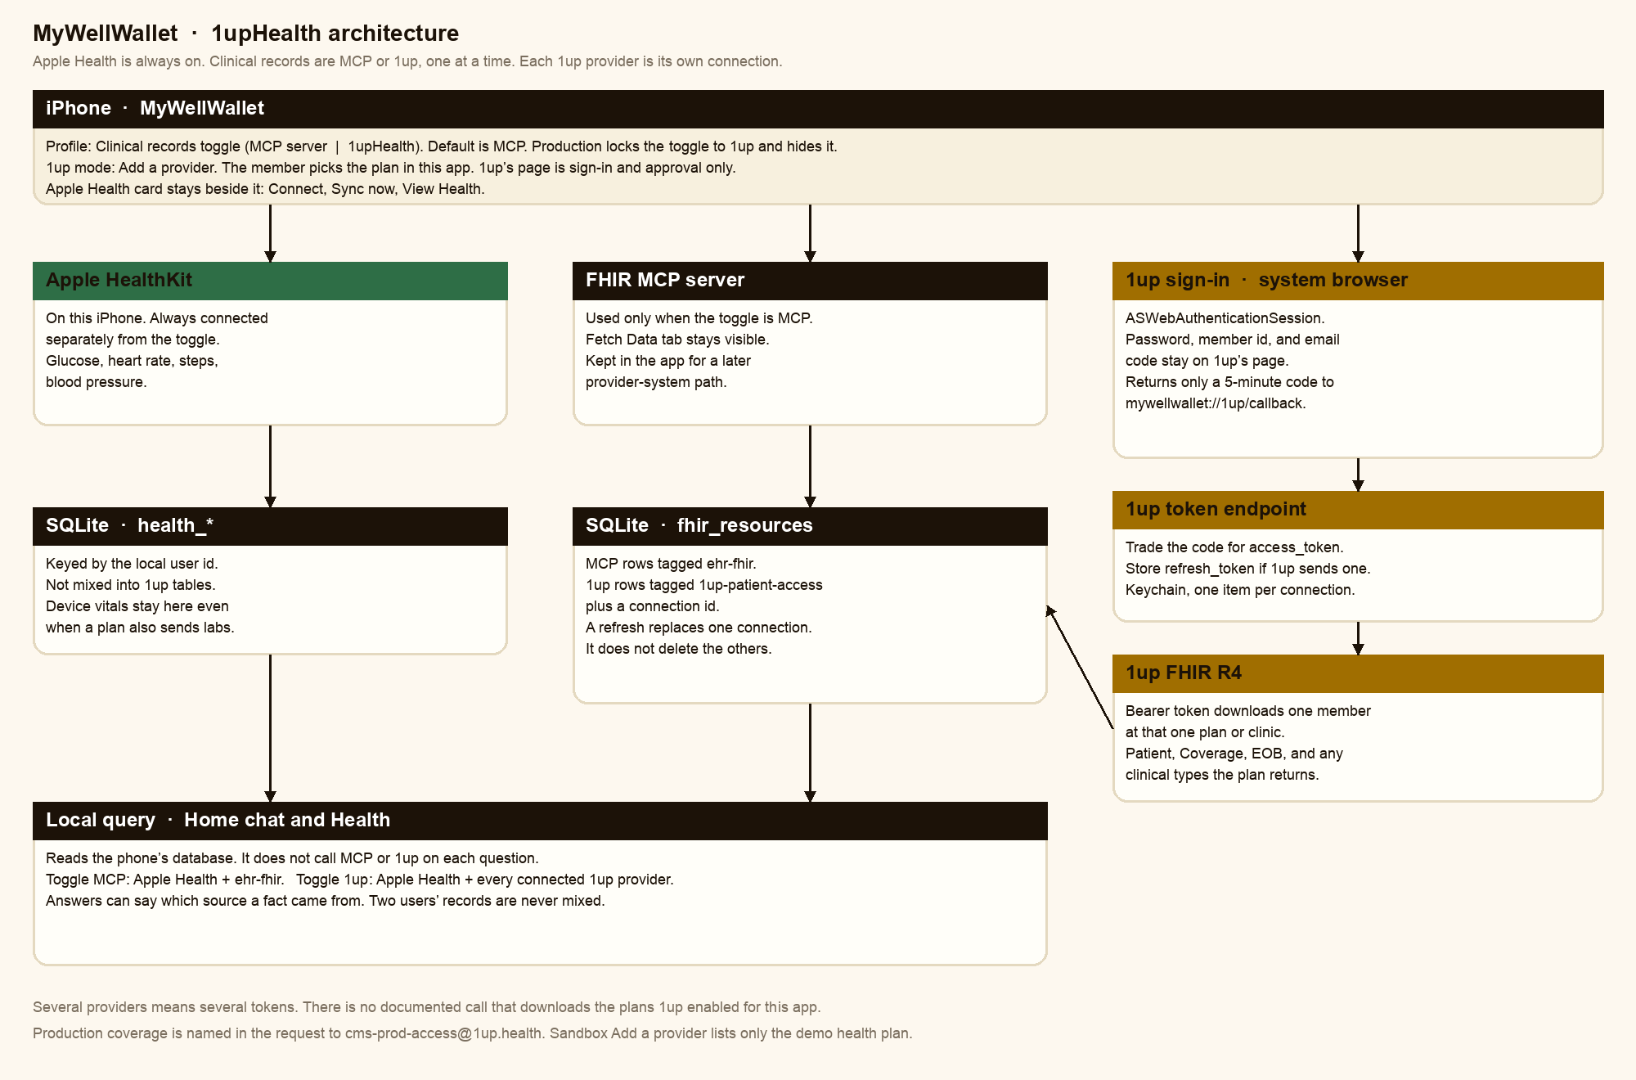

3. Which 1up product
The matching product is Patient Access. A member authorizes the app, and the app reads that one member’s FHIR R4 data. Access is read-only.
1up product | Use it? | Why
Patient Access | Yes | Member consent, one member at a time, read-only FHIR. Sandbox uses synthetic data. Production is a separate application to 1up.
Provider Access | No | Bulk data for a provider organization. Not a person’s wallet.
Payer-to-Payer | No | Exchange between payers, not a consumer app.
Patient Connect | No | 1up sunset this product on September 30, 2026. Do not build on it.

Sources: docs.1up.health — Dev Portal, Info for third-party developers, Client credentials and OAuth 2.0, Third-party applications, and the Patient Connect sunset notice.

4. The flow in plain language
The member never types a health-plan password, member id, or email code into MyWellWallet. Those fields exist only on 1up’s page, or on the health plan’s own login, inside an Apple system browser sheet. The app cannot read that page. When the member finishes, 1up sends the phone back to mywellwallet://1up/callback with a one-time code. The code lasts five minutes. It is not the health record. The app trades it for a token.
How we get an access token. The member taps Add a provider, picks one plan or clinic in MyWellWallet, and the app opens that provider’s authorize URL. After they approve, the app POSTs the code, the client id, and the client secret to https://auth.1uphealthdemo.com/oauth2/token with grant_type=authorization_code. The access_token in the response is sent as Authorization: Bearer on later FHIR downloads. One token is one member at one provider. A second provider is a second approval and a second token.
Where we persist it. The access token, and the refresh token when 1up includes one, go in the iOS Keychain under that connection’s id. They are not written to SQLite, logs, or the FHIR JSON. SQLite stores the connection’s display name, kind, 1up system id, authorize URL, FHIR Patient id, last sync time, and status. The downloaded chart goes in fhir_patients and fhir_resources, tagged with 1up-patient-access and the connection id.
How we get a refresh token. The app does not generate one. It keeps refresh_token only if that same token JSON contains it. 1up’s third-party app policy says a Patient Access app can be issued a refresh token, and that 1up can revoke it. Their older Connect API FAQ says the access token, the refresh token, and the authorization code each expire after 7200 seconds, that there is only one refresh token for a given access token, and that a new pair can be requested before those two hours end. The published demo example only says to copy access_token. The first successful sandbox exchange shows whether refresh_token and expires_in are present. If they are, a later refresh is a POST to the same token URL with grant_type=refresh_token. If 1up returns a new refresh token, it replaces the one in the Keychain. If the field is missing, or the refresh call fails, that connection shows Reconnect. The member approves again. Every other connection is left alone.
How sign-in stays out of our sight. ASWebAuthenticationSession is the system browser, not a WebView the app owns. The app does not add member-id, date-of-birth, email, or password fields for this step. It does not log the redirect URL. The session returns the code and a state value. The code is discarded as soon as the token call returns.

5. Apple Health beside 1up
 | Apple Health (already built) | 1up Patient Access
What it is | Data on this iPhone | The member’s health-plan or clinic record
Examples | Glucose, heart rate, steps, blood pressure | Patient, Coverage, ExplanationOfBenefit, plus clinical resources that plan returns
How we connect | HealthKit permission in Profile | Member signs in on 1up’s page and approves MyWellWallet
Where it lands | health_* tables, keyed by users.id | fhir_patients and fhir_resources, keyed by the FHIR Patient id
Provenance | apple-health | 1up-patient-access plus a connection id

Device vitals stay on Apple Health even after 1up is connected. If a plan also returns Observations or labs, those are stored as FHIR with the 1up tag. They are not written into the Apple Health tables.
Home chat reads the local database. It does not call MCP or 1up on each question. While the toggle is 1up, a query uses apple-health and every connected 1up provider. While it is MCP, a query uses apple-health and ehr-fhir. The two clinical tags are not mixed in one answer.

6. MCP and 1up as a toggle
The MCP FHIR gateway stays. It is the clinical source the app already has, and it may become the main way the wallet talks to provider systems later. The member uses one clinical source at a time. Apple Health is not on this toggle.
Choice | What the member sees | What startup does
MCP server (default) | Fetch Data stays in the bottom nav. Add a provider is hidden. | MCPClient.initialize() runs. 1up is not called.
1upHealth | Fetch Data is hidden. Profile shows Health plan: Add a provider, and one row per connection with Refresh and Disconnect. | Startup does not call MCP, so a down MCP host does not block the app.

The choice is stored on the device as clinical_record_source, either mcp or oneup. Switching does not delete the other source’s rows.
When production 1up is turned on, the toggle is removed from Profile and the source is forced to oneup. There is no switch to turn 1up off. Fetch Data stays unlinked. MCPClient and the fetch screen remain in the project. Turning MCP back on later is a new build, not a setting the member can flip.

7. Add a provider
Add a provider is on the Health plan card whenever the toggle is 1up. The member types part of a name and picks one result in MyWellWallet. That opens only that provider’s 1up sign-in. Finishing it adds a connection. It does not replace connections they already have. A person with a chronic disease can keep a health plan and one or more clinics at the same time.
The 1up page is not a directory. 1up’s Patient Access steps say the member selects the health plan in the third-party app first, and only then lands on that plan’s auth page.
- Health plans. In production the member chooses a plan that 1up has enabled for this app. Each plan has its own sign-in page. The same client id is used across those environments. 1up does not publish a typeahead API for plan names, so the app filters the list of enabled plans as the member types.
- Clinics and health systems. 1up’s Provider Search accepts a partial name: GET https://api.1up.health/connect/system/provider?query= matches a doctor, clinic, hospital, or address and returns the health-system id used to open that system’s authorization. That route belongs to the Connect API, which shipped with Patient Connect. That product sunset on September 30, 2026. The app will not call Provider Search until 1up confirms the route still works for a Patient Access app.
- Sandbox. Add a provider lists only the demo health plan. The search box filters that one row locally.
There is no documented call that downloads every provider 1up has enabled for this app. Production coverage is specified in the email to cms-prod-access@1up.health: one named payer, or all of their payer customers (they cite 60 or more health plans). After approval, 1up copies the client id and redirect URL into those plan environments. The docs do not publish the per-plan authorize URLs. 1up has to provide that list of names and sign-in URLs so Add a provider can search it. A static payer-network page and the old Connect catalog are not that list.

8. Refresh
Token refresh and data refresh are separate.
- Token. If the token response includes refresh_token, store it in that connection’s Keychain item. If expiry is within 10 minutes, or a FHIR call returns 401, POST grant_type=refresh_token to the same token URL before downloading. If 1up rotates the refresh token, replace the stored one. If there is no refresh token, or the call is rejected, that row shows Reconnect. Other connections stay connected.
- Data. Refresh on a connection downloads FHIR again after the token check. When the app becomes active, do the same for any connection whose last sync is older than its interval. The default interval is 24 hours, with the same choices as Apple Health (6 hours, 12 hours, 24 hours, weekly). iOS will not reliably do this while the app is suspended, so this is an on-open and on-tap strategy, not an overnight guarantee.
Refreshing or disconnecting one connection does not delete another connection’s rows or Apple Health rows.

9. What to enter in the 1up app
In the 1up Dev Portal, create a sandbox client:
Portal field | Value
Access type | Patient Access
Client name | MyWellWallet
Redirect URL | mywellwallet://1up/callback

The redirect string is copied exactly. It includes the scheme mywellwallet://, it has no trailing slash, and it has no query string. When it is placed on the authorize request it is percent-encoded as mywellwallet%3A%2F%2F1up%2Fcallback. The portal field itself is not percent-encoded. Do not register http://localhost or a second redirect for the sandbox client.
Copy client_id and client_secret from Sandbox Clients into a local gitignored config. Then email payer-patient-access@1up.health with the company name, a short description of MyWellWallet, and the client id, and ask them to sync the app to the demo environment. Creating the client is not enough.
The iOS bundle id is com.mywellwallet.mywellwallet. Info.plist does not declare a URL scheme yet. The sandbox build adds the scheme mywellwallet. The path /1up/callback is part of the redirect URL, not part of the scheme. The system browser session uses callbackURLScheme mywellwallet and prefersEphemeralWebBrowserSession false so the member can finish the identity form.

10. Authorize, token, and FHIR calls
Sandbox authorize URL, plus a state value the app generates and holds only in memory:
GET https://auth.1uphealthdemo.com/oauth2/authorize/test?client_id={CLIENT_ID}&redirect_uri=mywellwallet%3A%2F%2F1up%2Fcallback&state={STATE}
1up’s published demo link requires client_id and redirect_uri. State is added so a stale callback cannot be reused. The first sandbox attempt does not send scope, because the published demo URL does not include it. If a later test shows the token cannot read data, add scope=patient%2F*.read%20launch%2Fpatient%20openid. The slash in patient/*.read must be encoded.
Token exchange, immediately after the callback. The code is single-use.
POST https://auth.1uphealthdemo.com/oauth2/token with Content-Type application/x-www-form-urlencoded and the body client_id, client_secret, grant_type=authorization_code, and code. Do not log the request or the response. The client secret is not a Dart constant. Before a production client exists, this POST moves off the phone so the secret is not inside the app binary.
FHIR base URL: https://api.1uphealthdemo.com/r4/ . Every call sends Authorization: Bearer and Accept: application/fhir+json. The token is already limited to the member who consented, so these calls are not searched by name or member id.
Required, in order. A failure on Patient aborts the sync and does not delete the previous local rows for that connection: Patient, then Coverage, ExplanationOfBenefit, Organization, Practitioner, and Location. Then try Observation, Condition, MedicationRequest, AllergyIntolerance, Procedure, DiagnosticReport, Encounter, and Immunization, and ignore a 404 or an OperationOutcome that says the type is not supported. Follow a bundle link whose relation is next before moving to the next type.
Before insert, each resource is tagged:
meta.source = https://1up.health ; meta.tag codes 1up-patient-access and the connection id.

11. Step by step on the phone
- 1. Profile toggle is oneup. Fetch Data is hidden. MCP is not initialized.
- 2. Member taps Add a provider and picks the demo health plan (the only sandbox row).
- 3. The app generates state and opens the system browser to the authorize URL.
- 4. On 1up’s demo page the member confirms identity. The published synthetic member is John Allen, birthdate 10/19/1950, plan member id 123456789123, zip 02114. Those values are typed on 1up’s page, not stored in the app.
- 5. 1up redirects to mywellwallet://1up/callback?code=…&state=…
- 6. If the redirect has error, or state does not match, or code is missing, stop. No database write.
- 7. POST the code to the token URL. Save access_token and refresh_token, if present, in the Keychain for this connection. Drop the code from memory.
- 8. Download FHIR. Replace rows tagged with this connection id only.
- 9. Mark the row connected and set last synced.
Closing the browser sheet returns to Profile with no token change and no database write. Refresh on an existing row skips the browser when the access token is still outside the 10-minute expiry window.

12. Failures
Condition | What the app does
Member closes the auth sheet | Stay on Profile. No write.
Redirect error | Show error_description or error. No token call.
state does not match | Ignore the code.
Token HTTP error, or no access_token | Show the HTTP status. Leave a previous token in place if one existed.
GET Patient fails | Keep the new token so Refresh can retry. Keep previous FHIR rows.
A later required type fails | Keep Patient and any types already saved this run. The row shows sync incomplete.
An optional type fails | Continue.
401 after a refresh attempt | Drop this connection’s Keychain item. That row shows Reconnect.

13. First build, then production
The first build is sandbox only.
- Sandbox client in the Dev Portal, redirect URL registered, demo sync requested from 1up.
- Profile toggle, default MCP. 1up mode shows Add a provider with only the demo health plan.
- Token exchange, Keychain storage, FHIR download, and tags described above.
- Apple Health connect, sync, and the Health tab stay as they are.
- A home question can see the stored 1up Patient or Coverage record and still see Apple Health vitals.
Out of scope until that path works on the phone: production credentials, a token-exchange backend, writing data back to 1up, and calling Provider Search before 1up confirms it. The data model already allows a second connection. The sandbox list has only the demo health plan.
Production starts only after the sandbox flow is visible in the app. Email cms-prod-access@1up.health with the privacy and security attestation, a screen recording of the demo connection, terms of service, privacy policy, logo, a user support email, a security contact, a short description of who the app is for, and the choice of one payer or the broader plan network. That production build locks the toggle to 1up. Apple Health remains a separate connection on the phone.

14. Related files in the repository
- docs/ONEUP_HEALTH_CONNECTION_DESIGN.md
- docs/ONEUP_HEALTH_TECHNICAL_DESIGN.md
- docs/INTEGRATED_HEALTH_EHR_DESIGN.md
- docs/APPLE_HEALTH_SETUP.md

