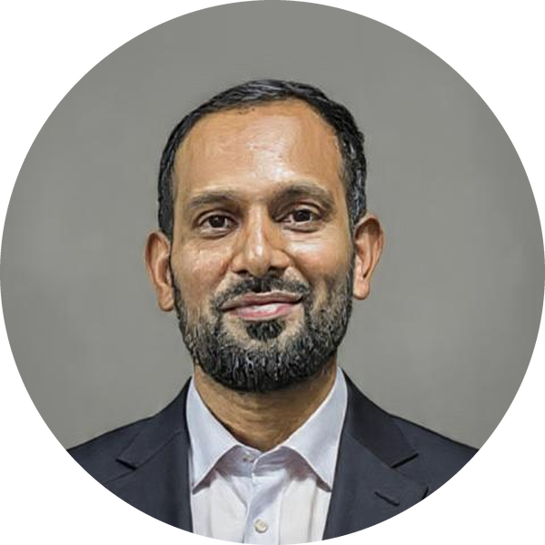  Mahesh  Basavaraj  Educator · AI Researcher  Contact  Location  Bengaluru, Karnataka, India  Phone  +91 98866 42542  Email  mahesh-csds@dsatm.edu.in  Email  BMaheshbasavaraj@gmail.com  ORCID  0000-0002-2242-212X  Google Scholar  aANFb2EAAAAJ  Scopus  60345533200  Website  maheshbasavaraj.github.io  At a glance | Cover Letter  Prepared for the Assistant Professor (Computer Science) role — UNSW Bengaluru Campus  25 October 2026 · The Selection Committee — Faculty Recruitment · UNSW Bengaluru · Embassy Manyata Business Park, Nagavara, Bengaluru 560045  Re: Application for Assistant Professor, Computer Science — UNSW Bengaluru Campus  Dear Members of the Selection Committee,  I am applying for the Assistant Professor, Computer Science position at the UNSW Bengaluru campus. I am currently Assistant Professor in CSE (Data Science) at DSATM, Bengaluru, and a doctoral researcher at Visvesvaraya Technological University. My sixteen years divide evenly between industry and academia, and both halves taught me the same habit: when a course needs software to make its ideas visible, I build it.  Teaching Software I Have Built  ▪ CPU Rush — OS students predict scheduling, paging, deadlock and file systems, commit to an answer, and a server grades every decision.  ▪ Data Structure Design Studio — a progressive, scored decision track under changing constraints.  ▪ Game Forge — generates single-file browser games, one concept each.  ▪ ButterCloud Quiz — students choose the best stack and architecture for realistic requirements.  Eight such tools are public at github.com/maheshbasavaraj and in daily classroom use, and every course I teach produces more. These are not demonstrations — they are how the syllabus is taught.  How I Teach  I teach through case studies and from first principles. I start with the basic necessity of a topic — why it exists, what breaks without it — and only then show how it works. The why earns a student's attention; the how earns the skill. Wherever a subject allows, the learning is hands-on: students decide, watch the machine answer, and correct themselves. They leave with a mental model they can defend, not definitions they can recite.  Teaching Experience  I have taught object-oriented programming, data structures, operating systems, database systems and deep learning at undergraduate and postgraduate level, and I supervise capstone projects end to end. At DSATM I designed and led a six-month Agentic AI immersion with Capabl and run faculty development programmes for colleagues. I am ready to adopt myExperience and the Integrated Curriculum Framework, to work within standards-based assessment, and to complete Ready to Teach.  Research and Industry  My research in Agentic AI, large language models and spatio-temporal deep learning has produced three utility patents, a published application and eleven peer-reviewed papers — work that fits this campus's AI focus and its Centre of Excellence with Deloitte India. Eight years at Infosys and Accenture let me build work-integrated learning around real repositories, code review and delivery discipline.  UNSW Bengaluru offers a top-20 global degree with local consequence, and Progress for All is a mission I can teach to. Helping establish a new campus's standards rather than inherit them is rare. I am based in Bengaluru, ready from the first teaching period, and glad to demonstrate CPU Rush live or teach a class on any topic in the curriculum.  Yours sincerely,  Mahesh Basavaraj  Assistant Professor, CSE (Data Science) · DSATM, Bengaluru  Enclosures: Curriculum Vitae · Research Publications & Patents · Teaching Methodology
  8  years teaching CS | 11  peer-reviewed papers
  4  patents & applications | 8  teaching tools built

