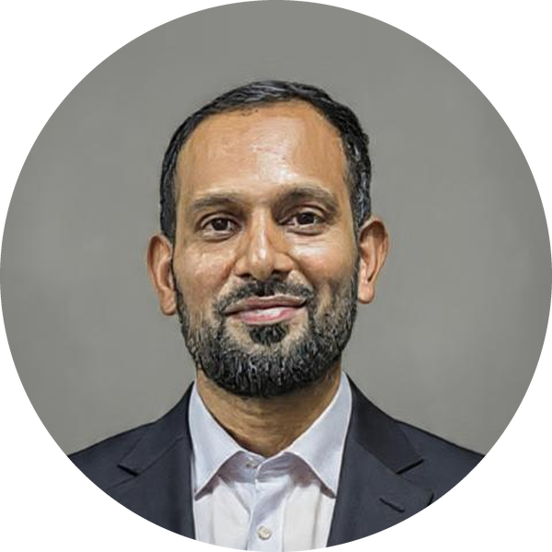  Mahesh  Basavaraj  AI Researcher · Educator  Contact  Location  Bengaluru, Karnataka, India  Phone  +91 98866 42542  Email  mahesh-csds@dsatm.edu.in  Email  BMaheshbasavaraj@gmail.com  ORCID  0000-0002-2242-212X  Google Scholar  aANFb2EAAAAJ  Scopus  60345533200  Website  maheshbasavaraj.github.io  At a glance  Research Areas  ▪ Agentic AI & LLM systems  ▪ Spatio-temporal & attention models  ▪ EEG & brain–computer interfaces  ▪ Cognitive IoT & cross-layer optimisation  ▪ Responsible AI & fairness  ▪ Anomaly detection | Research Publications & Patents  Prepared for the Assistant Professor (Computer Science) role — UNSW Bengaluru Campus  Research Profile  My research asks how intelligent systems can be made reliable and useful outside the laboratory: how agentic systems built on large language models coordinate to solve multi-step problems, how deep models recover structure from noisy spatio-temporal signals, and how constrained networked devices share resources fairly. The work is deliberately applied. It has produced three utility patents and a published application, and it is shaped by eight years of building production software before I moved into academia. Current threads are the evaluation and reliability of LLM-based agents, attention architectures for EEG and motor-imagery decoding, cross-layer optimisation in heterogeneous IoT, and fairness in deployed machine-learning models.  Selected Contributions  ▪ Multi-scale spatio-temporal attention for motor-imagery decoding — a network combining frequency–spatial parallel attention with multi-scale temporal modelling (IEEE ICIICS 2026).  ▪ Lightweight multi-agent Q-learning for wireless IoT — cross-layer optimisation that balances energy across heterogeneous devices without central coordination (IEEE ICMNWC 2025).  ▪ Agentic LLM systems as a route to general intelligence — a collaborative multi-agent framework analysed against SayCan, ChatDev and Devin (INDJCST 2025).  ▪ Fairness in deployed models — a patented framework for bias mitigation and fairness verification in machine-learning pipelines (2026).  Journal Articles  Medical Science Educator Comment on “Incorporating Artificial Intelligence in Qualitative Research: Exploring the Role of ChatGPT in Thematic Analysis”  Vol. 36, Issue 2, pp. 1063–1064 · 2026  DOI 10.1007/s40670-025-02618-y  with S. Banerjee, I. H. Madar  J. Neurological Sciences Comment on “Improving care for amyotrophic lateral sclerosis with artificial intelligence and affective computing”  Vol. 486 · 2026  with S. U. Adhyapak, P. Mishra  INDJCST Agentic Approach in the Quest for AGI  Indian Journal of Computer Science and Technology, pp. 279–289 · 2025  DOI 10.59256/indjcst.20250402043  IRJET A Review of Deep Learning Techniques in Detection of Anomaly in Credit Card Transactions  Vol. 9, Issue 9 · 2022  Patents  01 A Bulk Silkworm Cocoon Inspection and Assisted Sorting Machine Using Shallow-Layer Conveyor Spreading  Utility patent · 2026  02 Adaptive Quality of Service Management System for Heterogeneous Internet of Things Networks  Utility patent · 2026  03 Ethical and Responsible AI: Bias Mitigation and Fairness in Machine Learning Models  Utility patent · 2026  04 Cloud-based Social Virtual Reality IoT Network with Device Synchronization Between Real and Virtual Worlds  Published application 202441098998 · filed 14 Dec 2024, published 20 Dec 2024
  11  peer-reviewed papers | 4  patents & applications
  4  journal articles | 7  conference papers
Doctoral Research  Ph.D. in Computer Science & Engineering, Visvesvaraya Technological University (enrolled 2023), in applied deep learning and intelligent systems. Supervised through DSATM, Bengaluru.  Research Training  Deep Learning — Elite  NPTEL · 2025  Blockchain Technology  NPTEL · 2025  Data Analytics with Python  NPTEL · 2024  Machine Learning & NLP  Infosys Springboard FDP · 2025  Cyber Security  AICTE · VTU FDP · 2023  Reproducibility  Research code and teaching systems are public at github.com/maheshbasavaraj | Conference Papers  ICIICS 2026 Multi-Scale Spatio-Temporal Network with Frequency–Spatial Parallel Attention for Motor Imagery Classification  3rd Intl. Conf. on Integrated Intelligence and Communication Systems, pp. 1–7 · May 2026  DOI 10.1109/ICIICS67880.2026.11483407  with R. A. M. Sait, B. Y. Vineetha, G. Priyadharshini, N. Sitanshu  ICIICS 2026 Predictive Mobility-Aware Cognitive Medium Access Control for Underwater Vehicle Communication  3rd Intl. Conf. on Integrated Intelligence and Communication Systems · 2026  with P. Maderamitla, J. Ulaganathan, G. Bindu, K. Anguraj  ICBDML 2026 Harnessing Large Language Models for Next-Generation Artificial Intelligence Applications  2nd Intl. Conf. on Big Data and Machine Learning · Feb 2026  with N. Garg, S. Yangalasetty, T. Vangalapat, M. Kumari, M. Gupta  IEEE ICMNWC 2025 Lightweight Multi-Agent Q-learning Cross-Layer Optimization in Wireless IoT Networks for Balanced Energy Utilization  IEEE Intl. Conf. on Modelling, Networks and Wireless Communication · Dec 2025  ICEASD 2024 Using AI Agents Built on LLMs for Building AGI  Intl. Conf. on Engineering Advancements and Sustainable Development, JETIR Vol. 11, Issue 5 · May 2024  ICAMSnT 2023 The Alignment Problem in AI  Intl. Conf. on Advances in Modern Science and Technology · Apr 2023  ICAPCTA 2022 Evaluating OpenAI Codex for Real-World Coding  Intl. Conf. on Advances in Parallel Computing Technologies & Applications · Jan 2022  Research Supervision  Final-year capstone and project supervision since 2021 (DSATM, City Engineering College, T. John Institute of Technology), across applied machine learning, data engineering and intelligent systems. Teams are expected to produce a working artefact, a written report and a defensible evaluation — several capstones have grown out of the open-source teaching systems listed overleaf.  Research Communication & Outreach  I write and speak about AI for a general technical audience, which keeps my research legible outside the conference circuit.  ▪ The Ghost in the Feed: Inside the First AI Civilization  ▪ Thermodynamic Computing: Extropic’s Chip and the Path to Efficient AI  ▪ The Patent Paradox: AI and the Future of Intellectual Property  ▪ Indian Academia’s Obsolete Secret  ▪ Scientific Papers are DOA  Video explainers on the Echoes of AI YouTube channel.  Collaboration Interests  Open to joint work on agent evaluation and LLM reliability, spatio-temporal modelling for biomedical signals, QoS in large-scale IoT deployments, and applied fairness auditing — particularly with industry partners who can supply real data and deployment constraints.

