
National College of Computer Studies
(NCCS-College of IT & Management)
Final Examination (2020)
BCA/First Semester/ CAMT104: Mathematics ICandidates are required to answer the questions in their own words as far as practicable.

Full Marks: 50
Time: 2hr 40 min
Set A

Group B
Attempt any six questions [6×5=30]
- Out of group of 20 teachers in a school, 10 teach Maths, 9 teach Physics, 7 teach Chemistry, 4 teach Math and Physics, but none teach both Math and Chemistry:
- How many teach Physics and Chemistry?
- How many teach only Physics?
- How many teach only Chemistry?
- Let R be the relation on the set of integers Z defined by 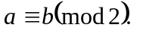Prove that R is an equivalence relation on Z.
- Prove that (using properties):
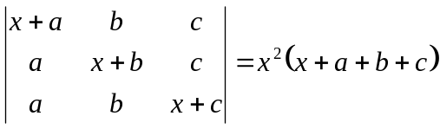
- Define orthogonal matrix. If a transformation T is defined by 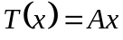 where 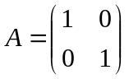, Show that T is an orthogonal transformation.
- Derive the standard equation of the parabola 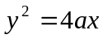
- If 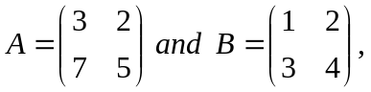verify that 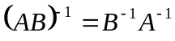
- In how many ways can the letter of the word “TUESDAY” be arranged? How many of these arrangements donot begin with T? How many begin with T and donot end with Y?

Group C
Attempt any two questions. [2×10=20]
- Define composite function. Let 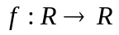be defined by 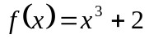and 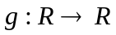be defined by 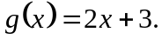 Find 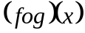and 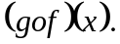 Also show that 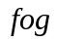and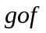are bijective.
- Define Arithmetic Mean. State the properties of Arithmetic Progression (A.P). If ‘a’ and ‘b’ be any two unequal positive numbers then show that:
  - 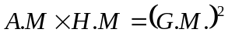
  - 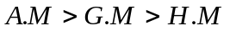
- Define Scalar Tripple product in three dimensional space and interpret its geometrically meaning. Using vector method prove that:

***********

National College of Computer Studies
(NCCS-College of IT & Management)
Final Examination (2020)
BCA/First Semester/ CAMT104: Mathematics ICandidates are required to answer the questions in their own words as far as practicable.

Full Marks: 50
Time: 2hr 40 min

Set B

Group B [6×5=30]
Attempt any six questions
- In a group of students, 24 study Maths, 30 study Biology, 22 study Physics, 8 study Math only, 14 study Biology only, 6 study Biology and Physics only and 2 study Maths and Biology only. Find:
  - How many study all three subjects?
  - How many students were in the group?
- Define an irrational number. Show that is an irrational number.
- Express the following matrix as a sum of a symmetric matrix and skew-symmetric matrix:
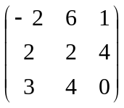
- Define linear transformation. Transform 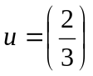and 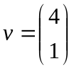by the matrix 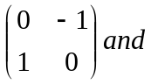show that this transformation is linear.
- Prove the following determinant using properties:
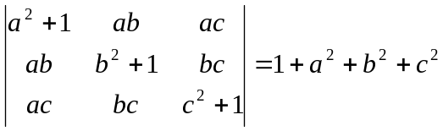
- Derive the standard equation of an ellipse: 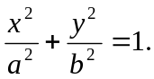
- From 6 gentlemen and 4 ladies a committee of 5 is to be formed. In how many ways can this be done so as to include at least one lady?

Group C
Attempt any two questions. [2×10=20]
- a. Define domain and range of a function. Find the domain a function 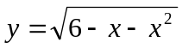.
b. Let a function 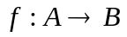be defined by 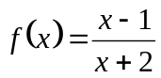with 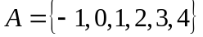and 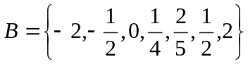. Find the range of f. Is the function f one to one and onto both? If not, how can you make it one to one and onto both?
- State the properties of Geometric Progression (G.P). If 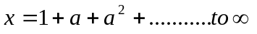and
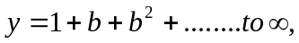Prove that : 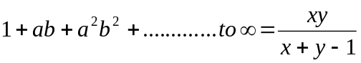where 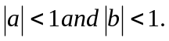
- Define vector product of two vectors and interpret its geometrically meaning. Using vector method prove that:

***********

