**DevOps Tasks 1**

**Write bash script to loop on all databases into a postgresql server then backup and compress each database into a different directory then upload it to a S3 bucket**

**STEP1: Install and Create Postgresql database.**

$ sudo sh -c 'echo "deb https://apt.postgresql.org/pub/repos/apt $(lsb_release -cs)-pgdg main" > /etc/apt/sources.list.d/pgdg.list'

$ wget --quiet -O - https://www.postgresql.org/media/keys/ACCC4CF8.asc | sudo apt-key add -

Warning: apt-key is deprecated. Manage keyring files in trusted.gpg.d instead (see apt-key(8)).



$ sudo apt update

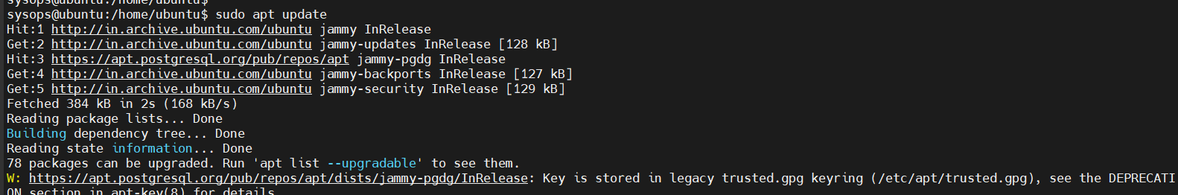

$ sudo apt install postgresql postgresql-contrib

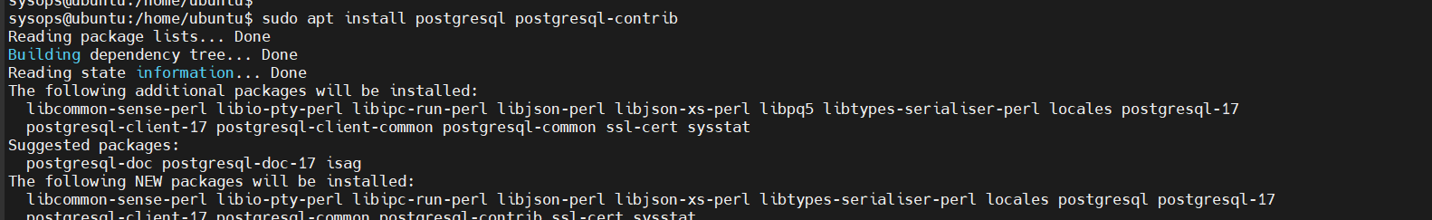

$ sudo su – postgres

postgres=# CREATE DATABASE TestDB;

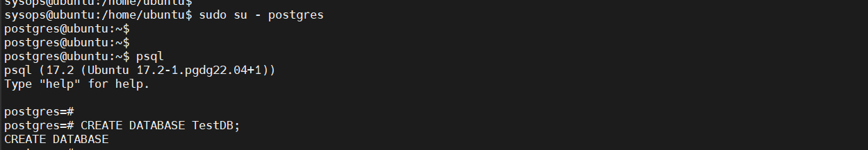

postgres=# \conninfo



$ sudo -u postgres psql

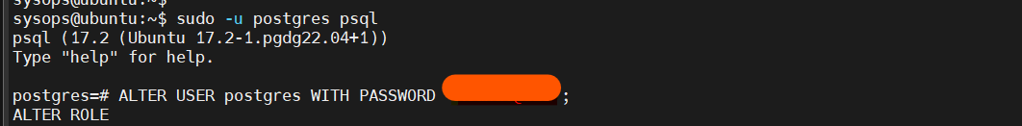

postgres=# ALTER USER postgres WITH PASSWORD 'Redhat@123';



$ sudo systemctl restart postgresql



$ psql -U postgres -W

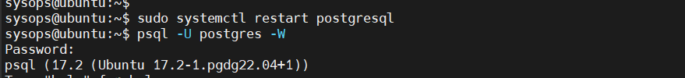

postgres=# \q

$ psql -U postgres -h localhost -d postgres -c "\l"

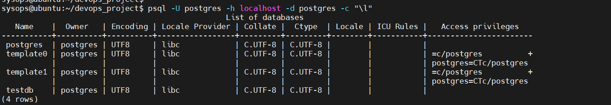

**STEP 2: Install and Configure AWS cli**

$ sudo apt update

$ sudo apt install awscli -y



$ aws –version



$ aws configure

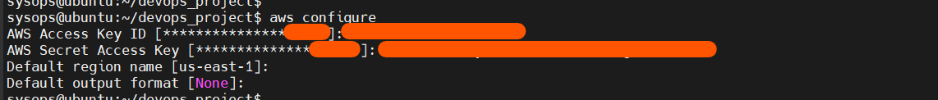

$ aws s3 ls



**STEP 3: Create S3 Bucket in AWS account as below,**

Bucket name must be unique. My bucket name is "**my-postgresbucket**." Additionally, I need to block public access by using the following checklist with the default settings.

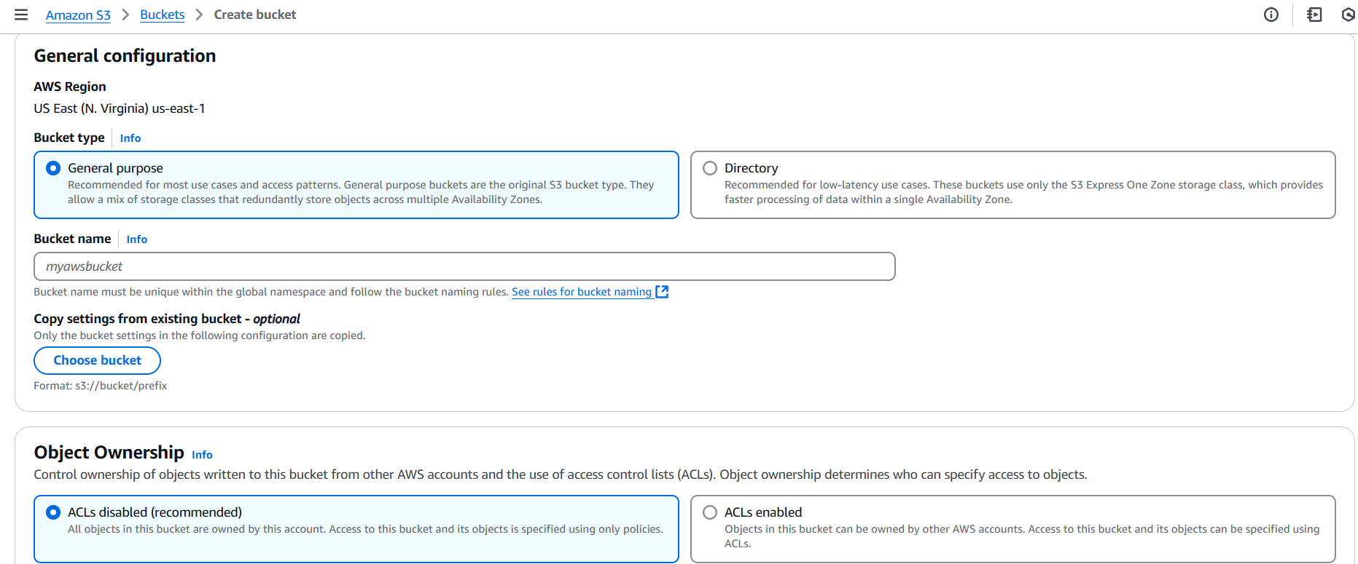

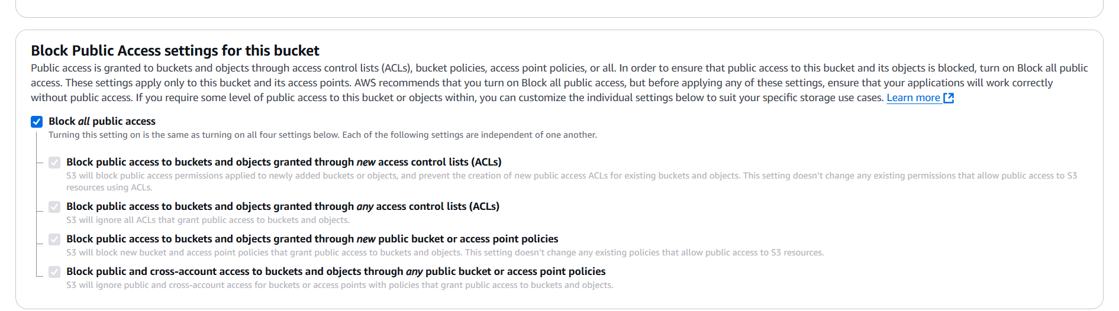

Next, click on create bucket.  
  
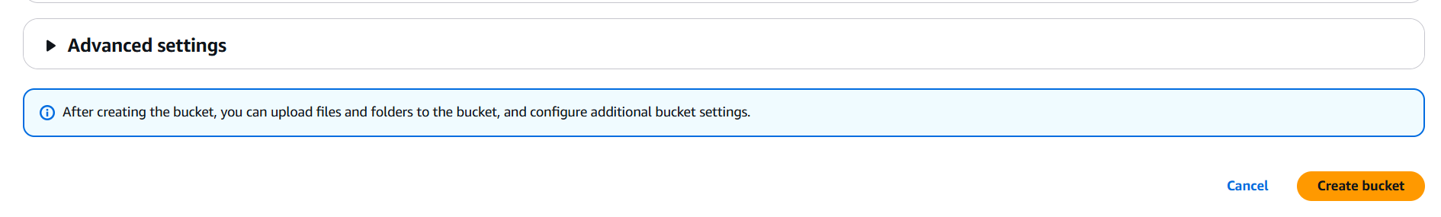

Ckeck the available Bucket on AWS S3 service,

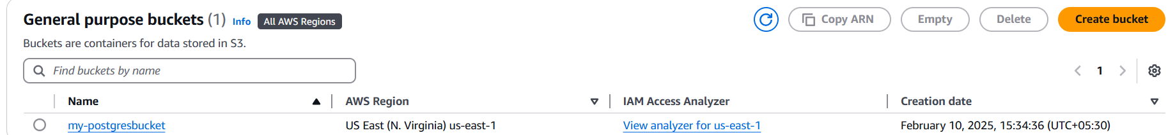

**STEP 4: Create a bash script as below**.

$ nano backup_postgres.sh

#!/bin/bash

# Define AWS S3 bucket name

S3_BUCKET="my-postgresbucket"

# Define PostgreSQL credentials

PG_USER="postgres"

PG_HOST="localhost"

BASE_BACKUP_DIR="/home/sysops/postgres_backups"

# Export PostgreSQL password to avoid interactive prompt

export PGPASSWORD=$PG_PASSWORD

# Create the main backup directory if it does not exist

mkdir -p $BASE_BACKUP_DIR

# Get the list of all databases

DB_LIST=("postgres" "testdb")

# Loop through all databases and back them up

for DB in "${DB_LIST[@]}"; do

TIMESTAMP=$(date +%Y-%m-%d_%H-%M-%S)

DB_BACKUP_DIR="$BASE_BACKUP_DIR/$DB"

BACKUP_FILE="$DB_BACKUP_DIR/${DB}_${TIMESTAMP}.sql.gz"

# Create a separate directory for each database

mkdir -p $DB_BACKUP_DIR

echo "Backing up database $DB"

pg_dump -U $PG_USER -h $PG_HOST -F c $DB | gzip > $BACKUP_FILE

echo "Uploading $BACKUP_FILE to S3"

aws s3 cp $BACKUP_FILE s3://$S3_BUCKET/$DB/

# Remove the local backup after upload

rm -f $BACKUP_FILE

done

echo "All databases have been backed up and uploaded to S3 successfully"

Next, change the file permissions by granting execute access using the following command.

$ chmod +x backup_postgres.sh

Before running the script, we need to store the PostgreSQL user password as a secret instead of placing it in the Bash script, as shown below.

$ nano ~/.pgpass

localhost:5432:*:postgres:<postgres pass>



$ chmod 600 ~/.pgpass

$ bash backup_postgres.sh

After successfully running the above script then backup will store on S3 Bucket in different directory as shown in below screenshot.

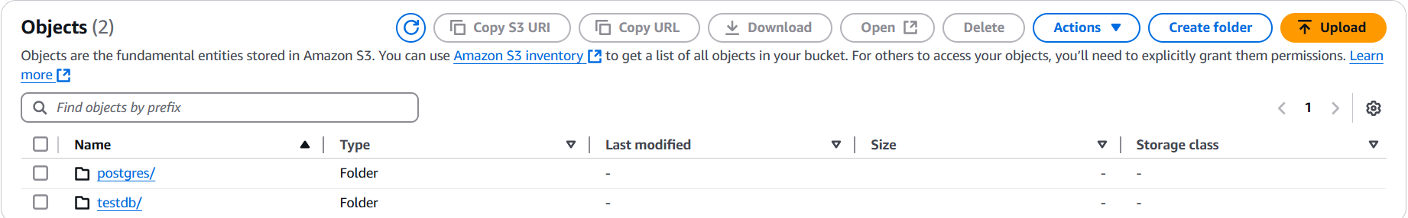

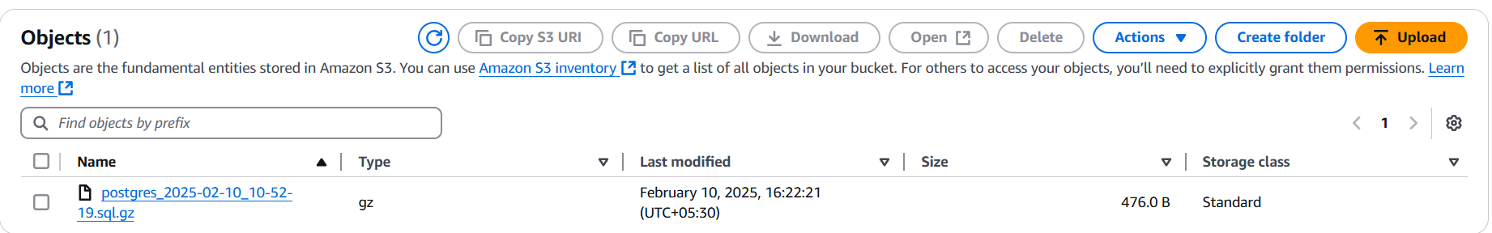

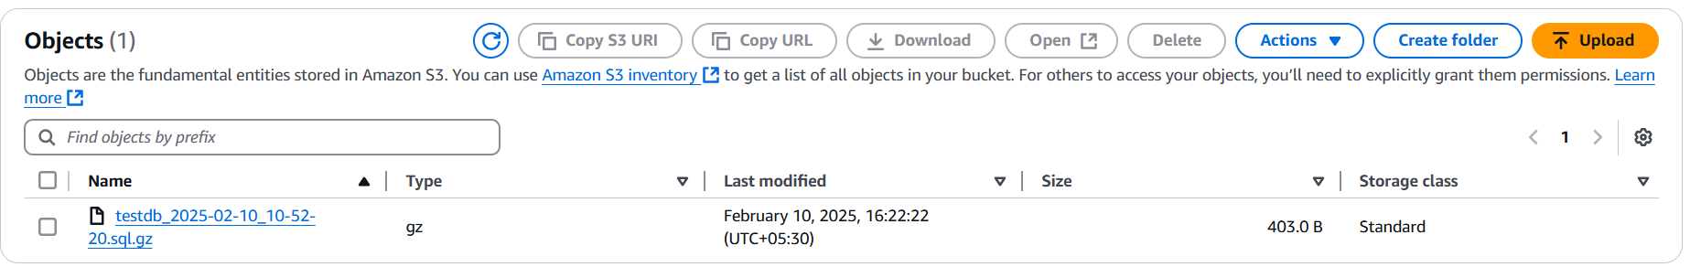

Also, check the backup directory on the server by using the following command.

$ cd /home/sysops/postgres_backups

$ ls

