**DevOps Tasks 2**

Create a Terraform project to create:

* 1VPC
* 3 public subnets
* 3 private subnets
* 3 Private routing tables
* 1 public routing table
* 1 internet gateway
* 3 Elastic IP's for NAT Gateways
* 3 NATGateWays

This document will give you brief idea about to create infrastructure on AWS using .tf file

**Pre-requisites:**

1. Terraform must be up and running on server
2. Terraform must be connected to provider AWS using aws configure command.

**STEP 1: Install and Configure AWS cli**

$ sudo apt update

$ sudo apt install awscli -y



$ aws –version



$ aws configure

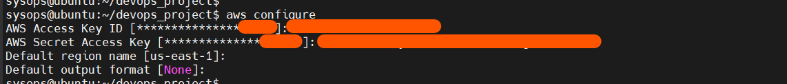

**STEP 2: Write a tf file to create infrastructure on AWS as below**,

$ nano main.tf  
  
provider "aws" {

region = "us-east-1"

}

resource "aws_vpc" "my_vpc" {

cidr_block = "10.0.0.0/16"

tags = {

Name = "MyVPC"

}

}

resource "aws_subnet" "public_subnets" {

count = 3

vpc_id = aws_vpc.my_vpc.id

cidr_block = "10.0.${count.index}.0/24"

map_public_ip_on_launch = true

tags = {

Name = "Public-Subnet-${count.index + 1}"

}

}

resource "aws_subnet" "private_subnets" {

count = 3

vpc_id = aws_vpc.my_vpc.id

cidr_block = "10.0.${count.index + 3}.0/24"

tags = {

Name = "Private-Subnet-${count.index + 1}"

}

}

resource "aws_internet_gateway" "igw" {

vpc_id = aws_vpc.my_vpc.id

tags = {

Name = "My-Internet-Gateway"

}

}

resource "aws_route_table" "public_rt" {

vpc_id = aws_vpc.my_vpc.id

tags = {

Name = "Public-Route-Table"

}

}

resource "aws_route" "public_internet_access" {

route_table_id = aws_route_table.public_rt.id

destination_cidr_block = "0.0.0.0/0"

gateway_id = aws_internet_gateway.igw.id

}

resource "aws_eip" "nat" {

count = 3

tags = {

Name = "Elastic-IP-${count.index + 1}"

}

}

resource "aws_nat_gateway" "nat" {

count = 3

subnet_id = element(aws_subnet.public_subnets[*].id, count.index)

allocation_id = element(aws_eip.nat[*].id, count.index)

tags = {

Name = "NAT-Gateway-${count.index + 1}"

}

}

resource "aws_route_table" "private_rt" {

count = 3

vpc_id = aws_vpc.my_vpc.id

tags = {

Name = "Private-Route-Table-${count.index + 1}"

}

}

resource "aws_route" "private_nat_access" {

count = 3

route_table_id = aws_route_table.private_rt[count.index].id

destination_cidr_block = "0.0.0.0/0"

nat_gateway_id = aws_nat_gateway.nat[count.index].id

}

$ terraform init

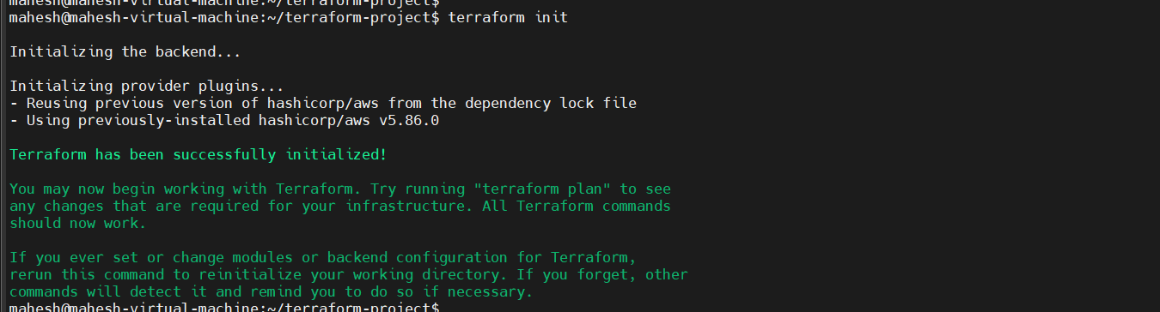

$ terraform plan



$ terraform apply -auto-approve



Next, check on AWS as below,

* VPC



* SUBNET

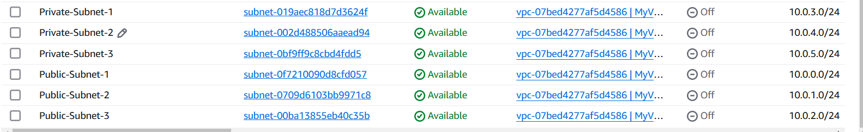

* ROUTE-TABLE



* Internet-Gateway



* NAT-Gateway



* Elastic-IP

