# Testing

## Introduction

Testing deals the process where it investigate, evaluate, and ascertain the completion of the software with its complete quality. It helps to identify different errors, gaps as well as missing requirements. Through this process we can make our software durable.

## Testing type

There are two types that I have done in this project. It contain Unit Testing and Black Box testing.

## Unit Testing

In this testing individual units or component of the developed software are tested. It helps to know the developer about the unfixed issued and helps to notice and fix them. This testing include the validation testing. It has few input and usually have single output. The smallest unit called method which are the most usable things to test the software.

**Screenshot of Unit testing**

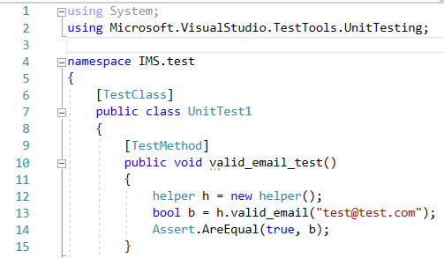

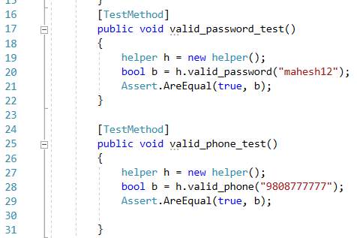

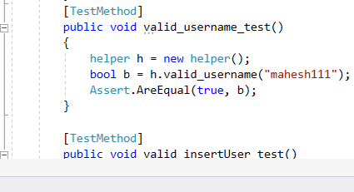

**Screenshot of Successful Unit Testing:**

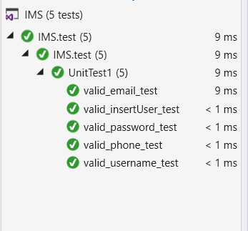

## Black Box Testing

This is the kinds of testing that simply show input and output to show the data are valid and invalid. If result output got pass then it show the Expected result successful otherwise it show fail.

The unsuccessful data that is teste is noticed with red highlight and successful data with normal white highlight.

|  |  |  |  |  |  |  |
| --- | --- | --- | --- | --- | --- | --- |
| **ID** | **Test Case & Description** | **Test Data** | **Expected Results** | **Actual Results** | **Status** | **Remark** |
| **Login** | | | | | | |
| 1 | Verification of user name and Password | mahesh, mahesh | Success | Unsuccessful with incorrect username or password. | Failed | Incorrect username or password |
| 2 | Verify user name and Password | mahesh, mahesh | successful | login successful | passed |  |
| User | | | | | | |
| 3 | Add new user | Fill up all field required data | User added successfully | Please fill up all fields | Failed | Null values not accepted |
| 4 | Add new user | Add all required data | User added successfully | Successfully  Added | passed |  |
| Search User | | | | | | |
| 5 | Data search | mahesh | Successful | data not shown | Failed | Enter existing data |
| 6 | Data search | mahesh | Successfully searched | Successful found | passed |  |
| Search Supplier | | | | | | |
| 7 | Search Supplier | Tech company | Supplier found | Data not shown | Failed | Add exising data |
| 8 | Search Supplier | Tech Company | Supplier found | supplier found | passed |  |
| Product | | | | | | |
| 9 | Add New Product | Fill all mandatory fields | Product added | Every field is mandatory | Failed | All field are necessary |
| 10 | Add New Product | Fill all mandatory fields | Product added | Product added successfully | Passed |  |
| Delete Product | | | | | | |
| 11 | Delete Product | Select row to delete | Product deleted | Product not selected | Failed | Product need to select |
| 12 | Delete Product | Select row to delete | Product deleted | Product Deleted successfully | Passed |  |
| Setting | | | | | | |
| 13 | Connect database SQL server | Fill all mandatory fields | Database Connected | All field are mandatory | Failed | Enter all the Data |
| 14 | Connect database SQL server | Fill all mandatory fields | Database Connected | Connected Successfully | Passed |  |
| View Category | | | | | | |
| 15 | View Category | Select view button | It should view data | No data | Failed | Category should be added |
| 16 | View Category | Select view button | It should view data | Data shown | Passed |  |
| Delete Category | | | | | | |
| 17 | Delete Category | Click Delete button | Data Deleted Successfully | Not deleted | Failed | Data not selected |
| 18 | Delete Category | Click Delete button | Data Deleted Successfully | Deleted successfully | Passed |  |
| View Stock | | | | | | |
| 19 | View Stock | Click View button | All added stock should view in row | No data | Failed | User need to add stock to view it |
| 20 | View Stock | Click View button | All added stock should view in row | Data Shown | Passed |  |