FUNDSROOM RECRUITMENT — ROUND 1 TECHNICAL CASE STUDY
Mini ERP + CRM Operations Portal
Full-Stack Technical Solution & Architecture Report
Candidate Name: | Mahesh B K
University Roll Number: | 2023006427
GITAM Official Email ID: | mbk@gitam.in
Personal Email ID: | maheshbk1805@gmail.com
GitHub Repository URL: | https://github.com/maheshbk1805-web/fundsroom-mini-erp-crm

1. Executive Summary & Business Context
This document presents the complete engineering solution for the Fundsroom Full Stack Developer Case Study: a production-grade Mini ERP + CRM Operations Portal developed for a wholesale distribution enterprise. The enterprise model requires coordinating client acquisition, catalog inventory with alert thresholds, tamper-evident stock movement logs, and sales delivery challans.
Key engineering achievements in this submission include:
- • Role-Driven Architecture: Distinct, decoupled workspaces and login experiences for Executive Administrators versus Staff members (Sales, Warehouse, Accounts).
- • Concurrency Safety: Atomic stock deduction with PostgreSQL row-level locks (SELECT ... FOR UPDATE), guaranteeing zero negative inventory and no race conditions.
- • Historical Snapshot Integrity: Preserving product name, SKU, and unit price in challan_items to maintain historical accuracy regardless of future catalog changes.
- • Bonus Implementations: Full containerization via Docker Compose, automated CI/CD via GitHub Actions, and browser-native PDF delivery note export.
- • Immediate Joining Commitment: I confirm my 100% availability for immediate joining in Pune, Maharashtra upon selection.
2. Tools & Technologies Used & How They Work
The project leverages modern industry tools chosen specifically for speed, reliability, type safety, and scalability:
Tool / Technology | Layer | How It Works & Business Value
React 18 & TypeScript | Frontend Tier | Provides a robust Single Page Application (SPA) architecture with strict type safety, modular component lifecycle management, and instant sub-second bundling with Vite.
Node.js 24 & Express.js | Backend REST API | Asynchronous, event-driven RESTful micro-service with express-validator validation pipelines, role authorization middleware, and centralized error handling.
PostgreSQL (Neon Cloud AWS) | Database Tier | Serverless PostgreSQL engine providing ACID transactional integrity, multi-client connection pooling, and row-level locking primitives.
JSON Web Tokens (JWT) & Bcrypt | Security & Auth | Stateless authentication using cryptographically signed JWT tokens with 24-hour expiration, paired with salted bcrypt hashing (10–12 salt rounds) for password storage.
Docker & Docker Compose | Containerization (Bonus) | Multi-stage Dockerfiles for backend (Node 22-alpine) and frontend (Nginx alpine) orchestrated via docker-compose.yml with local PostgreSQL networking.
GitHub Actions | CI / CD Pipeline (Bonus) | Automated continuous integration pipeline (.github/workflows/ci.yml) validating TypeScript compilation, linting, and production builds on push/PR.
Postman Collection | API Testing (Bonus) | Structured collection (postman/Fundsroom-ERP.postman_collection.json) covering 100% of REST endpoints across auth, CRM, products, and challans.
Render Cloud Hosting | Cloud Deployment | Configured for zero-downtime deployment on Render.com with single-service production serving (Express serving client/dist static build).
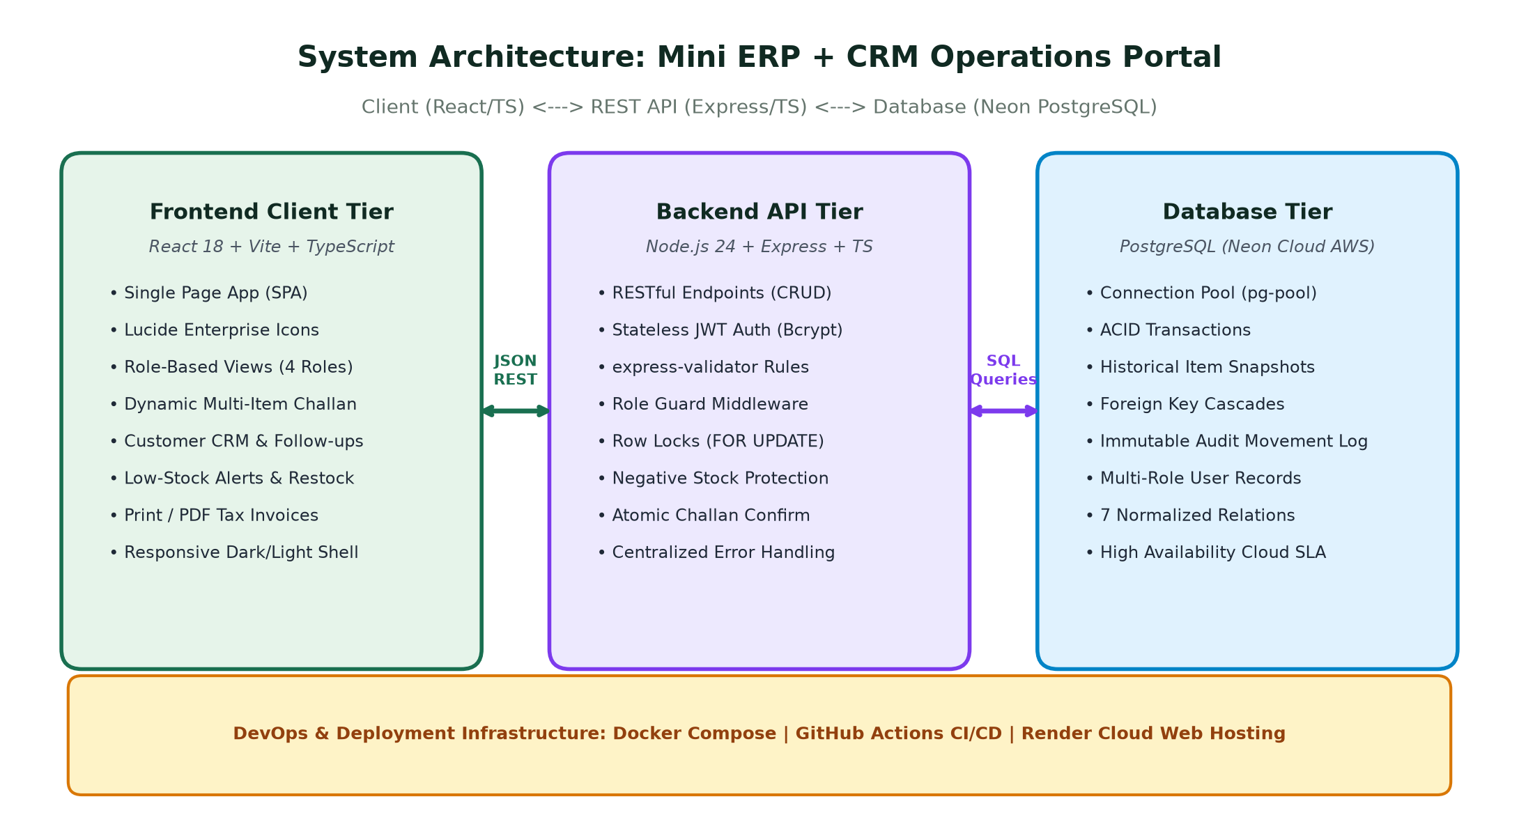
Figure 1: Full-Stack System Architecture (React Frontend, Express API, Neon PostgreSQL DB, and Docker/CI Infrastructure)
3. Database Schema & Data Integrity Design
The database architecture is designed with 7 normalized tables, enforcing relational foreign key constraints, automatic timestamps, and check constraints to prevent invalid operational states:
- users: Stores employee credentials, salted password hashes, and strictly enumerated roles (Admin, Sales, Warehouse, Accounts).
- customers: Complete CRM records including business name, mobile, email, customer type (Retail/Wholesale/Distributor), status (Lead/Active/Inactive), follow-up date, and optional GSTIN.
- customer_followups: Chronological interaction history linked to customers with created_by employee foreign key.
- products: Catalog SKUs, categories, unit prices (NUMERIC 12,2), on-hand stock (CHECK >= 0), minimum alert thresholds, and warehouse location.
- stock_movements: Immutable audit trail tracking product, movement direction (IN/OUT), quantity changed (> 0), reason reference, and authorized employee.
- challans: Outbound delivery orders with unique formatted challan numbers (CH-YYYY-XXXXXX), customer relation, total items, and status (Draft/Confirmed/Cancelled).
- challan_items: Historical product snapshot preserving product name, SKU, and unit price at moment of sale.
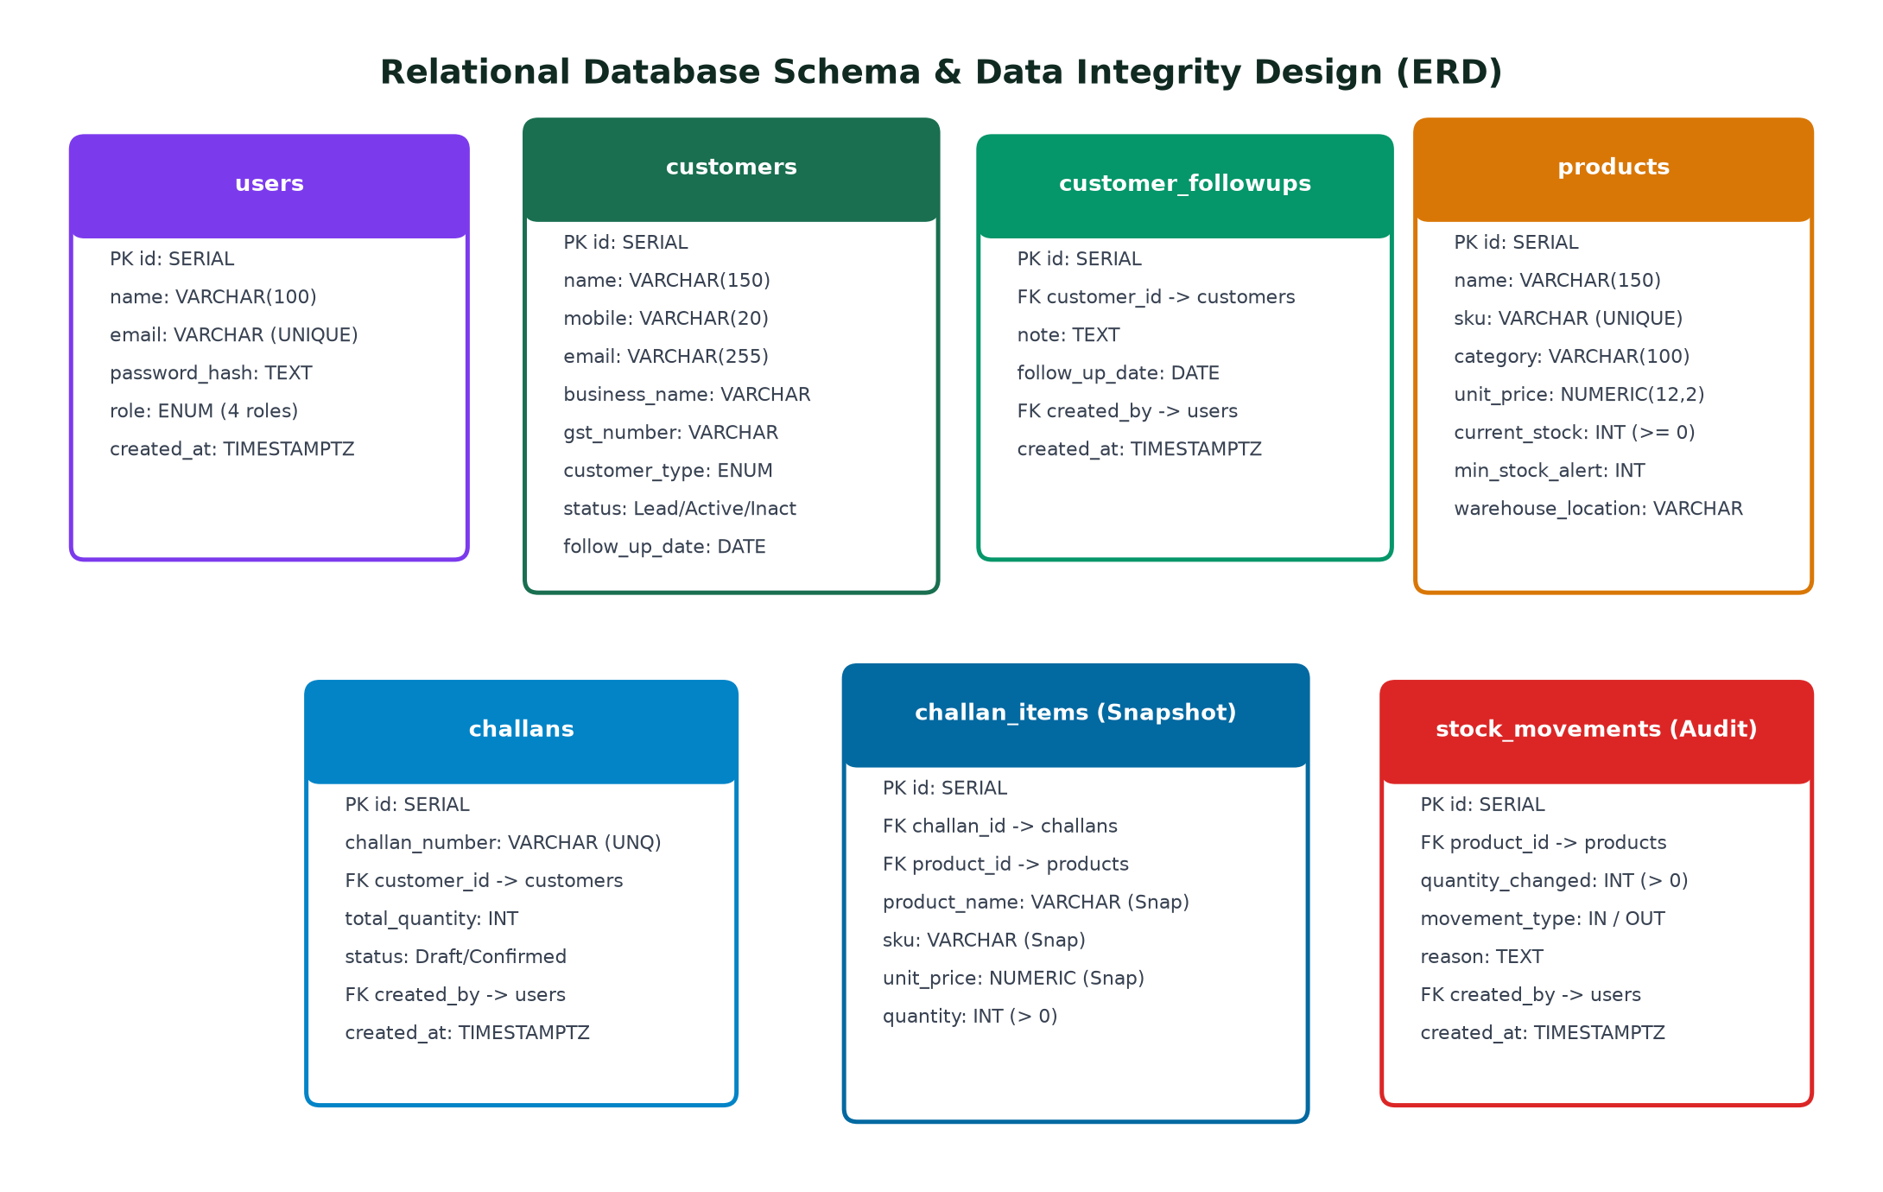
Figure 2: Relational Database Entity Relationship Diagram (ERD) with Constraints & Snapshots
4. Transaction Safety & Concurrency Control (Stock Safety)
In high-volume wholesale distribution, race conditions during order placement can lead to inventory overselling or negative stock balances. OrbitOps solves this at the database engine level:
- When a sales challan is confirmed, Express initiates an atomic transaction using BEGIN.
- PostgreSQL Row-Level Locking: Executes SELECT current_stock FROM products WHERE id = $1 FOR UPDATE. This locks the specific product rows against concurrent modifications.
- Zero Negative Stock Check: If current_stock < requested_quantity, the transaction immediately executes ROLLBACK and returns HTTP 409 Conflict with an error message.
- Atomic Stock Decrement: Deducts on-hand inventory via UPDATE products SET current_stock = current_stock - $1 WHERE id = $2.
- Automatic Audit Log: Concurrently writes an OUT entry in stock_movements linked to the confirmed challan number.
- Atomic COMMIT commits all updates together, ensuring no partial or corrupted states.
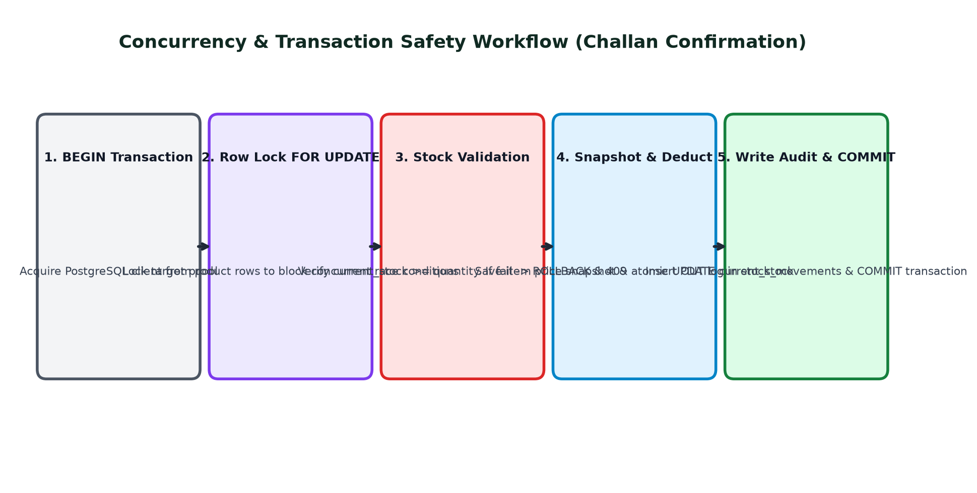
Figure 3: Five-Step Atomic Transaction Workflow with PostgreSQL Row-Level Locking (FOR UPDATE)
5. Role-Based Access Control: Admin vs. Staff Experience
Per the prompt instructions, distinct workspaces and portals were engineered for Executive Administrators versus Department Staff:
A. Login Page Role Separation
The sign-in interface features a Tabbed Entrance separating the Admin Portal from the Staff Workspace. Administrators enter through the purple Executive Portal, while staff select their respective department. One-click demo login buttons and a password visibility toggle (Eye icon) allow instant testing.
B. Executive Admin Portal Experience
When logging in as Admin (admin@fundsroom.local):
- Executive Command Center: Dashboard displaying high-level operational health, inventory asset value, live low-stock warnings, and recent dispatches.
- Exclusive 'Team & Roles' Governance (/admin/users): Administrators have exclusive access to view all registered employees and dynamically reassign or promote roles (Admin, Sales, Warehouse, Accounts) via dropdowns.
- Unrestricted Access: Admin can perform all operations across CRM, Catalog, Restock, Dispatches, and Auditing.
C. Department Staff Workspaces (Sales, Warehouse, Accounts)
When logging in as Staff:
- Sales (sales@fundsroom.local): Dedicated workspace for Customer CRM leads, follow-up scheduler, and multi-product Challan generation. Cannot modify warehouse stock directly.
- Warehouse (warehouse@fundsroom.local): Dedicated logistics workspace with on-hand inventory, low-stock alerts, 1-click Quick Restock, and goods inward logs. Cannot view customer CRM.
- Accounts (accounts@fundsroom.local): Read-only financial auditing workspace with delivery notes, GSTIN verification, and printable tax invoices.
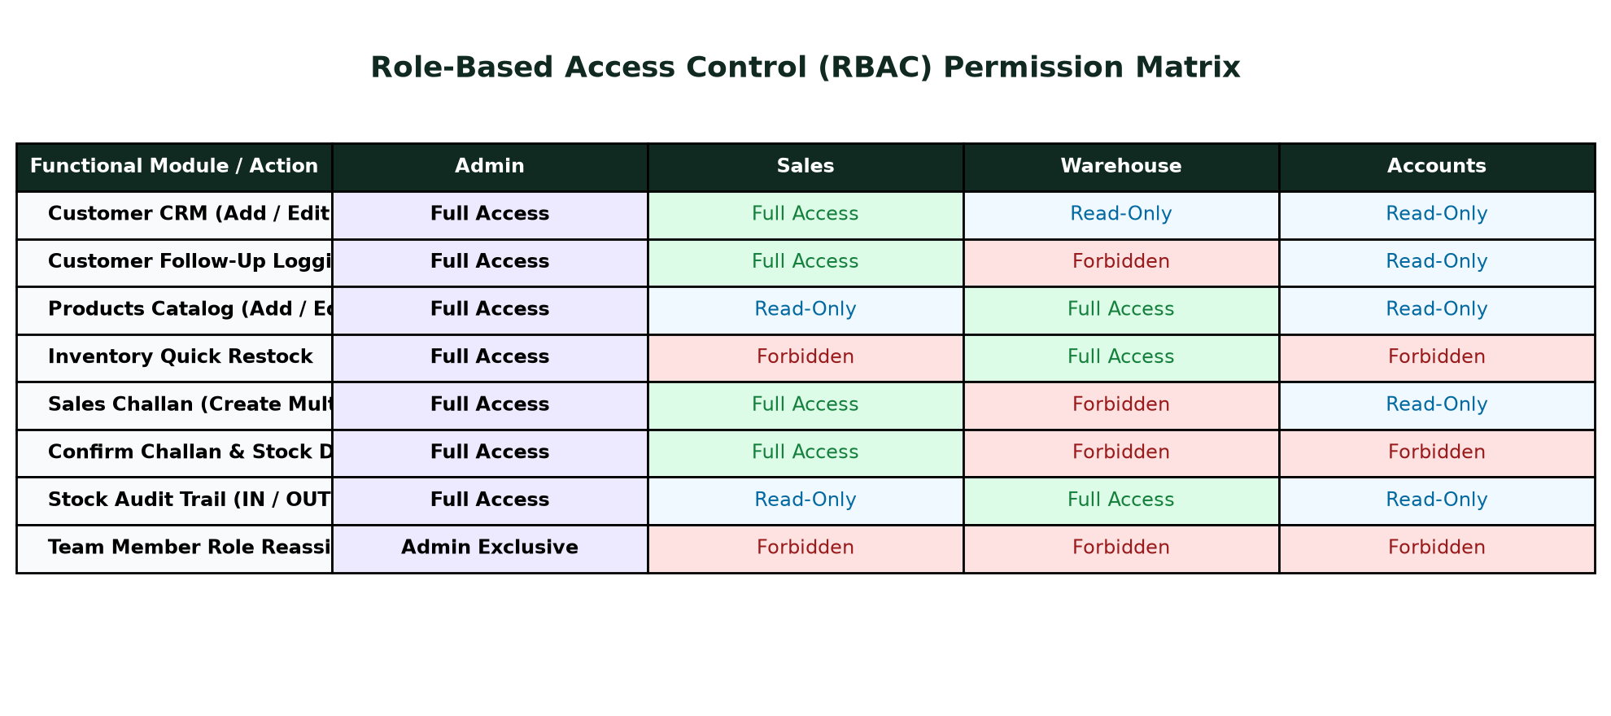
Figure 4: Comprehensive Role-Based Access Control (RBAC) Permission Matrix across All 4 Roles
6. Development Environment & Repository Evidence
The development environment in Visual Studio Code and the official GitHub repository setup are shown below:
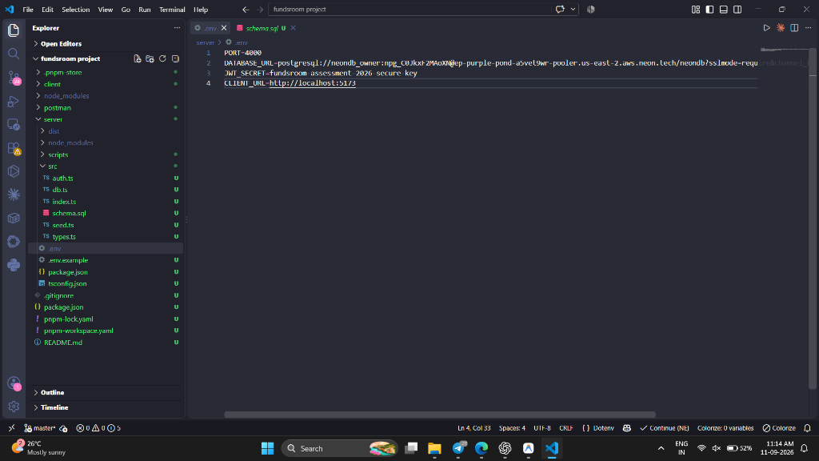
Figure 5: Local VS Code Workspace with Neon PostgreSQL Active Database Configuration (.env) & Monorepo Structure
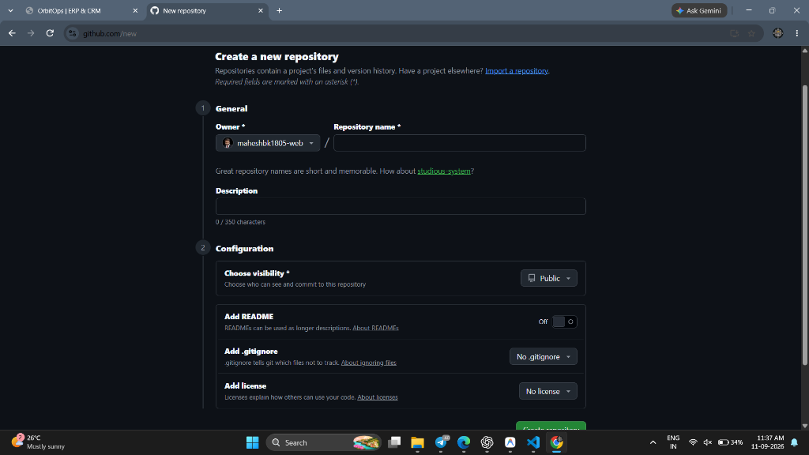
Figure 6: Official GitHub Repository Creation for fundsroom-mini-erp-crm (maheshbk1805-web)
7. Verified Test Login Credentials
All accounts are pre-seeded in the Neon Cloud database with password:
Universal Password: Password@123
Role | Login Email | Password | Workspace Access Scope
Admin | admin@fundsroom.local | Password@123 | Executive full access: CRM, Inventory, Orders, Audit logs, and exclusive User Role Governance.
Sales | sales@fundsroom.local | Password@123 | Sales domain: Register clients, log follow-ups, draft and confirm multi-item delivery challans.
Warehouse | warehouse@fundsroom.local | Password@123 | Logistics domain: Manage catalog products, set reorder alert thresholds, 1-click Quick Restock.
Accounts | accounts@fundsroom.local | Password@123 | Auditing domain: Read-only operational visibility across all records and printable delivery invoices.
8. Screen Recording & Google Form Submission Checklist
Per the case study instructions, follow this exact procedure for the submission:
- 1. Screen Recording: Start your screen recorder (Windows Game Bar [Win + G], OBS Studio, or Loom).
- 2. Admin Flow: Demonstrate Admin login, Executive Command Center metrics, and the User Management page.
- 3. CRM Flow: Go to Customer CRM &rarr; Add customer with GSTIN &rarr; Open Profile &rarr; Log a follow-up note.
- 4. Inventory Flow: Go to Inventory &rarr; Show low-stock alert badge &rarr; Click '+ Restock' to inward goods in 1 click.
- 5. Challan Flow: Go to Sales Challans &rarr; Click 'New Challan' &rarr; Add multiple products &rarr; Create Confirmed &rarr; Show printable Tax Invoice.
- 6. Audit Log: Go to Stock Audit Log &rarr; Show the automated OUT movement logged for the confirmed challan.
- 7. Role Switching: Sign out &rarr; Log in as Sales or Accounts to showcase the tailored role workspace.
- 8. Drive Upload: Upload your video recording to Google Drive. Right-click &rarr; Share &rarr; Set General Access to 'Anyone with the link can view'.
- 9. Form Submission: Submit the Google Form before 6:00 PM with your Drive link and this PDF document.
9. Immediate Joining Commitment
I, Mahesh B K, confirm my genuine interest and availability for immediate joining at Fundsroom in Pune, Maharashtra. I am fully comfortable with the Pune work location and look forward to clearing Rounds 2 and 3 and joining the organization without fail.

