COMPREHENSIVE DATA ANALYSIS
REPORT
Yuva Intern – Week 4 Final Task
Statistical Analysis, Visualization and Predictive Modeling using R

Item | Details
Name | Mahesh
Dataset | Air Quality Missing Data
Tools | R, RStudio, Microsoft Word
Project Scope | Data cleaning, visualization, statistical analysis and predictive modeling
Weeks Integrated | Week 1, Week 2 and Week 3

Final report integrating the work completed across the first three weeks.

Executive Summary
This final report consolidates the data cleaning, visualization, statistical analysis, and predictive modeling work completed during the Yuva Intern project using R. The project used the Air Quality Missing Data dataset containing 153 observations and five variables: Date, Ozone, Solar, Wind, and Temp. The workflow progressed from data preparation to visual exploration, hypothesis testing, regression modeling, predictive evaluation, cross-validation, and diagnostic assessment.
During Week 1, missing values were identified in Ozone and Solar and treated using median imputation. The cleaned data contained no remaining missing values. Preliminary analysis found a Pearson correlation of 0.6008328 between Ozone and Temperature. Week 2 expanded the analysis through four planned visualization types: a scatter plot, a temperature-group bar chart, a temperature-over-time line chart, and an Ozone histogram. The available embedded figures show the positive Ozone–Temperature pattern, differences across temperature groups, and the right-skewed concentration of Ozone observations.
Week 3 introduced formal statistical analysis and predictive modeling. Pearson correlation testing produced p < 2.2e-16, providing evidence against a zero linear correlation in this dataset. A multiple linear regression model using Temp, Wind, and Solar explained 47.21% of the observed Ozone variation in the full cleaned dataset. On the held-out test set, the model achieved RMSE 20.29155, MAE 14.38105, and R-squared 0.522513. Five-fold cross-validation produced an average RMSE of 21.44839. Diagnostic analysis identified departures from standard linear-regression assumptions, so the model is best treated as an initial predictive model rather than a final optimized solution.

1. Introduction
The objective of this project was to demonstrate an end-to-end data analysis workflow in R. Rather than performing only one type of analysis, the project progressed through data preparation, exploratory visualization, statistical testing, predictive modeling, and model diagnostics. The final Week 4 report integrates these stages into one coherent narrative so that both technical and non-technical readers can follow how the conclusions were reached.
The central analytical question was whether Ozone concentration is linearly associated with Temperature and whether Ozone can be predicted using Temperature, Wind, and Solar. The Week 3 report explicitly distinguishes association from causation; therefore, the findings in this report describe relationships observed in the dataset rather than causal effects.

2. Dataset Description
The project used the Air Quality Missing Data dataset. The uploaded Week 1 report documents 153 observations and five variables: Date, Ozone, Solar, Wind, and Temp.
Variable | Role / Description
Date | Date of observation; retained for time-based visualization
Ozone | Target variable / ozone concentration
Solar | Solar radiation measurement; predictor in regression
Wind | Wind speed; predictor in regression
Temp | Temperature; predictor and main variable in correlation analysis

3. Data Preparation and Cleaning – Week 1
The first stage was data cleaning. Missing values were checked with is.na() and column-wise counts. The uploaded Week 1 report records 37 missing values in Ozone and 7 missing values in Solar. Median imputation was selected for these missing observations. The median Ozone value was 31.5 and the median Solar value was 205. After replacement, the dataset contained no missing values.
Cleaning Step | Result
Missing Ozone values | 37
Missing Solar values | 7
Ozone imputation value | Median = 31.5
Solar imputation value | Median = 205
Missing values after cleaning | 0
Representative R code used for the cleaning stage:
Air_Quality_Missing_Data <- read.csv(
"C:/Users/mahes/Downloads/Air Quality Missing Data.csv",
na.strings = "NA"
)

colSums(is.na(Air_Quality_Missing_Data))

Air_Quality_Missing_Data$Ozone[
is.na(Air_Quality_Missing_Data$Ozone)
] <- median(Air_Quality_Missing_Data$Ozone, na.rm = TRUE)

Air_Quality_Missing_Data$Solar[
is.na(Air_Quality_Missing_Data$Solar)
] <- median(Air_Quality_Missing_Data$Solar, na.rm = TRUE)
This cleaning stage established the dataset used in the subsequent visualization and modeling work.

4. Exploratory Statistical Analysis
After cleaning, summary statistics were used to understand the central tendency and range of the main variables. The Week 3 report records the following values.
Variable | Mean | Median | Minimum | Maximum
Ozone | 39.56 | 31.5 | 1 | 168
Solar | 186.8 | 205 | 7 | 334
Wind | 9.958 | 9.7 | 1.7 | 20.7
Temperature | 77.88 | 79 | 56 | 97
The Ozone distribution was not normal according to the Shapiro-Wilk test (W = 0.83598, p = 8.439e-12). This result is consistent with the visual distribution, which contains many observations in lower-to-middle ranges and a smaller number of relatively high Ozone observations.

5. Data Visualization – Week 2
The visualization stage translated numerical information into graphical form. The Week 2 report documents four visualization types: Ozone versus Temperature scatter plot, Average Ozone by Temperature Group bar chart, Temperature Trend Over Time line chart, and Ozone Distribution histogram. The uploaded Week 2 report contains embedded figures for the first two visualizations; the final report therefore uses those source figures directly and does not invent missing screenshots.

5.1 Ozone vs Temperature
The scatter plot shows a generally positive relationship: higher temperatures tend to be associated with higher Ozone values. The points are not perfectly linear, and the relationship represents association rather than causation. The correlation reported across the project is approximately 0.60.
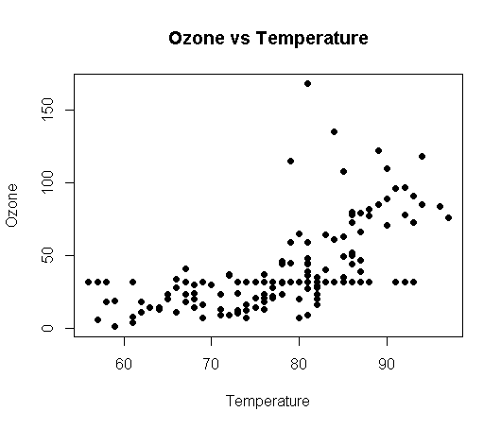
Figure 1. Ozone versus Temperature from the cleaned dataset.

5.2 Average Ozone by Temperature Group
Temperature was grouped into Low (≤70), Moderate (71–80), and High (>80). The bar chart shows increasing average Ozone across these groups, supporting the positive pattern seen in the scatter plot.
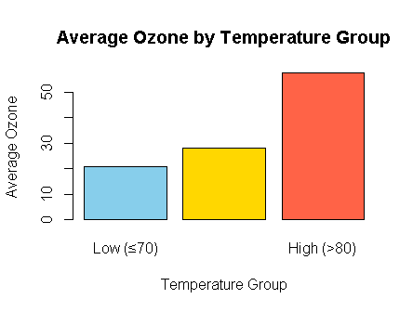
Figure 2. Average Ozone by Temperature Group.

5.3 Temperature Trend Over Time
The Week 2 analysis also created a line chart of Temperature against Date. The documented interpretation states that temperature varied throughout the observation period, with several increases and decreases. The uploaded Week 2 report does not contain an embedded image of this chart, so this final report preserves the documented interpretation without creating a replacement screenshot.

5.4 Distribution of Ozone
The Ozone histogram shows that most observations are concentrated in lower-to-middle ranges, while a smaller number of observations have considerably higher values. This distributional pattern is relevant to the later normality testing and regression diagnostics.
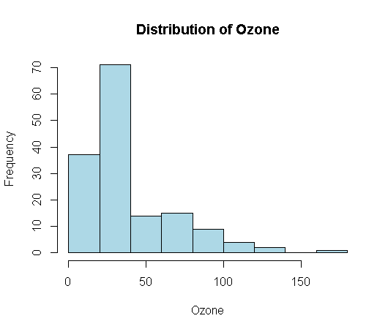
Figure 3. Distribution of Ozone concentration.

Visualization Findings
- Temperature and Ozone show a moderate positive association.
- Average Ozone differs across temperature groups, with higher groups showing higher average Ozone.
- Temperature changes over the observation period rather than remaining constant.
- Ozone has a concentrated lower-to-middle range with relatively high observations in the upper tail.

6. Hypothesis Testing and Correlation
The main correlation hypothesis was defined as H0: there is no linear correlation between Ozone and Temperature (population correlation = 0), versus H1: there is a linear correlation (population correlation ≠ 0).
cor_test <- cor.test(
Air_Quality_Cleaned$Ozone,
Air_Quality_Cleaned$Temp,
method = "pearson"
)
print(cor_test)
Statistic | Result
Pearson correlation | 0.6008328
t statistic | 9.2362
Degrees of freedom | 151
p-value | < 2.2e-16
95% CI | 0.4887518 to 0.6934026
The p-value is far below 0.05, providing evidence against the null hypothesis of zero linear correlation. The estimated correlation is positive. The result indicates an association between Temperature and Ozone in this dataset; it does not establish causation.

7. Predictive Modeling – Multiple Linear Regression
A multiple linear regression model was developed with Ozone as the target variable and Temperature, Wind, and Solar as predictors. Date was retained in the dataset but was not used as a regression predictor.
model <- lm(
Ozone ~ Temp + Wind + Solar,
data = Air_Quality_Cleaned
)
print(summary(model))
The estimated model was:
Ozone = -39.35406 + 1.23295(Temp) - 2.78709(Wind) + 0.05696(Solar)
Model Term | Coefficient | p-value | Direction
Intercept | -39.35406 | 0.04276 | —
Temperature | 1.23295 | 3.97e-08 | Positive
Wind | -2.78709 | 1.36e-06 | Negative
Solar | 0.05696 | 0.00586 | Positive
Model Measure | Value
Residual standard error | 21.32
Multiple R-squared | 0.4721
Adjusted R-squared | 0.4615
Overall F-statistic | 44.42
Overall model p-value | < 2.2e-16
The model explains approximately 47.21% of the observed Ozone variation in the full cleaned dataset. Within the fitted model, Temperature has a positive estimated association with Ozone, Wind has a negative estimated association, and Solar has a positive estimated association, holding the other predictors constant. These coefficients describe associations in the fitted model and should not be interpreted as causal effects.

8. Model Evaluation
For predictive evaluation, an 80/20 train-test split was used with a fixed random seed. The training set contained 122 observations and the test set contained 31 observations.
set.seed(123)

train_index <- sample(
1:nrow(Air_Quality_Cleaned),
size = 0.8 * nrow(Air_Quality_Cleaned)
)

train_data <- Air_Quality_Cleaned[train_index, ]
test_data <- Air_Quality_Cleaned[-train_index, ]

train_model <- lm(
Ozone ~ Temp + Wind + Solar,
data = train_data
)

predictions <- predict(
train_model,
newdata = test_data
)
Metric | Test Result | Meaning
RMSE | 20.29155 | Prediction error on the Ozone scale; lower is better
MAE | 14.38105 | Average absolute prediction error; lower is better
Test R-squared | 0.522513 (~52.25%) | Variation in held-out Ozone explained by the model
The test R-squared indicates that approximately 52.25% of the variation in Ozone in the held-out test data is explained by the model. RMSE and MAE quantify prediction error on the Ozone scale.

9. Five-Fold Cross-Validation
Five-fold cross-validation was applied to the training data to obtain an additional estimate of predictive error across different validation subsets.
Fold | Validation RMSE
1 | 14.60028
2 | 29.22272
3 | 22.93368
4 | 17.22473
5 | 23.26054
Average | 21.44839
The average five-fold CV RMSE was 21.44839. The variation among folds shows that predictive error changes across different subsets of the training data. Cross-validation therefore provides useful evidence about model stability beyond a single train-test split.

10. Regression Diagnostics
The standard four regression diagnostic plots were examined: Residuals vs Fitted, Normal Q-Q, Scale-Location, and Residuals vs Leverage.
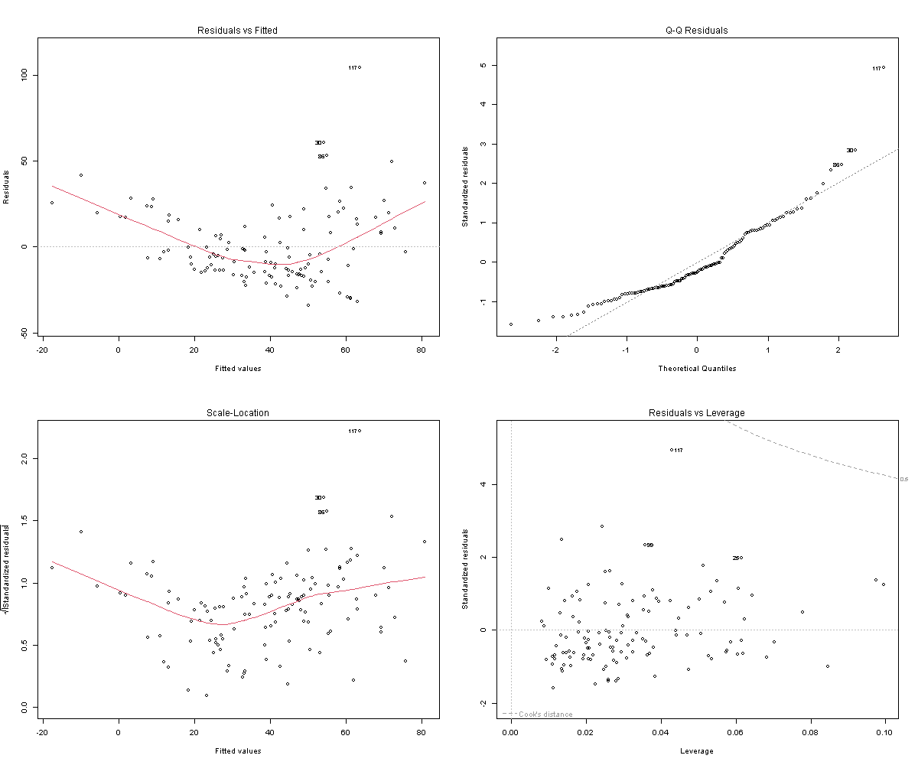
Figure 4. Complete four-panel regression diagnostic plots from the training model.
- Residuals vs Fitted: some curvature/non-linearity was visible, with a noticeable unusual observation around observation 117.
- Normal Q-Q: departures from the reference line were visible, particularly in the upper tail.
- Scale-Location: the residual spread suggested that constant variance may not fully hold.
- Residuals vs Leverage: observations including 117, 99, and 25 appeared worthy of further investigation; the plot alone does not establish that they are definitively influential.
A Shapiro-Wilk test was also applied to the regression residuals. The result was W = 0.90359 with p = 2.5e-07, indicating that the residuals were not normally distributed at conventional significance levels. This agrees with the departure from the reference line observed in the Normal Q-Q plot.

11. Integrated Findings and Discussion
The three analytical stages form a consistent sequence. First, the data required preparation because Ozone and Solar contained missing observations. Median imputation produced a complete dataset for downstream analysis. Second, visualization revealed a moderate positive pattern between Temperature and Ozone and showed that higher temperature groups had higher average Ozone values. Third, formal statistical testing confirmed a statistically significant positive linear association in the dataset.
The regression stage added multiple environmental predictors. Temperature, Wind, and Solar were all statistically significant in the fitted full-data regression model. The model explained 47.21% of the observed Ozone variation. When evaluated on the held-out test set, the model achieved an R-squared of approximately 52.25%, with RMSE 20.29 and MAE 14.38. Cross-validation produced an average RMSE of 21.45, with noticeable fold-to-fold variation.
The diagnostics are important when interpreting these performance values. The residual plots and residual normality test indicate that several standard linear-regression assumptions are not fully satisfied. Consequently, the current model should be viewed as an initial predictive model. The results are useful for demonstrating the modeling workflow, but further model development would be appropriate before treating the model as a final optimized predictor.

12. Practical / Data-Driven Implications
Within this dataset, Temperature is consistently associated with Ozone across the scatter plot, grouped averages, Pearson correlation, and regression coefficient. Wind and Solar also contribute to the fitted regression model. For a data-analysis workflow, this demonstrates how combining visualization and statistical modeling can reveal patterns that are not fully captured by a single summary statistic.
These findings should be used as evidence about the observed dataset rather than as causal claims or universal rules about air quality. A larger and more representative dataset, additional environmental variables, and stronger validation would be needed before applying a model to operational decision-making.

13. Challenges Encountered
- Handling missing values in Ozone and Solar while keeping the dataset usable for later analysis.
- Moving from basic visualization to formal statistical testing and regression modeling.
- Evaluating a predictive model using both a held-out test set and cross-validation.
- Interpreting regression diagnostics instead of relying only on performance metrics.
- Keeping the distinction between statistical association and causal interpretation clear throughout the report.

14. Lessons Learned
- Data cleaning is a necessary foundation for reliable downstream analysis.
- Different visualization types communicate different aspects of the same dataset.
- A statistically significant relationship does not imply causation.
- Predictive performance should be assessed on data not used to fit the model.
- Cross-validation can reveal variation in predictive error across subsets.
- Model diagnostics are essential because a good-looking performance metric does not guarantee that regression assumptions are satisfied.

15. Future Improvements
- Investigate unusual observations such as observation 117 and other potentially influential points using formal influence diagnostics.
- Consider appropriate transformations of Ozone or predictors if justified by further analysis.
- Explore nonlinear relationships using polynomial terms or flexible regression methods when supported by the data.
- Examine heteroscedasticity with a formal test and consider robust standard errors where appropriate.
- Compare alternative predictive models using the same cross-validation procedure.
- Use repeated cross-validation or a larger dataset for more stable performance estimates.
- Keep a separate final test set when comparing multiple candidate models to reduce test-set overfitting.

16. Conclusion
This final report integrates the complete analytical workflow performed across Weeks 1–3. The project began with data cleaning and median imputation, continued with exploratory visualization, and progressed to hypothesis testing and multiple linear regression. The analysis identified a statistically significant positive association between Temperature and Ozone. The regression model included Temperature, Wind, and Solar and explained approximately 47.21% of Ozone variation in the full cleaned dataset.
Predictive evaluation on a held-out test set produced RMSE = 20.29155, MAE = 14.38105, and R-squared = 0.522513. Five-fold cross-validation produced an average RMSE of 21.44839. Regression diagnostics identified non-normal residuals, possible non-linearity, possible non-constant variance, and observations that merit further investigation. Therefore, the current model is best considered an initial predictive model. Future work should focus on improving model assumptions, testing alternative models, and obtaining more stable validation estimates.

17. Reproducibility and Key R Code
The project was performed in R/RStudio. A fixed seed of 123 was used for the train-test split and five-fold cross-validation. The Week 3 analysis script is named week3_statistical_modeling.R.

Key workflow
# Load cleaned data
Air_Quality_Cleaned <- read.csv(
"C:/Users/mahes/Desktop/Air_Quality_Cleaned.csv"
)
Air_Quality_Cleaned$Date <- as.Date(Air_Quality_Cleaned$Date)

# Correlation
cor_test <- cor.test(
Air_Quality_Cleaned$Ozone,
Air_Quality_Cleaned$Temp,
method = "pearson"
)

# Multiple regression
model <- lm(
Ozone ~ Temp + Wind + Solar,
data = Air_Quality_Cleaned
)

# Diagnostics
par(mfrow = c(2, 2))
plot(train_model)
par(mfrow = c(1, 1))

18. Source Integration Note
This final report was prepared by integrating the three uploaded weekly reports. The Week 1 report supplied the documented cleaning procedure and preliminary statistics; the Week 2 report supplied the documented visualization workflow and interpretations; and the Week 3 report supplied the hypothesis tests, regression model, predictive metrics, cross-validation, diagnostics, strengths, and improvement points. Only figures actually embedded in the uploaded source documents were reused as visuals in this final report.

