Data Cleaning & Preliminary Analysis with R
Yuva Intern – Week 1 Task
Dataset: Air Quality Missing Data
Dataset Overview
The dataset used for this project is the Air Quality Missing Data dataset. It contains air quality and weather-related information. The dataset has 153 observations and 5 variables: Date, Ozone, Solar, Wind, and Temp. The dataset was used to practice data cleaning and preliminary analysis using R.
Data Cleaning
The dataset was checked for missing values using the is.na() function in R. Missing values were found in the Ozone and Solar columns. There were 37 missing values in Ozone and 7 missing values in Solar.
Missing Value Treatment
Missing values were replaced using the median of the respective columns. The median value of Ozone was 31.5, and the median value of Solar was 205. After replacement, the dataset contained no missing values.
R Code Used
# Load dataset
Air_Quality_Missing_Data <- read.csv(
"C:/Users/mahes/Downloads/Air Quality Missing Data.csv",
na.strings = "NA"
)

# Check missing values
colSums(is.na(Air_Quality_Missing_Data))

# Find median values
median(Air_Quality_Missing_Data$Ozone, na.rm = TRUE)
median(Air_Quality_Missing_Data$Solar, na.rm = TRUE)

# Replace missing Ozone values
Air_Quality_Missing_Data$Ozone[
is.na(Air_Quality_Missing_Data$Ozone)
] <- median(Air_Quality_Missing_Data$Ozone, na.rm = TRUE)

# Replace missing Solar values
Air_Quality_Missing_Data$Solar[
is.na(Air_Quality_Missing_Data$Solar)
] <- median(Air_Quality_Missing_Data$Solar, na.rm = TRUE)

# Check missing values after cleaning
colSums(is.na(Air_Quality_Missing_Data))

Preliminary Analysis
After cleaning the dataset, summary statistics were calculated using R. The total dataset contains 153 observations. The median Ozone value is 31.5, while the median Solar value is 205. The median Wind value is 9.7 and the median Temperature value is 79
Correlation Analysis
The correlation between Ozone and Temperature was calculated as 0.6008. This indicates a positive relationship between the two variables in the cleaned dataset.
Visualizations

Two visualizations were created in R to understand the data:
- Ozone vs Temperature Scatter Plot – This plot shows the relationship between temperature and ozone values.
- Ozone Distribution Histogram – This histogram shows the distribution of ozone values in the dataset.

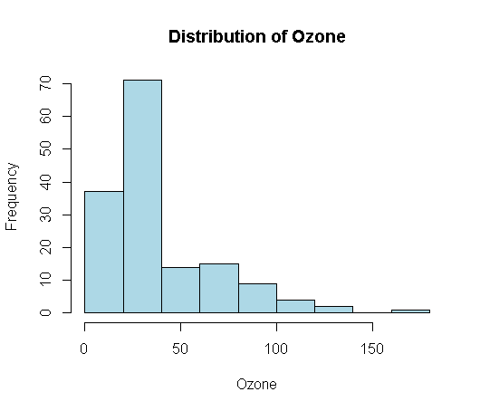
Ozone vs Temperature
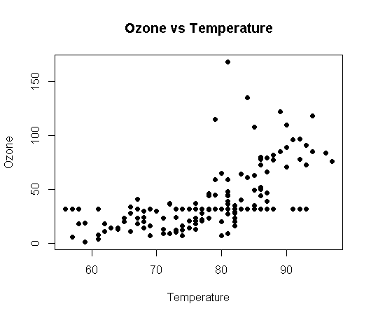

Initial Findings
- The dataset initially contained missing values in the Ozone and Solar variables.
- Median imputation was used to handle the missing values.
- After cleaning, no missing values remained in the dataset.
- The median Ozone value was 31.5.
- The median Solar value was 205.
- The correlation between Ozone and Temperature was 0.6008, showing a positive relationship in this dataset.
- The visualizations helped to understand the relationship and distribution of the air-quality data.

Conclusion
The dataset was successfully loaded and cleaned using R. Missing values in the Ozone and Solar variables were identified and replaced using median values. Summary statistics and correlation analysis were performed to understand the dataset. Visualizations were also created to examine the relationship between Ozone and Temperature and the distribution of Ozone values. This analysis provided a basic understanding of data cleaning and preliminary analysis using R.

