Problem Statement:

Being a foodie and moving to new location, wanted to explore the restaurants and types of Cuisines available in and around the Neighborhoods of Toronto. I have taken the Toronto dataset since some preprocessing was already done in previous assignments.

Target Audience: Anyone who is migrating to Canada for the first time and would like to know the best place to stay if they are foodie like me. Based on available Restaurants and locality one can choose the best locality based on their favorite cuisine or If someone wants to start a new cuisine.

Dataset used : <https://en.wikipedia.org/wiki/List_of_postal_codes_of_Canada:_M>

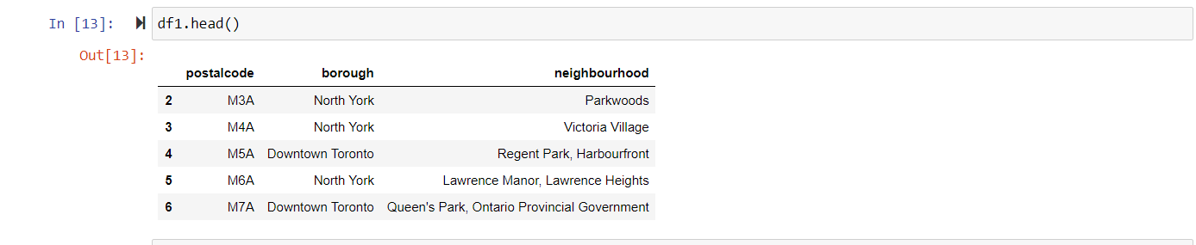

Data extraction using: Beautiful soup.

We get the Neighborhoods from the above dataset, using geocoder api we then map the neighborhoods to corresponding latitude and Longitude.

How Can I Solve the Problem:

Using this Dataset, I will try getting the Venue details from Foursquare API and find the Restaurants available and see if there are any cuisines missing. If there is a chance of opening a new cuisine like Authentic Indian we can utilize this analysis and find a right place for starting a new restaurant.

Below is the output from foursquare API. Based on this Json I would create a Data Frame of Location , Venue, Latitue, Longitude etc.

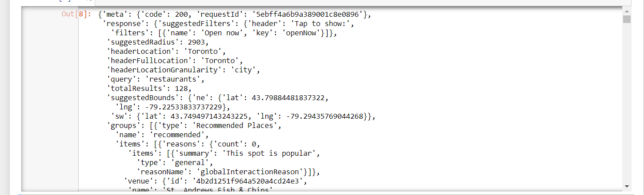

I will use K means clustering to find the clusters in identifying the possible location for a new Cuisine. I would be using Venue, latitude, Longitude and category as features. Then I will form the clusters and from the formed clusters will conclude the analysis of new possible location for the restaurant.