# Project Overview:

* This project aims to developed a web application Create a web application which will perform following operations to help John to manage his companies. Where he can see all his data & find data.

# Problem Statement:

* Create a web application which will perform following operations to help John to manage his companies. Where he can see all his data & find
* data.
* Sign Up & Login
* List of companies (Use: Datatable to show list)
* Add Company (with following fields)
* Company Name
* Company Website (Validation Required)
* Company Phone Number
* Company Address
* Company City
* Company State
* Company Country
* Industry List (Dropdown field with values Account, IT, Sales, Health Care)
* Edit Company
* Delete Company
* Also he can be able to logout from the systemCreate a web application which will perform following operations to help John to manage his companies. Where he can see all his data & find
* data.
* Sign Up & Login
* List of companies (Use: Datatable to show list)
* Add Company (with following fields)
* Company Name
* Company Website (Validation Required)
* Company Phone Number
* Company Address
* Company City
* Company State
* Company Country
* Industry List (Dropdown field with values Account, IT, Sales, Health Care)
* Edit Company
* Delete Company
* Also he can be able to logout from the system

# Technical Requirements:

|  |  |
| --- | --- |
| Hardware/Software | Specifications |
| HTML | Frontend |
| CSS | Frontend |
| JAVASCRIPT | Frontend |
| PHP | Backend |
| PROCESSOR | I5 |
| RAM | 8GB |
| MySQL | Database |

# WorkFlow Diagram:

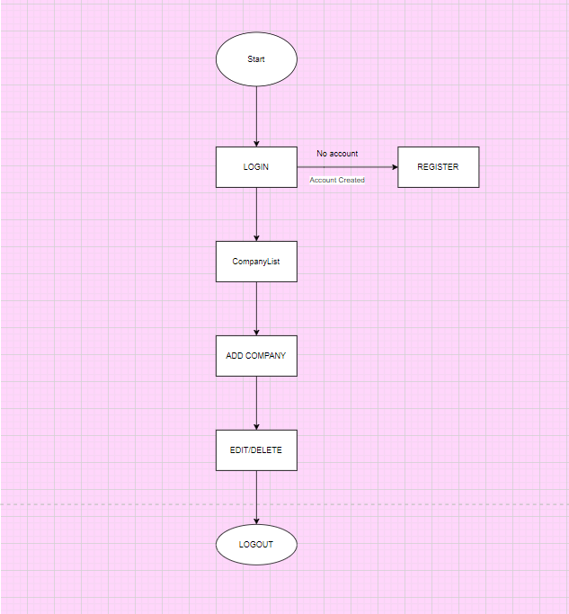

# OUTPUT:

