CAST-Net: Context-Aware Sparse-Transformer GAN
for Image Inpainting
Mahesh Patil and Vikas Tiwari
Manuscript draft | Single-seed ADE20K evaluation | August 2026

Abstract
Image inpainting requires semantic coherence over long spatial ranges while preserving local texture and high-frequency boundaries. We present CAST-Net, a compact encoder-decoder GAN that combines Sparse Global Context (SGC), a learned top-k attention mechanism; a Cross-Scale Affinity Mixer (CSAM), which retrieves texture only from observed spatial locations; and Frequency-Aware Residual Refinement (FARR), which applies mask-restricted residual correction. The full 5.276M-parameter generator was trained for 100 epochs on a deterministic 80/10/10 split of the ADE20K training images using free-form masks at 256 x 256 resolution. On 2,021 frozen test image-mask pairs, the selected seed-42 checkpoint achieved 19.873 +/- 3.331 dB hole PSNR, 0.8999 +/- 0.0502 full-image SSIM, 0.0696 +/- 0.0338 LPIPS, 10.466 FID, and 0.3957 +/- 0.1643 hole edge MAE. A preliminary 100-step engineering benchmark reduced generator parameters by 74.9% (to 1.325M) and reached 16.653 dB validation hole PSNR, but it is not a converged test-set result. All per-image metrics, configuration hashes, and reproducibility metadata are publicly available on GitHub. Because the completed quantitative evidence currently contains one training seed and no common-protocol external baselines or component ablations, the reported uncertainty describes variation across test images, not variation across independently trained models.
Keywords: image inpainting; sparse attention; cross-scale affinity; frequency-aware refinement; ADE20K; reproducibility

1. Introduction
Image inpainting synthesizes plausible content inside missing regions while maintaining consistency with observed pixels. Early deep approaches learned semantic completion using encoder-decoder networks and reconstruction plus adversarial objectives [1]. Later work improved irregular-mask handling through partial or gated convolutions [2,3], explicitly borrowed distant context through contextual attention [4], reasoned progressively from hole boundaries [6], predicted structural edges before color completion [5], and expanded receptive fields with Fourier convolutions [7].
These developments expose three coupled requirements. First, global context must be available without the quadratic cost of unrestricted dense attention. Second, texture transfer should avoid copying from invalid hole locations. Third, coarse semantic predictions need explicit boundary and frequency correction. CAST-Net addresses these requirements in a single model through SGC, CSAM, and FARR.
This paper makes three contributions. (1) SGC lets every bottleneck query attend to a learned 10% subset of context tokens, producing N x K rather than N x N attention. (2) CSAM performs mask-aware cross-scale retrieval and gates transported observed texture into hole features. (3) FARR predicts a bounded residual applied only inside the hole and is supervised with frequency and edge objectives. We additionally release the exact configuration, hashes, per-image test records, and result summary for independent inspection.

2. Related Work

2.1 Deep generative inpainting
Context Encoders established adversarially trained semantic completion [1]. Partial convolutions condition convolution on valid pixels and update masks across layers [2], while gated convolutions learn dynamic feature selection for free-form masks [3]. Earlier patch-based synthesis methods propagated texture through exemplar matching [13,14], whereas deep generative modeling enabled semantic hypotheses beyond local copying [15]. Multi-column and coarse-to-fine networks further expanded receptive-field diversity [16]. CAST-Net keeps standard convolutional encoding but passes the validity mask as an explicit input and preserves observed pixels by deterministic compositing.

2.2 Context, structure, and texture propagation
Contextual attention explicitly copies relevant surrounding features into missing regions [4]. EdgeConnect separates edge prediction from image completion [5], and RFR progressively propagates features from hole boundaries with knowledge-consistent attention [6]. Structure and texture have also been coupled through semantic coherence [17], conditional dual generation [18], and external-internal learning [19]. Pluralistic completion models recognize that a masked input can admit multiple valid solutions [20-23], while CoModGAN combines conditional and stochastic style representations for large-scale completion [8]. CAST-Net is deterministic and instead couples learned sparse global selection with observed-only, cross-scale affinity transfer.

2.3 Frequency and perceptual considerations
LaMa uses Fourier convolutions to obtain image-wide receptive fields and reports strong large-mask behavior [7]. WaveFill separates frequency bands with a wavelet representation [24], Zoom-to-Inpaint targets high-frequency detail through high-resolution refinement [25], and later analysis identifies limitations of vanilla Fourier convolution for low-level restoration [26]. CAST-Net uses frequency information differently: a spatial decoder produces a coarse result, after which a local residual head and a discrete-cosine high-frequency loss target missing-region detail. Evaluation includes SSIM [10], LPIPS [9], and FID [11] to complement pixel fidelity.

2.4 Transformers and efficient deployment
The Transformer architecture popularized content-dependent global interaction through self-attention [27]. In inpainting, MAT restricts aggregation using dynamically updated validity information [28], incremental transformer designs progressively recover masked structure [29], and information-preserving tokenization supports pluralistic completion [30]. Continuously Masked Transformer explicitly models error propagation in token masks [31], while TransInpaint adapts context and enhances texture [32]. Mobile-oriented MI-GAN demonstrates the importance of deployment-aware design [33]. CAST-Net's SGC branch targets the same long-range requirement but reduces the context set to learned top-k tokens; the lightweight pilot is motivated by this efficiency literature.

2.5 Training and evaluation foundations
CAST-Net is trained within the adversarial framework introduced by Goodfellow et al. [15], uses Adam optimization [34], and applies spectral normalization to stabilize the discriminator [35]. The reconstruction and edge terms use robust absolute and Charbonnier-style penalties [36], while the high-frequency objective is computed with a two-dimensional discrete cosine transform [37]. These foundations are stated explicitly because differences in objectives and metric implementations can materially affect inpainting comparisons.

3. Method
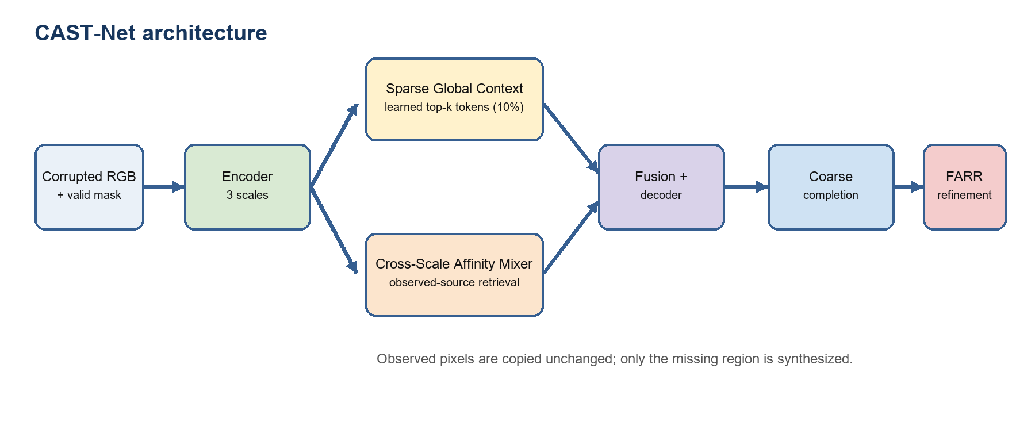
Figure 1. CAST-Net combines sparse global context, observed-only cross-scale texture retrieval, and mask-restricted residual refinement.

3.1 Problem formulation
Let x be a target RGB image and m in {0,1}^(H x W) be a validity mask, where one denotes an observed pixel. The corrupted input is x_c = m * x. Given [x_c, m], the generator predicts a completed image x_hat. At both coarse and final stages, CAST-Net enforces x_hat = m * x_c + (1-m) * x_pred, so observed pixels are copied exactly.

3.2 Encoder-decoder backbone
The network concatenates the three-channel corrupted image and one-channel mask, then applies three convolutional encoder stages with residual blocks. With base width b=64, the bottleneck contains 4b channels. Global and local-context branches operate at this bottleneck, their outputs are concatenated and fused, and two skip-connected upsampling blocks reconstruct full-resolution features. A tanh coarse head produces RGB values in [-1,1].

3.3 Sparse Global Context
For N flattened bottleneck tokens z, a learned scalar scorer ranks tokens and retains K=ceil(rN), with r=0.10. Multi-head queries are computed for all N tokens, whereas keys and values are computed only for the selected K tokens. Attention therefore has N x K spatial complexity. A straight-through score modulation lets selection scores influence learning while preserving hard top-k selection in the forward pass.

3.4 Cross-Scale Affinity Mixer
CSAM projects the intermediate encoder feature to the bottleneck channel width and resizes it to bottleneck resolution. Normalized bottleneck queries attend to keys derived from the mixed coarse/fine representation. Invalid source positions are masked before softmax, so retrieved values originate only from observed locations. A learned gate injects the transported feature only at hole positions.

3.5 Frequency-Aware Residual Refinement
FARR concatenates the coarse RGB output, the shallow decoder feature, and the validity mask. It predicts a tanh-bounded RGB residual, scaled by 0.25 and applied only within the missing region. This residual design protects known pixels and constrains refinement magnitude.

3.6 Training objective
The generator objective combines hole-normalized L1 reconstruction, a high-frequency DCT L1 loss, a Sobel-edge Charbonnier loss inside the hole, and an adversarial term. The three auxiliary weights are lambda_frequency=lambda_edge=lambda_adversarial=0.1. A patch discriminator is optimized jointly with the generator.

4. Experimental Protocol

4.1 Dataset and frozen splits
Experiments use ADE20K [12]. The project deterministically split ADEChallengeData2016 images/training into 80% training, 10% validation, and 10% test partitions with split seed 2026. The resulting test manifest contains 2,021 images. Images were resized bicubically to 256 x 256. Validation and test free-form masks were frozen in registries; one indicates observed pixels and zero indicates missing pixels. Image and mask hashes were verified during data loading.

4.2 Optimization and model selection
Setting | Value
Training seed | 42
Epochs / optimizer steps | 100 / 101,100
Optimizer | Adam, lr=2e-4, beta=(0.5, 0.999)
Batching | microbatch 4; accumulation 4; effective batch 16
Precision | automatic mixed precision
Generator parameters | 5,276,359
Checkpoint selection | maximum validation hole PSNR
Hardware | NVIDIA GeForce RTX 4050 Laptop GPU, 6 GB

Table 1. Full-model training configuration.
The best checkpoint occurred at epoch 44 (zero-based epoch index 43), with validation hole PSNR 19.912 dB. Deterministic algorithms were enabled. The run used Python 3.12.10, PyTorch 2.13.0+cu130, CUDA 13.0, TorchMetrics 1.9.0, and torch-fidelity 0.3.0.

4.3 Metrics
Hole PSNR is the primary pixel-fidelity metric and is computed only on missing pixels. SSIM and LPIPS are computed on the full completed image. FID compares the distribution of all completed images with their targets. Hole edge MAE measures Sobel-gradient disagreement within missing regions. For PSNR, SSIM, LPIPS, and edge MAE, the reported standard deviation is across the 2,021 test images. FID is a dataset-level statistic and therefore has no per-image standard deviation.

5. Results

5.1 Training behavior
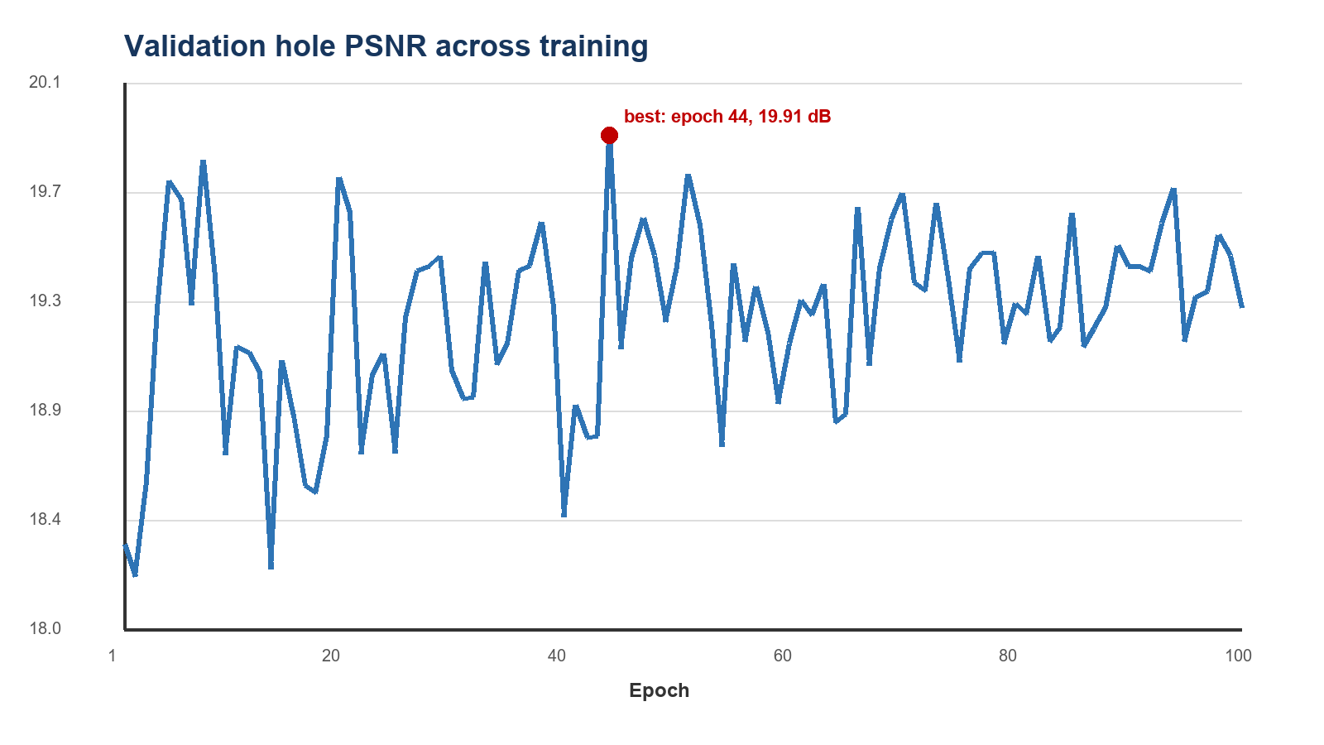
Figure 2. Validation hole PSNR for the 100-epoch seed-42 run. The red marker shows the selected checkpoint at epoch 44.
Validation PSNR rose from 18.350 dB after the first epoch to a maximum of 19.912 dB at epoch 44. The final epoch reached 19.255 dB, supporting selection by held-out validation score rather than by training endpoint.

5.2 Frozen test-set performance
Metric | Mean +/- image SD | Minimum | Maximum
Hole PSNR (dB) | 19.873 +/- 3.331 | 9.725 | 33.670
Full SSIM | 0.8999 +/- 0.0502 | 0.6679 | 0.9880
Full LPIPS | 0.0696 +/- 0.0338 | 0.0076 | 0.2370
Hole edge MAE | 0.3957 +/- 0.1643 | 0.0507 | 1.4195
Full FID | 10.466 | - | -

Table 2. Seed-42 performance on 2,021 frozen ADE20K test pairs. SD is across images, not training runs.
The checkpoint obtained 19.873 dB mean hole PSNR and 0.8999 mean full-image SSIM. LPIPS was 0.0696 and FID was 10.466; lower is better for both. The wide per-image PSNR range (9.725-33.670 dB) indicates substantial variation in mask coverage and scene difficulty.

5.3 Qualitative behavior
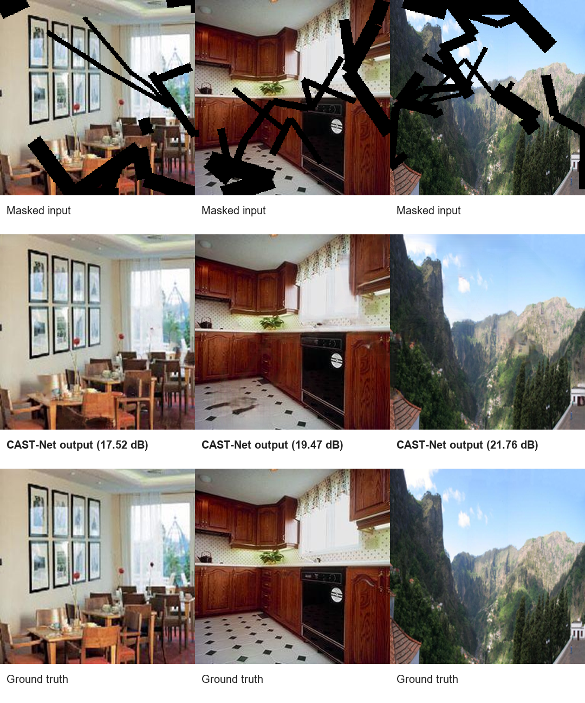
Figure 3. Deterministically selected 25th-, 50th-, and 75th-percentile test cases by hole PSNR (columns). Rows show masked input, CAST-Net completion, and ground truth.
Across representative quartiles, CAST-Net preserves all visible pixels and fills irregular holes with colors and structures consistent with surrounding context. Lower-PSNR cases tend to involve ambiguous object geometry or masks crossing strong boundaries; higher-PSNR cases provide more redundant nearby context. These examples are percentile-selected rather than manually chosen best cases.

5.4 Preliminary lightweight engineering benchmark
Variant | Base channels | Generator parameters | 100-step validation PSNR
Full CAST-Net | 64 | 5,276,359 | 16.163
Lightweight CAST-Net | 32 | 1,324,903 | 16.653
Relative change | - | -74.9% | +0.490 dB

Table 3. Preliminary 100-step benchmark using the same seed and validation protocol. These are not converged test results.
Halving the base width reduced parameters by 74.9% while producing a 0.490 dB higher validation score after exactly 100 optimizer steps. This small pilot does not establish final lightweight quality: short-run optimization can favor one width temporarily, and the lightweight checkpoint has not been trained to convergence or evaluated on the frozen test set.

6. Discussion
The seed-42 experiment shows that a modest 5.276M-parameter generator can combine global token selection, observed-only texture retrieval, and local residual refinement on a 6 GB laptop GPU. The 19.873 dB hole PSNR and low full-image LPIPS indicate that the model often generates completions close to the paired target while retaining observed content. However, image inpainting is intrinsically multimodal; paired fidelity alone cannot establish that every plausible alternative is visually preferable.
The lightweight pilot is promising as a resource-aware direction, especially because it preserves all three architectural mechanisms. Its role in this manuscript is hypothesis generation, not a final model comparison. A full lightweight study should repeat seeds 42, 43, and 44, select checkpoints independently, evaluate each on the identical frozen test bank, and report run-mean variability plus synchronized latency and memory.

6.1 Limitations and validity
The present evidence package contains one completed full-model training seed. Consequently, the manuscript cannot estimate variability across initialization and data-order randomness. The +/- values in Table 2 are descriptive variation across test images only. No numerical external baseline row is included because DeepFill v2, EdgeConnect, RFR, CoModGAN, and related systems have not yet been run with the same ADE20K split, masks, 256 x 256 preprocessing, compositing rule, and metric implementation. Likewise, component ablations are not claimed. These omissions prevent a defensible state-of-the-art or component-causality claim, but they do not invalidate the reported seed-42 measurements.
The evaluation uses images drawn from a deterministic split of ADE20K's training-image collection rather than the dataset's canonical scene-parsing split. Results therefore describe this released protocol only. Resizing to 256 x 256 also limits conclusions about high-resolution behavior.

7. Reproducibility, Code, and Data Availability
The public repository is https://github.com/maheshchudaman/CAST-Net-Full-Seed42-RTX4050. It contains source code, the resolved configuration, run metadata, the complete 2,021-record per-image JSONL file, the dataset-level summary, environment versions, and instructions for reconstructing the evaluation. ADE20K images, the trained checkpoint, generated image bundle, and pretrained metric weights are not redistributed in Git because of dataset terms and artifact size. The best-checkpoint SHA-256 is 723b61c509365473407acb591e564491dd1979a4805a37e1c99824ef10f274f2; the resolved-configuration SHA-256 is 879853af47cd99f1f5adabd08b32a07018ea5dd590651d9542630082808c23cd.

8. Conclusion
CAST-Net integrates learned sparse global attention, mask-aware cross-scale retrieval, and frequency-aware residual refinement for free-form image inpainting. A completed 100-epoch seed-42 run on a frozen ADE20K protocol achieved 19.873 dB hole PSNR, 0.8999 SSIM, 0.0696 LPIPS, 10.466 FID, and 0.3957 hole edge MAE over 2,021 test pairs. The released evidence enables exact audit of these measurements. The next experiments required for a stronger submission are two additional full or lightweight seeds, common-protocol baselines, and component ablations.

References
[1] D. Pathak, P. Krahenbuhl, J. Donahue, T. Darrell, and A. A. Efros, 'Context Encoders: Feature Learning by Inpainting,' CVPR, pp. 2536-2544, 2016.
[2] G. Liu, F. A. Reda, K. J. Shih, T.-C. Wang, A. Tao, and B. Catanzaro, 'Image Inpainting for Irregular Holes Using Partial Convolutions,' ECCV, pp. 85-100, 2018.
[3] J. Yu, Z. Lin, J. Yang, X. Shen, X. Lu, and T. S. Huang, 'Free-Form Image Inpainting With Gated Convolution,' ICCV, pp. 4471-4480, 2019.
[4] J. Yu, Z. Lin, J. Yang, X. Shen, X. Lu, and T. S. Huang, 'Generative Image Inpainting With Contextual Attention,' CVPR, pp. 5505-5514, 2018.
[5] K. Nazeri, E. Ng, T. Joseph, F. Qureshi, and M. Ebrahimi, 'EdgeConnect: Structure Guided Image Inpainting Using Edge Prediction,' ICCV Workshops, 2019.
[6] J. Li, N. Wang, L. Zhang, B. Du, and D. Tao, 'Recurrent Feature Reasoning for Image Inpainting,' CVPR, pp. 7760-7768, 2020.
[7] R. Suvorov et al., 'Resolution-Robust Large Mask Inpainting With Fourier Convolutions,' WACV, pp. 2149-2159, 2022.
[8] S. Zhao et al., 'Large Scale Image Completion via Co-Modulated Generative Adversarial Networks,' ICLR, 2021.
[9] R. Zhang, P. Isola, A. A. Efros, E. Shechtman, and O. Wang, 'The Unreasonable Effectiveness of Deep Features as a Perceptual Metric,' CVPR, pp. 586-595, 2018.
[10] Z. Wang, A. C. Bovik, H. R. Sheikh, and E. P. Simoncelli, 'Image Quality Assessment: From Error Visibility to Structural Similarity,' IEEE Trans. Image Process., 13(4), pp. 600-612, 2004.
[11] M. Heusel, H. Ramsauer, T. Unterthiner, B. Nessler, and S. Hochreiter, 'GANs Trained by a Two Time-Scale Update Rule Converge to a Local Nash Equilibrium,' NeurIPS 30, 2017.
[12] B. Zhou, H. Zhao, X. Puig, T. Xiao, S. Fidler, A. Barriuso, and A. Torralba, 'Semantic Understanding of Scenes Through the ADE20K Dataset,' Int. J. Comput. Vis., 127(3), pp. 302-321, 2019, doi:10.1007/s11263-018-1140-0.
[13] A. A. Efros and T. K. Leung, 'Texture Synthesis by Non-Parametric Sampling,' Proc. IEEE ICCV, pp. 1033-1038, 1999.
[14] C. Barnes, E. Shechtman, A. Finkelstein, and D. B. Goldman, 'PatchMatch: A Randomized Correspondence Algorithm for Structural Image Editing,' ACM Trans. Graph., 28(3), 2009.
[15] I. Goodfellow et al., 'Generative Adversarial Nets,' Advances in Neural Information Processing Systems 27, 2014.
[16] Y. Wang et al., 'Image Inpainting via Generative Multi-Column Convolutional Neural Networks,' Advances in Neural Information Processing Systems 31, 2018.
[17] L. Liao, J. Xiao, Z. Wang, C.-W. Lin, and S. Satoh, 'Image Inpainting Guided by Coherence Priors of Semantics and Textures,' CVPR, pp. 6539-6548, 2021.
[18] X. Guo, H. Yang, and D. Huang, 'Image Inpainting via Conditional Texture and Structure Dual Generation,' ICCV, pp. 14134-14143, 2021.
[19] T. Wang, H. Ouyang, and Q. Chen, 'Image Inpainting With External-Internal Learning and Monochromic Bottleneck,' CVPR, pp. 5120-5129, 2021.
[20] C. Zheng, T.-J. Cham, and J. Cai, 'Pluralistic Image Completion,' CVPR, pp. 1438-1447, 2019.
[21] H. Liu, Z. Wan, W. Huang, Y. Song, X. Han, and J. Liao, 'PD-GAN: Probabilistic Diverse GAN for Image Inpainting,' CVPR, pp. 9371-9381, 2021.
[22] J. Peng, D. Liu, S. Xu, and H. Li, 'Generating Diverse Structure for Image Inpainting With Hierarchical VQ-VAE,' CVPR, pp. 10775-10784, 2021.
[23] L. Zhao, Q. Mo, S. Lin, Z. Wang, Z. Zuo, H. Chen, W. Xing, and D. Lu, 'UCTGAN: Diverse Image Inpainting Based on Unsupervised Cross-Space Translation,' CVPR, pp. 5741-5750, 2020.
[24] Y. Yu, F. Zhan, S. Lu, J. Pan, F. Ma, X. Xie, and C. Miao, 'WaveFill: A Wavelet-Based Generation Network for Image Inpainting,' ICCV, pp. 14114-14123, 2021.
[25] S. Y. Kim et al., 'Zoom-to-Inpaint: Image Inpainting With High-Frequency Details,' CVPR Workshops, pp. 477-487, 2022.
[26] T. Chu et al., 'Rethinking Fast Fourier Convolution in Image Inpainting,' ICCV, pp. 23195-23205, 2023.
[27] A. Vaswani et al., 'Attention Is All You Need,' Advances in Neural Information Processing Systems 30, 2017.
[28] W. Li, Z. Lin, K. Zhou, L. Qi, Y. Wang, and J. Jia, 'MAT: Mask-Aware Transformer for Large Hole Image Inpainting,' CVPR, pp. 10758-10768, 2022.
[29] Q. Dong, C. Cao, and Y. Fu, 'Incremental Transformer Structure Enhanced Image Inpainting With Masking Positional Encoding,' CVPR, pp. 11358-11368, 2022.
[30] Q. Liu et al., 'Reduce Information Loss in Transformers for Pluralistic Image Inpainting,' CVPR, pp. 11347-11357, 2022.
[31] K. Ko and C.-S. Kim, 'Continuously Masked Transformer for Image Inpainting,' ICCV, pp. 13169-13178, 2023.
[32] P. Shamsolmoali, M. Zareapoor, and E. Granger, 'TransInpaint: Transformer-Based Image Inpainting with Context Adaptation,' ICCV Workshops, pp. 849-858, 2023.
[33] A. Sargsyan et al., 'MI-GAN: A Simple Baseline for Image Inpainting on Mobile Devices,' ICCV, 2023.
[34] D. P. Kingma and J. Ba, 'Adam: A Method for Stochastic Optimization,' International Conference on Learning Representations, 2015.
[35] T. Miyato, T. Kataoka, M. Koyama, and Y. Yoshida, 'Spectral Normalization for Generative Adversarial Networks,' International Conference on Learning Representations, 2018.
[36] P. Charbonnier, L. Blanc-Feraud, G. Aubert, and M. Barlaud, 'Two Deterministic Half-Quadratic Regularization Algorithms for Computed Imaging,' Proc. IEEE ICIP, pp. 168-172, 1994.
[37] N. Ahmed, T. Natarajan, and K. R. Rao, 'Discrete Cosine Transform,' IEEE Trans. Computers, C-23(1), pp. 90-93, 1974.

Appendix A. Evidence Identifiers
Artifact | Identifier
Run ID | ade20k_rtx4050_seed42
Test image-mask pairs | 2021
Test manifest SHA-256 | 7959e8734ae69ba5b242fc7d7d004afd5d1f853ba438a9ff22b89b18fa3eae09
Test mask registry SHA-256 | 2e0b23da7ae14c2e4fcd5866dc6bda05e60abc7d6e15d0621ff0ae10f63ebd82
Best checkpoint SHA-256 | 723b61c509365473407acb591e564491dd1979a4805a37e1c99824ef10f274f2
Resolved configuration SHA-256 | 879853af47cd99f1f5adabd08b32a07018ea5dd590651d9542630082808c23cd

Table A1. Exact identifiers for the reported evaluation.

