ORIGINAL RESEARCH - PILOT STUDY
Beyond Big-O: A Reproducible Apple-Silicon Pilot Study of Runtime Performance for Common Data Structures in Python and C++
Mahesh Patil and Student Research Team
Affiliation to be added before submission
Draft status: Prepared from measurements executed in Codex on 23 August 2026. This manuscript is intended for internal academic review and methodological refinement before journal submission.

Abstract
Asymptotic analysis predicts how algorithmic cost grows, but it does not capture language-runtime overhead, container representation, allocation behaviour or constants that influence observed execution time. This pilot study compared dynamic arrays, linked structures and hash tables under identical build, search, deletion and traversal workloads in Python 3.13 and optimized C++17. Experiments were executed on an Apple M2 MacBook Air with 8 GB memory and macOS 26.5.2. Four input sizes (1,000-25,000) were tested using three warm-ups and ten recorded repetitions, yielding 240 validated measurement records. At n = 25,000, median Python runtimes were 1.86-91.68 times the corresponding C++ medians across the twelve structure-operation combinations. Batched search and deletion for sequential structures exhibited empirical scaling exponents of approximately 1.85-2.00 because both the collection size and the number of operations increased with n; hash workloads were closer to linear. All implementations produced identical search-hit counts and post-deletion checksums. The findings support teaching Big-O together with implementation-aware measurement, while the single-machine scope, absence of Java and hardware-counter data, and submicrosecond C++ measurements make the work a pilot rather than a final general-purpose benchmark.
Keywords: data structures; Big-O; empirical algorithmics; Python; C++; microbenchmarking; reproducibility

1. Introduction
Big-O notation provides a machine-independent description of growth as input size increases. It is indispensable for algorithm design, yet it intentionally suppresses constant factors, representation costs and hardware effects [1]. Consequently, two implementations with the same asymptotic class can differ substantially in observed runtime, while a theoretically favourable structure may carry a higher construction or traversal cost for a particular workload.
This distinction is especially important in undergraduate computing education. Students often learn that hash-table lookup is expected O(1), array search is O(n), and linked-list traversal is O(n), but they may not observe how language runtimes, boxed objects, allocation strategies and contiguous memory influence actual measurements. Computer architecture texts likewise emphasise that locality and the memory hierarchy shape performance beyond instruction counts [2].
The objective of this pilot is not to declare one programming language universally superior. It is to test whether a small, reproducible experiment can connect theoretical complexity with measured behaviour while making its assumptions and limitations explicit. The resulting protocol is intended as a foundation for a student research project and a later multi-platform study.

1.1 Research questions
- RQ1: How do language and data-structure implementation affect observed runtime for equivalent workloads?
- RQ2: Do measured scaling patterns agree with the workload-level complexity predicted from Big-O analysis?
- RQ3: Which methodological limitations must be addressed before extending the pilot into a journal-ready benchmark?

1.2 Contributions
- A common, deterministic dataset and workload definition shared by Python and C++ implementations.
- A reproducible execution pipeline with correctness checks, raw-data hashing and environment metadata.
- An empirical distinction between per-operation complexity and the complexity of a batch whose operation count also grows with n.
- A transparent account of measurement-resolution, implementation-equivalence and external-validity limitations.

2. Background and Related Work
The analysis of algorithms separates growth rate from implementation detail [1]. Experimental algorithmics complements that abstraction by examining implementations on specified workloads and machines. Algorithm engineering has been described as a methodology connecting design, implementation, experimentation and refinement [3]. This perspective motivates reporting sufficient detail to reproduce not only the code but also the experimental conditions.
Performance measurement is vulnerable to effects that are easy to overlook. Mytkowicz et al. showed that apparently harmless environmental changes can alter conclusions [4]. Georges et al. and Kalibera and Jones argued for warm-ups, repeated measurements, uncertainty reporting and explicit treatment of runtime-system variability [5,6]. Fleming and Wallace further cautioned that benchmark summaries can mislead when inappropriate averages are used [7]. The present pilot therefore prioritises medians, dispersion, warm-ups, immutable raw results and correctness checks.
The study is deliberately modest. It does not claim that its three containers exhaust data-structure design or that Python and C++ expose equivalent internal representations. Instead, it investigates idiomatic implementations under a shared external workload. That decision improves classroom relevance but weakens causal attribution: measured differences reflect the combined effect of language, runtime, library implementation and element representation.

3. Materials and Methods

3.1 Execution environment
Table 1. Recorded execution environment.
Item | Recorded value
Computer | MacBook Air (Mac14,2)
Processor | Apple M2, 8 cores (4 performance, 4 efficiency), arm64
Memory | 8 GB unified memory
Operating system | macOS 26.5.2, Darwin 25.5.0
Python | CPython 3.13.5
C++ | C++17 compiled with Apple Clang 21.0.0 using -O2
Java | Not executed: no working JDK was available
Hardware counters | Not collected: Linux perf unavailable on macOS
Execution date | 23 August 2026

3.2 Structures and workload
The experiment used three abstract structures. The dynamic-array condition used Python list and C++ std::vector<int>; the linked condition used a custom Python singly linked list and C++ std::list<int>; and the hash condition used Python dict and C++ std::unordered_map<int,int>. Inputs contained unique integers in a deterministic shuffled order.
Table 2. Common experimental workload.
Component | Definition
Input size | 1,000; 5,000; 10,000; 25,000
Build | Construct the structure from all n values
Search | Query max(10, 0.01n) keys; half present and half absent
Delete | Delete max(1, 0.01n) keys known to be present
Traverse | Sum all keys remaining after deletion
Correctness | Compare search-hit count and post-deletion checksum
Timing boundary | Exclude dataset parsing and CSV output

3.3 Dataset generation and validation
A fixed seed (20260823) generated one text dataset per input size. Every language read the same files. A manifest stored each file's SHA-256 digest. Before performance analysis, all result groups were checked for identical search-hit counts and identical post-deletion checksums. Any disagreement would have invalidated the performance data; none occurred.

3.4 Measurement protocol
For every language-structure-size combination, the program performed three unrecorded warm-ups followed by ten recorded repetitions. Jobs were shuffled with the experiment seed. Operation durations were measured using monotonic high-resolution clocks and reported in nanoseconds. The complete design produced 2 languages x 3 structures x 4 sizes x 10 repetitions = 240 records.
Measurement caveat: Some optimized C++ workloads completed in less than one microsecond, and the C++ hash-search median at n = 1,000 was recorded as zero. Such values are below a dependable single-shot timing range and are treated as resolution-limited rather than literal zero-cost operations.

3.5 Analysis
The primary summary was the median across ten repetitions, with the mean, standard deviation and non-parametric bootstrap interval retained in the generated analysis file. Coefficient of variation (CV) was used to describe group dispersion. Python-to-C++ median ratios at n = 25,000 were calculated descriptively; Cliff's delta was also computed. Scaling exponents between n = 5,000 and n = 25,000 were estimated as log(T2/T1) / log(n2/n1). No causal language claim is made because language and container representation were not independently manipulated.

4. Results

4.1 Correctness and measurement stability
All 240 records passed the hit-count and checksum validation. The median CV across the 96 language-structure-size-operation groups was 4.0%. The maximum CV was 129.1% and occurred in the resolution-limited C++ hash-search group at n = 1,000. The data therefore show generally stable repeated measurements while also identifying the exact region in which the timer cannot support strong absolute claims.

4.2 Search scaling
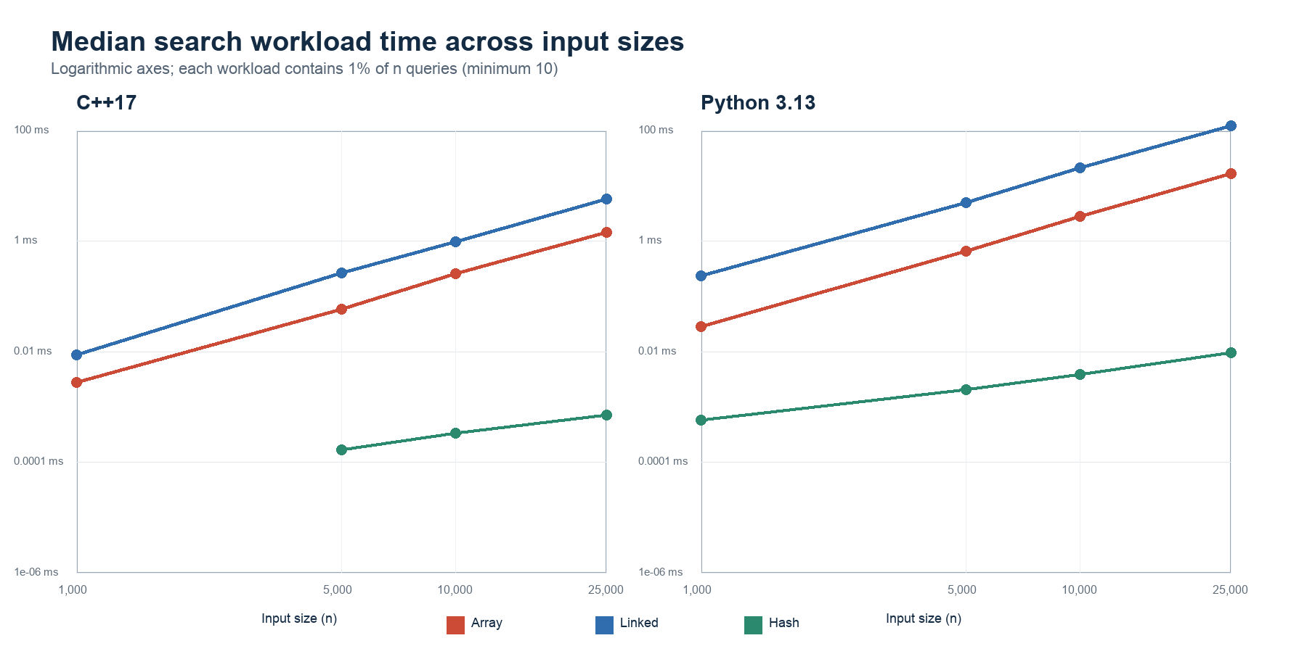
Figure 1. Median search-workload time across input sizes. The zero C++ hash-search median at n = 1,000 is omitted from the logarithmic plot.
Sequential search rose much more sharply than hash search. Between 5,000 and 25,000 elements, the estimated search exponent was 1.99 for the C++ array and 2.00 for the Python array; the linked implementations produced 1.91 and 1.99, respectively. The corresponding hash exponents were 0.90 for C++ and 0.97 for Python. This apparent quadratic-versus-linear contrast is consistent with the workload definition: the number of search queries itself increases in proportion to n, so an O(n) sequential search repeated O(n) times yields an O(n^2) batch, whereas expected O(1) hash lookup repeated O(n) times yields an O(n) batch.

4.3 Runtime at the largest input
Table 3. Median workload runtime at n = 25,000 (ten repetitions).
Structure | Operation | C++17 | Python 3.13 | Python/C++
Array | Insert | 0.0066 ms | 0.0312 ms | 4.76x
Array | Search | 1.425 ms | 16.389 ms | 11.50x
Array | Delete | 1.072 ms | 16.401 ms | 15.30x
Array | Traverse | 0.958 us | 0.0878 ms | 91.68x
Linked | Insert | 0.2152 ms | 3.376 ms | 15.69x
Linked | Search | 5.712 ms | 123.330 ms | 21.59x
Linked | Delete | 3.742 ms | 76.788 ms | 20.52x
Linked | Traverse | 0.0297 ms | 0.7406 ms | 24.91x
Hash | Insert | 0.2779 ms | 0.6200 ms | 2.23x
Hash | Search | 0.708 us | 0.0096 ms | 13.57x
Hash | Delete | 0.0049 ms | 0.0091 ms | 1.86x
Hash | Traverse | 0.0295 ms | 0.1087 ms | 3.68x

At n = 25,000, every Python median exceeded its corresponding C++ median; the descriptive ratios ranged from 1.86x for hash deletion to 91.68x for array traversal. Cliff's delta was 1.00 for all twelve comparisons, meaning every recorded Python duration in each comparison exceeded every corresponding C++ duration. These values characterise the tested implementations on this Mac and must not be interpreted as universal language speed factors.
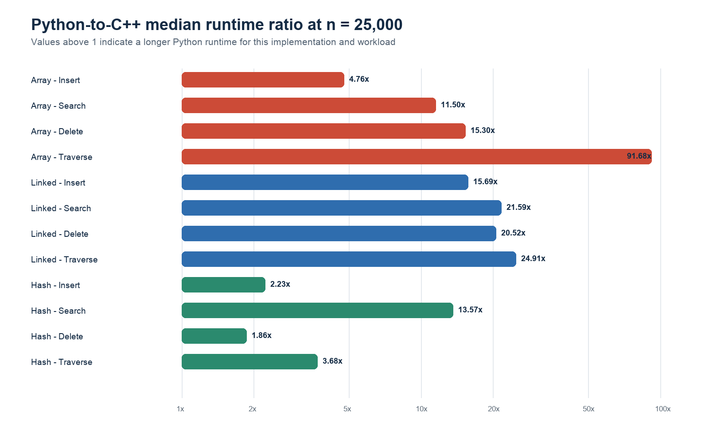
Figure 2. Python-to-C++ median runtime ratios at n = 25,000. The horizontal axis is logarithmic.

4.4 Deletion and traversal patterns
Array and linked deletion workloads also approached quadratic scaling because 1% of n keys were deleted and each deletion required sequential location; estimated exponents ranged from 1.85 to 1.89 for linked deletion and 1.87 to 1.89 for array deletion. Hash deletion remained close to linear at 1.00 in C++ and 1.02 in Python. Traversal generally approached linear growth, with exponents between 0.84 and 0.97 across the structures and languages. These patterns are more defensible than the smallest absolute timings because they rely on changes across larger workloads.

5. Discussion

5.1 Big-O explained, not contradicted
The results do not show a failure of asymptotic analysis. Instead, they demonstrate why the unit of analysis must be stated carefully. A single sequential search is O(n), but this experiment schedules 0.01n searches, creating an O(n^2) batch. A hash lookup is expected O(1) on average, and the corresponding O(n) batch grew close to linearly. The empirical exponents therefore connect measured behaviour to the composed workload rather than replacing theory.

5.2 Language and representation effects
The Python/C++ differences include many inseparable factors: interpretation versus optimized native code, boxed Python integers versus C++ primitive integers, object allocation, iterator implementation and library design. The largest ratio occurred for contiguous traversal, where optimized native loops can exploit compact primitive storage and compiler transformations. Hash insertion and deletion showed smaller ratios, indicating that language overhead is not a single constant applied uniformly to every structure and operation.

5.3 Educational value
A useful teaching sequence is therefore: predict complexity, define the entire workload, implement correctness checks, measure, and then explain both agreement and disagreement. Students should learn to ask not only 'What is the Big-O?' but also 'What exactly is repeated, what representation is used, what is inside the timed region, and is the measurement long enough for the clock?' The repository makes those questions visible and reproducible.

6. Threats to Validity

6.1 Internal validity
Background activity, thermal conditions and operating-system scheduling were not instrumented. Although jobs were shuffled and measurements were repeated, the study did not pin processes to performance cores. Extremely short C++ operations are vulnerable to timer quantisation and clock-call overhead. A revised benchmark should batch pure operations until each timed interval exceeds a predefined duration and should separately quantify timing overhead.

6.2 Construct validity
The structures are functionally comparable but not internally identical. Python's custom singly linked list differs from C++ std::list, which is typically doubly linked. Python list holds object references, whereas std::vector<int> stores primitive integers contiguously. Consequently, the experiment evaluates idiomatic implementation conditions rather than isolating a pure language effect. Peak memory and cache behaviour were proposed in the broader project but were not measured on this Mac and are not inferred in this paper.

6.3 External and conclusion validity
One Apple M2 laptop, one Python version and one C++ toolchain cannot represent other processors, operating systems, compilers or runtime configurations. Only four sizes and one random-input family were examined. Ten repetitions support descriptive stability but not broad population inference. Java was not executed because no working JDK was available. The conclusions are therefore restricted to this environment and protocol.

7. Conclusion and Future Work
This reproducible Mac pilot showed that theoretical growth and observed runtime can be taught together. Sequential search and deletion batches grew close to quadratically when both collection size and operation count increased, while hash batches grew close to linearly. Python and C++ showed substantial but operation-dependent runtime differences, and all correctness outputs agreed. The study also exposed a measurement weakness: several optimized C++ workloads were too short for reliable single-shot timing.
Before journal submission, the benchmark should use calibrated operation batching, add Java 17, collect peak resident memory and hardware cache counters on a controlled Linux machine, record temperature and power mode, test additional input distributions, and reproduce the experiment on at least one independent system. Those extensions should be reported as new evidence, not combined silently with the present Mac data.

Data and Code Availability
The repository contains the dataset generator, Python and C++ implementations, Java source, validation tests, execution configuration, raw CSV records and analysis scripts. The raw combined CSV contains 240 records and has SHA-256 digest c86df6732b7e5e78e7a71d6b72ae65535b648b10ccb4c39255a4652018ed3dff. A public repository URL and archived release identifier must be inserted before submission.

Ethics, Authorship and AI-Assistance Statement
No human-participant, personal or sensitive data were used. Codex assisted with repository scaffolding, code review, execution orchestration, analysis scripting and preparation of this draft. All numerical claims in the manuscript were generated programmatically from the preserved raw CSV; missing measurements were not fabricated. Before submission, the named authors must independently verify the code, results, citations and wording, approve authorship contributions, and adapt this disclosure to the selected journal's policy.

References
- Cormen, T. H., Leiserson, C. E., Rivest, R. L., and Stein, C. (2022). Introduction to Algorithms (4th ed.). MIT Press.
- Hennessy, J. L., and Patterson, D. A. (2019). Computer Architecture: A Quantitative Approach (6th ed.). Morgan Kaufmann.
- Sanders, P. (2009). Algorithm Engineering - An Attempt at a Definition. In Efficient Algorithms, LNCS 5760, 321-340. https://doi.org/10.1007/978-3-642-03456-5_22
- Mytkowicz, T., Diwan, A., Hauswirth, M., and Sweeney, P. F. (2009). Producing wrong data without doing anything obviously wrong! Proceedings of ASPLOS XIV, 265-276. https://doi.org/10.1145/1508244.1508275
- Georges, A., Buytaert, D., and Eeckhout, L. (2007). Statistically rigorous Java performance evaluation. Proceedings of OOPSLA 2007, 57-76. https://doi.org/10.1145/1297027.1297033
- Kalibera, T., and Jones, R. (2013). Rigorous benchmarking in reasonable time. Proceedings of ISMM 2013, 63-74. https://doi.org/10.1145/2464157.2464160
- Fleming, P. J., and Wallace, J. J. (1986). How not to lie with statistics: the correct way to summarize benchmark results. Communications of the ACM, 29(3), 218-221. https://doi.org/10.1145/5666.5673
- Efron, B., and Tibshirani, R. J. (1993). An Introduction to the Bootstrap. Chapman and Hall/CRC.
- Python Software Foundation. (2026). Python 3.13 documentation: Data structures. https://docs.python.org/3.13/tutorial/datastructures.html
- ISO/IEC. (2020). ISO/IEC 14882:2020 Programming Languages - C++. International Organization for Standardization.

Appendix A. Reproducibility Record
Table A1. Repository evidence map.
Evidence | Repository path
Experiment configuration | config/experiment.json
Dataset manifest | data/generated/manifest.json
Raw measurements | results/raw/combined.csv
Environment metadata | results/raw/environment.json
Paper analysis | paper/analyse_for_paper.py
Correctness tests | tests/test_benchmark.py; tests/test_dataset_manifest.py

