Mask Coverage as a Confounding Factor in Full-Image Evaluation of Image Inpainting
Mahesh Patil1*, Vikas Tiwari2
¹Department of Electronics and Communication Engineering, Oriental University, Indore, MP, India
²Department of Electronics and Communication Engineering, Oriental University, Indore, MP, India
E-mail: 1*mcpatil@gmail.com, 2dr.vikastiwari@orientaluniversity.in (*Corresponding author)
Abstract
Image-inpainting studies often report metrics over the complete image even when observed pixels are copied unchanged. This practice makes a score depend jointly on completion quality and missing-area coverage. We derive exact identities showing that, under observed-pixel preservation, full-image mean squared error and mean absolute error equal their hole-only counterparts multiplied by mask coverage, while full-image PSNR exceeds hole PSNR by −10 log10(h), where h is the missing-area fraction. We test the practical magnitude of this effect in a deterministic repeated-measures study using 2,000 ADE20K validation images, four mask families, five exact coverage levels from 10% to 50%, and four controlled completion probes, yielding 160,000 image-condition records. Mean full-image PSNR decreased from 22.204 to 15.114 dB and full-image SSIM from 0.9007 to 0.5652 between 10% and 50% coverage, whereas mean hole PSNR changed only from 12.204 to 12.104 dB. A 10,000-resample image-cluster bootstrap estimated a paired full-image PSNR difference of −7.090 dB [−7.124, −7.055]. In matched 10%-versus-50% condition pairs, full-image and hole PSNR preferred opposite coverage conditions in 44.2% of comparisons [43.4%, 45.0%]. In a counterfactual aggregation audit using the identical outputs, changing only the coverage prevalence from small-hole-heavy to large-hole-heavy shifted pooled full-image PSNR by 3.497 dB [3.481, 3.513], while hole PSNR shifted by 0.051 dB [0.035, 0.067]. Coverage accounted for 97.3% of the within-image variation in full-image PSNR but only 0.8% in hole PSNR. These findings show that full-image scores can change substantially because metric support changes. We recommend hole-specific primary metrics, identical versioned masks, coverage-stratified summaries, and explicit reporting of aggregation. The controlled probes are measurement instruments and do not rank learned architectures.
Keywords: image inpainting; evaluation protocol; PSNR; SSIM; mask coverage; reproducibility; ADE20K
1. Introduction
Image inpainting estimates content inside a missing region from visible context. Modern systems are evaluated with masks that vary in shape, location and area, and their final outputs commonly preserve observed pixels through deterministic compositing. This rule is desirable because it prevents unintended alteration of known content. It also creates an evaluation issue: a full-image score includes a potentially large region with exactly zero error.
Mask size is an established difficulty variable in inpainting benchmarks. Black et al. [5] reported results at multiple masking levels, and LaMa was designed for large-mask and high-resolution settings [6]. Generic fidelity measures also do not fully represent perceived completion quality [4, 7]. The narrower question addressed here is mathematical and procedural: when observed pixels are preserved exactly, how much of a full-image score is determined by missing-area coverage rather than reconstruction quality inside the hole?
The question matters when studies use different mask distributions, when a pooled mean combines small and large holes, or when metric support is not reported. Under these conditions, a numerically better full-image score need not indicate a better completion process. The present study isolates this measurement effect without training a neural network, making the protocol practical on commodity hardware.
The contributions are:
• Exact identities linking full-image MSE, MAE and PSNR to their hole-only counterparts under observed-pixel preservation.
• A deterministic repeated-measures experiment comprising 160,000 evaluations on 2,000 ADE20K validation images, with four mask families, five exact coverage targets and four controlled distortion probes.
• An image-cluster bootstrap analysis and an integrity check confirming exact preservation of observed pixels.
• A directly invertible coverage correction for MSE, MAE and PSNR, together with a reporting protocol designed to prevent mask coverage from being mistaken for model quality.
• A counterfactual aggregation audit that holds every output fixed and changes only mask-coverage prevalence, isolating the numerical consequence of an undisclosed test distribution.
• A public, executable repository containing the resolved configuration, analysis code, integrity checks, compact results and figure-generation workflow [12].
2. Background and Related Work
2.1 Inpainting architectures and evaluation
Deep inpainting progressed from context encoders [8] to partial convolutions [9], contextual attention [10], gated convolutions for free-form holes [11], and Fourier-convolution models for large masks [6]. These methods differ in how they use valid context and synthesize missing structure, but all require a clearly defined evaluation support. PSNR is a monotonic transformation of MSE, while SSIM compares local luminance, contrast and structure [2, 3]. LPIPS uses deep features to better reflect perceptual similarity [7].
Tiefenbacher et al. [4] found that PSNR and SSIM did not adequately represent subjective judgments across diverse inpainting results. Black et al. [5] further showed that reconstruction metrics need not predict downstream classification or retrieval performance. These findings motivate complementary perceptual, semantic or human evaluation; they do not remove the need to calculate and label fidelity measures correctly.
Recent large-hole systems, including CoModGAN, mask-aware transformers and diffusion-based RePaint, further emphasize that mask geometry and area define materially different completion regimes [13, 14, 17]. Distributional measures such as FID and KID can complement pairwise fidelity measures [15, 16], but they answer a population-level realism question and do not correct a support mismatch in per-image PSNR, MAE or SSIM.
2.2 Mask distributions and metric support
Inpainting difficulty depends on missing-area size, topology and scene content. Irregular holes can disconnect structures, while object-aligned holes remove coherent semantic regions. Large holes reduce available context and increase ambiguity. Aggregate scores are therefore difficult to interpret when the mask bank, coverage histogram or metric support is undisclosed. This study treats metric support itself as the object of analysis.
3. Analytical Relationship Between Full-Image and Hole Metrics
3.1 Proposition 1 Exact support identities
Let Ω contain all image pixels, H ⊂ Ω be the missing region, h = |H|/|Ω| be mask coverage, x be the reference image and ŷ be the composite output. Assume exact observed-pixel preservation: ŷᵢ = xᵢ for every i ∈ Ω \ H. Channel averaging is included in each pixelwise error term.
Proposition 1. Under these conditions, the full-image MSE and MAE are exactly the corresponding hole-only errors multiplied by h.
MSEfull = h · MSEhole, MAEfull = h · MAEhole
Proof. Split either full-image error sum into H and Ω \ H. Every term on Ω \ H is zero, leaving the hole sum divided by |Ω|. Multiplying and dividing by |H| gives h times the hole mean. This argument does not depend on the dataset, image resolution, mask shape or completion model. With unit data range, PSNR = −10 log10(MSE), giving Corollary 1:
PSNRfull = PSNRhole − 10 log10(h).
The added term depends only on coverage. It equals 10.00 dB at 10% coverage, 6.99 dB at 20%, 5.23 dB at 30%, 3.98 dB at 40% and 3.01 dB at 50%. Thus, full-image PSNR is systematically higher than hole PSNR, with the largest increase for the smallest holes. This is not a defect in PSNR; it is a consequence of changing the set of pixels over which error is averaged.
For example, output A may obtain 20 dB hole PSNR at 10% coverage and output B 22 dB at 40% coverage. Hole PSNR favors B by 2 dB, but their full-image scores become 30.00 and 25.98 dB, reversing the ordering because coverage differs. Comparisons remain valid when identical masks are used and support is explicitly defined.
Figure 1. Exact full-image PSNR increase caused solely by copying observed pixels.
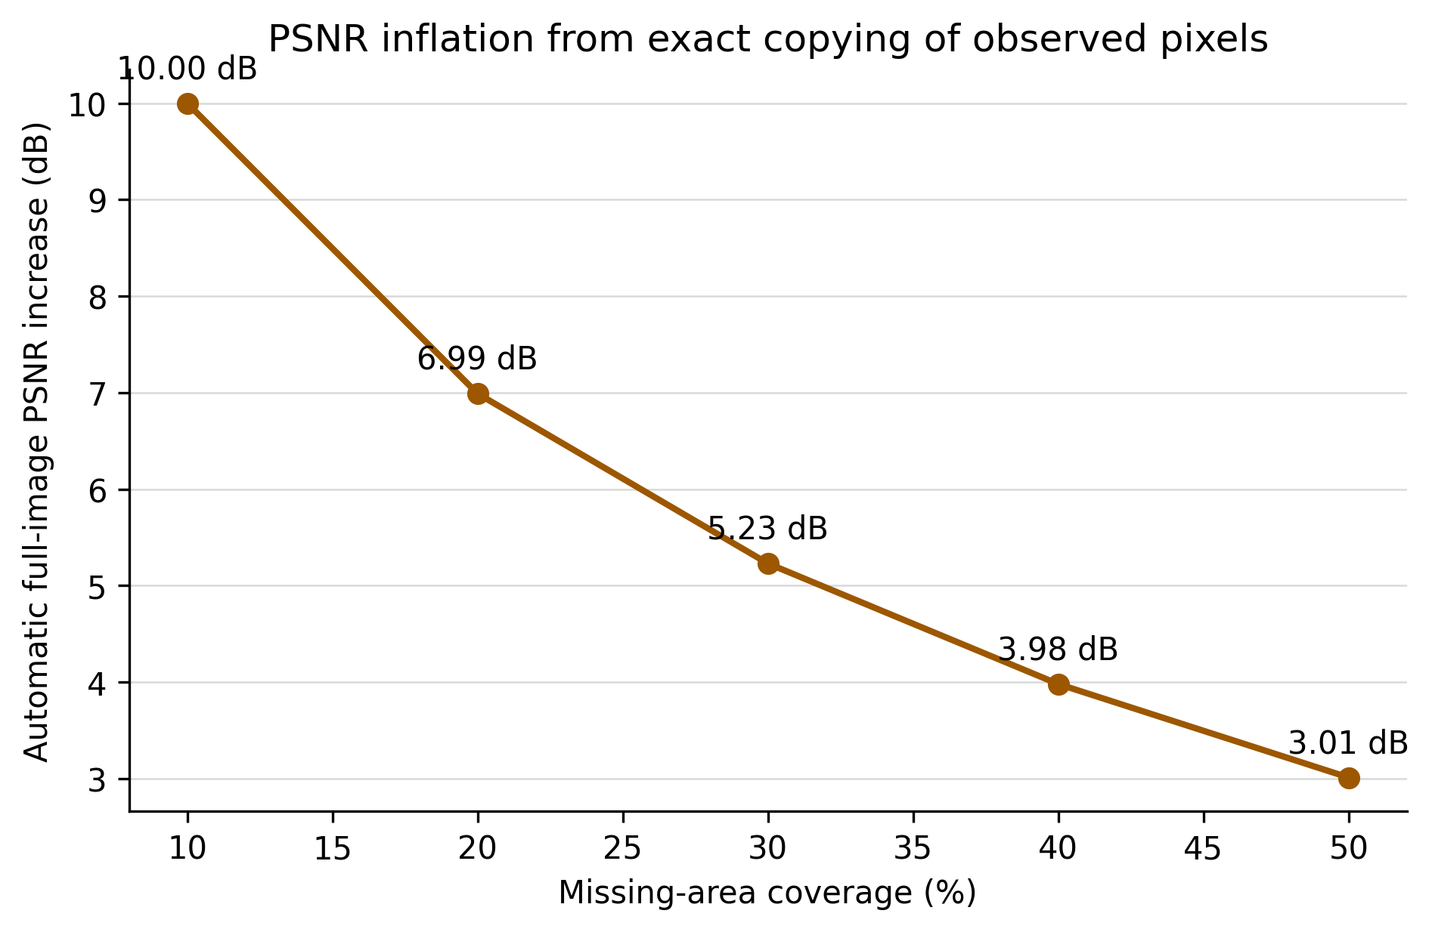
3.2 Proposition 2 Ordering invariance and its boundary
Proposition 2. For two methods evaluated on the same image and identical mask, the difference between their full-image PSNR values equals the difference between their hole PSNR values. Proof. The same −10 log10(h) term is added to both hole scores and therefore cancels. Consequently, the present argument does not invalidate a properly matched comparison. Confounding arises only when coverage differs between compared outputs, coverage strata receive unequal weights, or metric support is unstated. This boundary is central: the paper identifies an audit condition, not a universal defect in full-image PSNR.
No equally simple identity applies to SSIM because local windows can contain different mixtures of observed and missing pixels, and structural terms are nonlinear. Nevertheless, exact copied pixels raise similarity in many windows, so full-image SSIM can also inherit a strong coverage dependence. The empirical experiment therefore treats the PSNR relationship as an analytical invariant and the SSIM relationship as a measured property of this protocol.
3.3 Coverage-normalized recovery and audit rule
When a published evaluation confirms exact observed-pixel copying and reports the realised coverage h for each sample, the hole-only fidelity values can be recovered from full-image values: MSEhole = MSEfull/h, MAEhole = MAEfull/h and PSNRhole = PSNRfull + 10 log10(h). This correction must be applied per image and mask before aggregation; substituting the mean coverage into a pooled PSNR is generally invalid because the logarithm and averaging do not commute. The recovery rule provides a useful audit, but direct calculation on the missing region remains preferable because it exposes the intended support and also works when observed pixels are not preserved exactly.
3.4 Consequences for aggregation
A pooled mean over individual masks weights every evaluated composite equally, whereas a mean over coverage strata weights each coverage band equally. These estimands coincide only when the coverage distribution is balanced. Accordingly, an inpainting paper should identify the aggregation unit, publish the coverage histogram and state whether metrics were averaged per image, per mask, per coverage stratum or over all pixels. Confidence intervals should also respect repeated measurements from the same image.
4. Controlled Study
4.1 Data and preprocessing
The experiment used all 2,000 image–annotation pairs in the public ADE20K validation partition [1]. Each RGB image and semantic label map was resized to 256 × 256 pixels; bicubic interpolation was used for RGB images and nearest-neighbor interpolation for labels. No training, model fitting or hyperparameter selection was performed on these images.
4.2 Mask construction
Four mask families were generated: a centered square-like region, a randomly located rectangle with aspect ratio sampled between 0.5 and 2.0 on a logarithmic scale, a multi-stroke free-form mask, and a semantic mask initialized from ADE20K label regions. Each mask was deterministically adjusted to an exact target of 10%, 20%, 30%, 40% or 50% missing pixels. A SHA-256-derived condition seed made every mask reproducible. All probes shared the same mask for a given image, family and coverage.
4.3 Controlled completion probes
Four nonlearned probes generated different error structures inside each hole: (i) the observed-region RGB mean, (ii) a Gaussian-blurred reference with radius 7, (iii) clipped Gaussian noise centered on the observed-region mean with standard deviation 0.20, and (iv) a spatially shifted reference with a 12% image-width offset in both axes. Blur and shift deliberately access transformed reference content; they are controlled distortions, not deployable inpainting algorithms. The observed region was copied exactly after insertion.
4.4 Metrics and statistical analysis
For every composite, the analysis recorded full-image and hole-only MSE, PSNR and MAE, full-image SSIM, and Sobel edge-magnitude MAE inside the hole. Exact observed-pixel preservation and the analytical MSE, MAE and PSNR relationships were verified for every record. The prespecified primary contrast was the paired 50%-minus-10% coverage difference. To avoid pseudoreplication, mask families and probes were first averaged within each image-by-coverage cell; the image, not the condition record, was the inferential unit. Coverage means and paired differences were estimated across images with 10,000 image-cluster bootstrap resamples. Spearman correlations and variance-decomposition values are explicitly descriptive secondary analyses; no condition-level p-values are reported.
4.5 Counterfactual aggregation audit
To isolate aggregation from completion quality, three coverage mixtures were applied to the same image-by-coverage results. The small-hole-heavy mixture assigned weights (0.50, 0.20, 0.15, 0.10, 0.05) to coverage levels from 10% to 50%; the balanced mixture assigned 0.20 to each level; and the large-hole-heavy mixture reversed the small-hole-heavy weights. No image, mask or output was changed. Paired small-minus-large mixture differences were bootstrapped by image. A descriptive repeated-measures effect size was also computed after removing each image mean: the coverage sum of squares divided by total within-image sum of squares.
4.6 Balanced factorial design
The design is fully crossed: each image is evaluated under every mask-family, coverage and probe combination. This balance permits matched comparisons while keeping the image—not the individual condition record—as the statistical unit for uncertainty estimates.
Table 1. Experimental design and analysis units.
Design component | Specification | Contribution
ADE20K validation images | 2,000 | 2,000 image clusters
Mask families | 4 | Center, rectangle, free-form, semantic
Coverage targets | 5 | 10%, 20%, 30%, 40%, 50%
Controlled probes | 4 | Mean, blur, noise, shift
Conditions per image | 80 | 4 × 5 × 4
Total records | 160,000 | 2,000 × 80
Primary bootstrap | 10,000 | Resampling unit: image
Subgroup bootstrap | 3,000 | Resampling unit: image

4.7 Traceability and integrity controls
The resolved configuration records image size, base seed, target coverage levels, mask families, completion probes, blur radius, spatial shift and noise scale. Each image, mask and condition receives a recorded identifier or cryptographic digest. Integrity checks verify exact observed-pixel preservation and the MSE, MAE and PSNR identities for every record. The dataset images are not redistributed; the analysis package contains only configuration, code and derived records.
Figure 2. Example 30% free-form mask and four controlled completion probes. The probes isolate metric behavior and are not competitive inpainting methods.
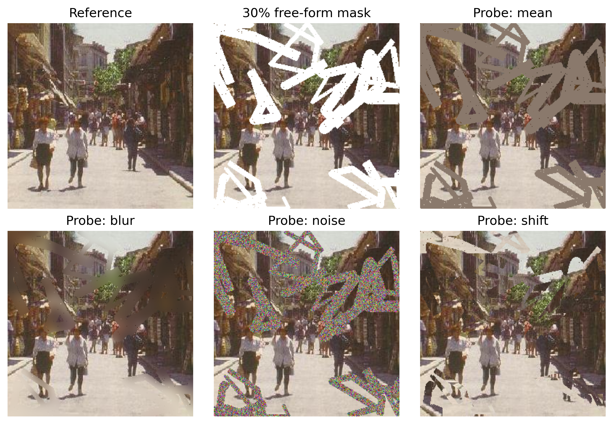
5. Results
5.1 Integrity and analytical checks
All 160,000 composites preserved observed pixels exactly, with maximum absolute observed-pixel error 0.00 × 10⁰. Maximum numerical residuals were 2.98 × 10⁻⁸ for the MSE identity, 4.72 × 10⁻⁸ for the MAE identity and 1.25 × 10⁻⁶ dB for the PSNR-gap identity, consistent with floating-point rounding.
Table 2. Record-level integrity checks across all 160,000 composites.
Check | Maximum residual | Interpretation
Observed-pixel equality | 0.00 | Exact preservation
MSE identity | 2.98 × 10⁻⁸ | Floating-point tolerance
MAE identity | 4.72 × 10⁻⁸ | Floating-point tolerance
PSNR-gap identity | 1.25 × 10⁻⁶ dB | Floating-point tolerance

5.2 Coverage-dependent metric behavior
Table 3. Image-level means with image-cluster bootstrap 95% confidence intervals in brackets.
Coverage | Full PSNR (dB) | Hole PSNR (dB) | Full SSIM | Hole MAE
10% | 22.204 [22.131, 22.275] | 12.204 [12.131, 12.275] | 0.9007 [0.9002, 0.9012] | 0.1862 [0.1845, 0.1880]
20% | 19.157 [19.088, 19.229] | 12.167 [12.098, 12.239] | 0.8081 [0.8072, 0.8089] | 0.1866 [0.1849, 0.1883]
30% | 17.380 [17.312, 17.451] | 12.151 [12.083, 12.222] | 0.7251 [0.7239, 0.7264] | 0.1866 [0.1849, 0.1883]
40% | 16.090 [16.021, 16.160] | 12.110 [12.042, 12.180] | 0.6441 [0.6425, 0.6457] | 0.1872 [0.1856, 0.1889]
50% | 15.114 [15.045, 15.182] | 12.104 [12.034, 12.172] | 0.5652 [0.5632, 0.5672] | 0.1870 [0.1854, 0.1886]

Full-image metrics changed strongly with coverage. Mean full-image PSNR decreased from 22.204 dB at 10% coverage to 15.114 dB at 50%, and mean full-image SSIM decreased from 0.9007 to 0.5652. Over the same change, mean hole PSNR moved from 12.204 to 12.104 dB. Descriptive Spearman correlations were −0.829 for full PSNR, −0.964 for full SSIM, −0.021 for hole PSNR and +0.009 for hole MAE.
Figure 3. Mean metric values by missing-area coverage. Bands are image-cluster bootstrap 95% confidence intervals.
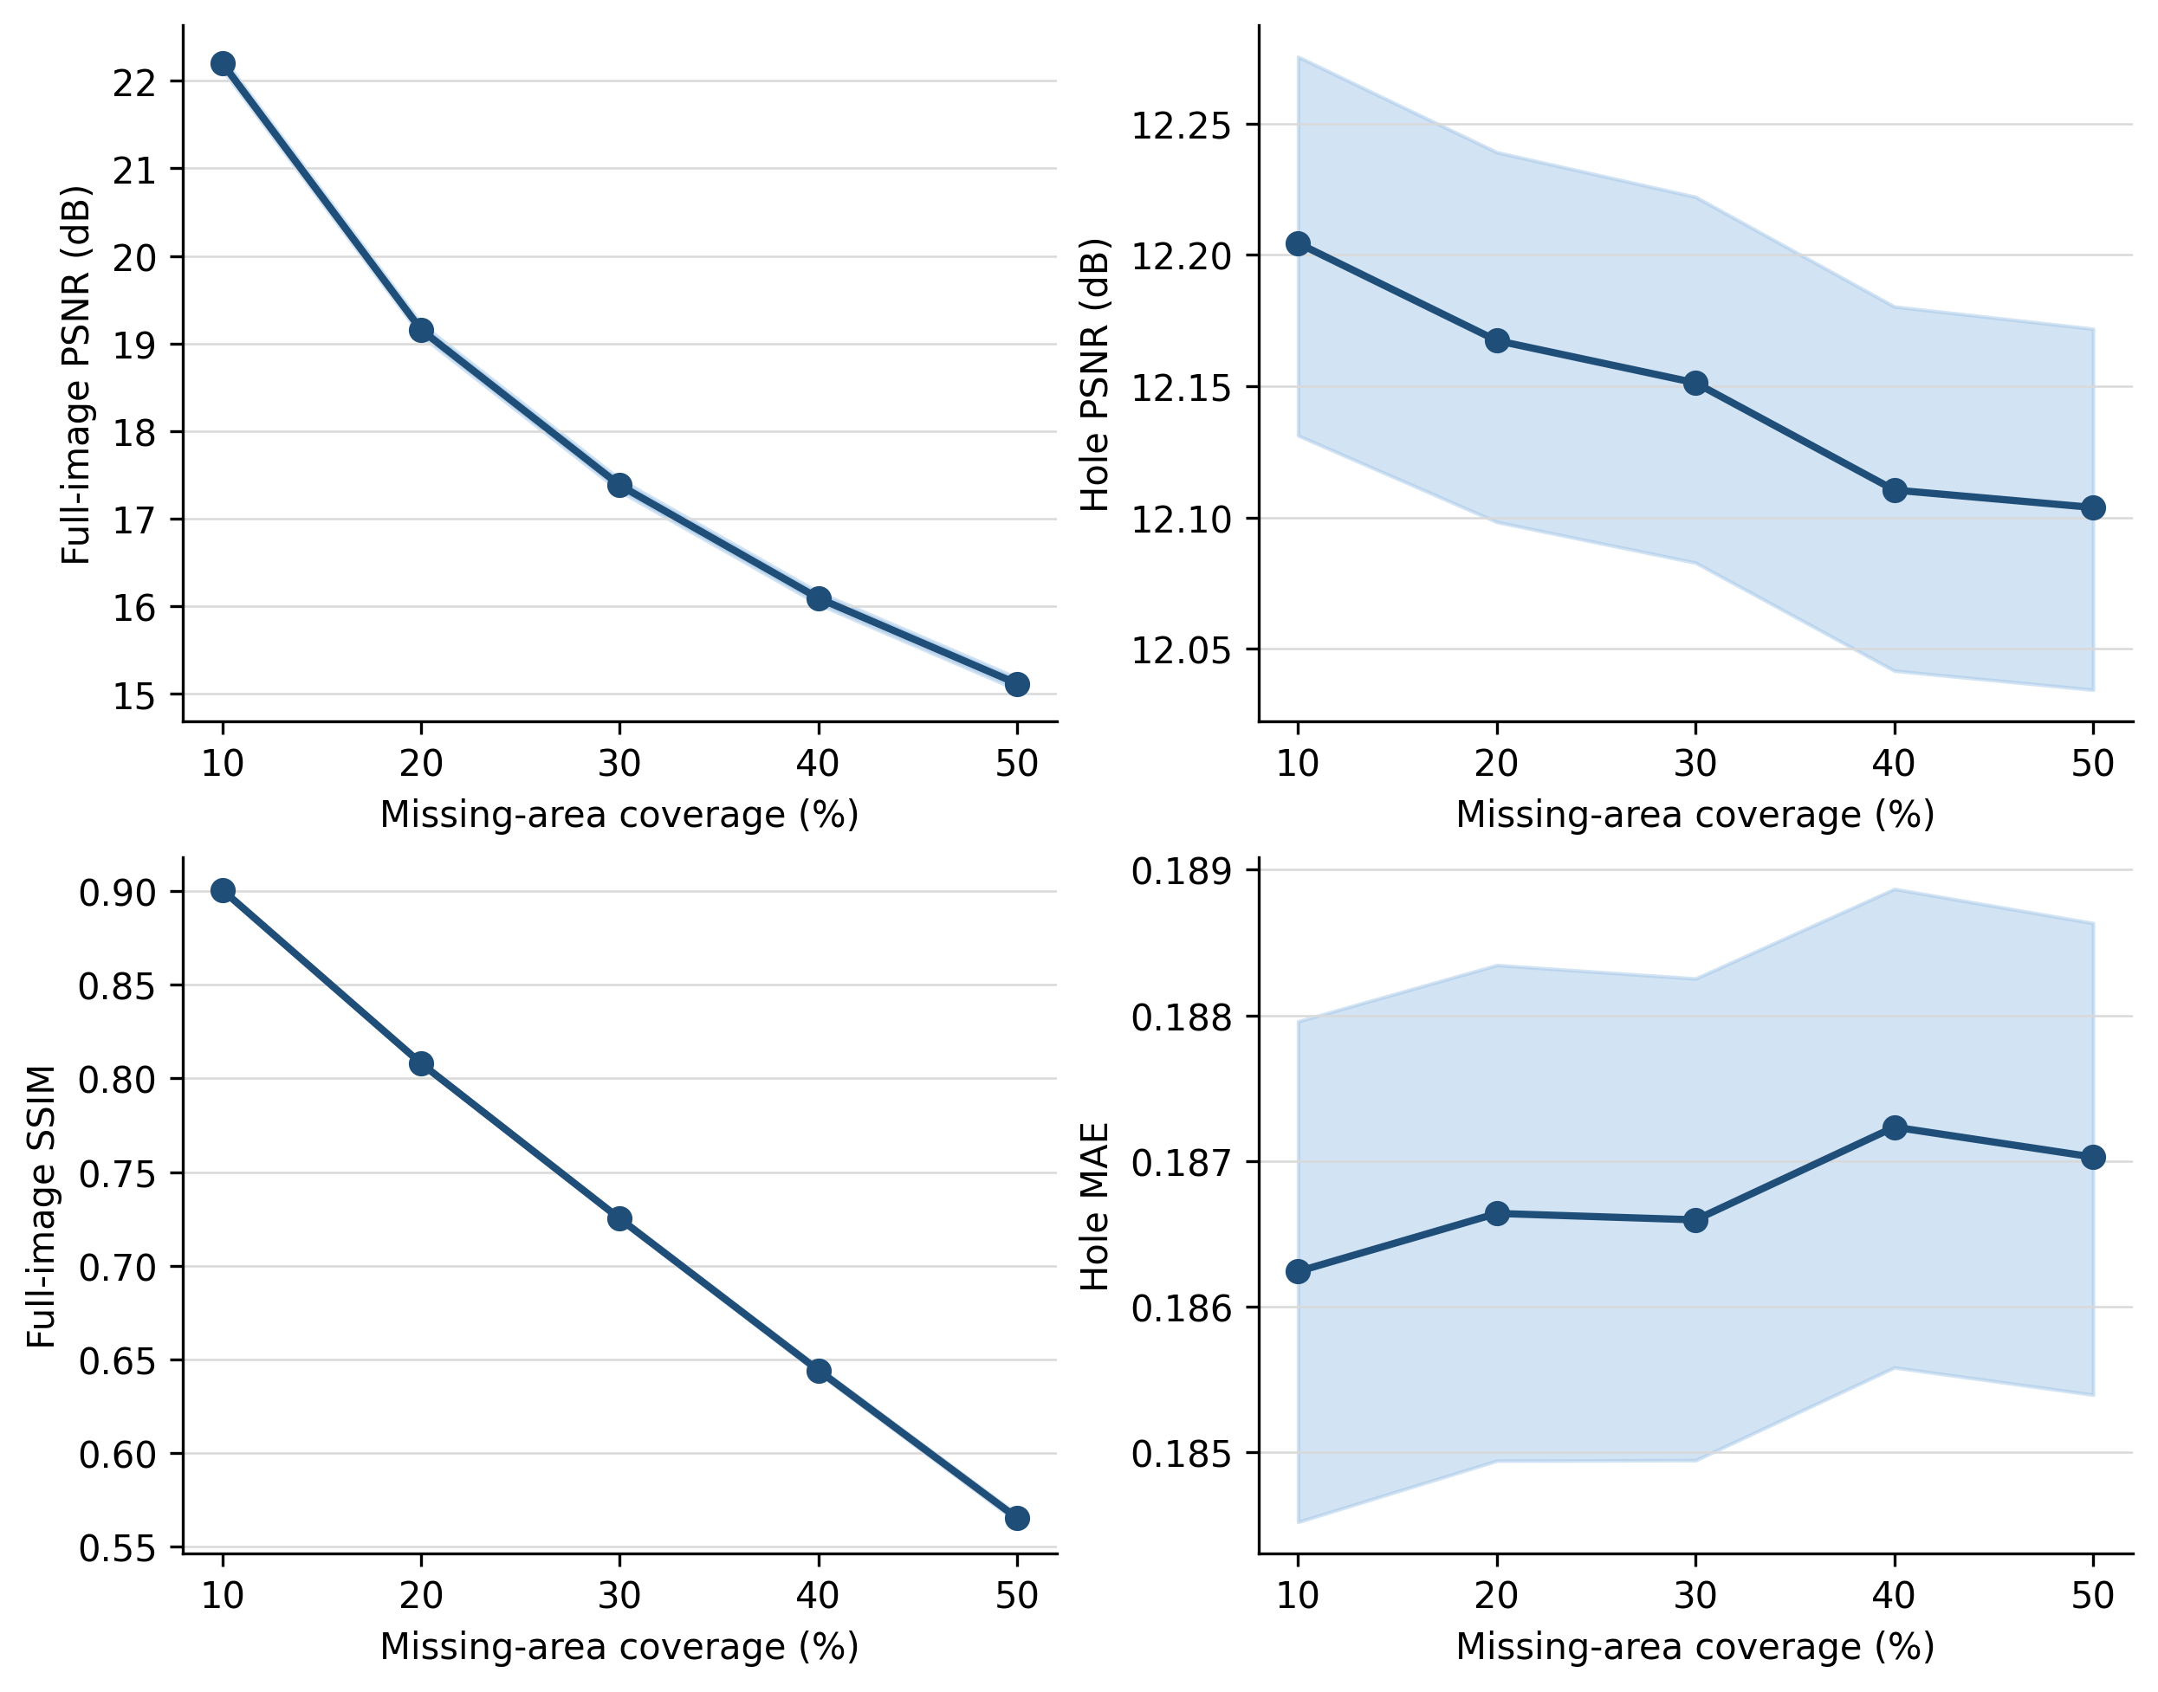
5.3 Mask-family and probe sensitivity
The coverage effect was not confined to one mask topology or one error structure. Full-image SSIM decreased strongly from 10% to 50% coverage for every mask family and every controlled probe. Hole PSNR was comparatively stable for the blur and shift probes, while the mean and noise probes showed modest decreases. Differences among probes were expected because each probe creates a different distortion; their purpose is to test whether the support effect persists across error structures.
Table 4. Subgroup means at the lowest and highest coverage levels.
Group | Level | Hole PSNR 10% → 50% | Full SSIM 10% → 50%
Mask family | Center | 12.283 → 12.212 | 0.910 → 0.584
Mask family | Rectangle | 12.427 → 12.071 | 0.912 → 0.586
Mask family | Free-form | 12.343 → 12.233 | 0.877 → 0.516
Mask family | Semantic | 12.517 → 12.039 | 0.903 → 0.575
Probe | Mean | 12.749 → 12.443 | 0.903 → 0.593
Probe | Blur | 19.570 → 19.596 | 0.941 → 0.714
Probe | Noise | 10.293 → 10.148 | 0.866 → 0.421
Probe | Shift | 11.041 → 11.080 | 0.892 → 0.533

The nonlinear conversion from MSE to PSNR means that subgroup PSNR means need not average exactly to the pooled PSNR reported in Table 3. Each subgroup estimate was therefore formed from the appropriate within-image mean squared errors before conversion to PSNR. The subgroup analysis is descriptive and uses the same image-cluster principle as the primary analysis.
Figure 4. Coverage trends separated by mask family and controlled completion probe.
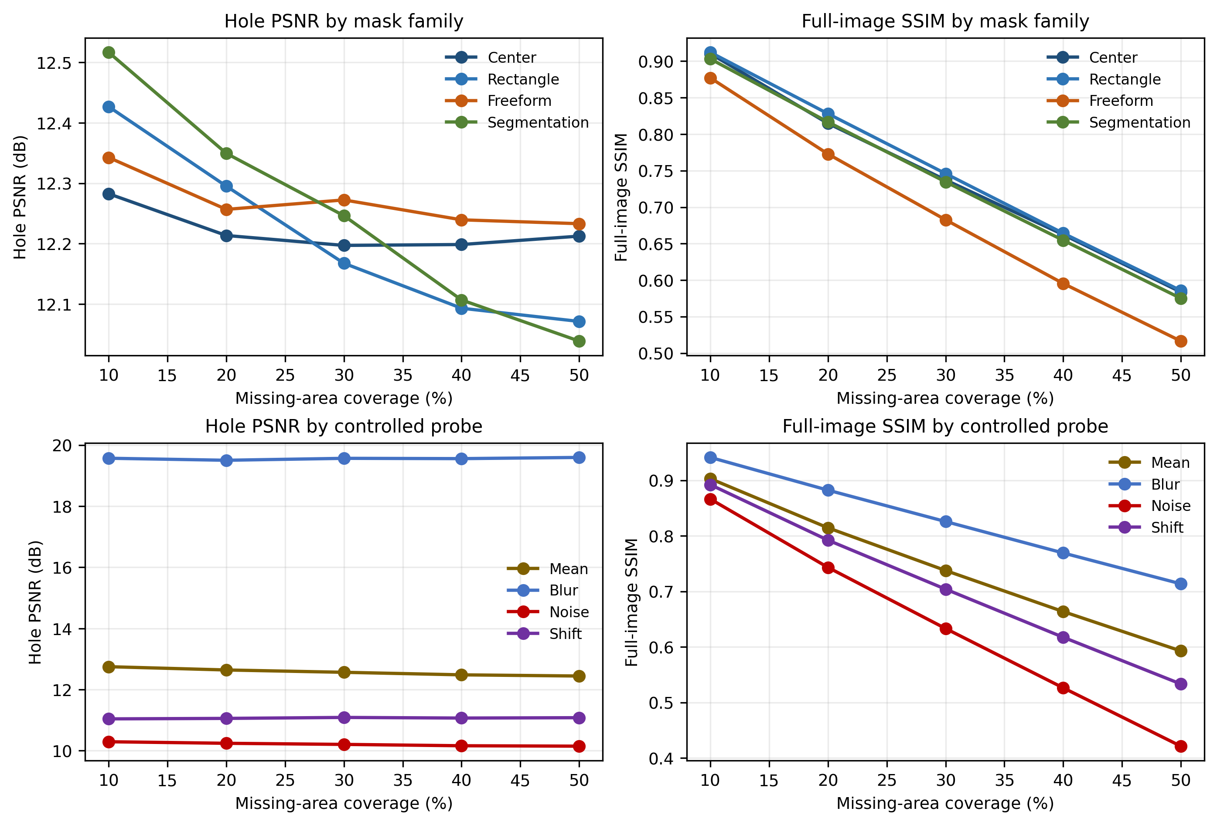
5.4 Ranking disagreement under unmatched coverage
A matched sensitivity analysis compared the 10% and 50% conditions for every image, mask family and probe. Full-image and hole PSNR preferred opposite coverage conditions in 44.23% of the paired comparisons. Averaging the 16 condition-level indicators within each image and bootstrapping images produced a 95% interval of 43.39% to 45.03%. Disagreement was observed for all mask families, ranging from 37.48% for semantic masks to 50.06% for centered masks. This analysis does not rank inpainting methods; it quantifies how changing metric support can change the direction of a comparison.
Figure 5. Percentage of matched 10%-versus-50% pairs in which full-image and hole PSNR preferred opposite conditions. Error bars are image-cluster bootstrap 95% confidence intervals.
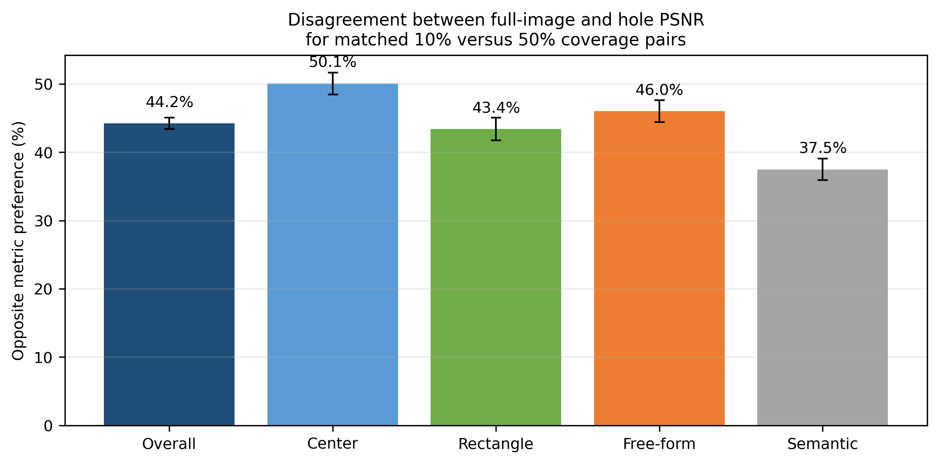
5.5 Paired low-to-high coverage differences
Table 5. Paired 50%-minus-10% differences after within-image averaging across probes and mask families.
Metric | Mean paired difference [95% CI]
Full-image PSNR (dB) | −7.090 [−7.124, −7.055]
Hole PSNR (dB) | −0.101 [−0.135, −0.066]
Full-image SSIM | −0.335477 [−0.337221, −0.333702]
Hole MAE | +0.000785 [−0.000027, +0.001601]
Hole edge MAE | −0.011 [−0.013, −0.009]

The full-image PSNR and SSIM differences were large and precisely estimated. Hole-specific measures were less directly tied to the number of unchanged pixels because their support remained the missing region. Any remaining coverage trend in hole metrics reflects changes in hole location, geometry and probe error—not dilution by copied observations.
5.6 Same outputs under different coverage mixtures
The counterfactual audit changed only the prevalence assigned to the five coverage strata. With every underlying output held fixed, the small-hole-heavy mixture produced a pooled full-image PSNR of 19.905 dB, compared with 16.408 dB for the large-hole-heavy mixture. The paired difference was 3.497 dB [3.481, 3.513]. By contrast, pooled hole PSNR changed by only 0.051 dB [0.035, 0.067]. Full-image SSIM changed by 0.1674 [0.1665, 0.1682], whereas hole MAE changed by −0.00041 [−0.00080, −0.00003]. Thus, a study can obtain materially different pooled full-image scores from identical outputs solely through its coverage distribution.
Table 6. Counterfactual pooled metrics using identical outputs and different coverage prevalence.
Metric | Small-hole heavy | Balanced | Large-hole heavy | Small − large [95% CI]
Full PSNR (dB) | 19.905 | 17.989 | 16.408 | 3.497 [3.481, 3.513]
Hole PSNR (dB) | 12.175 | 12.147 | 12.124 | 0.051 [0.035, 0.067]
Full SSIM | 0.8134 | 0.7286 | 0.6460 | 0.1674 [0.1665, 0.1682]
Hole MAE | 0.1865 | 0.1867 | 0.1869 | −0.00041 [−0.00080, −0.00003]

Figure 6. Counterfactual aggregation audit. Every image, mask and completion output is unchanged; only coverage-stratum weights differ.
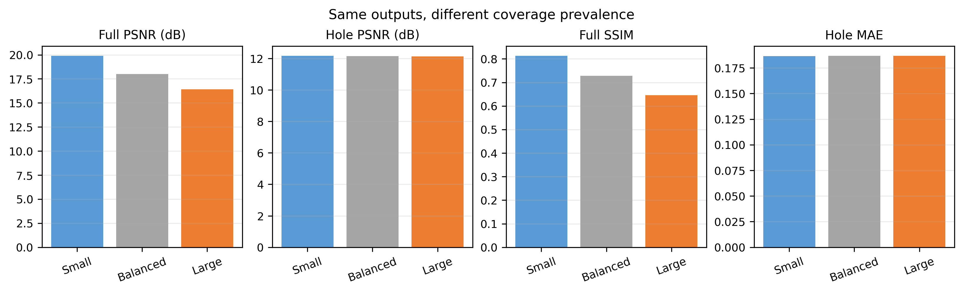
5.7 Descriptive within-image effect size
After removing each image mean, the common coverage trend accounted for 97.3% of within-image variation in full-image PSNR and 98.0% in full-image SSIM. The corresponding values were 0.8% for hole PSNR and 0.1% for hole MAE. These descriptive ratios are not causal estimates; they quantify how strongly the repeated measurements follow the common coverage gradient under this controlled protocol.
6. Discussion
6.1 Implications for evaluation practice
Full-image metrics need not be prohibited. They can describe final-composite fidelity and remain directly comparable when every method uses the same images and masks. The risk arises when a full-image score is interpreted as hole-completion quality while coverage differs or is undisclosed. A minimally defensible report should:
• Use hole-only PSNR, MAE or related fidelity measures as primary reconstruction results and label full-image results explicitly.
• Report the test-set size, mask families, exact coverage distribution and aggregation rule.
• Use an identical, versioned mask bank for every method and publish mask identifiers or deterministic seeds.
• Stratify results by coverage and, where relevant, mask topology instead of relying only on a pooled mean.
• Separate variation across test images from uncertainty across independent training runs.
• Complement fidelity measures with perceptual, semantic or human evaluation when plausible completion is the target.
6.2 Why the primary result is model-independent
The exact MSE, MAE and PSNR results require no assumption about how the missing pixels were generated. They apply equally to convolutional, transformer, diffusion and nonlearned completions whenever observed pixels are copied exactly. Adding a particular learned model would illustrate the identity but could not strengthen or falsify it. The empirical probes instead serve two narrower purposes: they verify the implementation over diverse error structures and quantify nonlinear SSIM and aggregation behavior for which no exact identity is claimed. Learned-model evaluation remains necessary for claims about architectural quality, but this manuscript makes no such claim.
6.3 Contribution beyond the algebraic identity
The algebraic identity is intentionally simple. The substantive contribution is an auditable evaluation framework built around its consequences: a precise boundary for valid matched comparisons, per-sample recovery rules, clustered uncertainty for repeated conditions, a ranking-disagreement stress test, and a counterfactual mixture analysis that changes no output. Together these elements convert a familiar intuition—small holes can make full-image scores look better—into a falsifiable protocol with quantitative effect sizes and executable checks.
6.4 Minimum reporting matrix for comparable studies
Table 7. Recommended reporting elements and the comparison errors they prevent.
Reporting element | Minimum information | Risk if omitted
Metric support | Full image or missing region | Ambiguous numerical meaning
Mask distribution | Family and coverage histogram | Coverage confounding
Mask identity | Shared bank, hashes or seeds | Unmatched test conditions
Aggregation | Unit and weighting rule | Hidden stratum imbalance
Variability | Images versus training runs | Incorrect uncertainty claim
Perceptual evidence | LPIPS, task or human study | Pixel fidelity treated as plausibility
Efficiency | Hardware, batch, latency and memory | Unsupported deployment claim

6.5 Practical interpretation
Three comparison settings should be distinguished. First, when methods share every image and mask, full-image PSNR preserves the pairwise ordering induced by MSE, although its absolute value remains coverage-dependent. Second, when mask distributions differ, hole-specific metrics and coverage-stratified summaries are required before a performance claim is credible. Third, when plausible semantic completion is the objective, neither full-image nor hole-only pixel fidelity is sufficient by itself; perceptual, task-based or human evidence should complement the fidelity results.
7. Limitations
The experiment uses one dataset and one spatial resolution. The MSE, MAE and PSNR propositions are dataset-, resolution- and model-independent, but the empirical SSIM and ranking-disagreement magnitudes require external validation. The four probes are controlled distortions rather than trained generative models, so they cannot estimate relative architectural quality or perceptual realism. SSIM is reported over the full image because region-restricted SSIM lacks a single universally accepted implementation. LPIPS, FID and human preference are not included because they answer related but distinct questions. The three counterfactual coverage mixtures are transparent stress-test scenarios rather than estimates of prevalence in the literature. Finally, semantic masks are deterministically adjusted to exact coverage, so their boundaries do not always coincide with complete annotated objects. These boundaries restrict the empirical generalisation while leaving the exact support identities unchanged.
8. Conclusion
Mask coverage is part of the numerical definition of a full-image fidelity score whenever observed pixels are copied exactly. The exact propositions identify when full-image comparisons are valid and when coverage enters as a confounder. Across 160,000 controlled ADE20K evaluations, full-image and hole PSNR preferred opposite 10%-versus-50% conditions in 44.23% of matched comparisons. More decisively, reweighting the identical outputs from a small-hole-heavy to a large-hole-heavy distribution shifted pooled full-image PSNR by 3.497 dB but hole PSNR by only 0.051 dB. The remedy is operational: use identical versioned masks, report realised coverage and metric support, make hole-specific fidelity primary, stratify by coverage, and state the aggregation unit. These checks turn an ambiguous score table into an auditable comparison without changing the underlying inpainting model.
Conflict of Interest
The authors declare that they have no conflict of interest.
Funding Information
This research received no external funding.
Ethical Statement
This study used the publicly available ADE20K dataset and did not involve human participants, animals or personally identifiable information.
Acknowledgement
The authors acknowledge the creators and maintainers of ADE20K and the open-source scientific Python ecosystem used for deterministic analysis.
Declaration on the Use of Artificial Intelligence Tools
Generative artificial intelligence tools were used for language editing and document preparation support. All mathematical derivations, experimental configuration, numerical results, interpretations and final wording were reviewed and approved by the authors, who accept full responsibility for the manuscript.
References
[1] Zhou, B., Zhao, H., Puig, X., Xiao, T., Fidler, S., Barriuso, A., & Torralba, A. (2019). Semantic understanding of scenes through the ADE20K dataset. International Journal of Computer Vision, 127(3), 302–321. https://doi.org/10.1007/s11263-018-1140-0
[2] Hore, A., & Ziou, D. (2010). Image quality metrics: PSNR vs. SSIM. 20th International Conference on Pattern Recognition, 2366–2369. https://doi.org/10.1109/ICPR.2010.579
[3] Wang, Z., Bovik, A. C., Sheikh, H. R., & Simoncelli, E. P. (2004). Image quality assessment: From error visibility to structural similarity. IEEE Transactions on Image Processing, 13(4), 600–612. https://doi.org/10.1109/TIP.2003.819861
[4] Tiefenbacher, P., Bogischef, V., Merget, D., & Rigoll, G. (2015). Subjective and objective evaluation of image inpainting quality. 2015 IEEE International Conference on Image Processing, 447–451. https://doi.org/10.1109/ICIP.2015.7350838
[5] Black, S., Keshavarz, S., & Souvenir, R. (2020). Evaluation of image inpainting for classification and retrieval. Proceedings of the IEEE/CVF Winter Conference on Applications of Computer Vision, 1060–1069.
[6] Suvorov, R., Logacheva, E., Mashikhin, A., Remizova, A., Ashukha, A., Silvestrov, A., Kong, N., Goka, H., Park, K., & Lempitsky, V. (2022). Resolution-robust large mask inpainting with Fourier convolutions. Proceedings of the IEEE/CVF Winter Conference on Applications of Computer Vision, 2149–2159. https://doi.org/10.1109/WACV51458.2022.00323
[7] Zhang, R., Isola, P., Efros, A. A., Shechtman, E., & Wang, O. (2018). The unreasonable effectiveness of deep features as a perceptual metric. Proceedings of the IEEE Conference on Computer Vision and Pattern Recognition, 586–595.
[8] Pathak, D., Krahenbuhl, P., Donahue, J., Darrell, T., & Efros, A. A. (2016). Context encoders: Feature learning by inpainting. Proceedings of the IEEE Conference on Computer Vision and Pattern Recognition, 2536–2544.
[9] Liu, G., Reda, F. A., Shih, K. J., Wang, T.-C., Tao, A., & Catanzaro, B. (2018). Image inpainting for irregular holes using partial convolutions. Proceedings of the European Conference on Computer Vision, 85–100.
[10] Yu, J., Lin, Z., Yang, J., Shen, X., Lu, X., & Huang, T. S. (2018). Generative image inpainting with contextual attention. Proceedings of the IEEE Conference on Computer Vision and Pattern Recognition, 5505–5514.
[11] Yu, J., Lin, Z., Yang, J., Shen, X., Lu, X., & Huang, T. S. (2019). Free-form image inpainting with gated convolution. Proceedings of the IEEE/CVF International Conference on Computer Vision, 4471–4480.
[12] Patil, M., & Tiwari, V. (2026). Mask coverage in inpainting evaluation: Reproducibility package [Computer software]. GitHub. https://github.com/maheshchudaman/mask-coverage-inpainting-evaluation
[13] Zhao, S., Cui, J., Sheng, Y., Dong, Y., Liang, X., Chang, E. I.-C., & Xu, Y. (2021). Large scale image completion via co-modulated generative adversarial networks. International Conference on Learning Representations.
[14] Li, W., Lin, Z., Zhou, K., Qi, L., Wang, Y., & Jia, J. (2022). MAT: Mask-aware transformer for large hole image inpainting. Proceedings of the IEEE/CVF Conference on Computer Vision and Pattern Recognition, 10758–10768.
[15] Heusel, M., Ramsauer, H., Unterthiner, T., Nessler, B., & Hochreiter, S. (2017). GANs trained by a two time-scale update rule converge to a local Nash equilibrium. Advances in Neural Information Processing Systems, 30.
[16] Bińkowski, M., Sutherland, D. J., Arbel, M., & Gretton, A. (2018). Demystifying MMD GANs. International Conference on Learning Representations.
[17] Lugmayr, A., Danelljan, M., Romero, A., Yu, F., Timofte, R., & Van Gool, L. (2022). RePaint: Inpainting using denoising diffusion probabilistic models. Proceedings of the IEEE/CVF Conference on Computer Vision and Pattern Recognition, 11461–11471.
Data and Code Availability
ADE20K is available from the dataset authors [1]. The resolved configuration, deterministic mask and probe generator, analysis scripts, integrity checks, compact derived results, figures and exact reproduction commands for this study are available at https://github.com/maheshchudaman/mask-coverage-inpainting-evaluation [12]. Original ADE20K images are not redistributed and must be obtained under the dataset’s own terms. The 160,000-record JSONL file can be regenerated from the official validation images; compact aggregate outputs and cryptographic checksums are included for verification.

