**Code versioning**

SVN is used as a version control system and TortoiseSVN as a client.

To create the SVN repository folder structure there are two approaches as below:

1. **Single trunk**

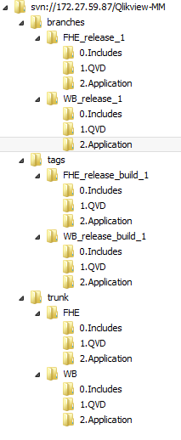

**Merits:**

* This approach is desirable if all the projects are deployed together.
* This is because you only have to tag the repository once when deploying.

1. **Customer wise different trunk**

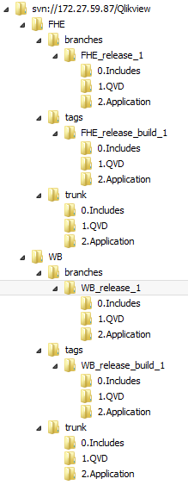

**Merits:**

* The advantage of this approach is, you can branch and tag each project independently.
* This is desirable if you need to deploy each project separately.

**Recommendation:**

For implementation, we will suggest to go with Single trunk approach.

**Jenkins build and deployment process:**

* The below solution is applicable for customer wise different trunk approach i.e first folder structure.
* We will create different Jenkins jobs as per each release

**Job configuration:**

We are keeping this build to run manually.

1. Here we will use Jenkins – Build with parameters plugin

We are using choice parameters to choose client level folder as shown below:

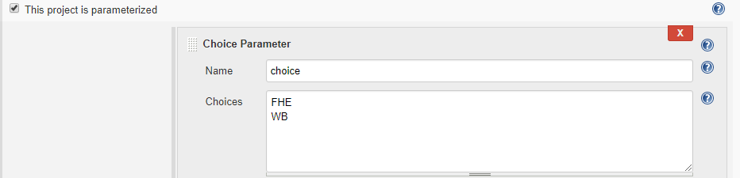

As above, we are declaring choice as a variable to be used in SVN url to checkout only the particular client code.

By selecting specific choice, Jenkins will fetch the code upto that client level only.

We can provide job level permissions here to decide user access to run the build.

1. Now in source code management section, we are mentioning SVN url with declared choice variable.

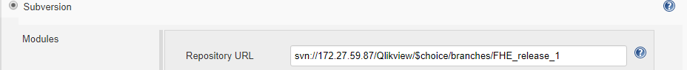

As the url is appended with $choice variable it will replace the value with selected choice.

1. We can delete the workspace before every build starts.

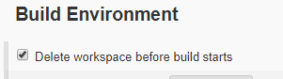

Once the configurations are done:

On left side, there will be option as Build with parameters:

You can select particular choice and run the build.

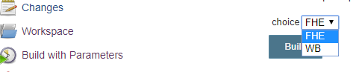

**Note**: The same job configuration will be repeated for other releases also.