Opinion Mining For Social Networking Sites

In this project users can register with the application and then login and post their topics and then other users may view that post topic and write their description/comment. User’s description/comment will rate using SVM classifier.

Create database by copying content from ‘DB.txt’ file and paste in MYSQL

Create ‘Python’ folder in C directory and then put ‘OpinionMining’ folder inside C:/Python folder and then start django server and run code in browser by using below URL

<http://127.0.0.1:8000/index.html> and press enter key to get below screen

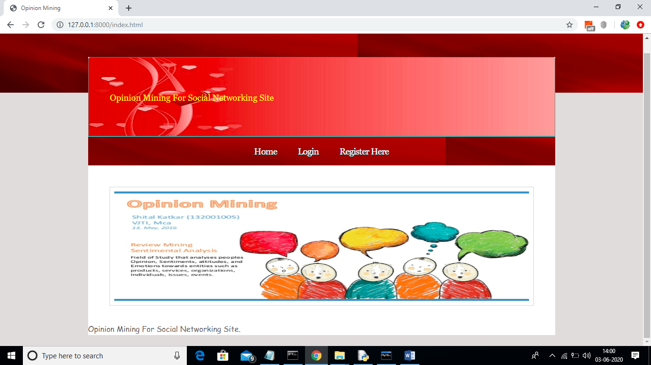

In above screen click on ‘Register Here’ link to add new user

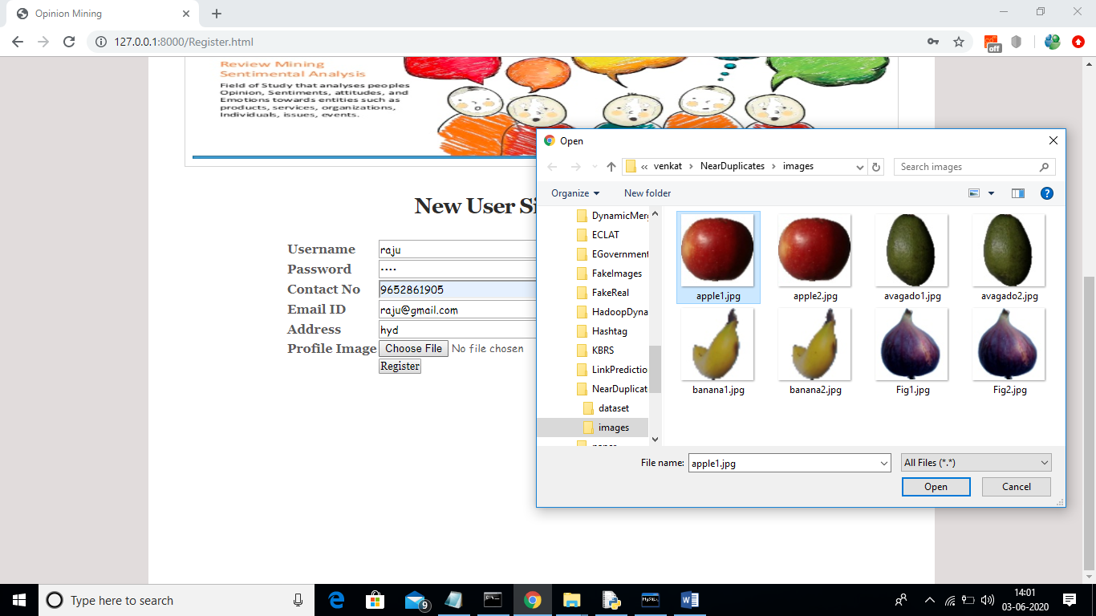

In above screen creating user profile with uploading image and then click on ‘Open’ button and then click on ‘Register’ button to complete registration process

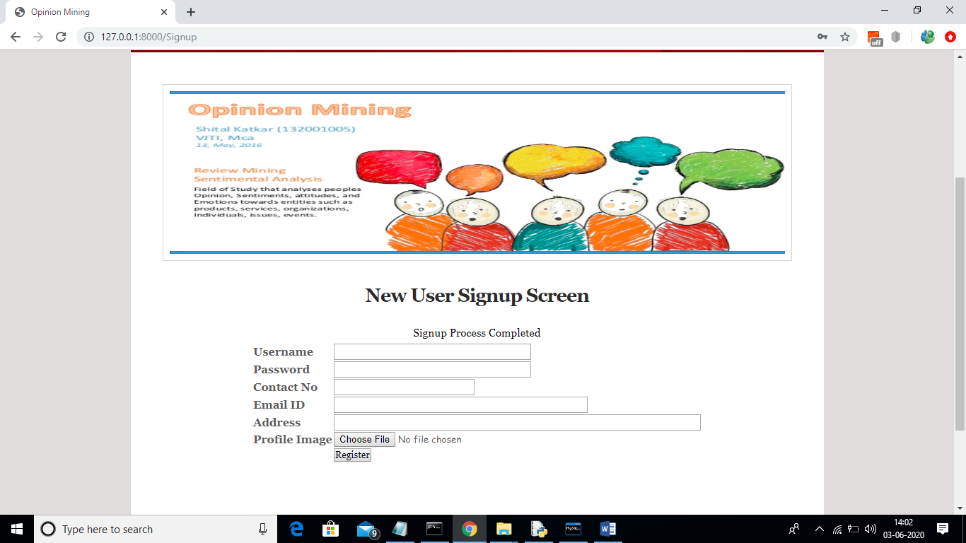

In above screen signup process completed and login as raju user to upload post topic

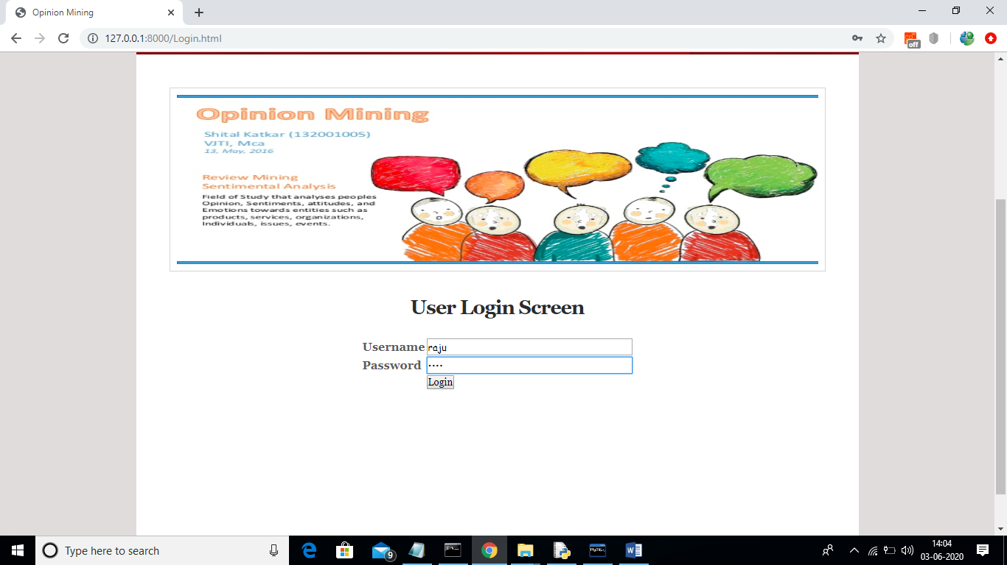

After login will get below screen

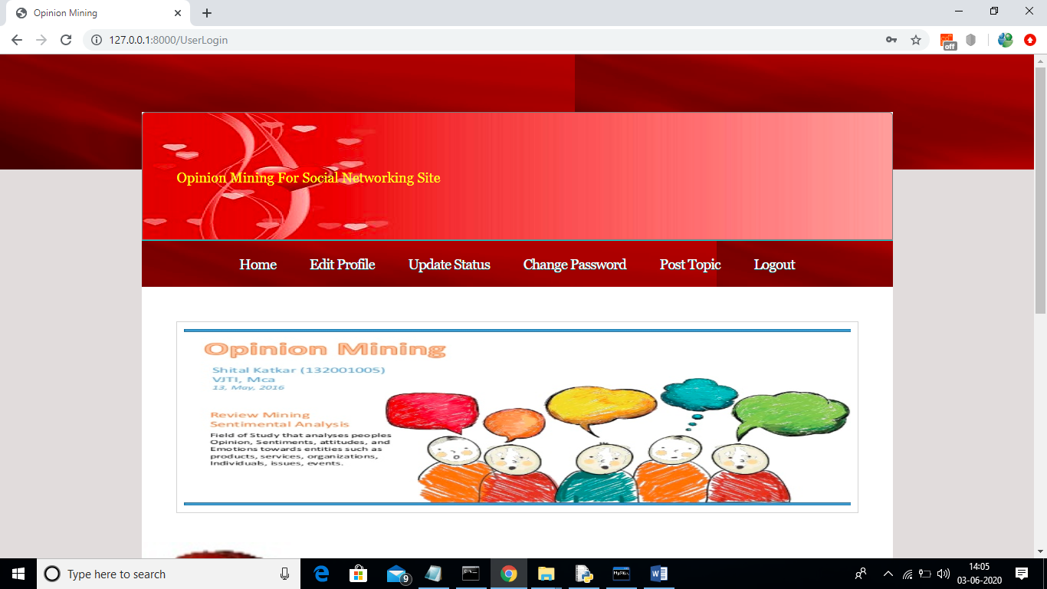

In above screen by clicking on Home Page user will get below screen and by clicking on ‘Edit Profile’ user may change profile image and other details and by using ‘Update Status’ link user can update his status text and by using Post Topic link he will post new topic.

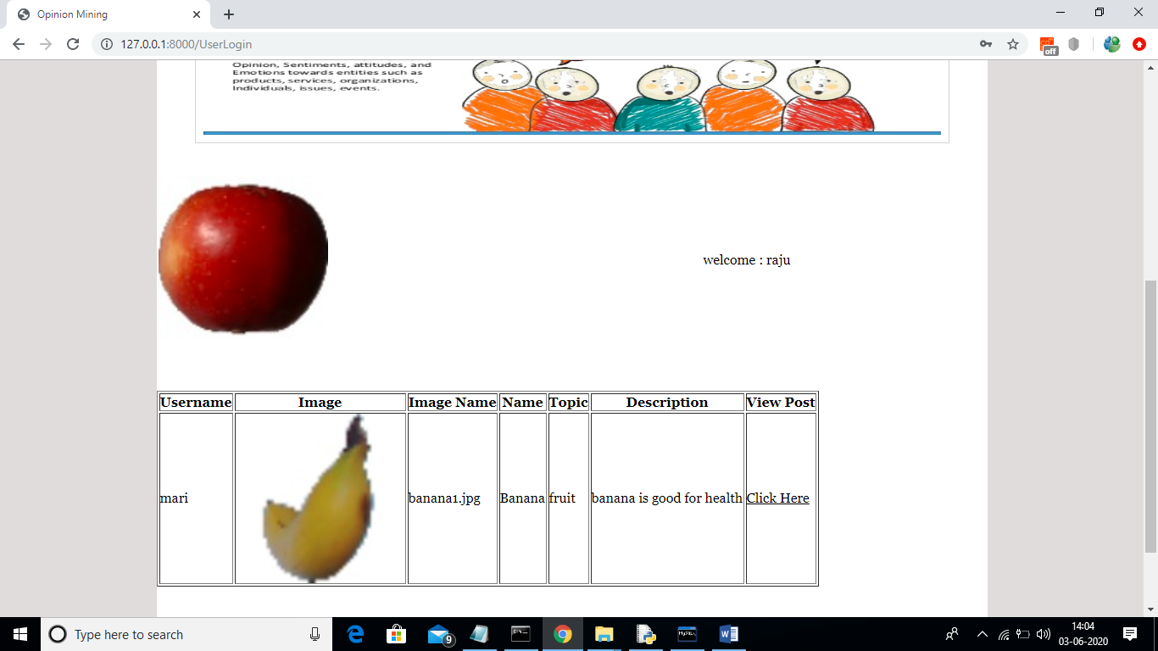

In above HomePage screen we can see raju user profile image and his name and below we can see all topics posted by different users. Now click on ‘status update’ link to add status

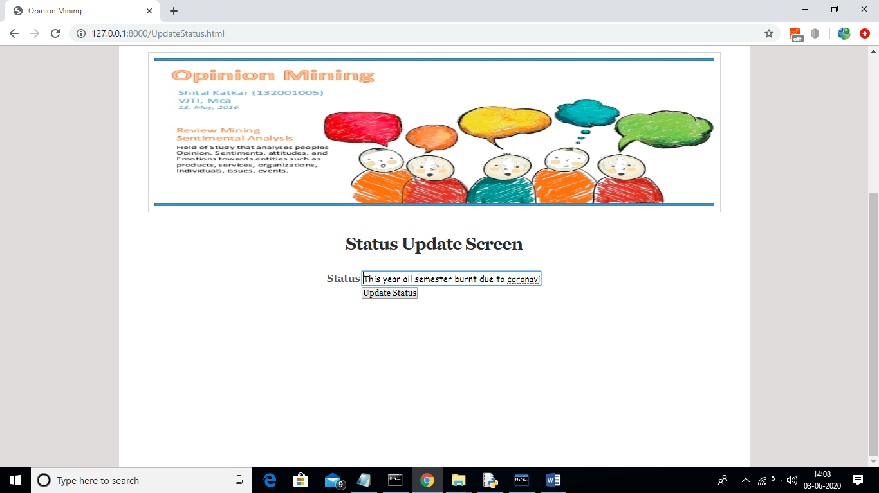

In above screen I am adding some status and now click on ‘Update Status’ button to get below screen

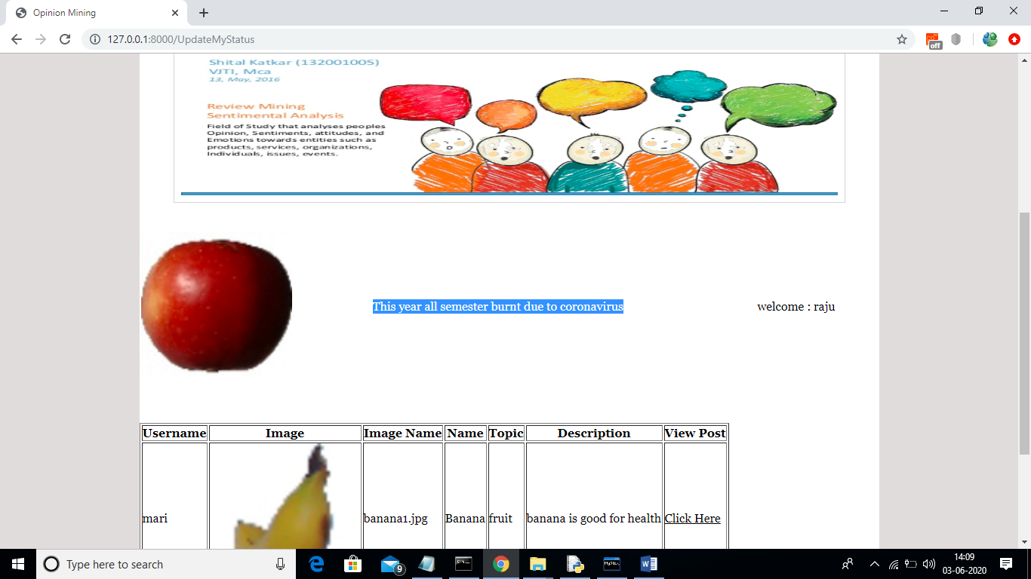

In above screen selected text we can see updated user status. Now user can post topic by clicking on post topic link

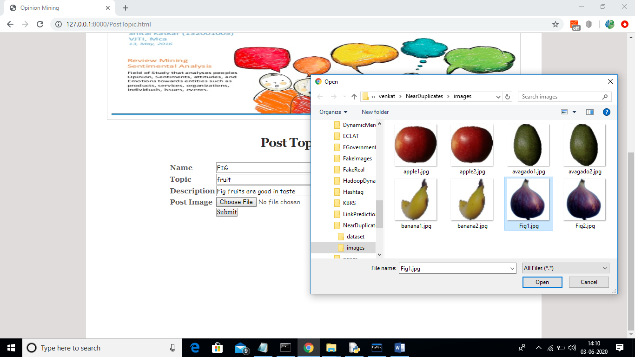

In above screen user is uploading some topics and now click ‘Open’ button and then press submit button to upload that topic

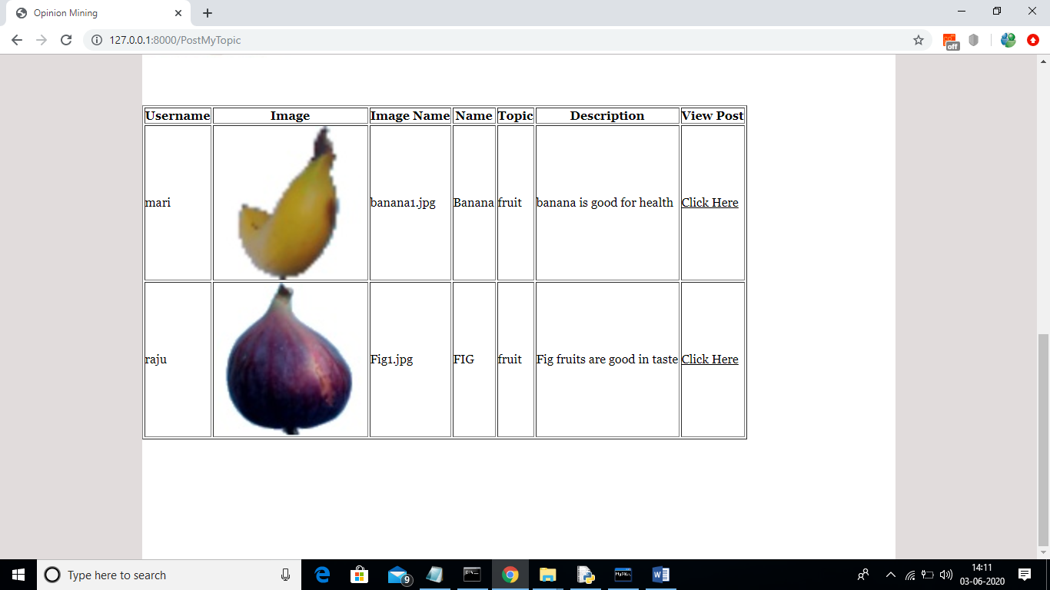

In this screen we can see 2 topics from 2 users mari and raju. Now both can comments on their topic. Now I will logout and login as mari and comment on raju topic. To comment on any topic click on ‘Click Here’ option to get below screen

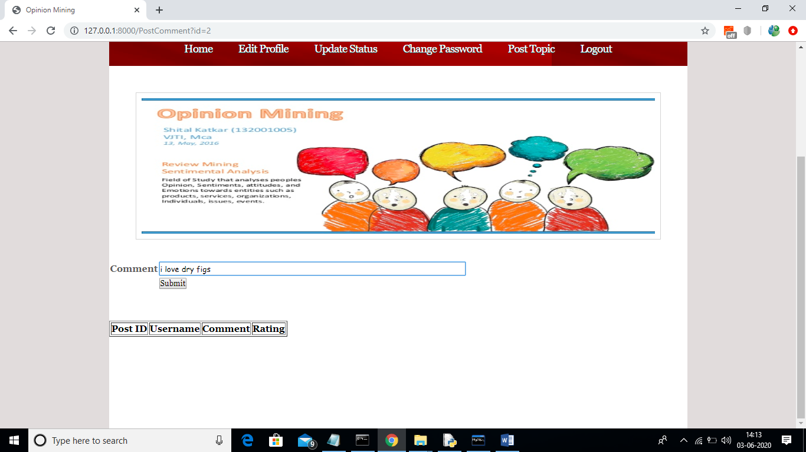

In above screen writing come comments and press submit button to get below screen

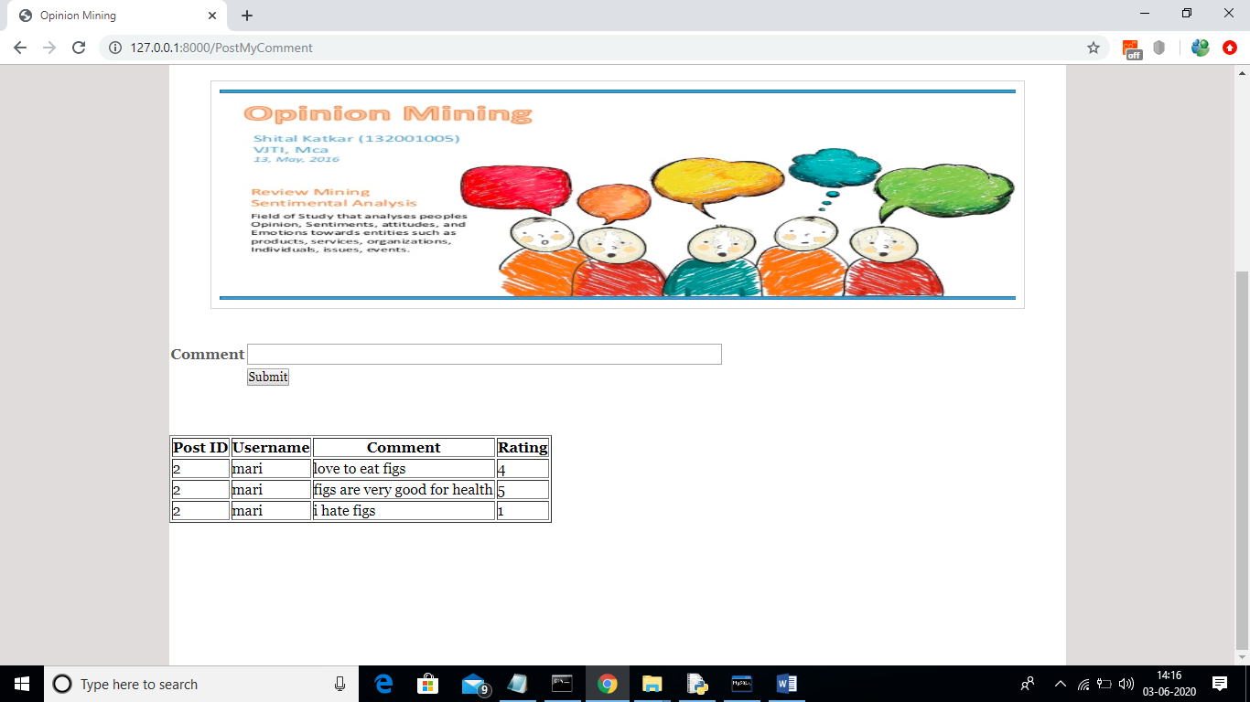

In above screen mari wrote some comments on raju post and then using SVM classifier we rate each comment.

Note: after starting server each time SVM classifier will take some loading time for first comment and from next comment it will run faster.

After editing profile picture then it will get update from next login as browser maintain its cache