Section 1.2.5 Exercises 3, 4, and 6
Kalpana Renjarla
2026-07-23
# Display all R code in the knitted HTML file.
knitr::opts_chunk$set(echo = TRUE, message = FALSE, warning = TRUE)
# Load the packages required for the exercises.
library(tidyverse)
## Warning: package 'tidyverse' was built under R version 4.4.3
## Warning: package 'ggplot2' was built under R version 4.4.3
## Warning: package 'tidyr' was built under R version 4.4.3
## Warning: package 'readr' was built under R version 4.4.3
## Warning: package 'purrr' was built under R version 4.4.3
## Warning: package 'dplyr' was built under R version 4.4.3
## Warning: package 'stringr' was built under R version 4.4.3
## Warning: package 'forcats' was built under R version 4.4.3
## Warning: package 'lubridate' was built under R version 4.4.3
## ── Attaching core tidyverse packages ──────────────────────── tidyverse 2.0.0 ──
## ✔ dplyr 1.1.4 ✔ readr 2.1.6
## ✔ forcats 1.0.1 ✔ stringr 1.6.0
## ✔ ggplot2 4.0.1 ✔ tibble 3.2.1
## ✔ lubridate 1.9.4 ✔ tidyr 1.3.2
## ✔ purrr 1.2.1
## ── Conflicts ────────────────────────────────────────── tidyverse_conflicts() ──
## ✖ dplyr::filter() masks stats::filter()
## ✖ dplyr::lag() masks stats::lag()
## ℹ Use the conflicted package (<http://conflicted.r-lib.org/>) to force all conflicts to become errors
library(palmerpenguins)

Introduction
This assignment answers Exercises 3, 4, and 6 from Section 1.2.5 of R for Data Science (2nd ed.). The exercises use the penguins dataset from the palmerpenguins package.

Exercise 3
Question: Make a scatterplot of bill_depth_mm versus bill_length_mm, with bill_depth_mm on the y-axis and bill_length_mm on the x-axis. Describe the relationship between the two variables.
# Create a scatterplot with bill length on the x-axis and bill depth on the
# y-axis. Color is mapped to species to make the clusters easier to interpret.
ggplot(
data = penguins,
mapping = aes(
x = bill_length_mm,
y = bill_depth_mm,
color = species
)
) +
geom_point(na.rm = TRUE) +
labs(
title = "Penguin Bill Depth versus Bill Length",
x = "Bill length (mm)",
y = "Bill depth (mm)",
color = "Species"
) +
theme_minimal()
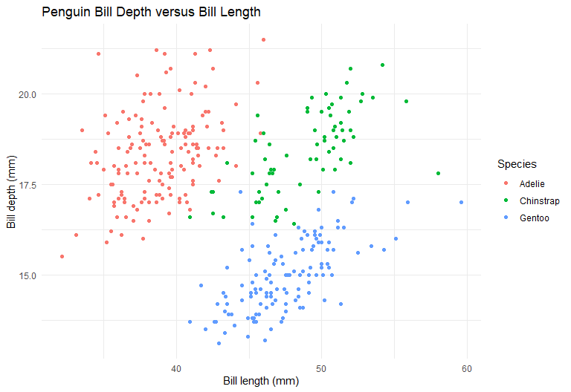
Interpretation: The relationship is not represented well by one simple straight line because the points form clusters associated with the three penguin species. Gentoo penguins generally have longer but shallower bills, while Chinstrap penguins tend to have longer and deeper bills. Adelie penguins usually have shorter bills. Within the species clusters, bill depth and bill length tend to have a positive relationship, but the combined dataset shows that species is an important variable for understanding the pattern.
What we did: We used ggplot() to compare two numerical variables: bill_length_mm on the x-axis and bill_depth_mm on the y-axis. We used geom_point() to create the scatterplot and assigned a different color to each species so that the groups could be compared more clearly. We also used na.rm = TRUE to exclude rows with missing bill measurements.
What we achieved: We created a clear scatterplot that revealed three species-related clusters. The result showed that the relationship between bill length and bill depth changes among Adelie, Chinstrap, and Gentoo penguins. Therefore, species helps explain the pattern better than one overall trend line would.

Exercise 4
Question: What happens if you make a scatterplot of species versus bill_depth_mm? What might be a better choice of geom?
# A point geom places observations into three vertical groups because species
# is categorical while bill depth is numerical. Many points overlap.
ggplot(
data = penguins,
mapping = aes(x = species, y = bill_depth_mm)
) +
geom_point(na.rm = TRUE) +
labs(
title = "Bill Depth by Penguin Species: Point Plot",
x = "Species",
y = "Bill depth (mm)"
) +
theme_minimal()
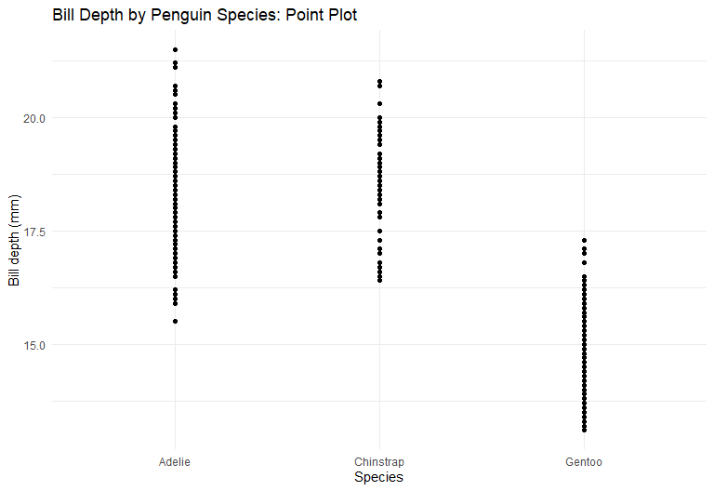
The point plot creates three vertical groups, one for each species. Because many penguins have similar bill-depth measurements, the points overlap and the distribution within each species is difficult to compare.
# A boxplot is a better choice for comparing the distribution of a numerical
# variable across the levels of a categorical variable.
ggplot(
data = penguins,
mapping = aes(x = species, y = bill_depth_mm, fill = species)
) +
geom_boxplot(na.rm = TRUE, show.legend = FALSE) +
labs(
title = "Distribution of Bill Depth by Penguin Species",
x = "Species",
y = "Bill depth (mm)"
) +
theme_minimal()
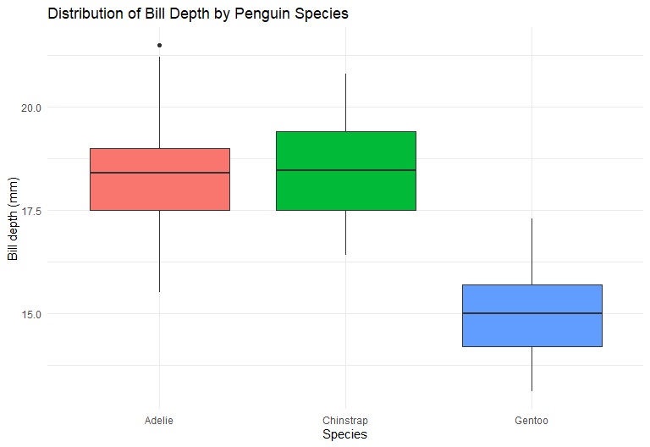
Interpretation: A boxplot is a better geom because it summarizes the median, spread, and possible outliers for each species. The graph shows that Gentoo penguins generally have shallower bills than Adelie and Chinstrap penguins. Chinstrap penguins have the highest typical bill depth, while Adelie penguins fall between the other two groups.
What we did: We first plotted the categorical variable species against the numerical variable bill_depth_mm with geom_point(). Because many points overlapped within three vertical groups, we created a second graph with geom_boxplot() to summarize and compare the bill-depth distributions.
What we achieved: We identified the boxplot as the more appropriate geom for this comparison. It made the median, spread, and possible outliers easier to see and showed clear differences in typical bill depth among the three penguin species.

Exercise 6
Question: What does the na.rm argument do in geom_point()? What is its default value? Create a scatterplot that successfully uses this argument set to TRUE.
The na.rm argument controls how missing values are handled by the geom. Its default value is FALSE. With the default, rows that contain missing values cannot be plotted and ggplot2 removes them while printing a warning. When na.rm = TRUE, those incomplete rows are removed silently, so the scatterplot is created without the missing-value warning.
# Remove observations with missing bill-length or bill-depth values silently
# and create the requested scatterplot.
ggplot(
data = penguins,
mapping = aes(x = bill_length_mm, y = bill_depth_mm)
) +
geom_point(na.rm = TRUE, color = "#2C7FB8", alpha = 0.75) +
labs(
title = "Bill Measurements with Missing Values Removed",
subtitle = "geom_point(na.rm = TRUE)",
x = "Bill length (mm)",
y = "Bill depth (mm)"
) +
theme_minimal()
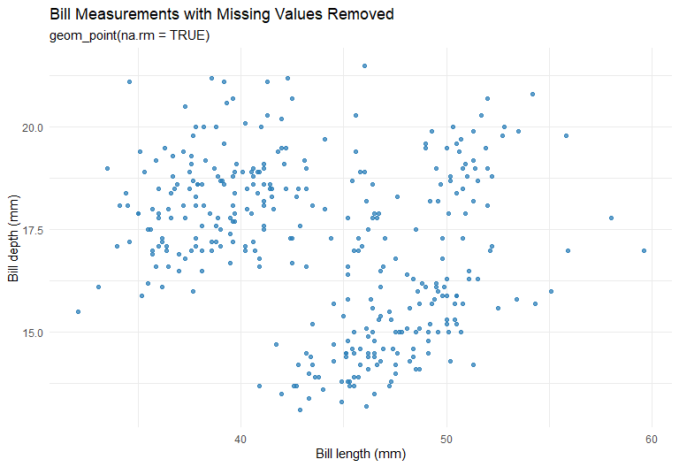
Interpretation: The scatterplot displays all observations that have both a bill-length value and a bill-depth value. Rows missing either measurement are excluded silently. Setting na.rm = TRUE changes the handling of the warning; it does not estimate or replace the missing measurements.
What we did: We examined the purpose and default setting of the na.rm argument in geom_point(). We then set na.rm = TRUE while creating a scatterplot of bill length and bill depth so that observations with missing values would be removed without producing the usual warning.
What we achieved: The graph was created successfully using all complete bill-measurement records. We also demonstrated that na.rm = TRUE removes incomplete rows silently but does not fill in, estimate, or otherwise change the missing values.

Conclusion
These exercises demonstrate that choosing an appropriate geom depends on the types of variables being compared. A scatterplot is suitable for two numerical variables, while a boxplot is more informative for comparing a numerical variable across categories. They also show how na.rm = TRUE allows a geom to remove incomplete observations without displaying a warning.

Reference
Wickham, H., Çetinkaya-Rundel, M., and Grolemund, G. (2023). R for Data Science: Import, Tidy, Transform, Visualize, and Model Data (2nd ed.). O’Reilly Media. https://r4ds.hadley.nz/data-visualize.html

