W2 Exercise 1.02: Exploring Dealership Sales Data
Kalpana Renjarla
CT5130 Intro to SQL for Data Analytcs - CRN195
Huseyin Umut Aksu
New England College
07-23-2026

Purpose and Dataset Setup
This activity explores dealership-level annual sales and the number of female employees. The analysis uses descriptive statistics, an outlier rule, quantiles, and correlation to summarize the 20 dealerships in the dataset.

Excel Setup
Excel range | Contents
A1 | Location
B1 | Net Annual Sales
C1 | Number of Female Employees
Rows 2-21 | The 20 dealership records

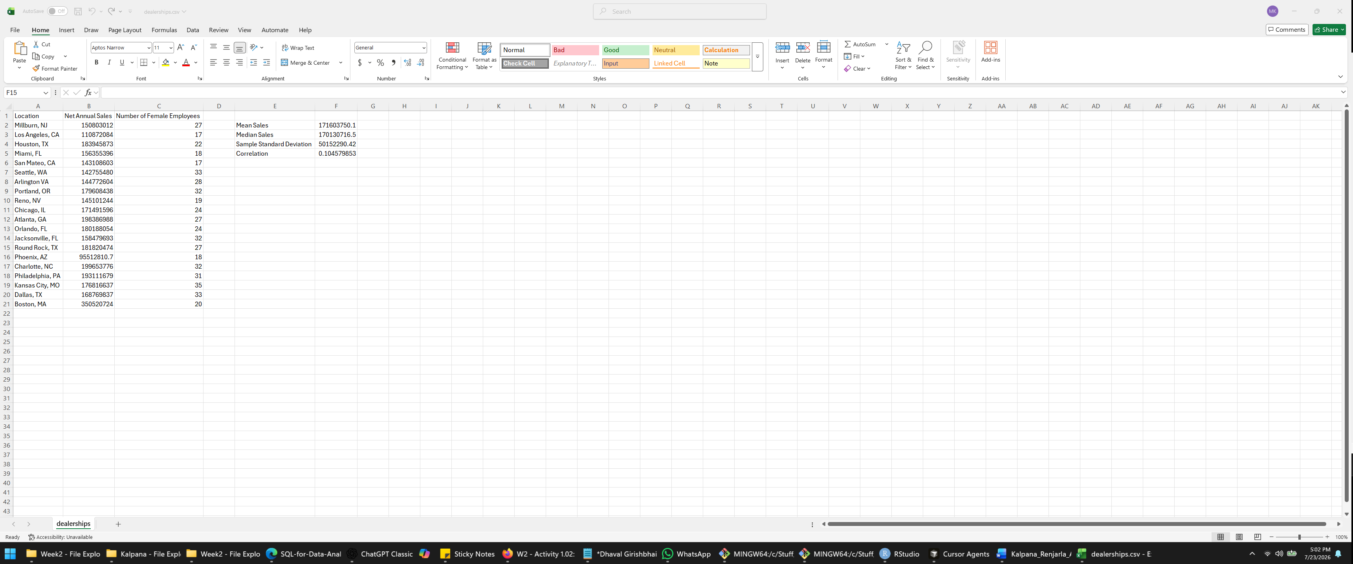

1. Frequency Distribution of Female Employees
What we did: We listed each distinct female-employee count and counted how many dealerships reported that value.
Female employees | Frequency
17 | 2
18 | 2
19 | 1
20 | 1
22 | 1
24 | 2
27 | 3
28 | 1
31 | 1
32 | 3
33 | 2
35 | 1

Excel formula: =COUNTIF($C$2:$C$21,E2)
Line-by-line explanation: COUNTIF counts records in cells C2 through C21 that match the employee count listed in E2. The dollar signs keep the source range fixed when the formula is copied downward.
Expected result: Copy the formula down beside employee counts 17 through 35. The frequencies should match the table above and total 20 dealerships.
What we achieved: The most frequent values are 27 and 32 female employees, with three dealerships in each group. The distribution ranges from 17 to 35.

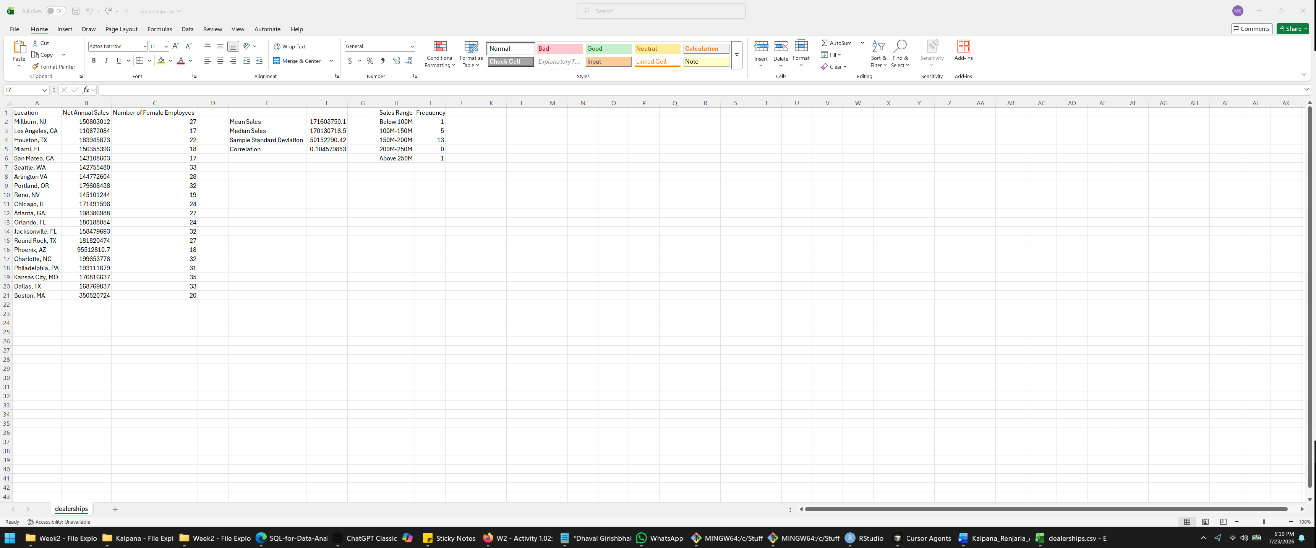

2. Average and Median Annual Sales
What we did: We calculated the arithmetic mean and the middle value of annual sales.
Excel formula: =AVERAGE(B2:B21)
Line-by-line explanation: AVERAGE adds the 20 annual-sales values in B2:B21 and divides the total by 20.
Expected result: $171,603,750.14
Excel formula: =MEDIAN(B2:B21)
Line-by-line explanation: MEDIAN sorts the annual-sales values and returns the midpoint. Because there are 20 records, Excel averages the 10th and 11th ordered values.
Expected result: $170,130,716.50
Interpretation: The mean and median are close, indicating that a typical dealership records approximately $170-$172 million in annual sales. The mean is slightly higher because the very large Boston value pulls it upward.

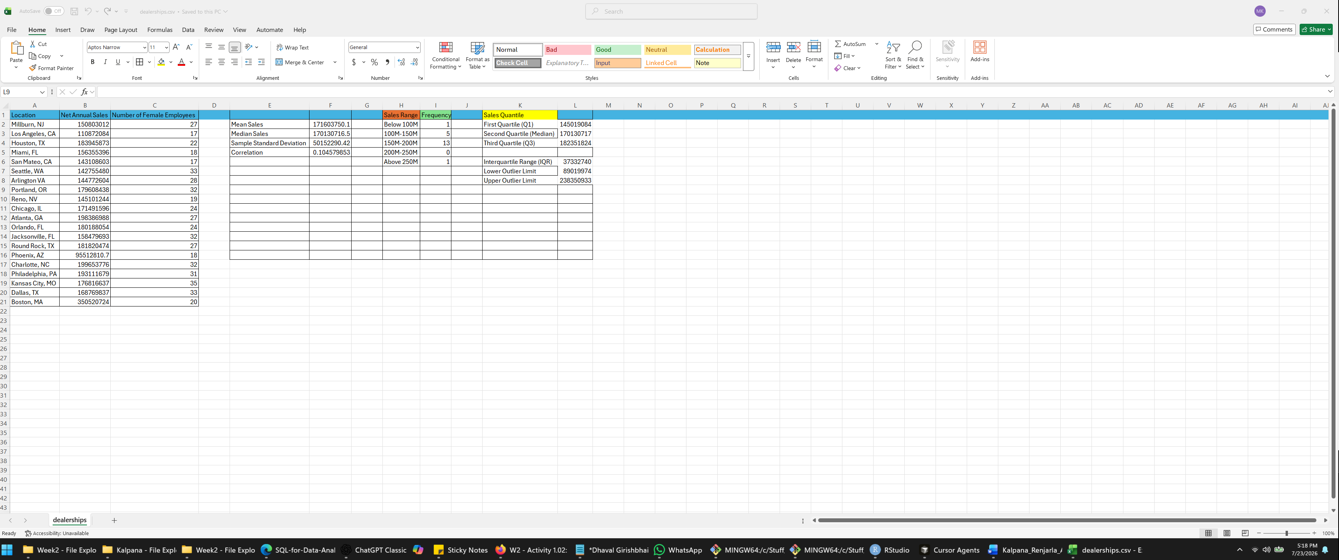

Average annual sales: $171,603,750.10

Median annual sales: $170,130,716.50

3. Standard Deviation of Annual Sales
What we did: We measured how widely dealership sales vary around the average.
Excel formula: =STDEV.S(B2:B21)
Line-by-line explanation: STDEV.S calculates the sample standard deviation for annual sales in B2:B21. It is appropriate when the observed dealerships are treated as a sample of a larger population of dealerships.
Interpretation: Annual sales typically vary by about $50.15 million from the mean. This relatively large spread is strongly influenced by Boston's unusually high annual sales.
The STDEV.S function calculates the sample standard deviation of annual sales for the 20 dealerships. The range B2:B21 contains the net annual sales values.
Interpretation:
The standard deviation is approximately $50.15 million. This means dealership annual sales typically vary by about $50.15 million from the average. The unusually high Boston sales value increases the amount of variation.

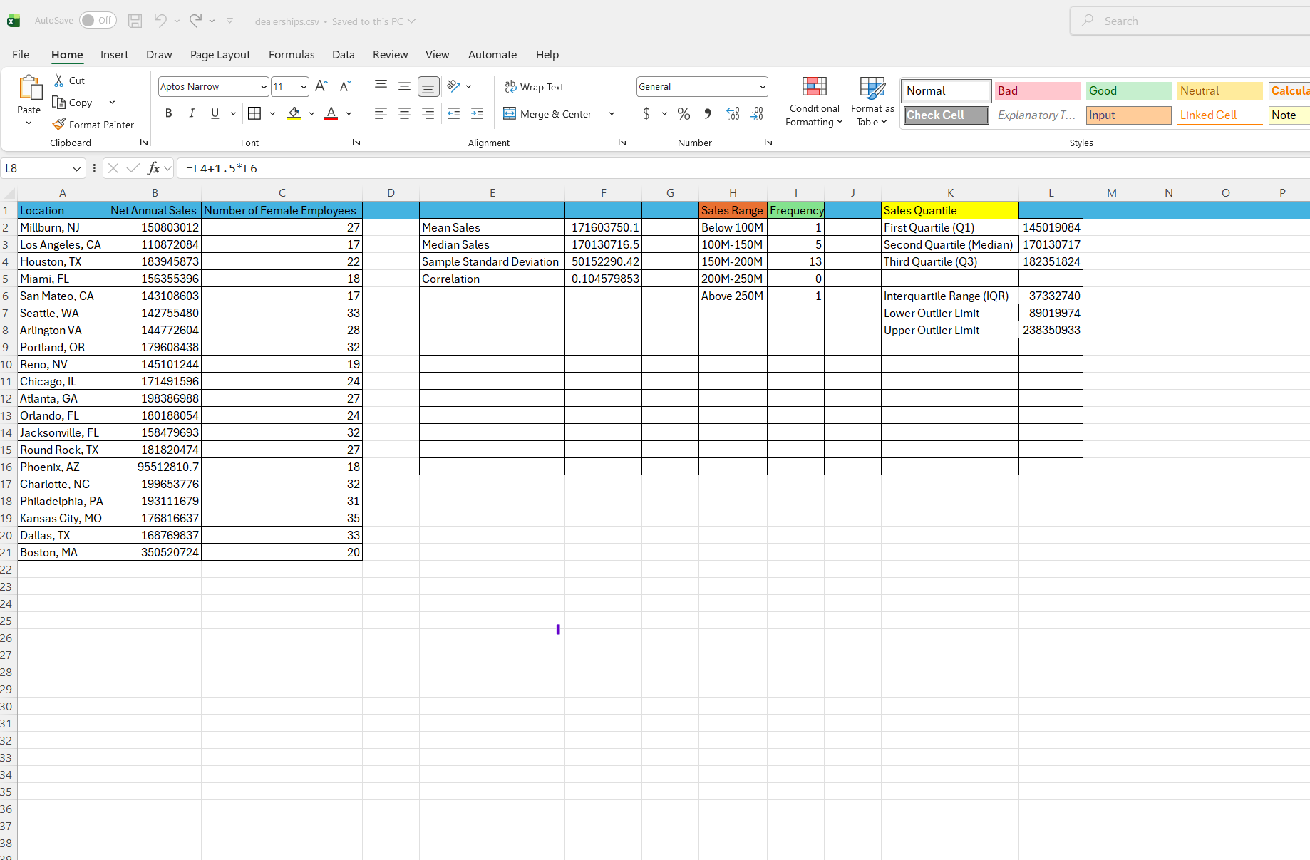

4. Outlier Evaluation
What we did: We used the interquartile range (IQR) rule. A value above Q3 + 1.5 x IQR or below Q1 - 1.5 x IQR is considered a possible outlier.
Measure | Excel calculation | Result
Q1 | =QUARTILE.INC(B2:B21,1) | $145,019,084.00
Q3 | =QUARTILE.INC(B2:B21,3) | $182,351,823.75
IQR | =Q3-Q1 | $37,332,739.75
Lower fence | =Q1-1.5*IQR | $89,020,974.38
Upper fence | =Q3+1.5*IQR | $238,350,933.38

Finding: Boston, MA has annual sales of $350,520,724.00, which is greater than the upper fence of $238,350,933.38. Therefore, Boston is a high outlier. No dealership falls below the lower fence.
What we achieved: We identified the outlier using a defined statistical rule instead of relying only on visual judgment.
The lower outlier limit is approximately $89.02 million, and the upper outlier limit is approximately $238.35 million. Boston recorded annual sales of $350,520,724, which exceeds the upper limit. Therefore, Boston is identified as a high-sales outlier. No dealership falls below the lower outlier limit.
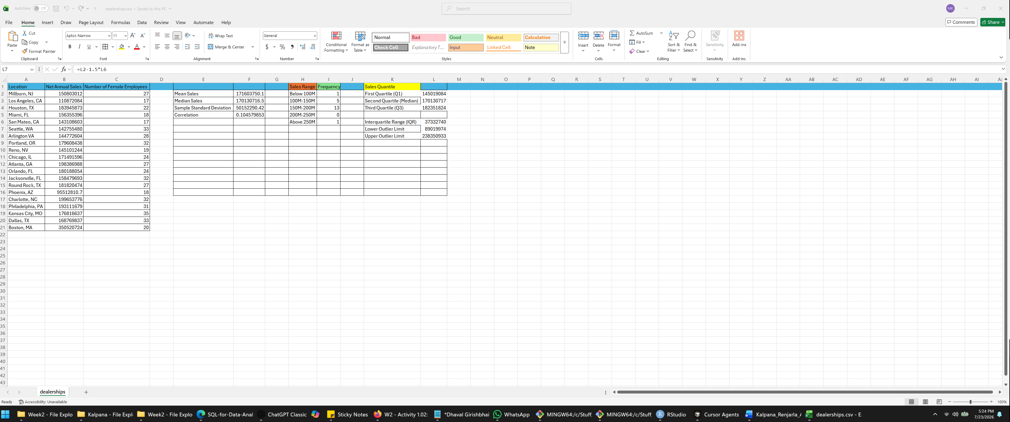

5. Quantiles of Annual Sales
What we did: We divided the ordered sales data into four equal sections using Excel's inclusive quartile function.
Quantile | Excel formula | Result
Minimum (0%) | =MIN(B2:B21) | $95,512,810.70
Q1 (25%) | =QUARTILE.INC(B2:B21,1) | $145,019,084.00
Median (50%) | =QUARTILE.INC(B2:B21,2) | $170,130,716.50
Q3 (75%) | =QUARTILE.INC(B2:B21,3) | $182,351,823.75
Maximum (100%) | =MAX(B2:B21) | $350,520,724.00

Interpretation: About 25% of dealerships have annual sales at or below $145.02 million, 50% are at or below $170.13 million, and 75% are at or below $182.35 million. The maximum is far above Q3 because of the Boston outlier.
The QUARTILE.INC function divides the annual sales data into four sections. Q1 indicates that approximately 25% of the dealerships recorded annual sales at or below $145.02 million. The median indicates that 50% recorded sales at or below approximately $170.13 million. Q3 indicates that approximately 75% recorded sales at or below $182.35 million. Therefore, the middle 50% of annual sales falls between approximately $145.02 million and $182.35 million.
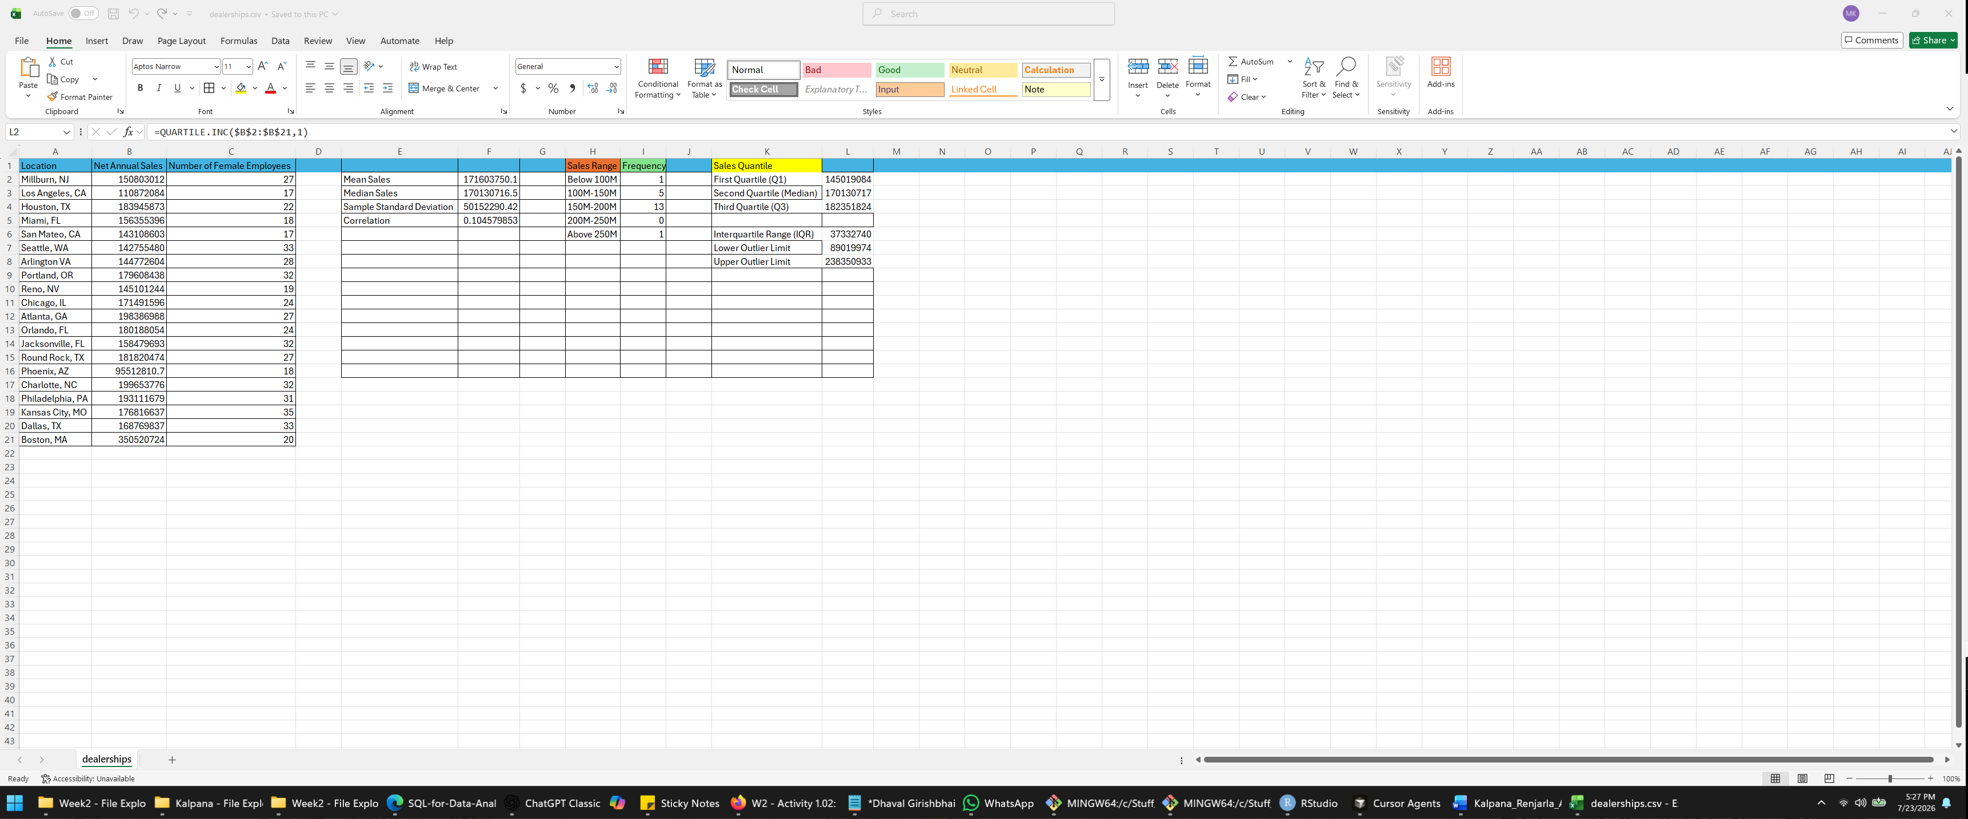

6. Correlation Between Sales and Female Employees
What we did: We measured the direction and strength of the linear relationship between net annual sales and the number of female employees.
Excel formula: =CORREL(B2:B21,C2:C21)
Line-by-line explanation: CORREL pairs each dealership's annual sales in Column B with its number of female employees in Column C and returns a Pearson correlation coefficient between -1 and +1.
Interpretation: The coefficient is positive but very close to zero. This shows an extremely weak positive linear relationship. In this dataset, dealerships with more female employees do not consistently have higher annual sales. Correlation also does not establish causation.
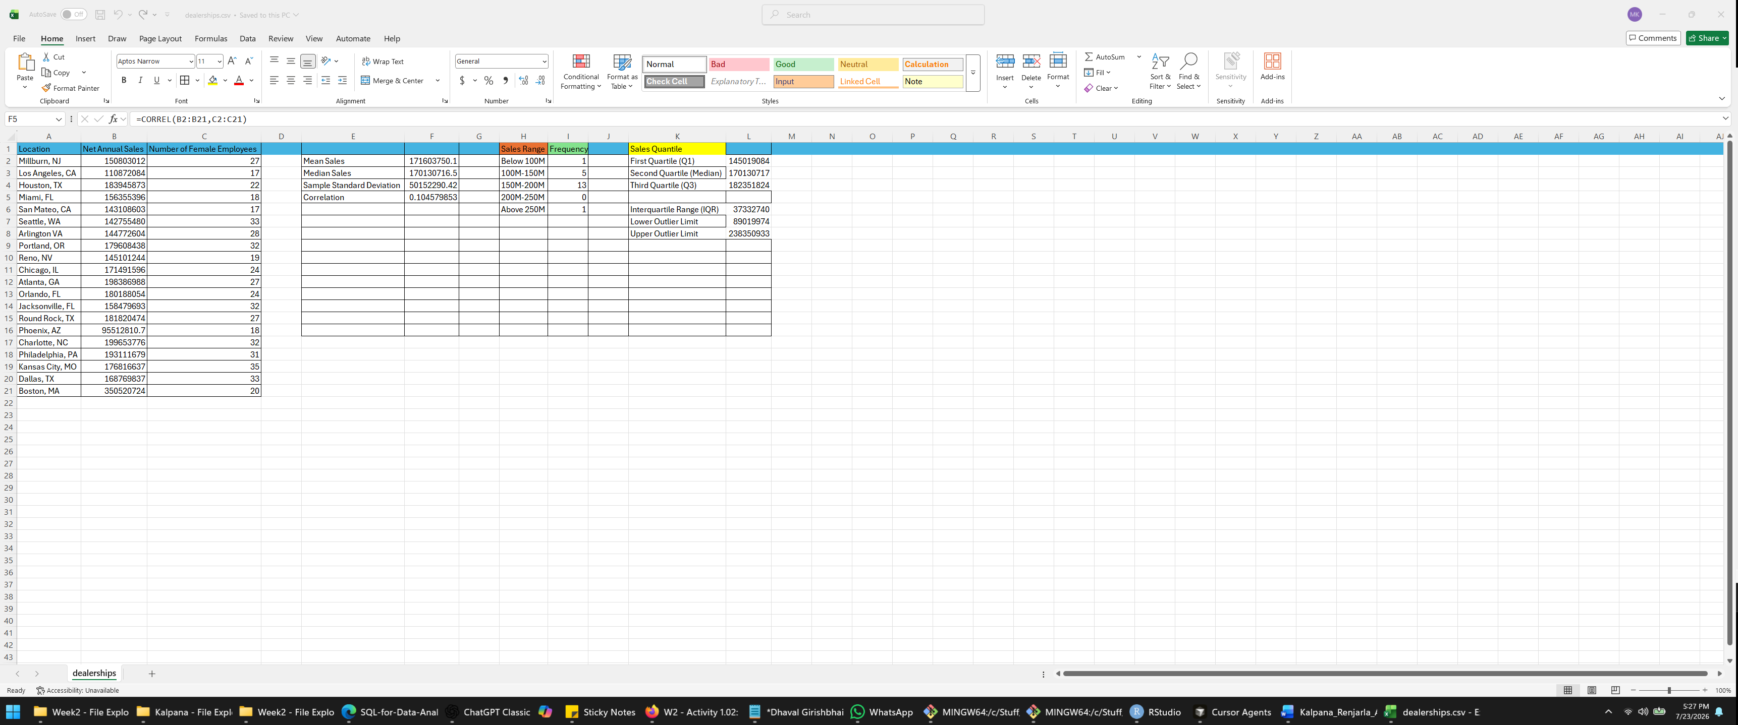

Overall Conclusion
The 20 dealerships have average annual sales of approximately $171.60 million and median sales of approximately $170.13 million. The sample standard deviation is approximately $50.15 million, showing meaningful variation across dealerships. The IQR method identifies Boston as a high-sales outlier. Finally, the correlation of approximately 0.105 indicates almost no linear relationship between annual sales and the number of female employees. These results demonstrate how descriptive statistics can summarize dealership performance and identify values that require additional investigation.

Reference
Shan, J., Goldwasser, M., Malik, U., & Johnston, B. (2022). SQL for data analytics: Harness the power of SQL to extract insights from data (3rd ed.). Packt Publishing.

