**CSCE 4523  
Assignment 5 - Due Thursday April 29, 2021; 11:59pm on Blackboard  
This assignment may be done in pairs (undergrads only).**

**Grad students must do the assignment individually.**

**Objective**

The goal is to review material covered in Chapters 12, 14, 15, 22.

**Do the following questions from the book.**

All answers that are just text/words should be done in a word processor. Diagrams may be hand drawn (if needed)

**12.4 Describe what the multiplicity constraint represents for a relationship type.**

**12.10 Create an ER model for each of the following descriptions:**

(a) Each company operates four departments, and each department belongs to one company.

(b) Each department in part (a) employs one or more employees, and each employee works for one department.

(c) Each of the employees in part (b) may or may not have one or more dependents, and each dependent belongs to one employee.

(d) Each employee in part (c) may or may not have an employment history.

(e) Represent all the ER models described in (a), (b), (c), and (d) as a single ER model.

**14.16 An agency called Instant Cover supplies part-time/temporary staff to hotels within Scotland. The table shown in Figure 14.20 ­displays sample data, which lists the time spent by agency staff working at various hotels. The National Insurance Number (NIN) is unique for every member of staff.**

(a) The table shown in Figure 14.20 is susceptible to update anomalies. Provide examples of insertion, deletion, and update anomalies.

(b) Identify the functional dependencies represented by the attributes shown in the table of Figure 14.20. State any assumptions that you make about the data and the attributes shown in this table.

(c) Describe and illustrate the process of normalizing the table shown in Figure 14.20 to 3NF. Identify primary, alternate, and foreign keys in your relations.

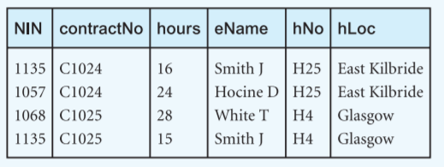

**Figure 14.20** Table displaying sample data for the Instant Cover agency

**15.8 BCNF is a stronger form of 3NF. Thus, every relation in BCNF is also in 3NF. However, a relation in 3NF is not necessarily in BCNF. Using example to emphasize your case, describe the situations when a 3NF relation is in BCNF and when it is not.**

**22.19 Draw a precedence graph for each of the following schedules:**

(a) read(T1, balx), read(T2, baly), write(T3, balx), read(T2, balx), read(T1, baly), commit(T1), commit(T2), commit(T3)

(b) read(T1, balx), write(T2, balx), write(T1, balx), read(T3, balx), commit(T1), commit(T2), commit(T3)

**22.22 Produce a wait-for graph for the following transaction scenario and determine whether deadlock exists:**

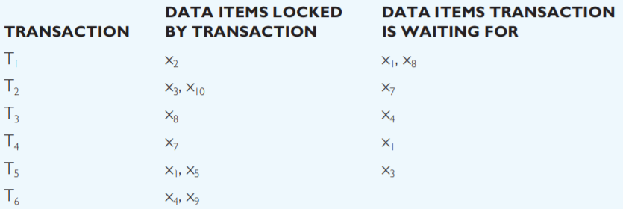

**B+ Tree Questions:**

|  |  |  |  |  |  |  |  |  |
| --- | --- | --- | --- | --- | --- | --- | --- | --- |
|  | 23 |  | 44 |  | 60 |  |  |  |

|  |  |  |  |
| --- | --- | --- | --- |
| 60 | 63 | 64 | 70 |

|  |  |  |  |
| --- | --- | --- | --- |
| 6 | 12 | 14 | 22 |

|  |  |  |  |
| --- | --- | --- | --- |
| 23 | 29 | 30 | 33 |

|  |  |  |  |
| --- | --- | --- | --- |
| 44 | 48 | 53 |  |

1. **Implement the following functions on the provided B+ Tree:**

* Insert 49.
* Insert 31.
* Delete 22
* Delete 14.

1. **What is the maximum number of unique keys (i.e., data records) that can be stored in a B+ Tree with k=399 and height=2 (where height is the number of pointer traversals from root to leaf)?**