**Assignment Requirement:**

The latest assembly available is GRCh38 but some users still use the previous assembly GRCh37. So I have to write the code to convert from new assembly to old assembly in the same region.

**Execution steps:**

Step1: Please copy below both files to appropriate directory,

AssemblyConverter.pl

assemblyconverter.in

Step2: You can add one or more lines of data to the assemblyconverter.in file.

(Please follow the same pattern while updating the file)

Sample input data: **chromosome: GRCh38:10:490000:500000:**

Step4: Run perl script (cd file/copied/directory; perl AssemblyConverter.pl)

I ran the script from Notepad++ for my convenience screen shot attached

.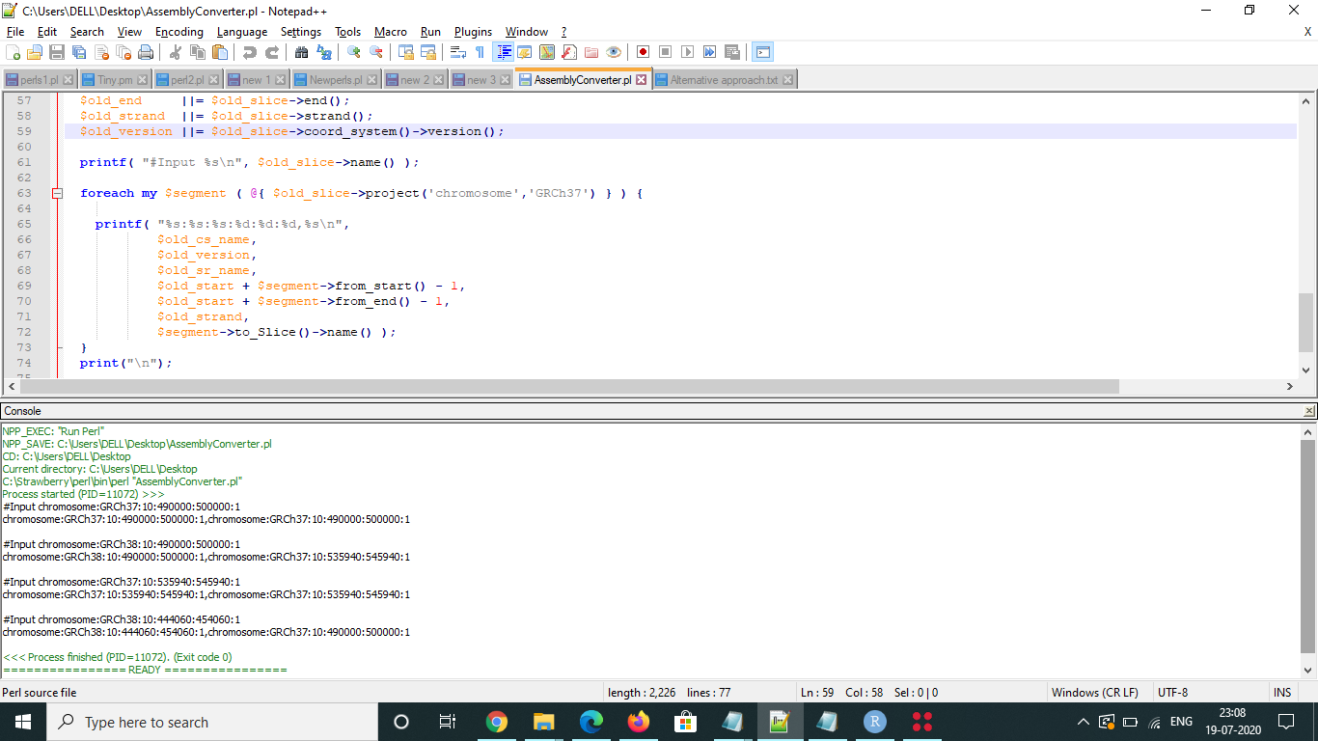

Also ran script from perl cmd prompt (Screen short attached):

