13.05.2024

Create a Billing alarm at the CLoudWatch

Make sure you have created your SNS topic in the N.V

Now go to the CloudWatch

Alarms >>> Billing >>>> Create a Alarm

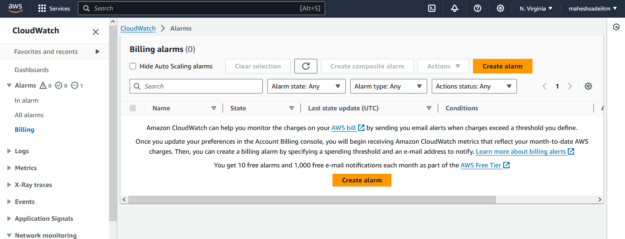

Currency and Threshold you can set as per your requirement - INR or USD

Click on next

Notification >> Select an existing SNS topic >>> Send a notification to… >>>> Choose your SNS Topic

Give the name as your desire and create

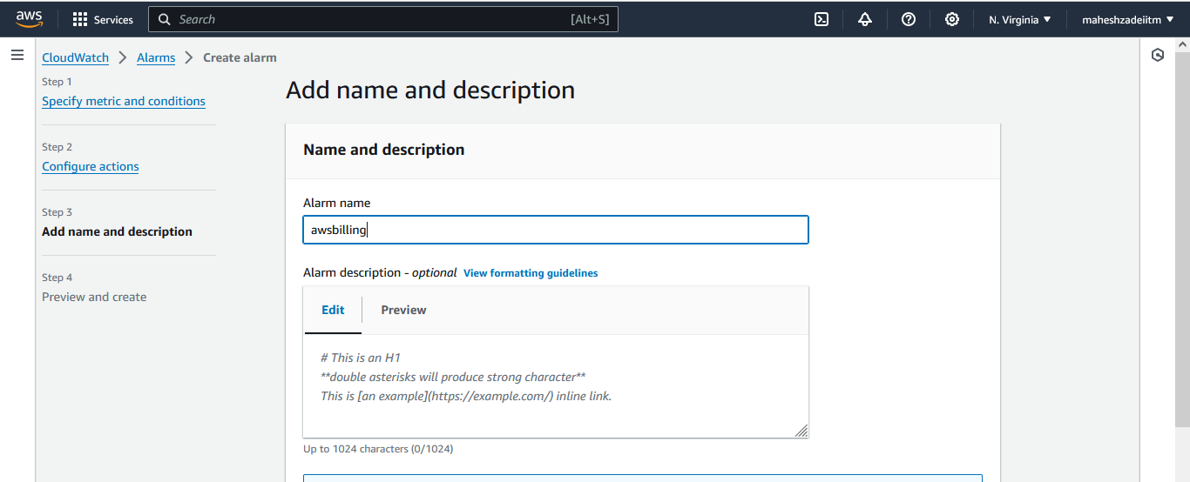

Click on create alarm

Pre-req

- Make sure you have more than TWO buckets and one should be Versioning enabled and other can be disabled so that you can identity the compliance report.

https://aws.amazon.com/config/pricing/

CloudTrail Vs Cloudwatch Vs Config

Set up AWS Config >>>> Get started (NOT One Click)

Recording method >>> All resource types with customizable overrides

Leave all the options as it is till "Delivery method"

Choose a bucket from your account >>>> Choose your bucket

Rules >>> AWS Managed Rules (143) >>>> Please explore these rule

Search for "s3-bucket-versioning-enabled" and select

Next

Review & Confirm

Now you can go inside and see whichever are complaint and non-complaint

SNS is DONE?

NO

- SNS Vs SQS

- S3 notification to the SNS

- etc