ISHIKA KARNIK
ROLL.NO-24UADS1063

OBJECTIVE-
WAP to evaluate the performance of implemented three-layer neural network with variations in activation functions, size of hidden layer, learning rate, batch size and number of epochs.
Description-
A three-layer neural network consists of an input layer, one hidden layer, and an output layer. The input layer receives the data, the hidden layer processes the data and learns patterns using weights and activation functions, and the output layer produces the final prediction or classification result.

Parameter Variations
Activation functions control neuron output. Hidden layer size affects learning capacity. Learning rate controls weight updates. Batch size defines how many samples are processed at a time. Epochs decide how long the network is trained.

Performance Evaluation
Performance is measured using accuracy, error vs epoch graph, and confusion matrix.
Proper tuning of parameters improves accuracy and reduces error in a three-layer neural network.

Code-
import tensorflow as tf
import tensorflow_datasets as tfds
import matplotlib.pyplot as plt

# ================= LOAD MNIST =================
def load_mnist(batch_size):
ds_train, ds_test = tfds.load('mnist', split=['train', 'test'], as_supervised=True)

def preprocess(img, lbl):
img = tf.reshape(tf.cast(img, tf.float32)/255.0, (784,))
return img, tf.cast(lbl, tf.int64)

train_ds = ds_train.map(preprocess).shuffle(10000).batch(batch_size)
test_ds = ds_test.map(preprocess).batch(batch_size)
return train_ds, test_ds

# ================= MODEL CREATION =================
def create_weights(hidden_units):
W1 = tf.Variable(tf.random.truncated_normal([784, hidden_units], stddev=0.1))
b1 = tf.Variable(tf.zeros([hidden_units]))
W2 = tf.Variable(tf.random.truncated_normal([hidden_units, 10], stddev=0.1))
b2 = tf.Variable(tf.zeros([10]))
return W1, b1, W2, b2

# ================= FORWARD PASS =================
def forward(x, W1, b1, W2, b2, activation):
z1 = tf.matmul(x, W1) + b1
if activation=="relu": h1 = tf.nn.relu(z1)
elif activation=="sigmoid": h1 = tf.nn.sigmoid(z1)
else: h1 = tf.nn.tanh(z1)
logits = tf.matmul(h1, W2) + b2
return logits

# ================= LOSS & ACCURACY =================
def compute_loss(logits, labels):
return tf.reduce_mean(tf.nn.sparse_softmax_cross_entropy_with_logits(labels=labels, logits=logits))

def compute_acc(logits, labels):
preds = tf.argmax(logits, axis=1)
return tf.reduce_mean(tf.cast(tf.equal(preds, labels), tf.float32))

# ================= TRAINING =================
def train_model(activation="relu", hidden_units=128, lr=0.1, batch_size=64, epochs=10):
train_ds, test_ds = load_mnist(batch_size)
W1, b1, W2, b2 = create_weights(hidden_units)
optimizer = tf.optimizers.SGD(lr)
history = {"acc":[]}

print(f"\nTraining: Activation={activation}, Hidden={hidden_units}, LR={lr}, Batch={batch_size}, Epochs={epochs}")

for epoch in range(epochs):
epoch_acc, batches = 0, 0
for x_batch, y_batch in train_ds:
with tf.GradientTape() as tape:
logits = forward(x_batch, W1, b1, W2, b2, activation)
loss = compute_loss(logits, y_batch)
grads = tape.gradient(loss, [W1,b1,W2,b2])
optimizer.apply_gradients(zip(grads, [W1,b1,W2,b2]))
epoch_acc += compute_acc(logits, y_batch).numpy()
batches += 1
history["acc"].append(epoch_acc/batches)
print(f"Epoch {epoch+1:02d} | Acc={history['acc'][-1]:.4f}")

return history, W1, b1, W2, b2, test_ds

# ================= CONFUSION MATRIX =================
def draw_cm(W1,b1,W2,b2,activation,test_ds,title):
all_preds, all_labels = [], []
for x_batch, y_batch in test_ds:
logits = forward(x_batch, W1, b1, W2, b2, activation)
preds = tf.argmax(logits, axis=1)
all_preds.extend(preds.numpy())
all_labels.extend(y_batch.numpy())
cm = tf.math.confusion_matrix(all_labels, all_preds).numpy()
plt.imshow(cm, cmap="Blues")
plt.title(title)
plt.xlabel("Predicted")
plt.ylabel("Actual")
for i in range(10):
for j in range(10):
plt.text(j, i, cm[i,j], ha="center", va="center", color="white" if cm[i,j]>cm.max()/2 else "black")
plt.colorbar()
plt.show()

# ================= EXPERIMENTS =================

# 🔹 Activation Variation
activations = ["relu","sigmoid","tanh"]
for act in activations:
history, W1, b1, W2, b2, test_ds = train_model(activation=act)
plt.plot(history["acc"])
plt.title(f"Accuracy - Activation={act}")
plt.xlabel("Epoch"); plt.ylabel("Accuracy"); plt.grid(); plt.show()
draw_cm(W1,b1,W2,b2,act,test_ds,f"Confusion Matrix - Activation={act}")

# 🔹 Batch Size Variation
batch_sizes = [64,128,256]
for bs in batch_sizes:
history, W1, b1, W2, b2, test_ds = train_model(batch_size=bs)
plt.plot(history["acc"])
plt.title(f"Accuracy - Batch Size={bs}")
plt.xlabel("Epoch"); plt.ylabel("Accuracy"); plt.grid(); plt.show()
draw_cm(W1,b1,W2,b2,"relu",test_ds,f"Confusion Matrix - Batch={bs}")

# 🔹 Learning Rate Variation
learning_rates = [0.01,0.05,0.1]
for lr in learning_rates:
history, W1, b1, W2, b2, test_ds = train_model(lr=lr)
plt.plot(history["acc"])
plt.title(f"Accuracy - Learning Rate={lr}")
plt.xlabel("Epoch"); plt.ylabel("Accuracy"); plt.grid(); plt.show()
draw_cm(W1,b1,W2,b2,"relu",test_ds,f"Confusion Matrix - LR={lr}")

Output-
Training: Activation=relu, Hidden=128, LR=0.1, Batch=64, Epochs=10
Epoch 01 | Acc=0.8892
Epoch 02 | Acc=0.9391
Epoch 03 | Acc=0.9545
Epoch 04 | Acc=0.9631
Epoch 05 | Acc=0.9690
Epoch 06 | Acc=0.9735
Epoch 07 | Acc=0.9764
Epoch 08 | Acc=0.9788
Epoch 09 | Acc=0.9813
Epoch 10 | Acc=0.9830

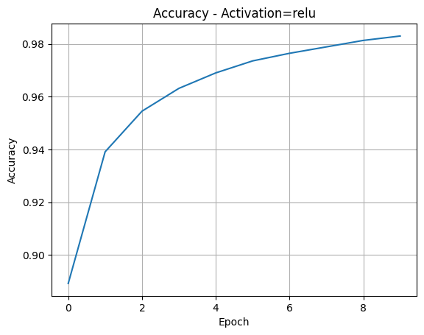

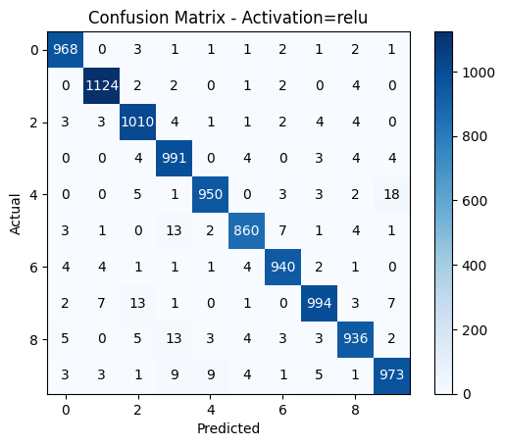
Training: Activation=sigmoid, Hidden=128, LR=0.1, Batch=64, Epochs=10
Epoch 01 | Acc=0.8198
Epoch 02 | Acc=0.8998
Epoch 03 | Acc=0.9120
Epoch 04 | Acc=0.9196
Epoch 05 | Acc=0.9249
Epoch 06 | Acc=0.9303
Epoch 07 | Acc=0.9356
Epoch 08 | Acc=0.9386
Epoch 09 | Acc=0.9433
Epoch 10 | Acc=0.9463
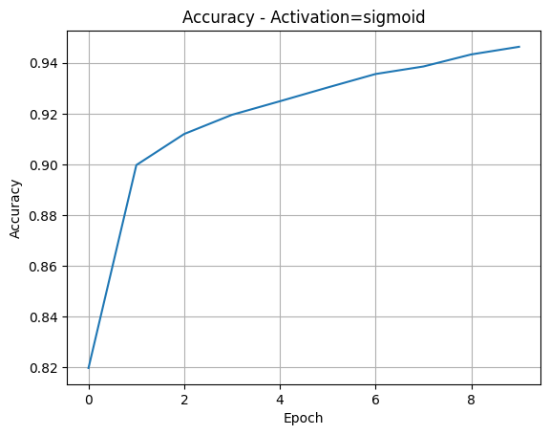
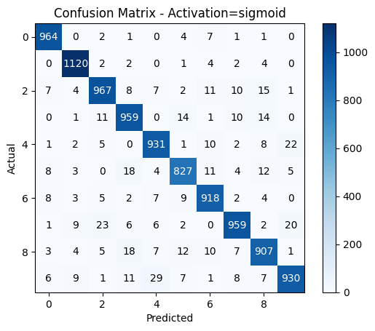
Training: Activation=tanh, Hidden=128, LR=0.1, Batch=64, Epochs=10
Epoch 01 | Acc=0.8850
Epoch 02 | Acc=0.9313
Epoch 03 | Acc=0.9467
Epoch 04 | Acc=0.9562
Epoch 05 | Acc=0.9629
Epoch 06 | Acc=0.9679
Epoch 07 | Acc=0.9720
Epoch 08 | Acc=0.9754
Epoch 09 | Acc=0.9774
Epoch 10 | Acc=0.9801
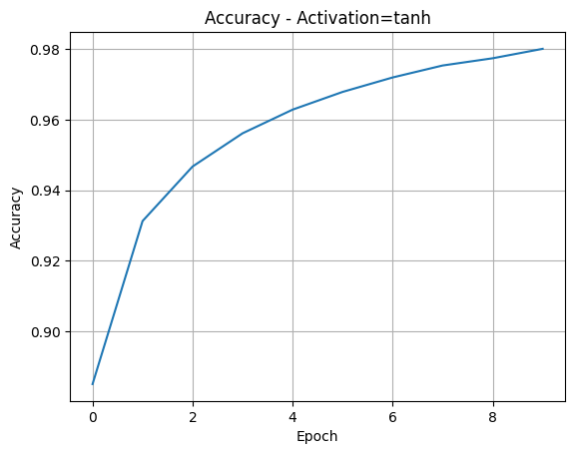

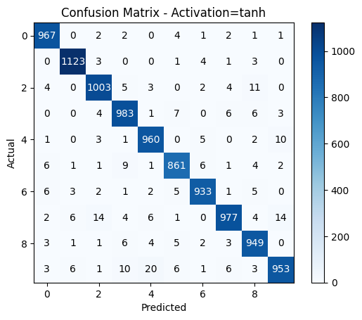
Training: Activation=relu, Hidden=128, LR=0.1, Batch=64, Epochs=10
Epoch 01 | Acc=0.8880
Epoch 02 | Acc=0.9397
Epoch 03 | Acc=0.9548
Epoch 04 | Acc=0.9630
Epoch 05 | Acc=0.9693
Epoch 06 | Acc=0.9738
Epoch 07 | Acc=0.9765
Epoch 08 | Acc=0.9796
Epoch 09 | Acc=0.9810
Epoch 10 | Acc=0.9827
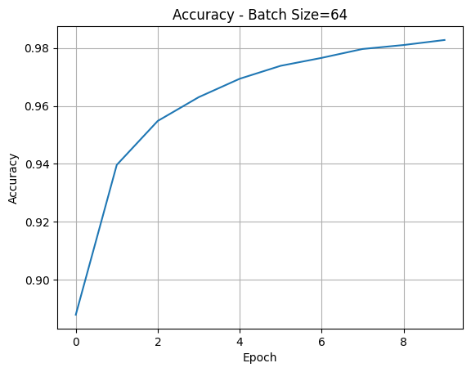
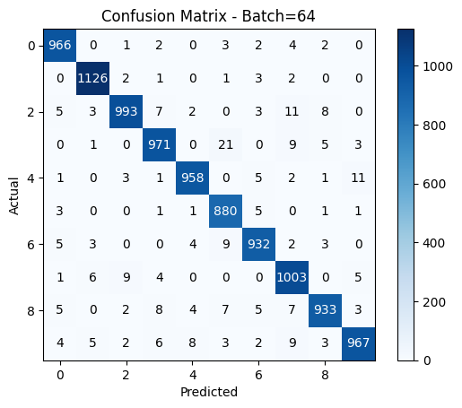
Training: Activation=relu, Hidden=128, LR=0.1, Batch=128, Epochs=10
Epoch 01 | Acc=0.8607
Epoch 02 | Acc=0.9236
Epoch 03 | Acc=0.9388
Epoch 04 | Acc=0.9478
Epoch 05 | Acc=0.9547
Epoch 06 | Acc=0.9601
Epoch 07 | Acc=0.9645
Epoch 08 | Acc=0.9681
Epoch 09 | Acc=0.9712
Epoch 10 | Acc=0.9731
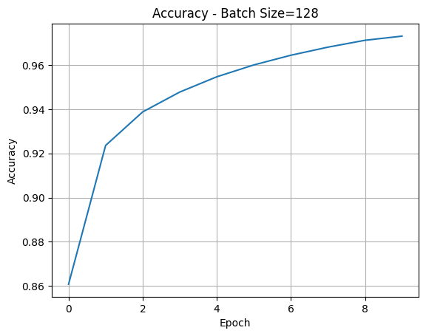

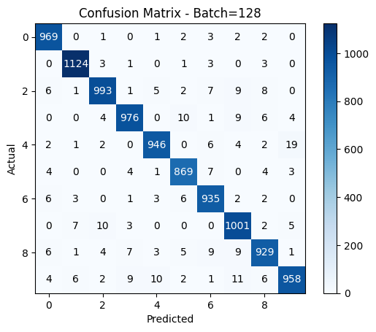
Training: Activation=relu, Hidden=128, LR=0.1, Batch=256, Epochs=10
Epoch 01 | Acc=0.8315
Epoch 02 | Acc=0.9081
Epoch 03 | Acc=0.9215
Epoch 04 | Acc=0.9311
Epoch 05 | Acc=0.9377
Epoch 06 | Acc=0.9422
Epoch 07 | Acc=0.9468
Epoch 08 | Acc=0.9502
Epoch 09 | Acc=0.9535
Epoch 10 | Acc=0.9571
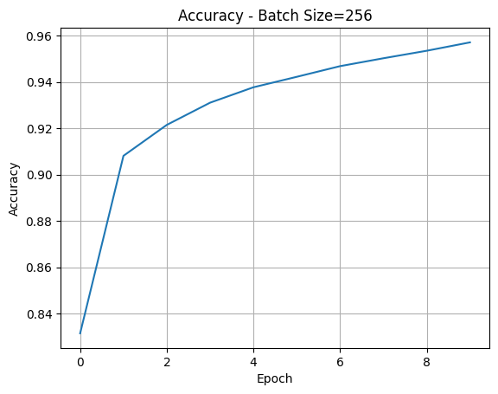
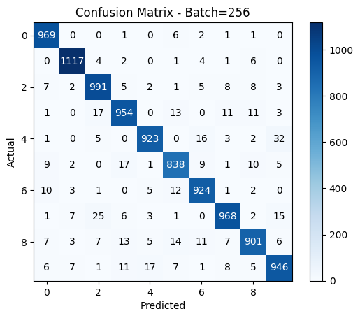
Training: Activation=relu, Hidden=128, LR=0.01, Batch=64, Epochs=10
Epoch 01 | Acc=0.7545
Epoch 02 | Acc=0.8790
Epoch 03 | Acc=0.8956
Epoch 04 | Acc=0.9046
Epoch 05 | Acc=0.9113
Epoch 06 | Acc=0.9167
Epoch 07 | Acc=0.9217
Epoch 08 | Acc=0.9254
Epoch 09 | Acc=0.9288
Epoch 10 | Acc=0.9320
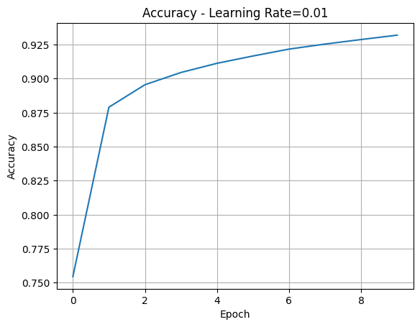
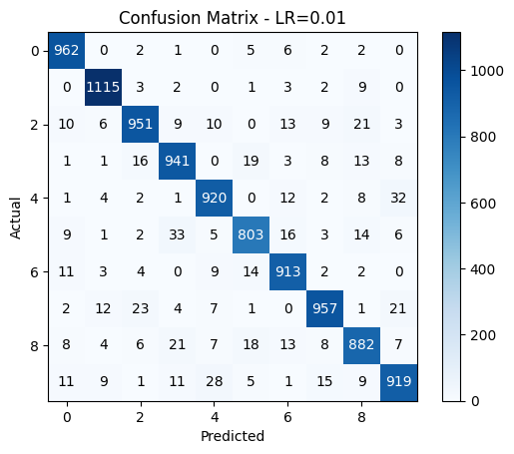
Training: Activation=relu, Hidden=128, LR=0.05, Batch=64, Epochs=10
Epoch 01 | Acc=0.8603
Epoch 02 | Acc=0.9222
Epoch 03 | Acc=0.9370
Epoch 04 | Acc=0.9457
Epoch 05 | Acc=0.9533
Epoch 06 | Acc=0.9583
Epoch 07 | Acc=0.9625
Epoch 08 | Acc=0.9663
Epoch 09 | Acc=0.9686
Epoch 10 | Acc=0.9715
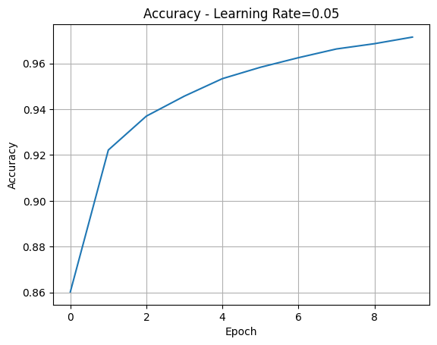
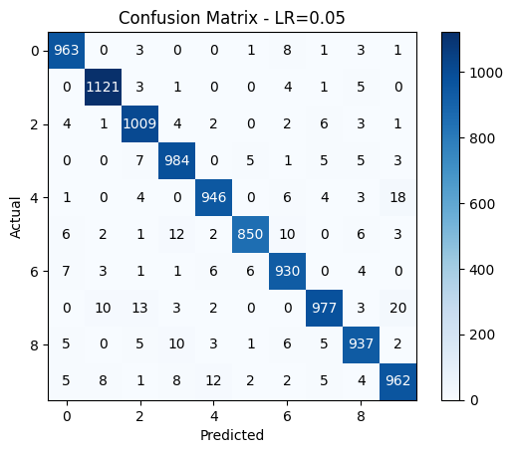
Training: Activation=relu, Hidden=128, LR=0.1, Batch=64, Epochs=10
Epoch 01 | Acc=0.8882
Epoch 02 | Acc=0.9397
Epoch 03 | Acc=0.9547
Epoch 04 | Acc=0.9628
Epoch 05 | Acc=0.9688
Epoch 06 | Acc=0.9733
Epoch 07 | Acc=0.9760
Epoch 08 | Acc=0.9788
Epoch 09 | Acc=0.9812
Epoch 10 | Acc=0.9829
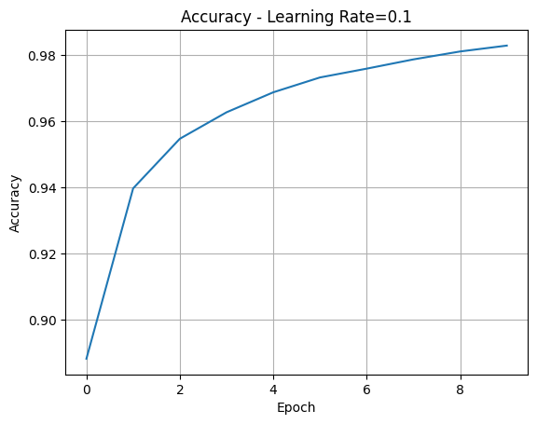
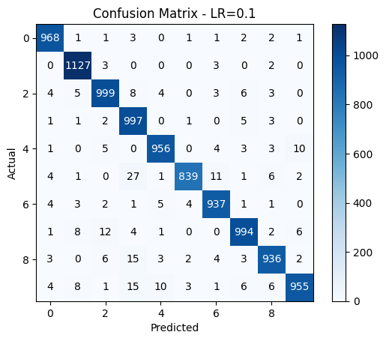

COMMENTS-.
I learned that ReLU activation gives the best accuracy and trains faster compared to Sigmoid and Tanh. A medium hidden layer (128 neurons) is usually enough, while very small layers underfit and very large layers do not improve accuracy much. A medium batch size (64) balances speed and accuracy, whereas small batches are slow but more stable and large batches train faster but slightly reduce accuracy. A moderate learning rate (0.05) works best, while very low rates are slow and very high rates can be unstable.

