OBJECTIVE-
WAP to train and evaluate a convolutional neural network using Keras Library to classify MNIST fashion dataset. Demonstrate the effect of filter size, regularization, batch size and optimization algorithm on model performance.
Description-
In this experiment, we train and evaluate a Convolutional Neural Network (CNN) using TensorFlow and Keras to classify images from the Fashion MNIST dataset. This dataset contains 28 × 28 grayscale images of clothing items such as shirts, trousers, bags, and shoes. There are 10 different classes in the dataset.
First, the dataset is loaded using Keras. To reduce execution time, only a smaller portion of the dataset is used for training and testing. The pixel values of images originally range from 0 to 255. These values are normalized using the formula:
$$X_{normalized}=\frac{X}{255}$$
Normalization helps the model train faster and improves performance.
After preprocessing, the images are reshaped to 28 × 28 × 1 so that they can be used as input for the CNN model.
Next, the CNN model is created. It contains Convolution layers, Max Pooling layers, a Flatten layer, and Dense layers.
Convolution Layer
The convolution layer extracts important features from the image using filters. The basic convolution operation can be represented as:
$$Feature\text{ =}Input*Filter+Bias$$
where * represents the convolution operation.
Activation Function
The ReLU (Rectified Linear Unit) activation function is used in convolution layers:
$$ReLU(x)=max(0,x)$$
It removes negative values and introduces non-linearity.
Max Pooling
Max pooling reduces the size of the feature map and keeps the most important features. It selects the maximum value from a region of the feature map.
Flatten Layer
The flatten layer converts the 2D feature map into a 1D vector so that it can be used by the dense layer.
Output Layer
The output layer uses the SoftMax activation function to classify images into 10 categories:
$$Softmax(x_{i})=\frac{e^{x_{i}}}{∑e^{x_{j}}}$$
This function converts outputs into probabilities.
Loss Function
The model uses Sparse Categorical Cross entropy as the loss function:
$$Loss=-∑ylog⁡(\hat{y})$$
This helps measure the difference between predicted values and actual values.

Parameter Experiments
In this experiment, the model performance is tested by changing different parameters:
Filter Size
Different filter sizes 3×3, 5×5, and 7×7 are used to observe how feature extraction changes.
Regularization
Regularization helps reduce overfitting.
Two types are used:
L1 Regularization:
$$Loss=Loss+λ∑∣w∣$$
L2 Regularization:
$$Loss=Loss+λ∑w^{2}$$
Batch Size
Batch sizes 32, 64, and 128 are used to check how training speed and accuracy change.
Optimizers
Different optimizers are tested:
- Adam
- SGD
- RMSprop
Optimizers update the weights using the gradient descent rule:
$$W=W-η\frac{∂L}{∂W}$$
where
$W$= weight
$η$= learning rate
$L$= loss function

Evaluation
After training, the model predictions are compared with the actual labels using a Confusion Matrix. It shows how many predictions are correct or incorrect for each class.
Accuracy is calculated using:
$$Accuracy=\frac{Correct Predictions}{Total Predictions}$$
Graphs are also plotted to visualize training and validation accuracy during the training process.

Code-
import tensorflow as tf
from tensorflow import keras
from tensorflow.keras import layers, regularizers
import matplotlib.pyplot as plt
import numpy as np
from sklearn.metrics import confusion_matrix
import seaborn as sns

# ===============================
# Load Dataset
# ===============================
(x_train, y_train), (x_test, y_test) = keras.datasets.fashion_mnist.load_data()

# Reduce dataset for faster execution
x_train = x_train[:15000]
y_train = y_train[:15000]

x_test = x_test[:3000]
y_test = y_test[:3000]

# Normalize
x_train = x_train/255.0
x_test = x_test/255.0

# Reshape
x_train = x_train.reshape(-1,28,28,1)
x_test = x_test.reshape(-1,28,28,1)

# ===============================
# CNN Model Function
# ===============================
def create_model(filter_size=3, reg=None, optimizer='adam'):

model = keras.Sequential([

layers.Conv2D(32,(filter_size,filter_size),
activation='relu',
kernel_regularizer=reg,
input_shape=(28,28,1)),

layers.MaxPooling2D((2,2)),

layers.Conv2D(64,(filter_size,filter_size),
activation='relu',
kernel_regularizer=reg),

layers.MaxPooling2D((2,2)),

layers.Flatten(),

layers.Dense(128,activation='relu'),

layers.Dense(10,activation='softmax')
])

model.compile(
optimizer=optimizer,
loss='sparse_categorical_crossentropy',
metrics=['accuracy']
)

return model

# ===============================
# Function to Show Results
# ===============================
def show_results(history, model, title):

# Accuracy Graph
plt.figure()
plt.plot(history.history['accuracy'])
plt.plot(history.history['val_accuracy'])
plt.title(title + " Accuracy")
plt.xlabel("Epoch")
plt.ylabel("Accuracy")
plt.legend(["Train","Validation"])
plt.show()

# Loss Graph
plt.figure()
plt.plot(history.history['loss'])
plt.plot(history.history['val_loss'])
plt.title(title + " Loss")
plt.xlabel("Epoch")
plt.ylabel("Loss")
plt.legend(["Train","Validation"])
plt.show()

# Confusion Matrix
predictions = model.predict(x_test)
y_pred = np.argmax(predictions,axis=1)

cm = confusion_matrix(y_test,y_pred)

plt.figure(figsize=(6,5))
sns.heatmap(cm,annot=True,fmt='d',cmap='Blues')
plt.title(title + " Confusion Matrix")
plt.xlabel("Predicted")
plt.ylabel("Actual")
plt.show()

# ===============================
# 1 Filter Size Variation
# ===============================
print("\n FILTER SIZE VARIATION")

for f in [3,5,7]:

print("\nTraining Filter Size:",f)

model = create_model(filter_size=f)

history = model.fit(
x_train,y_train,
epochs=3,
batch_size=64,
validation_data=(x_test,y_test)
)

loss,acc = model.evaluate(x_test,y_test,verbose=0)
print("Test Accuracy:",acc)

show_results(history,model,"Filter Size "+str(f))

# ===============================
# 2 Regularization Variation
# ===============================
print("\n REGULARIZATION VARIATION")

regularizations = {
"None":None,
"L1":regularizers.l1(0.001),
"L2":regularizers.l2(0.001)
}

for name,reg in regularizations.items():

print("\nTraining Regularization:",name)

model = create_model(reg=reg)

history = model.fit(
x_train,y_train,
epochs=3,
batch_size=64,
validation_data=(x_test,y_test)
)

loss,acc = model.evaluate(x_test,y_test,verbose=0)
print("Test Accuracy:",acc)

show_results(history,model,"Regularization "+name)

# ===============================
# 3 Batch Size Variation
# ===============================
print("\n BATCH SIZE VARIATION")

for b in [32,64,128]:

print("\nTraining Batch Size:",b)

model = create_model()

history = model.fit(
x_train,y_train,
epochs=3,
batch_size=b,
validation_data=(x_test,y_test)
)

loss,acc = model.evaluate(x_test,y_test,verbose=0)
print("Test Accuracy:",acc)

show_results(history,model,"Batch Size "+str(b))

# ===============================
# 4 Optimizer Variation
# ===============================
print("\n OPTIMIZER VARIATION")

for opt in ['adam','sgd','rmsprop']:

print("\nTraining Optimizer:",opt)

model = create_model(optimizer=opt)

history = model.fit(
x_train,y_train,
epochs=3,
batch_size=64,
validation_data=(x_test,y_test)
)

loss,acc = model.evaluate(x_test,y_test,verbose=0)
print("Test Accuracy:",acc)

show_results(history,model,"Optimizer "+opt)

Output-
Epoch 1/3
235/235 ━━━━━━━━━━━━━━━━━━━━ 15s 56ms/step - accuracy: 0.6486 - loss: 0.9880 - val_accuracy: 0.8227 - val_loss: 0.4838
Epoch 2/3
235/235 ━━━━━━━━━━━━━━━━━━━━ 13s 55ms/step - accuracy: 0.8354 - loss: 0.4490 - val_accuracy: 0.8327 - val_loss: 0.4514
Epoch 3/3
235/235 ━━━━━━━━━━━━━━━━━━━━ 20s 55ms/step - accuracy: 0.8621 - loss: 0.3775 - val_accuracy: 0.8623 - val_loss: 0.3906
Test Accuracy: 0.862333357334137
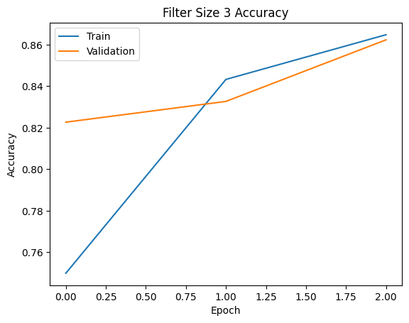
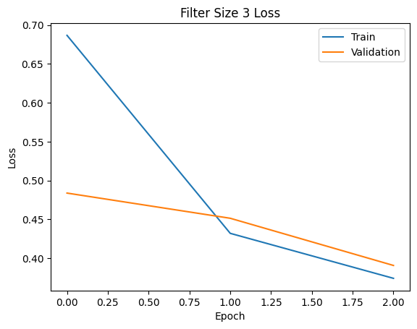
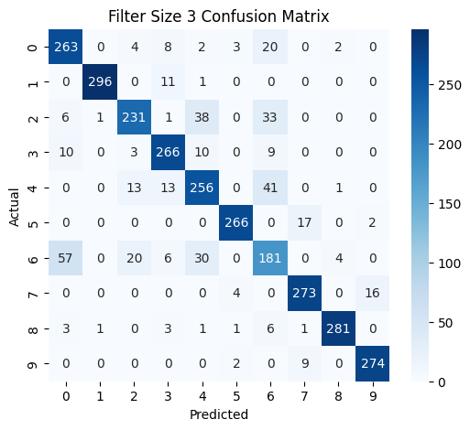
Training Filter Size: 5
Epoch 1/3
235/235 ━━━━━━━━━━━━━━━━━━━━ 18s 70ms/step - accuracy: 0.6251 - loss: 1.0854 - val_accuracy: 0.8013 - val_loss: 0.5406
Epoch 2/3
235/235 ━━━━━━━━━━━━━━━━━━━━ 17s 73ms/step - accuracy: 0.8244 - loss: 0.4808 - val_accuracy: 0.8527 - val_loss: 0.4201
Epoch 3/3
235/235 ━━━━━━━━━━━━━━━━━━━━ 20s 70ms/step - accuracy: Test Accuracy: 0.8506666421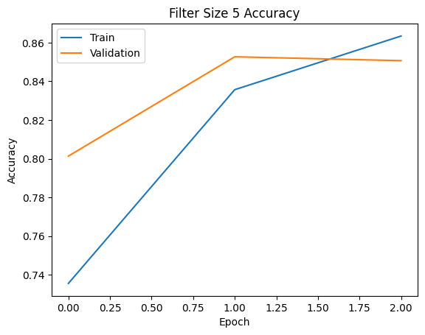

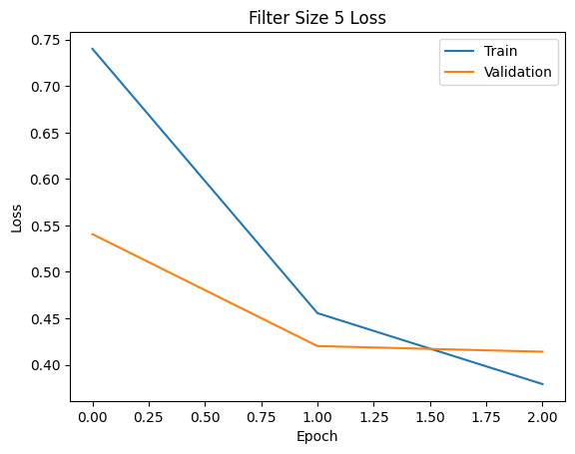
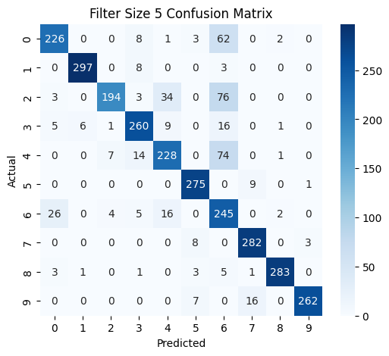
Training Filter Size: 7
Epoch 1/3
235/235 ━━━━━━━━━━━━━━━━━━━━ 21s 83ms/step - accuracy: 0.6233 - loss: 1.0567 - val_accuracy: 0.7887 - val_loss: 0.5734
Epoch 2/3
235/235 ━━━━━━━━━━━━━━━━━━━━ 19s 77ms/step - accuracy: 0.8131 - loss: 0.5116 - val_accuracy: 0.8300 - val_loss: 0.4862
Epoch 3/3
235/235 ━━━━━━━━━━━━━━━━━━━━ 20s 86ms/step - accuracy: 0.8420 - loss: 0.4492 - val_accuracy: 0.8377 - val_loss: 0.4497
Test Accuracy: 0.8376666903495789
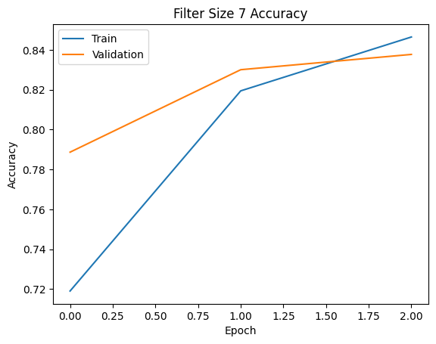
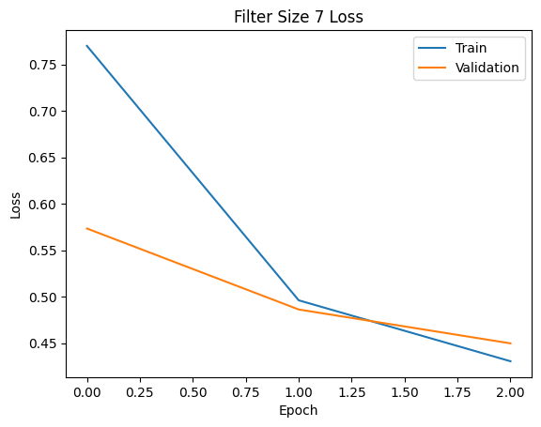
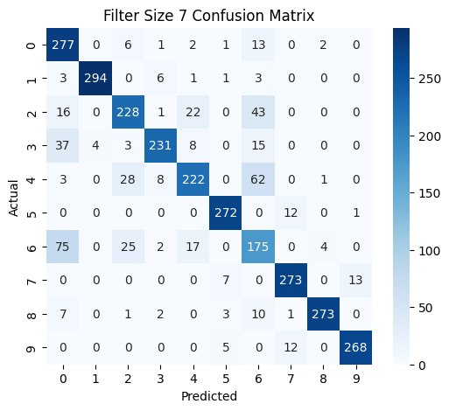
REGULARIZATION VARIATION

Training Regularization: None
Epoch 1/3
/usr/local/lib/python3.12/dist-
235/235 ━━━━━━━━━━━━━━━━━━━━ 15s 60ms/step - accuracy: 0.6274 - loss: 1.0468 - val_accuracy: 0.8210 - val_loss: 0.5027
Epoch 2/3
235/235 ━━━━━━━━━━━━━━━━━━━━ 14s 58ms/step - accuracy: 0.8323 - loss: 0.4529 - val_accuracy: 0.8380 - val_loss: 0.4496
Epoch 3/3
235/235 ━━━━━━━━━━━━━━━━━━━━ 14s 59ms/step - accuracy: 0.8579 - loss: 0.3902 - val_accuracy: 0.8647 - val_loss: 0.3973
Test Accuracy: 0.8646666407585144
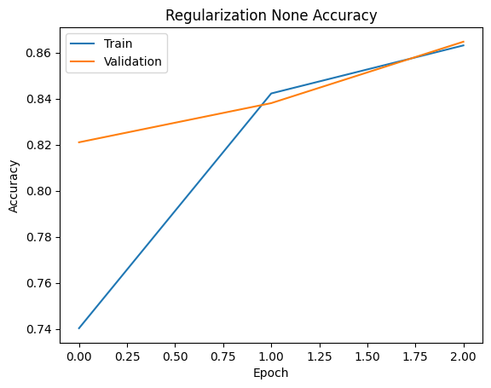

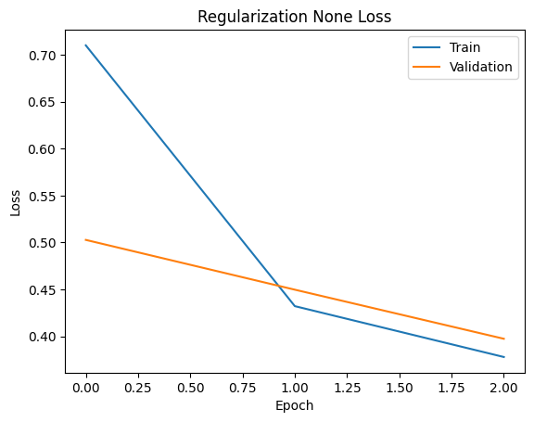

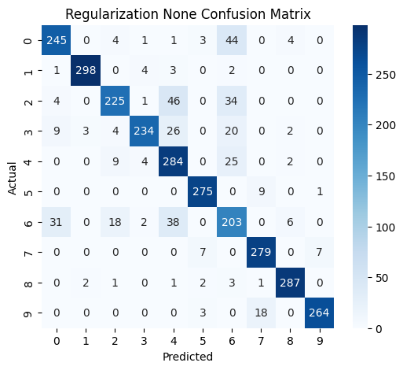
Training Regularization: L1
Epoch 1/3
235/235 ━━━━━━━━━━━━━━━━━━━━ 16s 61ms/step - accuracy: 0.6190 - loss: 1.5792 - val_accuracy: 0.7930 - val_loss: 0.8033
Epoch 2/3
235/235 ━━━━━━━━━━━━━━━━━━━━ 20s 59ms/step - accuracy: 0.8098 - loss: 0.7166 - val_accuracy: 0.8303 - val_loss: 0.6228
Epoch 3/3
235/235 ━━━━━━━━━━━━━━━━━━━━ 21s 59ms/step - accuracy: 0.8248 - loss: 0.6051 - val_accuracy: 0.8280 - val_loss: 0.5826
Test Accuracy: 0.828000009059906
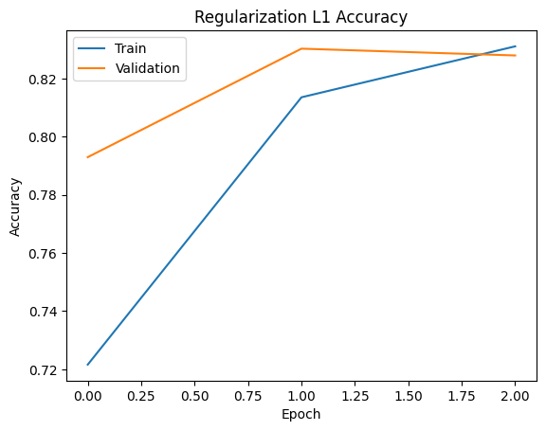
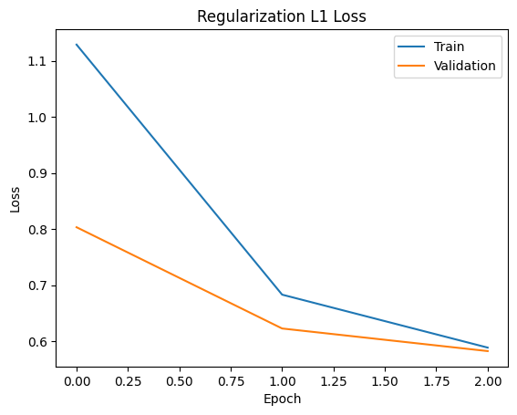
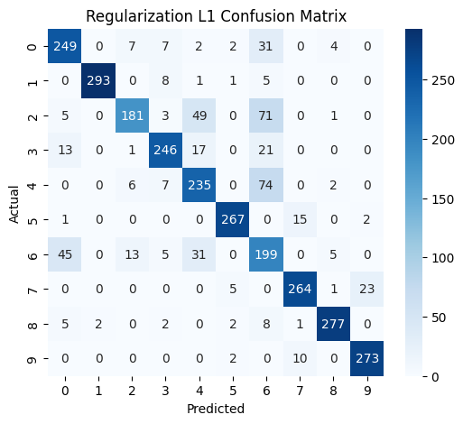
Training Regularization: L2
Epoch 1/3
235/235 ━━━━━━━━━━━━━━━━━━━━ 17s 66ms/step - accuracy: 0.6292 - loss: 1.0861 - val_accuracy: 0.8093 - val_loss: 0.5807
Epoch 2/3
235/235 ━━━━━━━━━━━━━━━━━━━━ 20s 62ms/step - accuracy: 0.8255 - loss: 0.5210 - val_accuracy: 0.8413 - val_loss: 0.4892
Epoch 3/3
235/235 ━━━━━━━━━━━━━━━━━━━━ 21s 63ms/step - accuracy: 0.8471 - loss: 0.4520 - val_accuracy: 0.8593 - val_loss: 0.4488
Test Accuracy: 0.859333336353302

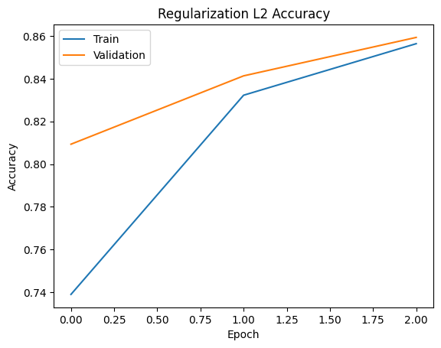
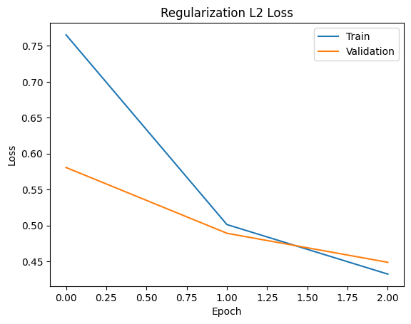
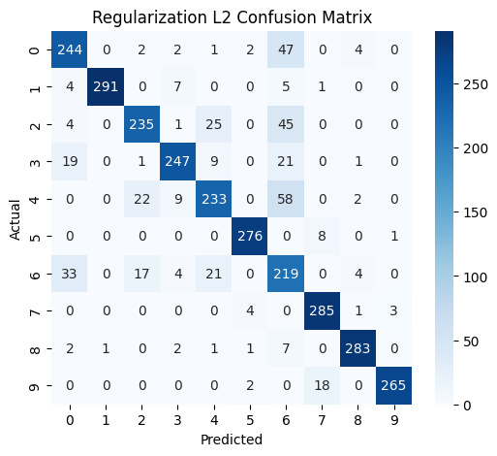
BATCH SIZE VARIATION

Training Batch Size: 32
Epoch 1/3
469/469 ━━━━━━━━━━━━━━━━━━━━ 18s 35ms/step - accuracy: 0.6749 - loss: 0.9253 - val_accuracy: 0.8170 - val_loss: 0.5006
Epoch 2/3
469/469 ━━━━━━━━━━━━━━━━━━━━ 17s 36ms/step - accuracy: 0.8399 - loss: 0.4358 - val_accuracy: 0.8303 - val_loss: 0.4588
Epoch 3/3
469/469 ━━━━━━━━━━━━━━━━━━━━ 18s 38ms/step - accuracy: 0.8617 - loss: 0.3673 - val_accuracy: 0.8713 - val_loss: 0.3649
Test Accuracy: 0.8713333606719971
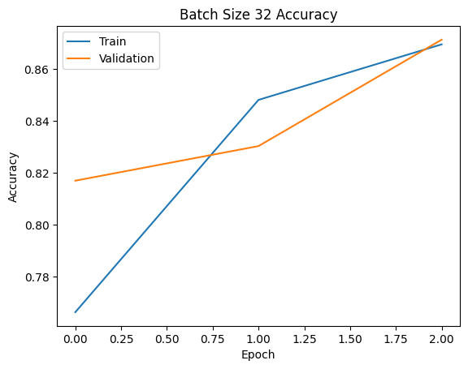
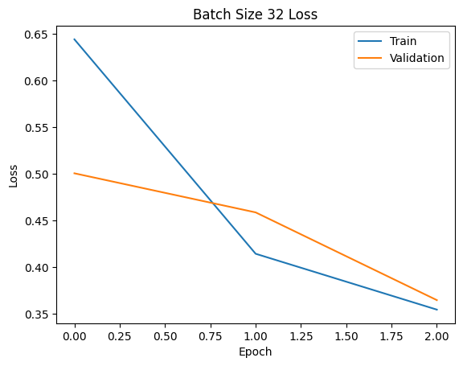
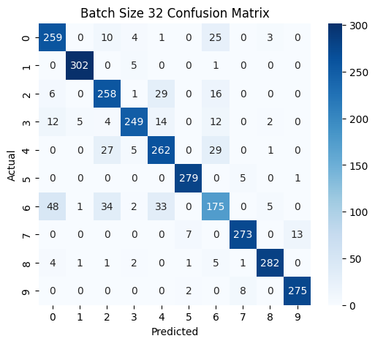
Training Batch Size: 64
Epoch 1/3
235/235 ━━━━━━━━━━━━━━━━━━━━ 17s 65ms/step - accuracy: 0.6429 - loss: 1.0446 - val_accuracy: 0.8247 - val_loss: 0.4970
Epoch 2/3
235/235 ━━━━━━━━━━━━━━━━━━━━ 15s 65ms/step - accuracy: 0.8385 - loss: 0.4417 - val_accuracy: 0.8457 - val_loss: 0.4231
Epoch 3/3
235/235 ━━━━━━━━━━━━━━━━━━━━ 15s 65ms/step - accuracy: 0.8610 - loss: 0.3839 - val_accuracy: 0.8300 - val_loss: 0.4603
Test Accuracy: 0.8299999833106995
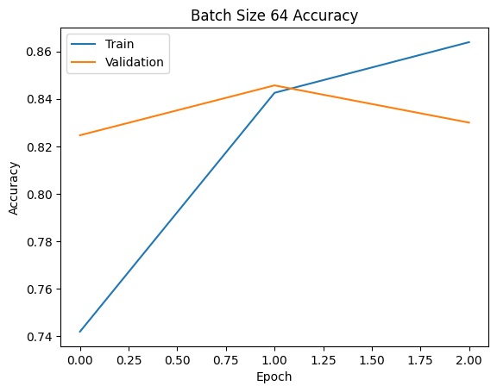
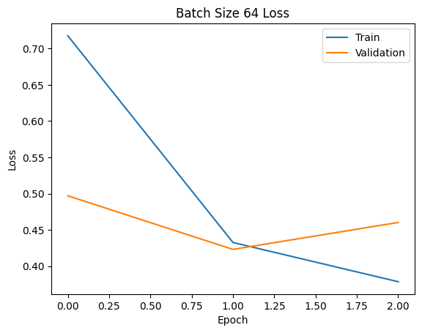
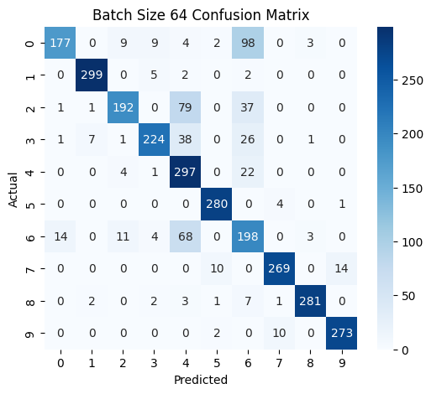
Training Batch Size: 128
Epoch 1/3
118/118 ━━━━━━━━━━━━━━━━━━━━ 15s 115ms/step - accuracy: 0.6091 - loss: 1.1648 - val_accuracy: 0.7600 - val_loss: 0.6138
Epoch 2/3
118/118 ━━━━━━━━━━━━━━━━━━━━ 13s 114ms/step - accuracy: 0.8032 - loss: 0.5376 - val_accuracy: 0.8270 - val_loss: 0.4767
Epoch 3/3
118/118 ━━━━━━━━━━━━━━━━━━━━ 20s 112ms/step - accuracy: 0.8423 - loss: 0.4385 - val_accuracy: 0.8587 - val_loss: 0.4214
Test Accuracy: 0.8586666584014893
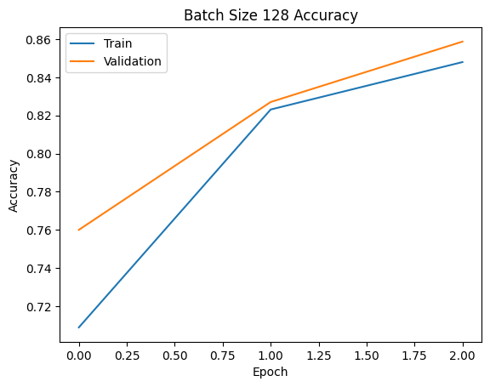
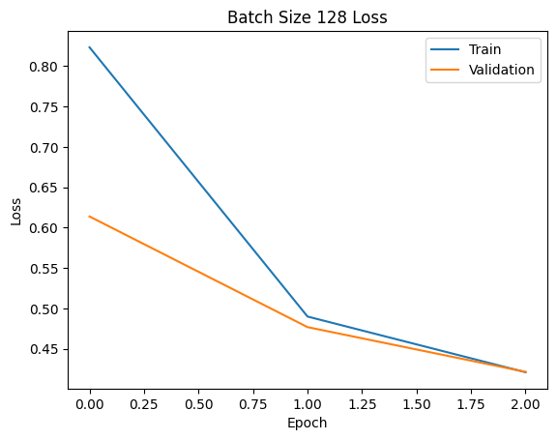
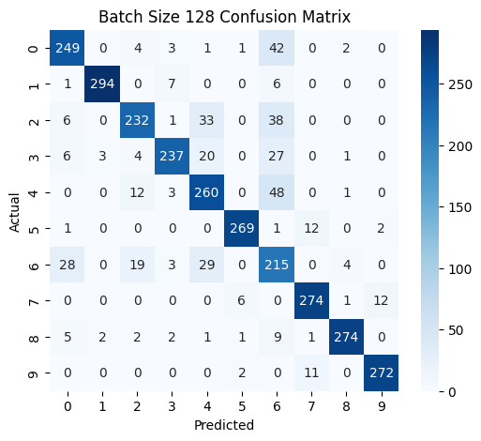
OPTIMIZER VARIATION

Training Optimizer: adam
Epoch 1/3
/usr/local/lib/python3.12/dist-packages/keras/src/layers/convolutional/base_conv.py:113: UserWarning: Do not pass an `input_shape`/`input_dim` argument to a layer. When using Sequential models, prefer using an `Input(shape)` object as the first layer in the model instead.
super().__init__(activity_regularizer=activity_regularizer, **kwargs)
235/235 ━━━━━━━━━━━━━━━━━━━━ 17s 68ms/step - accuracy: 0.6465 - loss: 1.0316 - val_accuracy: 0.7950 - val_loss: 0.5567
Epoch 2/3
235/235 ━━━━━━━━━━━━━━━━━━━━ 20s 67ms/step - accuracy: 0.8335 - loss: 0.4525 - val_accuracy: 0.8383 - val_loss: 0.4369
Epoch 3/3
235/235 ━━━━━━━━━━━━━━━━━━━━ 20s 66ms/step - accuracy: 0.8639 - loss: 0.3768 - val_accuracy: 0.8493 - val_loss: 0.4125
Test Accuracy: 0.8493333458900452
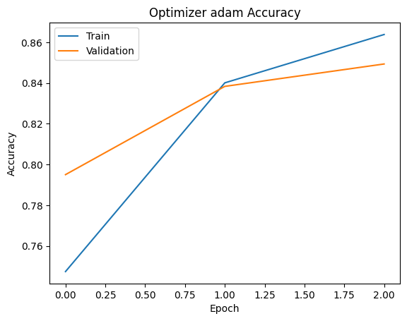
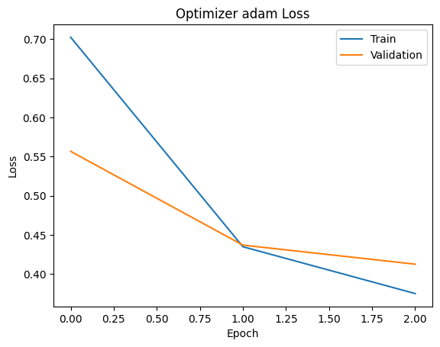
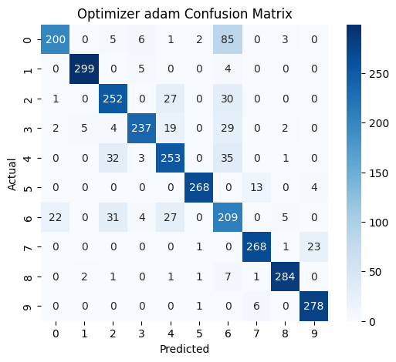
Training Optimizer: sgd
Epoch 1/3
235/235 ━━━━━━━━━━━━━━━━━━━━ 17s 68ms/step - accuracy: 0.2987 - loss: 2.1769 - val_accuracy: 0.5330 - val_loss: 1.1684
Epoch 2/3
235/235 ━━━━━━━━━━━━━━━━━━━━ 16s 67ms/step - accuracy: 0.6330 - loss: 0.9926 - val_accuracy: 0.6320 - val_loss: 0.9406
Epoch 3/3
235/235 ━━━━━━━━━━━━━━━━━━━━ 20s 65ms/step - accuracy: 0.6899 - loss: 0.8329 - val_accuracy: 0.6697 - val_loss: 0.9285
Test Accuracy: 0.6696666479110718
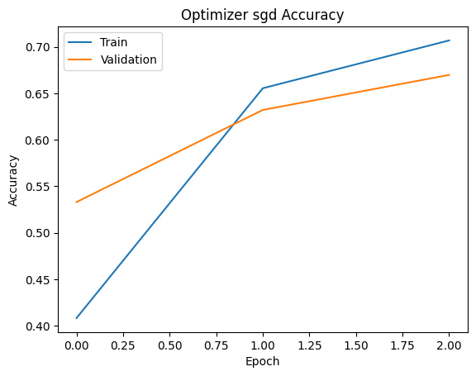
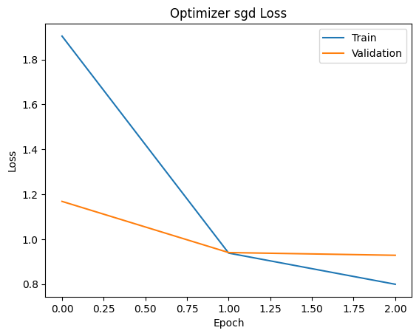
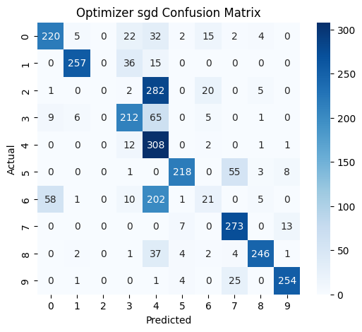
Training Optimizer: rmsprop
Epoch 1/3
/step - accuracy: 0.6079 - loss: 1.0498 - val_accuracy: 0.7687 - val_loss: 0.5919
Epoch 2/3
235/235 ━━━━━━━━━━━━━━━━━━━━ 16s 68ms/step - accuracy: 0.8141 - loss: 0.5058 - val_accuracy: 0.8397 - val_loss: 0.4439
Epoch 3/3
235/235 ━━━━━━━━━━━━━━━━━━━━ 20s 68ms/step - accuracy: 0.8490 - loss: 0.4108 - val_accuracy: 0.8373 - val_loss: 0.4384
Test Accuracy: 0.8373333215713501
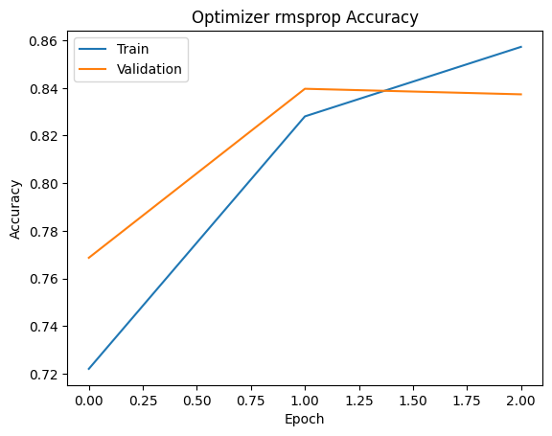
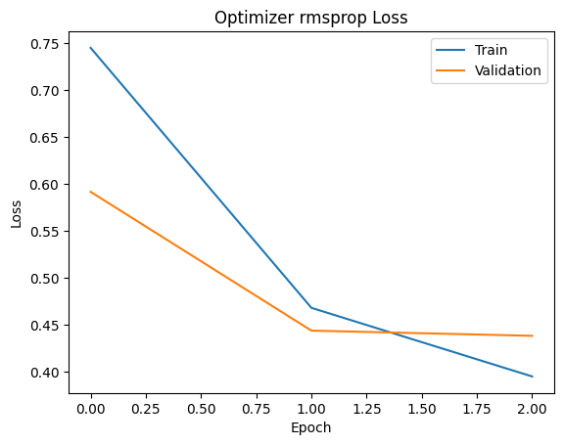
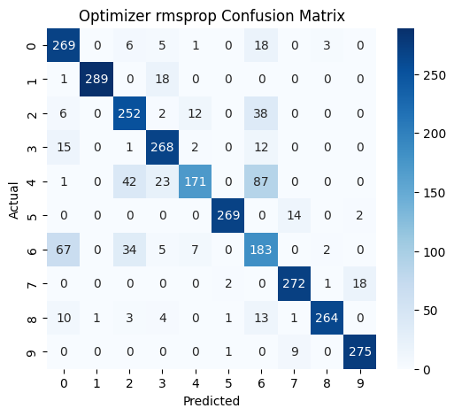

COMMENTS-.
- Learned how CNN works for image classification. Understood convolution, pooling, flatten and dense layers. Learned effect of filter size, regularization and batch size. Understood how optimizers improve model learning.
- Learned to evaluate performance using accuracy, loss graphs and confusion matrix.

