An Internship Document on

# CORE JAVA & ADVANCED JAVA

Submitted in partial fulfilment of the requirement of the Award of the Degree of

**BACHELOR OF TECHNOLOGY IN COMPUTER SCIENCE AND ENGINEERING**

**ARTIFICIAL INTELLIGENCE AND MACHINE LEARNING**

By

**M. Santhosh 226M1A4236**

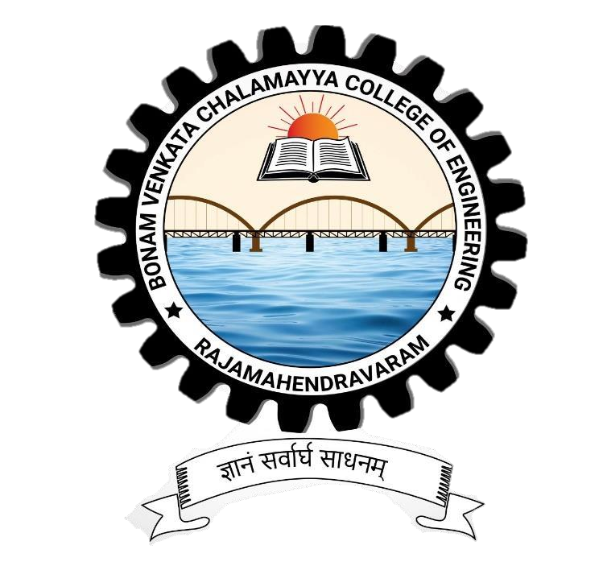

**DEPARTMENT**

**OF**

**COMPUTER SCIENCE & ENGINEERING**

## B.V.C COLLEGE OF ENGINEERING

**RAJAHMUNDRY , ANDHRA PRADESH.(2022-2026)**

**Accredited by NACC with “A” Grade**

CSS

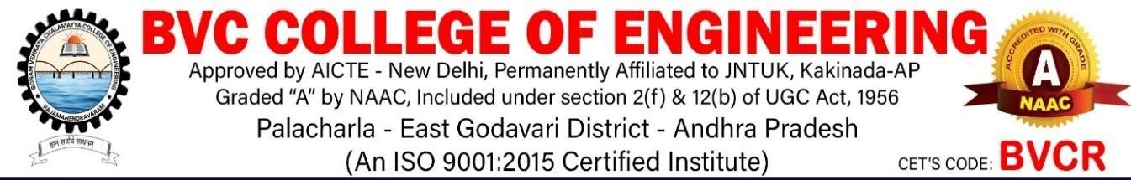

**DEPARTMENT OF COMPUTER SCIENCE & ENGINEERING**

**BVC COLLEGE OF ENGINEERING**

**(**An Autonomous Institution**)**

**RAJAHMUNDRY**

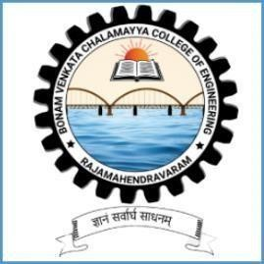

## *CERTIFICATE*

This is to certify that the “**INTERNSHIP REPORT**” submitted by **MATTA SANTHOSH (Regd.No:226M1A4236)** is work done by him and submitted during 2023 – 2024 academic year, in partial fulfillment of the requirements for the award of the degree of **BACHELOR OF TECHNOLOGY IN COMPUTER SCIENCE & ENGINEERING ARTIFICIAL INTELLIGENCE AND MACHINE LEARNING ,** at **HQL Edutech pvt.Ltd, Hyderabad.**

**EXAMINER Head of the Department**

## DECLARATION

First and foremost, we sincerely salute our esteemed. institution **B.V.C COLLEGE OF ENGINEERING** for giving this golden opportunity for fulfilling our warm dreams of becoming engineers.

We would like to express our utmost gratitude to our project guide **Mr.M.Satyanarayana MCA Assistant Professor** who in spite of being extraordinarily busy with his duties, took time to give us the valuable advices and guidance throughout the completion of the project. GI

We are highly obliged to our Head of the Department, **Mr.R.N.V.Vishnu Murthy, M.Tech,MISTE,PhD Associate professor** for his constant inspiration, extensive help and valuable support in our every step.

Last but not the least, we owe a great deal to our Principal **Dr. T.V. JANARDHANA RAO**, **BE, M.Tech, MBA ,Ph.D, MISTE, FIETE, MIEE.** for his extending a helping hand at every juncture of need.

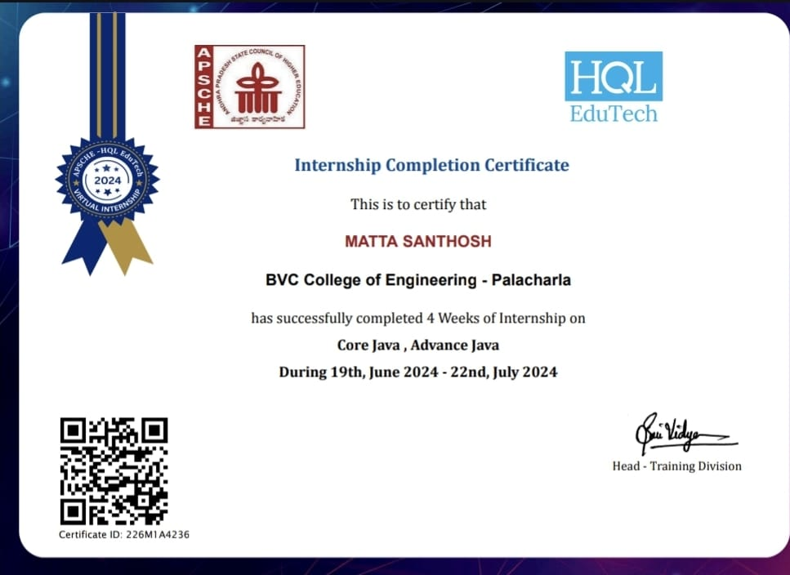

**ACKNOWLEDGMENT:**

First and foremost, we sincerely salute our esteemed institution, **B.V.C COLLEGE OF ENGINEERING**, for giving us this golden opportunity to fulfill our warm dreams of becoming engineers.

We would like to express our utmost gratitude to our Head of the Department, **Mr.R.N.V.Vishnu Murthy, M.Tech,MISTE,PhD Associate professor**, for his constant inspiration, extensive help, and valuable support at every step of our project.

Last but not least, we owe a great deal to our Principal, **Dr. T.V. JANARDHANA RAO**, BE, **M.Tech, MBA ,Ph.D, MISTE, FIETE, MIEE.**  for extending a helping hand at every juncture of need.





