**Initial load of master data from Authenticated state-wide Govt Website:**

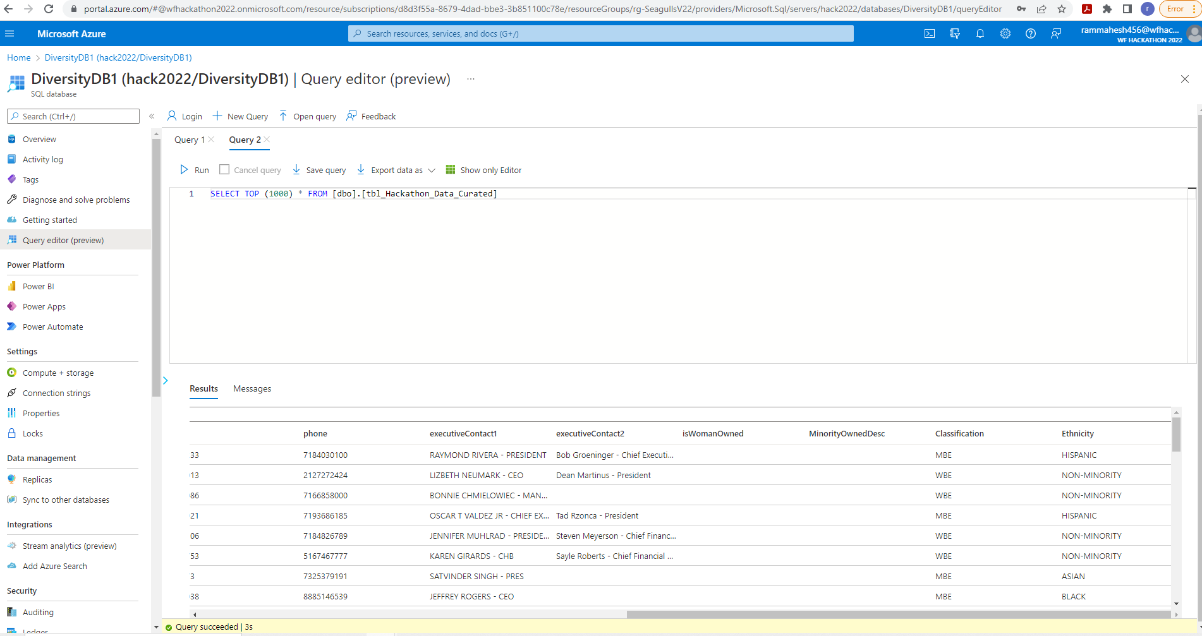

SerpAPI:

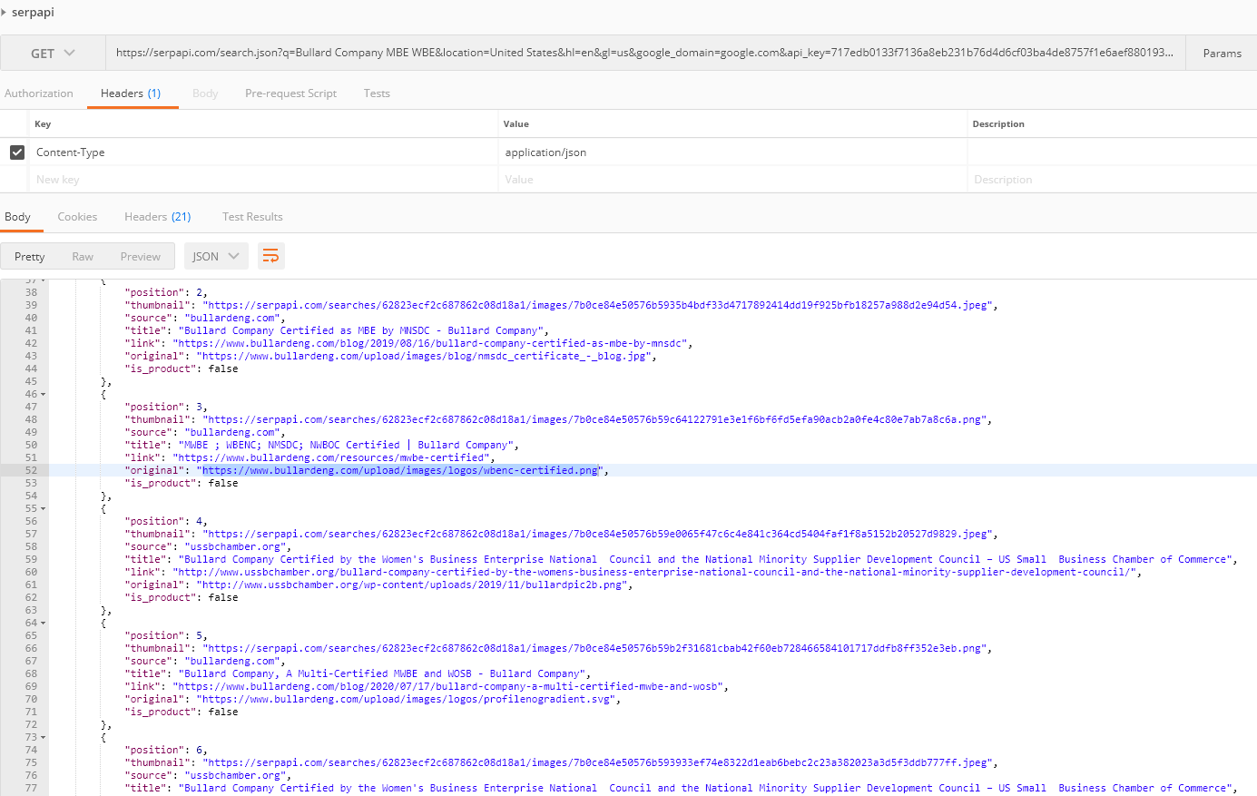

Azure Cognitive service (Scan API):

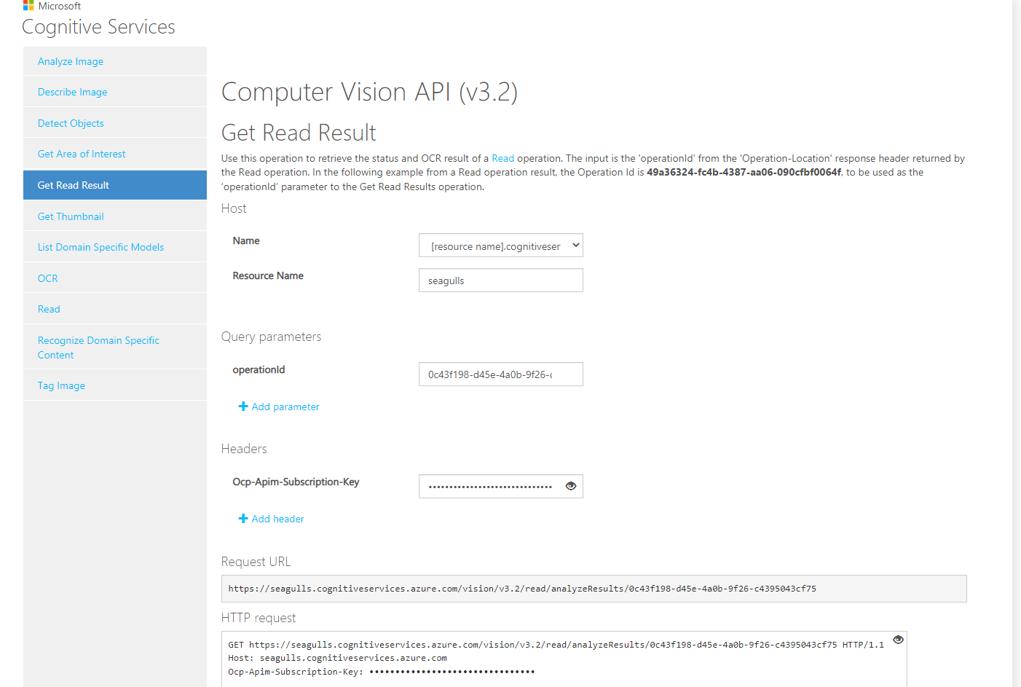

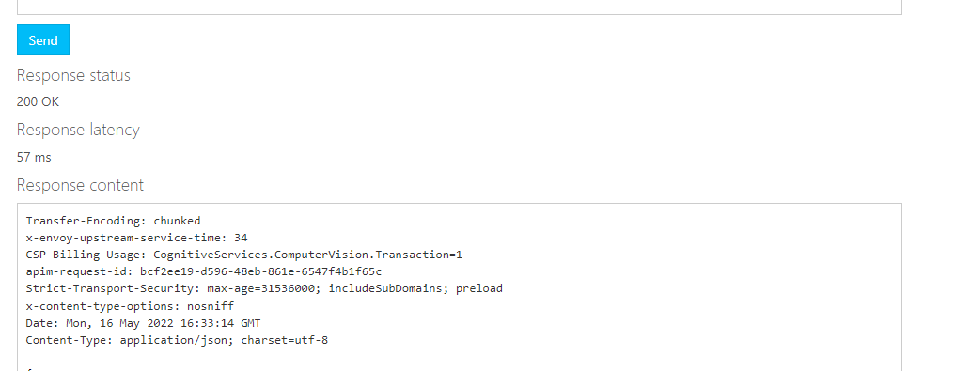

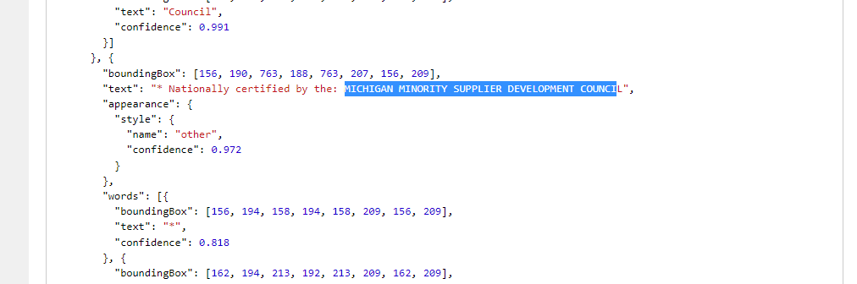

D&B API:

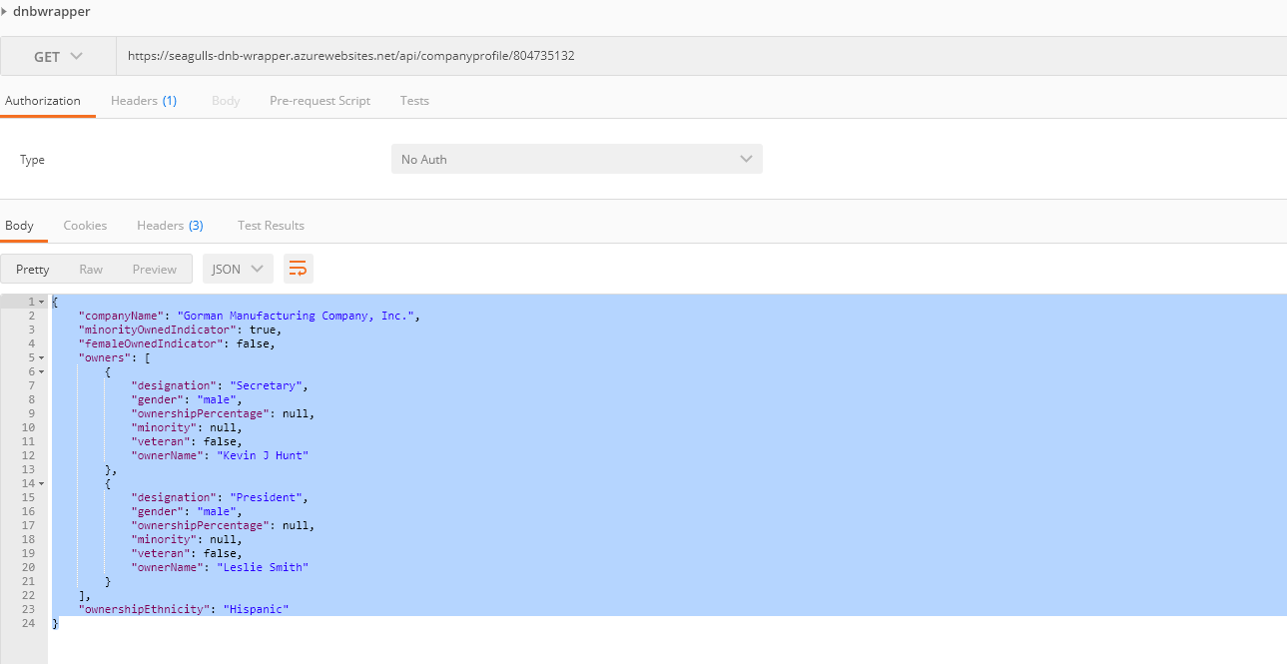

LinkedIn Automation output in Azure Blob store:

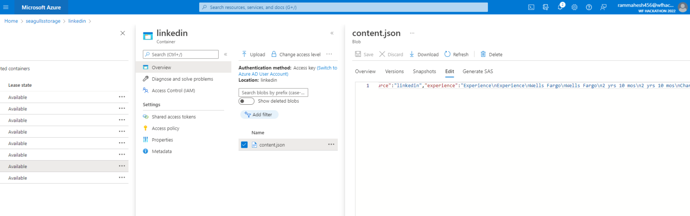

NLP output:

Knowledge Base:

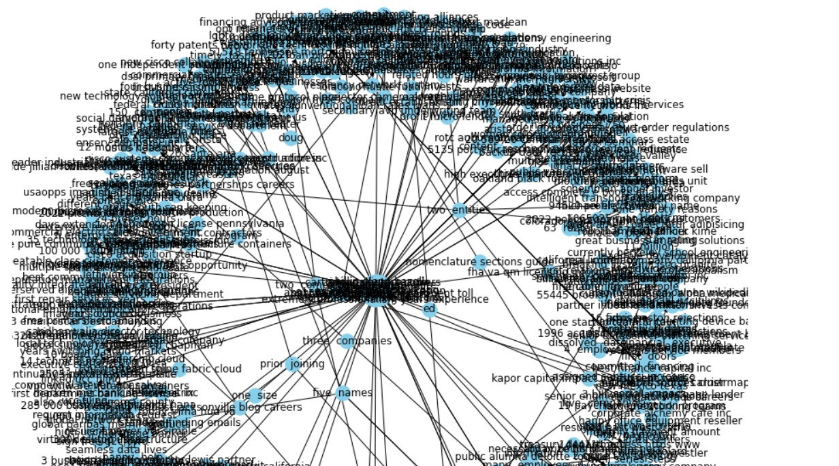

NLP Entity extraction: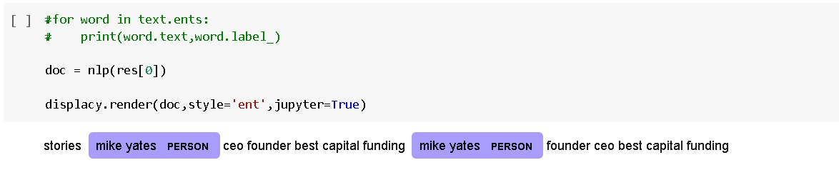

Similarity score:

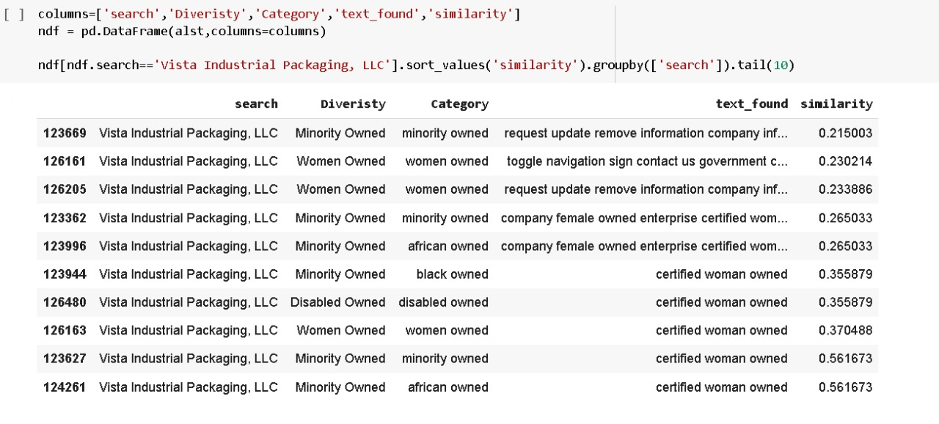

NLP Fast API service

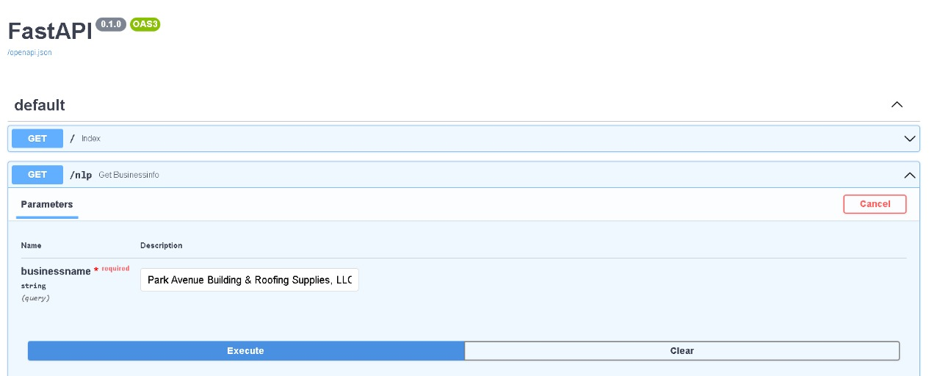

Reports/Metrics:

Diversity Dashboard

* **Diversity dashboard provides analysis of data collected from the proposed solution.**
* **It provides data based on Ethnicity, gender , organizational and employee diversity.**
* **Entire data from database has be populated in tabular foram having pagination and filters for ease of navigation and search.**
* **Provides indication of data source , which application captured form multiple data sources.**

* This dashboard provides flexibility to users to search for an organization and retrieves data as per requirement.
* User can search for any organization and dashboard provides data related to Company, Ownership details as wells as Employee diversity details.